Sing Ming Chen
Email : sing@paddingleft.com
Phone : (+886)910128813
Nationality : Taiwan

Career Summary
- 4 years' experience in web development, specialized in frontend
- Possess extensive and deep skill sets not only front-end but also NodeJS, C#, Webapi, databases
- Strong experience in performance tuning, SEO, ELK, CI/CD
- Top 10% user in Stackoverflow with 2k+ reputation
- Willing to learn and share, proactive in work, reliable team player
- Github : https://github.com/Asing1001

Skills Summary

Technical skill :
- Programming :
  - Advanced - Javascript, NodeJS, ReactJS, AngularJS, HTML, CSS, C#, ASP.NET MVC, ASP.NET Webapi
  - Skilled - GraphQL, Typescript, VueJS, Webpack
- Databases :
  - Skilled - Redis, MongoDB, MSSQL
- Testing :
  - Skilled - Mocha, Selenium, MSTest
- Other :
  - Advanced - Performance tuning, ELK, SEO, CI/CD, Crawler, GA/GTM, GIT

Language
- English - Fluent (TOEIC 900, Golden Certificate)
- Chinese - Native

Certificate
- Google Analytics certificate
- TOEIC Golden certificate

Work Experience

Xuenn - Senior full stack engineer - 2014/10-present

Responsibilities
- System design and development, focus on front-end, webapi, noSQL
- Production support
- Performance tuning, SEO
- Webapi integration with partners

Projects
Content management system
- Role: Full stack developer, 5 team members
- Solution:
  - Support custom RWD layout in CMS with dynamic bootstrap settings
  - Provide dynamic widgets with AngularJS directive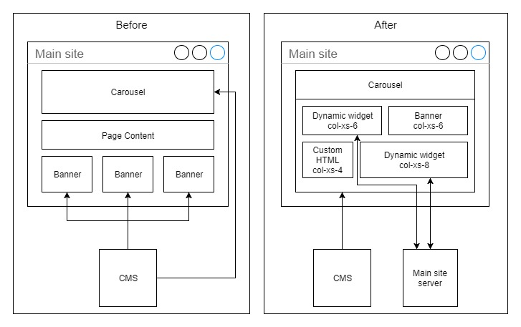
SEO enhancement - seo crawler & prerender
- Role: Project owner
- Solution: Make search engine index Ajax contents with making seo-crawler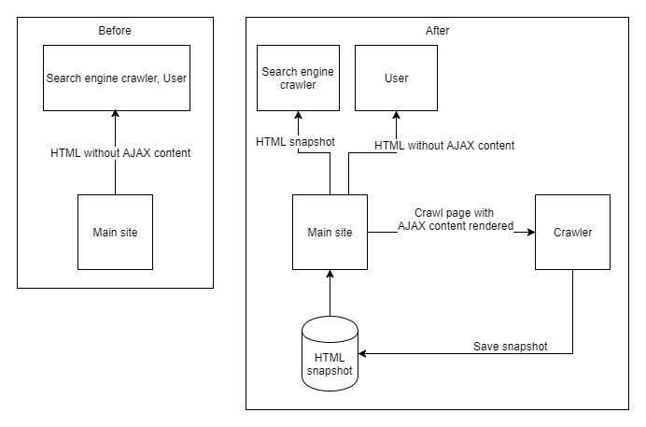
Online gaming portal (Desktop, Mobile, MobileApp webview)
- Role: Front-end major developer, 30 team members
- Solution:
  - Revamp UI with AngularJS and ASP.NET Webapi
  - Provide multi-language and localized gaming portal by integrating CMS
  - Extend maintainability by refactor and decouple system with TDD
Realtime messaging system
- Role: Front-end major developer, 3 team members
- Solution: Provide realtime functionality and notification by SignalR and Redis Pub/Sub

Main site performance tuning
- Role: Major developer, 2 team members
- Solution:
  - Service-worker - Reduce 50% page loading time by caching response from CMS/CDN
  - Redis-cache - Reduce 95% server start time and 90% read query by centralizing application cache into Redis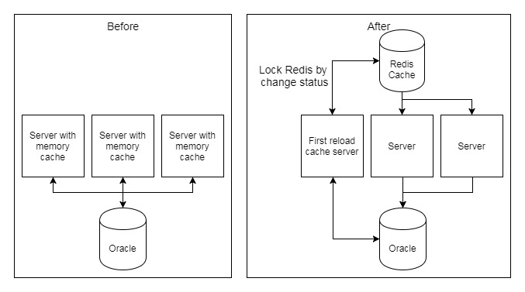
  - Angular template cache - Reduce 30% request by compressing AngularJS templates with webpack
  - Use .woff/.woff2 font file - Replace .ttf/.eot with smaller and browser-supported font file, reduce 50% sizing

Open Source projects (https://github.com/Asing1001)
Universiade ticket - https://github.com/Asing1001/universiade-ticket
- Role: Main contributor
- Purpose: Help people buy Universiade ticket easily by crawling official site then re-design
- Feature: 120+ Github Stars, 10+ News report, 5k buy action, 100k pageview in one week
- Reference news: https://buzzorange.com/techorange/2017/08/23/universiade-ticket-checker-app/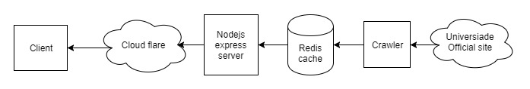
MVCshopping mall - https://github.com/Asing1001/MVCShoppingMall
- Role: Main contributor
- Purpose: Demonstrate how to build e-commerce platform by ASP.NET MVC
- Feature: Provide a one-click setup by code-first and data seeding
MovieRater - https://github.com/Asing1001/movieRater.React
- Role: Main contributor
- Purpose: To help people find movie's rating and comment easier
- Feature: Built by ReactJS, Typescript, GraphQL, NodeJS, MongoDB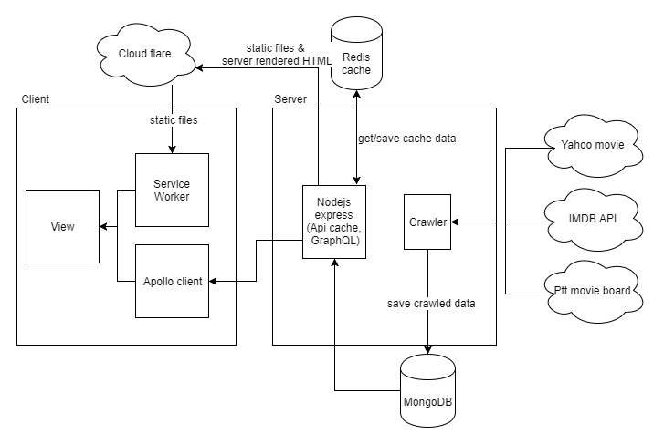

Awards
- 2017 Hsinchu Hackthon Best Popularity Award
- 2013 MSD Elite MedCamp - The Elite Team News Link
- 2011 National Taipei University Annual award

Education
- Microsoft Internet Technology Courses (636 hours), Institute for Information Industry, 2014/3-2014/9
- B.S. in Business Administration, National Taipei University, Taiwan, 2009/9-2013/6

