## Sing Ming Chen

Email : [sing@paddingleft.com](mailto:sing@paddingleft.com)  
Phone : (+886)910128813  
Nationality : Taiwan

## Career Summary

* 4 years' experience in web development, specialized in frontend
* Possess extensive and deep skill sets not only front-end but also NodeJS, C#, Webapi, databases
* Strong experience in performance tuning, SEO, ELK, CI/CD
* Top 10% user in Stackoverflow with 2k+ reputation
* Willing to learn and share, proactive in work, reliable team player
* Github : <https://github.com/Asing1001>

## Skills Summary

### Technical skill :

* Programming :
  + Advanced - Javascript, NodeJS, AngularJS, HTML, CSS, C#, ASP.NET MVC, ASP.NET Webapi
  + Skilled - GraphQL, Typescript, ReactJS, VueJS, Webpack
* Databases :
  + Skilled - Redis, MongoDB, MSSQL
* Testing :
  + Skilled - Mocha, Selenium, MSTest
* Other :
  + Advanced - Performance tuning, ELK, SEO, CI/CD, Crawler, GA/GTM, GIT

### Language

* English - Fluent (TOEIC 900, Golden Certificate)
* Chinese - Native

### Certificate

* Google Analytics certificate
* [TOEIC Golden certificate](https://goo.gl/photos/gGjX7pcqvkGqMoZB8)

## Work Experience

### Xuenn - Senior full stack engineer - 2014/10-present

#### Responsibilities

* System design and development, focus on front-end, webapi, noSQL
* Production support
* Performance tuning, SEO
* Webapi integration with partners

#### Projects

Content management system

* Role: Full stack developer, 5 team members
* Solution:
  + Support custom RWD layout in CMS with dynamic bootstrap settings
  + Provide dynamic widgets with AngularJS directive[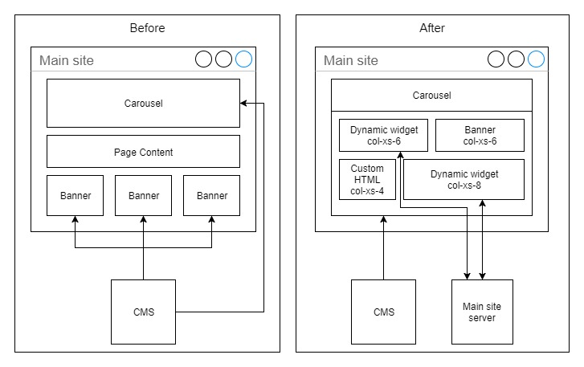](https://github.com/Asing1001/system-diagrams/blob/master/CMS.jpg?raw=true)

SEO enhancement - seo crawler & prerender

* Role: Project owner
* Solution: Make search engine index Ajax contents with making seo-crawler[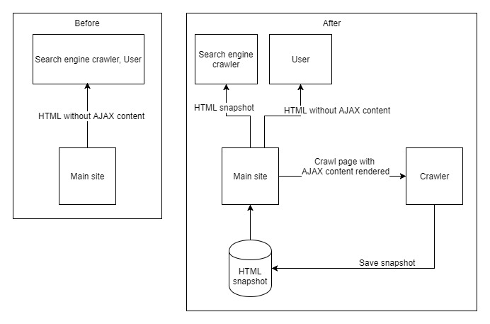](https://github.com/Asing1001/system-diagrams/blob/master/seo-crawler-prerender.jpg?raw=true)

Online gaming portal (Desktop, Mobile, MobileApp webview)

* Role: Front-end major developer, 30 team members
* Solution:
  + Revamp UI with AngularJS and ASP.NET Webapi
  + Provide multi-language and localized gaming portal by integrating CMS
  + Extend maintainability by refactor and decouple system with TDD

Realtime messaging system

* Role: Front-end major developer, 3 team members
* Solution: Provide realtime functionality and notification by SignalR and Redis Pub/Sub

Main site performance tuning

* Role: Major developer, 2 team members
* Solution:
  + Service-worker - Reduce 50% page loading time by caching response from CMS/CDN
  + Redis-cache - Reduce 95% server start time and 90% read query by centralizing application cache into Redis[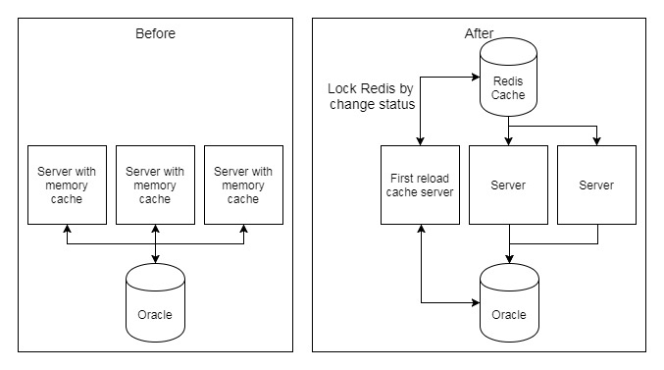](https://raw.githubusercontent.com/Asing1001/system-diagrams/master/centralized-cache.jpg)
  + Angular template cache - Reduce 30% request by compressing AngularJS templates with webpack
  + Use .woff/.woff2 font file - Replace .ttf/.eot with smaller and browser-supported font file, reduce 50% sizing

## Open Source projects (<https://github.com/Asing1001>)

[Universiade ticket](http://ticket.mvrater.com/) - <https://github.com/Asing1001/universiade-ticket>

* Role: Main contributor
* Purpose: Help people buy Universiade ticket easily by crawling official site then re-design
* Feature: 120+ Github Stars, 10+ News report, 5k buy action, 100k pageview in one week
* Reference news: <https://buzzorange.com/techorange/2017/08/23/universiade-ticket-checker-app/>[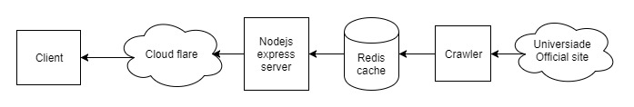](https://github.com/Asing1001/system-diagrams/blob/master/universiade-ticket.jpg?raw=true)

[MVCshopping mall](http://wecarestore.azurewebsites.net/) - <https://github.com/Asing1001/MVCShoppingMall>

* Role: Main contributor
* Purpose: Demonstrate how to build e-commerce platform by ASP.NET MVC
* Feature: Provide a one-click setup by code-first and data seeding

[MovieRater](https://www.mvrater.com/) - <https://github.com/Asing1001/movieRater.React>

* Role: Main contributor
* Purpose: To help people find movie's rating and comment easier
* Feature: Built by ReactJS, Typescript, GraphQL, NodeJS, MongoDB[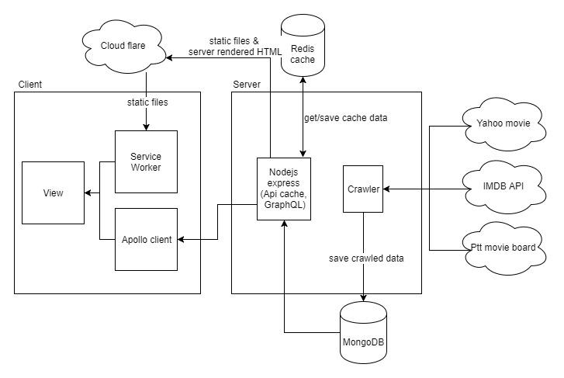](https://github.com/Asing1001/system-diagrams/blob/master/mvrater.jpg?raw=true)

## Awards

* 2017 Hsinchu Hackthon Best Popularity Award
* [2013 MSD Elite MedCamp - The Elite Team](https://goo.gl/photos/kSca7Xf9csrJ2bsd8) [News Link](http://bit.ly/1B7iH4H)
* [2011 National Taipei University Annual award](https://goo.gl/photos/QtC9zUMR6qgHiVME7)

## Education

* Microsoft Internet Technology Courses (636 hours), Institute for Information Industry, 2014/3-2014/9
* B.S. in Business Administration, National Taipei University, Taiwan, 2009/9-2013/6