1.Initialize Run
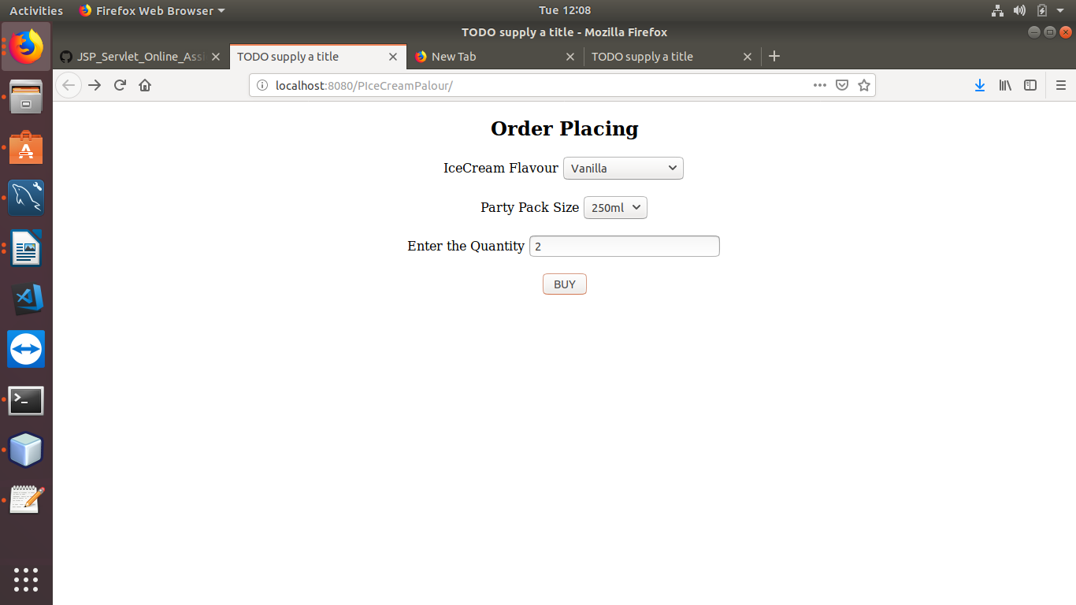
2.Asking for Details of the Customer .....Since Cookie is Not Stored and First User has Logged In

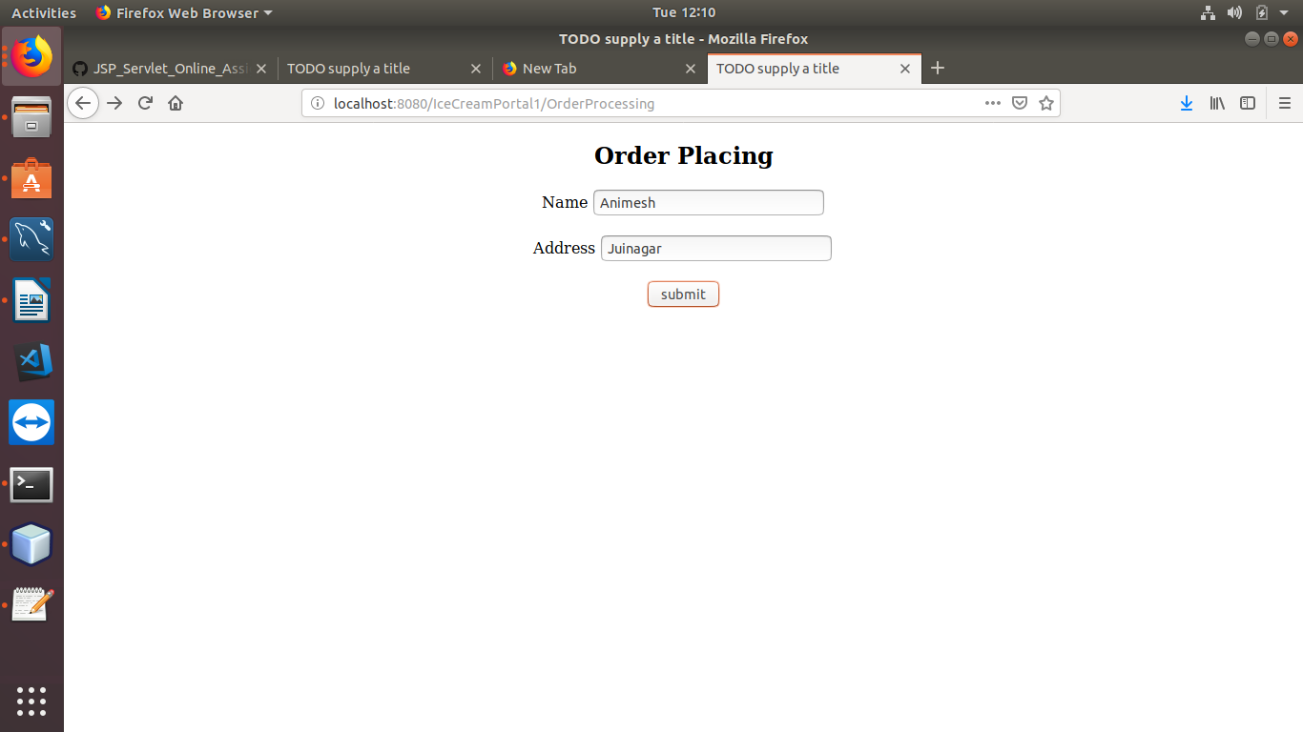
3.Calculating the Sum of the IceCream as Per Flavour+PartyPackSize+Quantity(Using Switch )

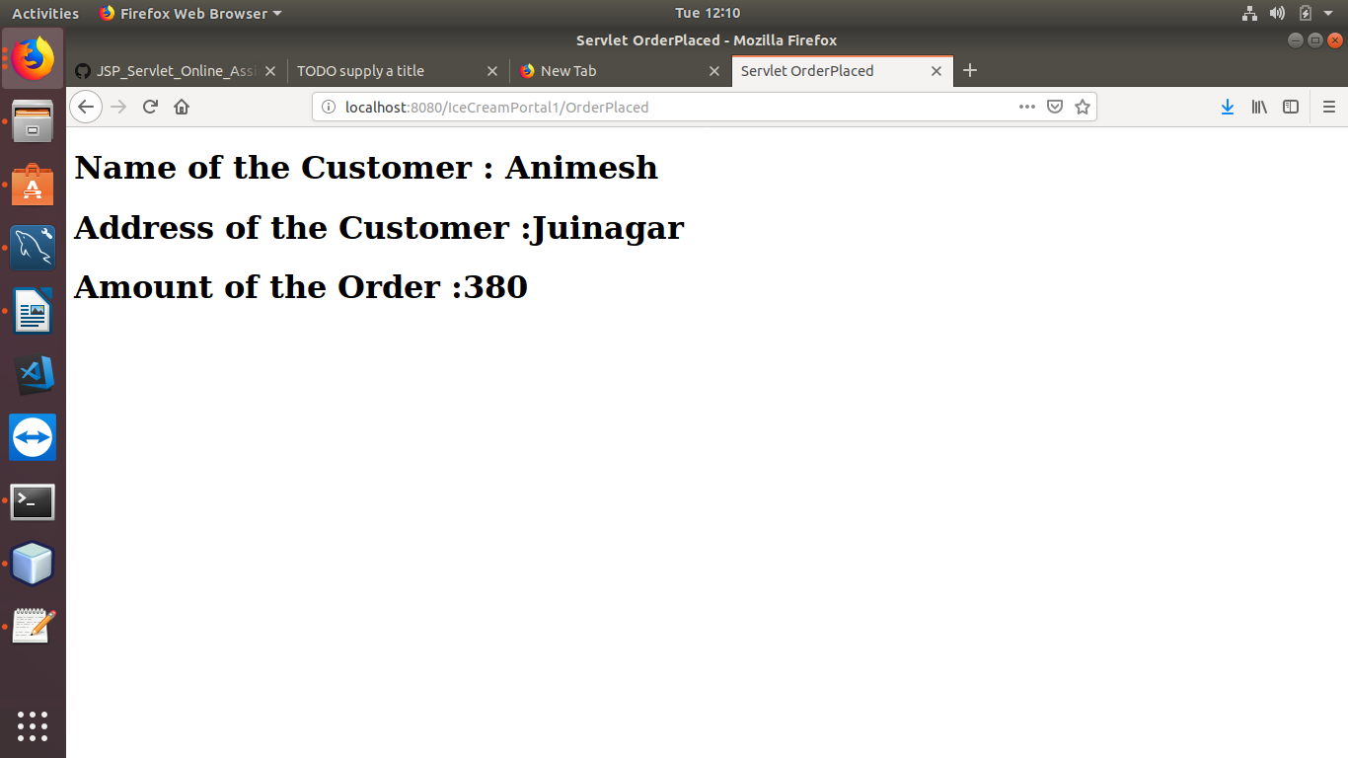
4.Again Running the Application(Server Side)

1.Now User has Accessed it Second Time
ThereFor e No Login is Asked ...Only ask for the Order+Bill is Calculated

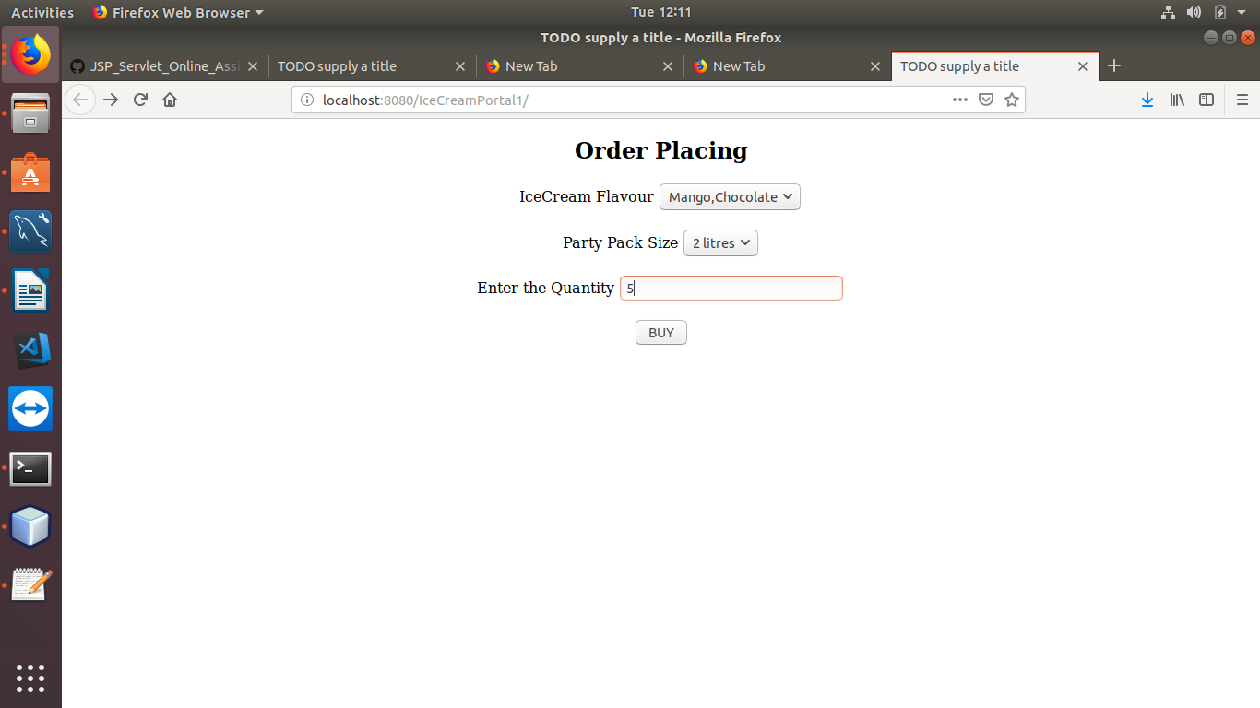

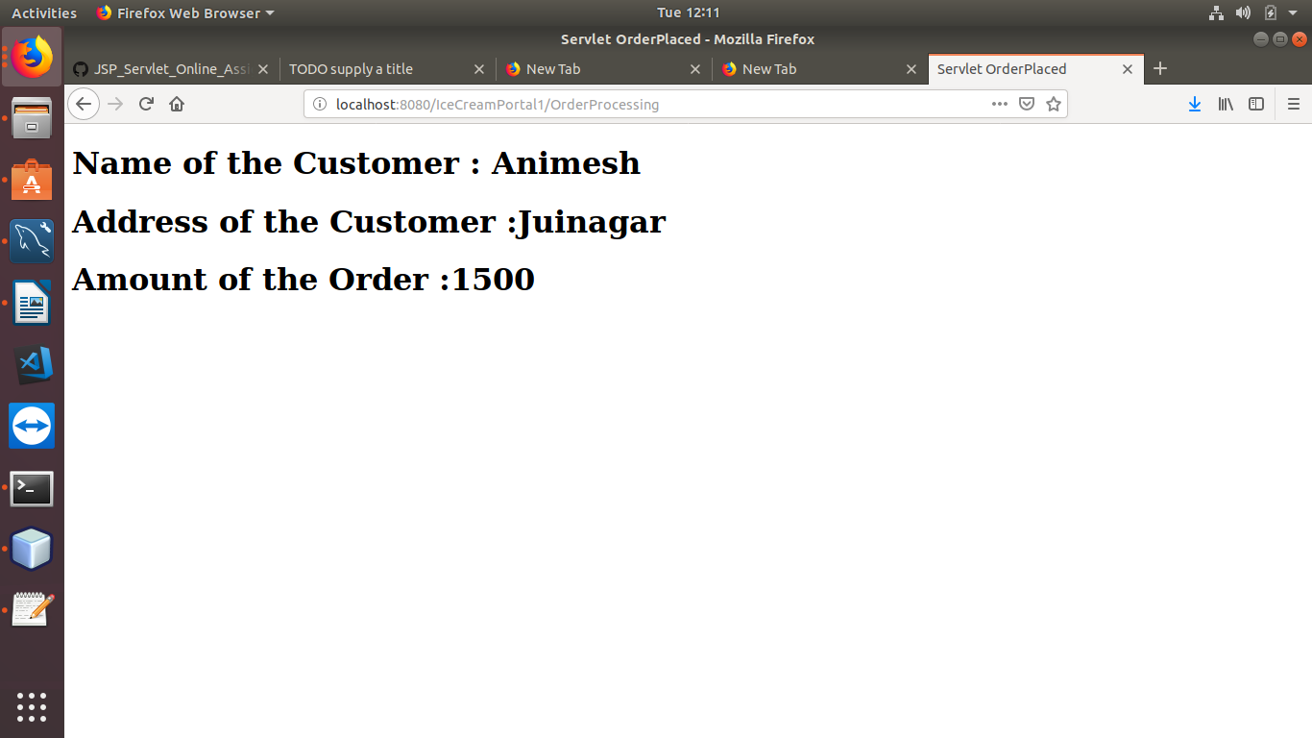

//*******************************Cookies is Deleted**************************

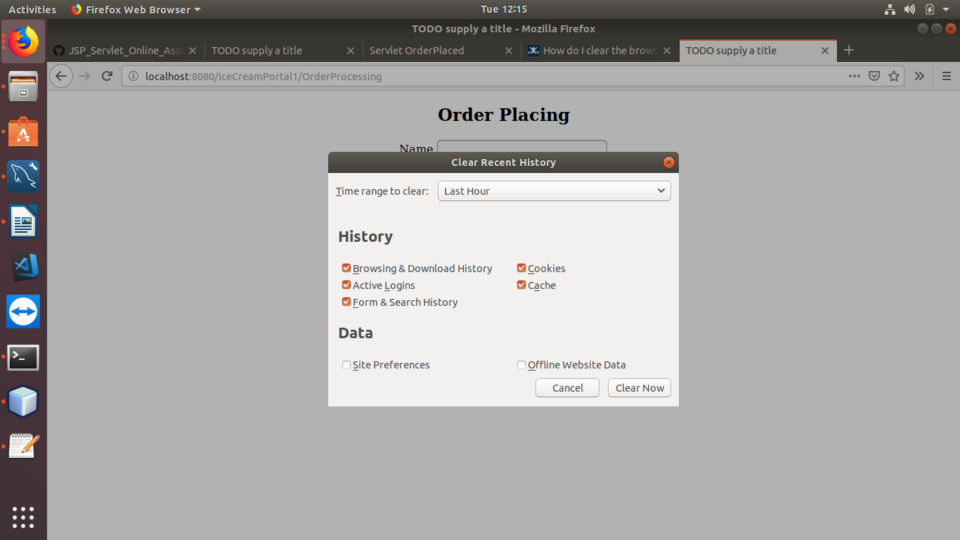
Therfore Again it Ask for the Details

