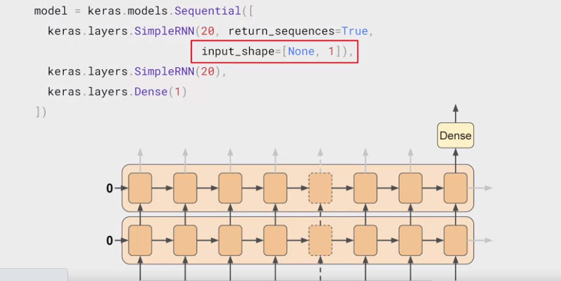

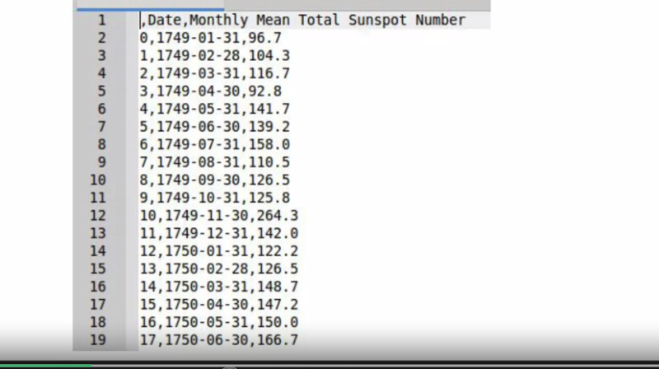

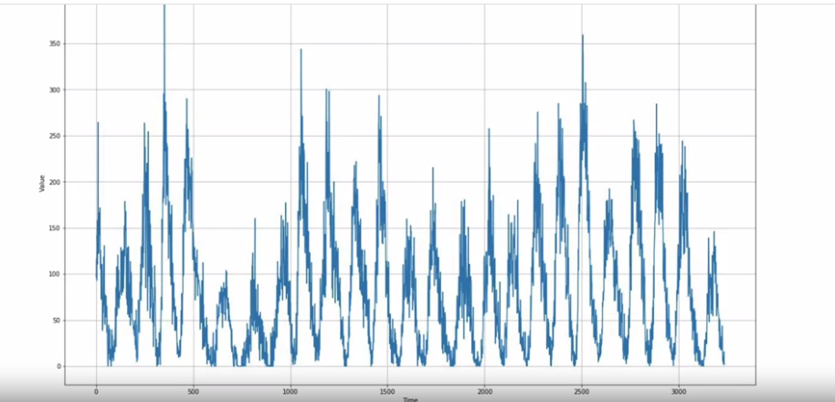

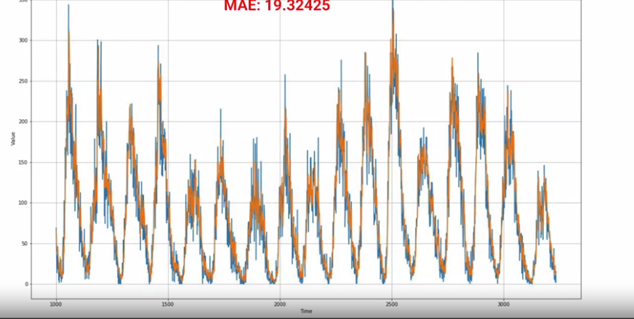

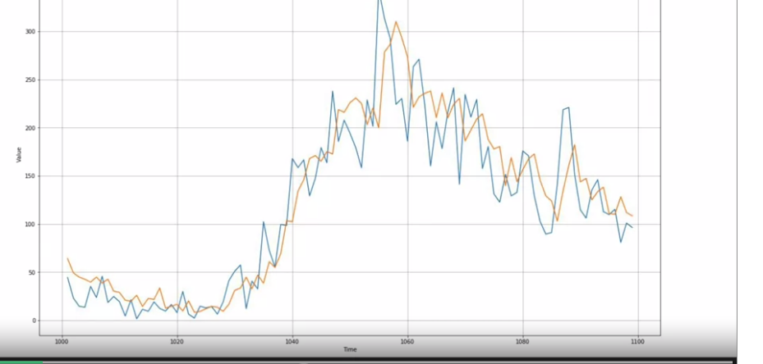

INCREASING THE WINDOW SIZE (CHECK IF ITS WORK ?)

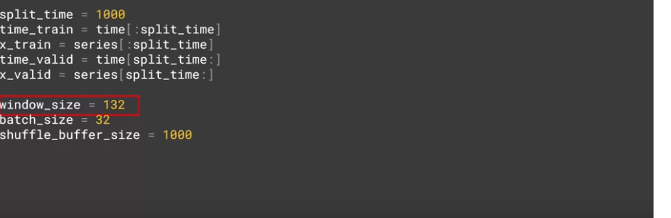

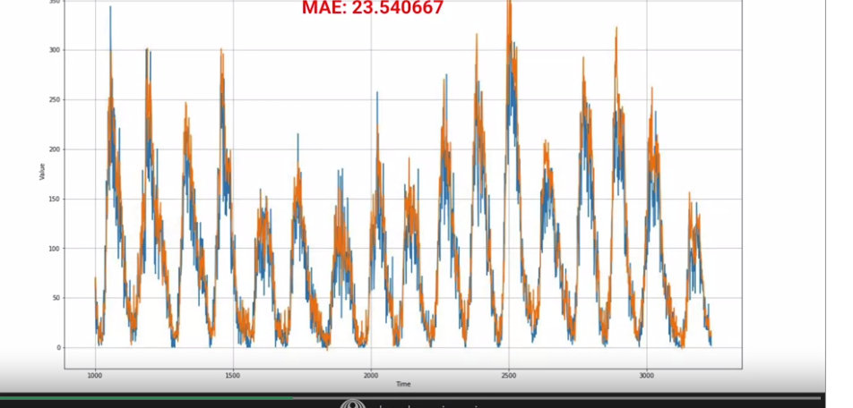

Just don’t need the All windows_size of 132 in 1 year

Just the Typical Time Series (Later just there is lot of noise) : Therefore we don’t need the huge window to train

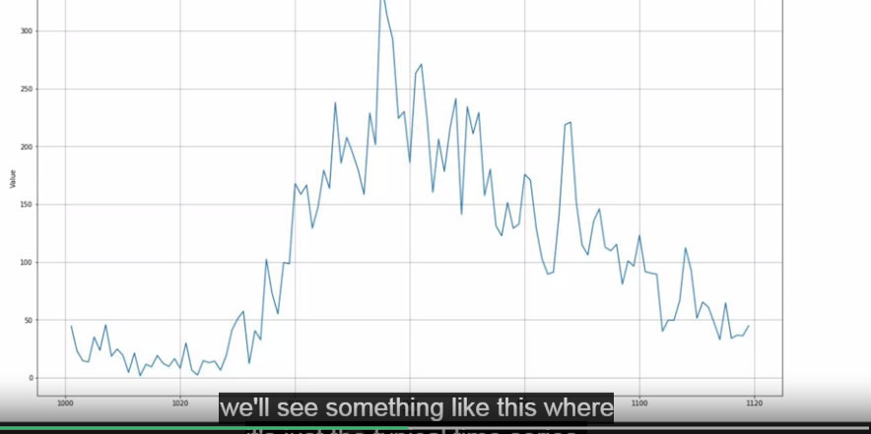

1. 3000 Training + 500 (Validation)
2. Window size = 30

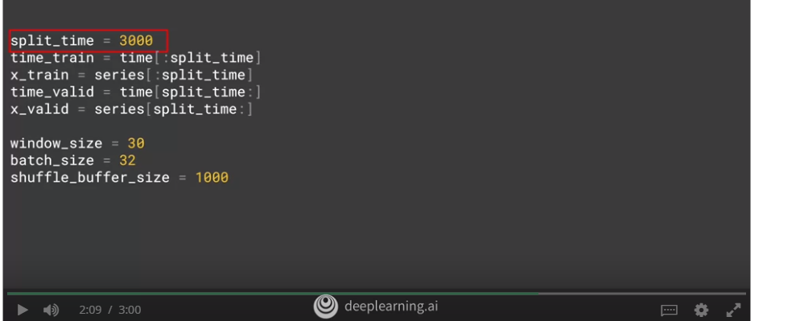

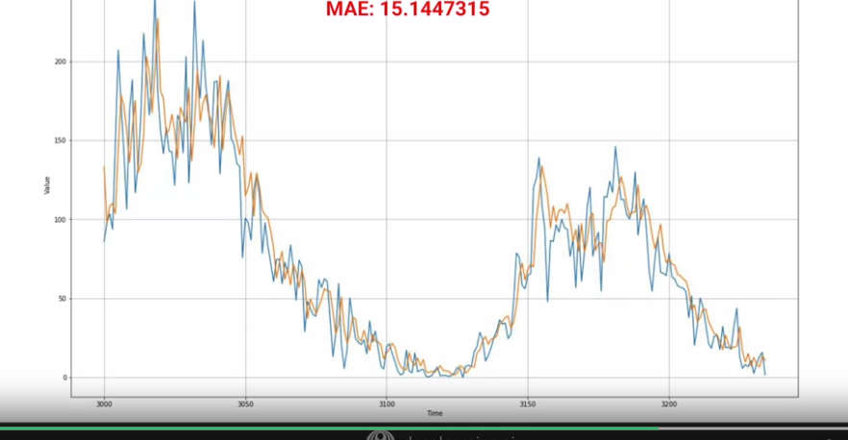

Tweaking the Learning Rate: (14.122)

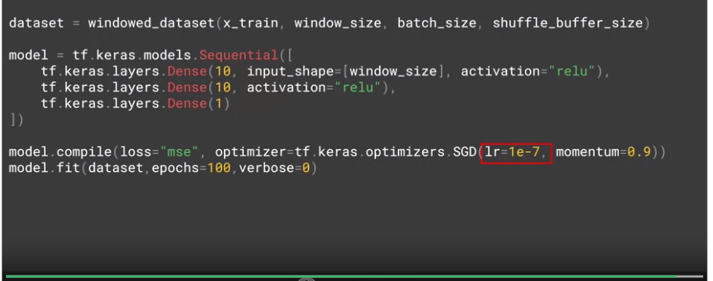

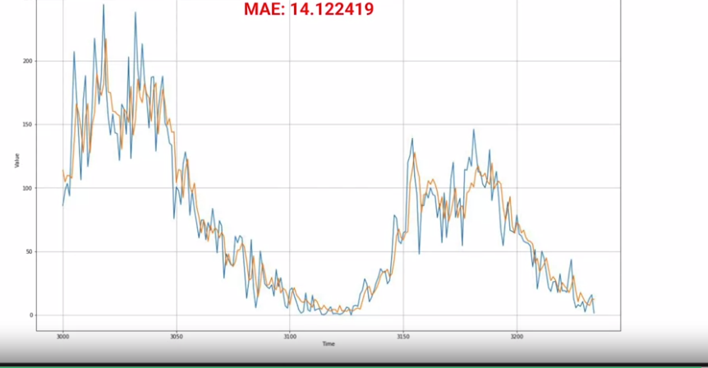

Prediction : 3500 (3205 : 3235)

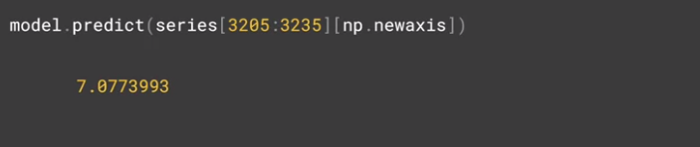

July 2018 Train and Predicting for August 2018

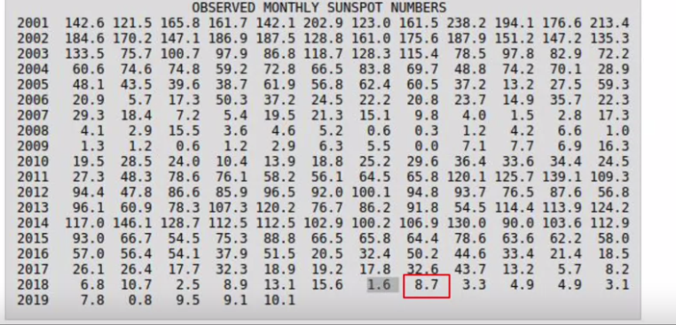

8.7 (Actual) vs 7.077 (Predicted)