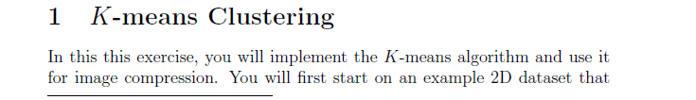

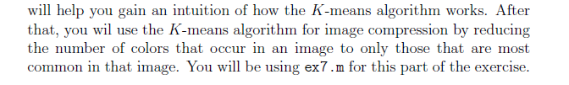

**findClosestCentroids.m :**

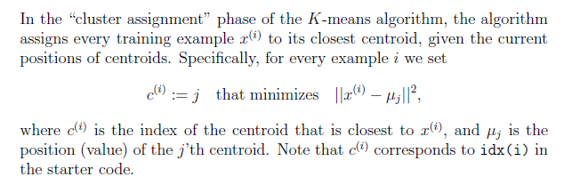



### computeCentroids.m :

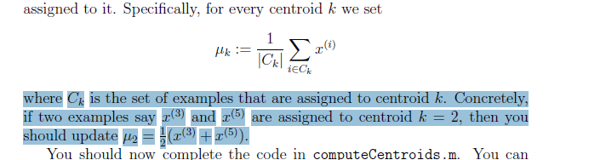

**Observe the Diagram(Shifting of Centroid Point and Also Grouping of Points )**

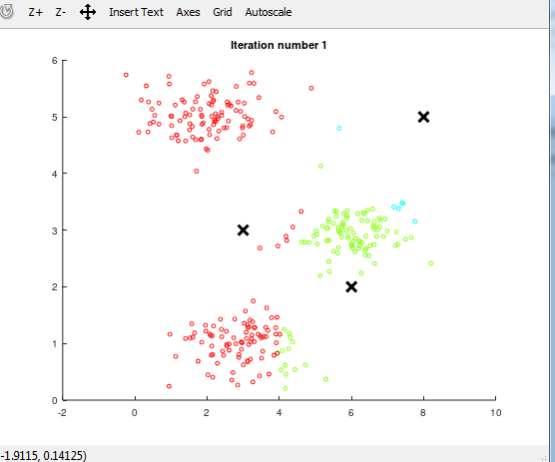

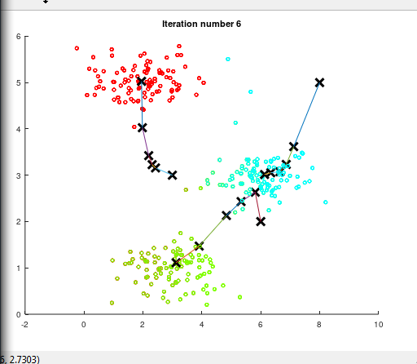

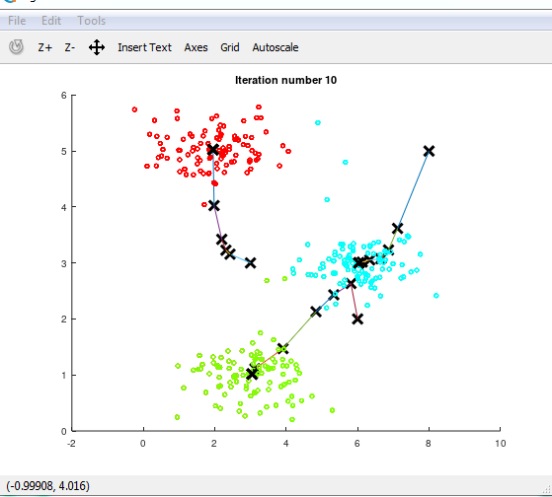

### kMeansInitCentroids.m :

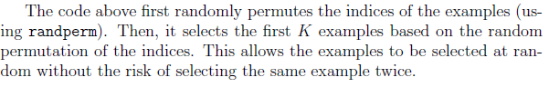

**K-means on pixels**



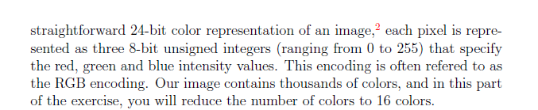

**PIXEL VALUES –**(45,245,105)(Red , Green , Blue – yeh Pixel me kitan red , Green and Blue ka ratio hai )

**But Compression me just 16 colors hi use karna hai**

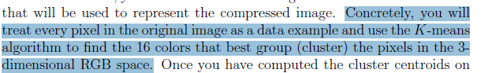

**We have pixel has data points (features) we want to cluster in into 16 Clusters**

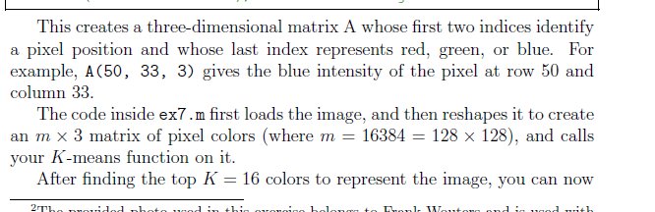

**V. Imp**

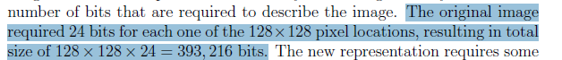



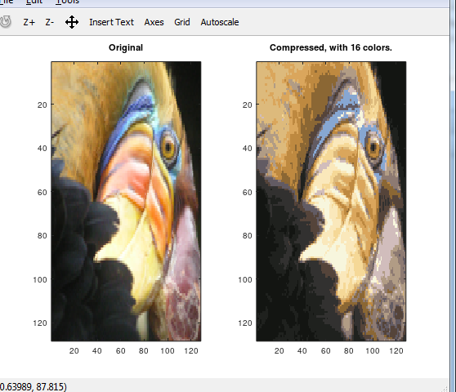

# PCA :

Feature Normalization before PCA :

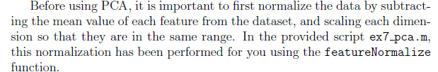

### pca.m :

### Convariance Matrix of Data : (Step 1)

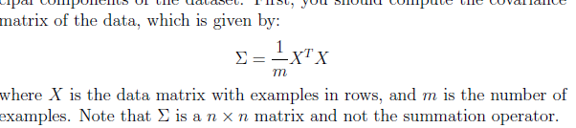

### SVD: (Step 2)

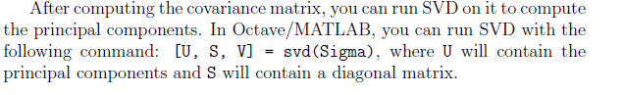

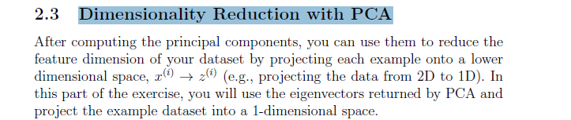

### projectData.m :

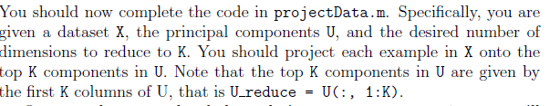

### recoverData.m :

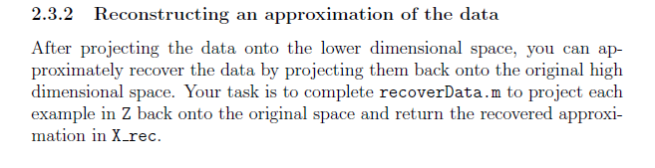

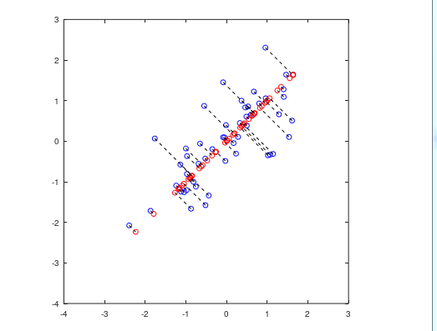

### Not do Exercise Already Coded Exercise :

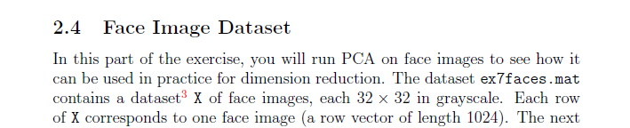

**Learning from Quiz**

1. 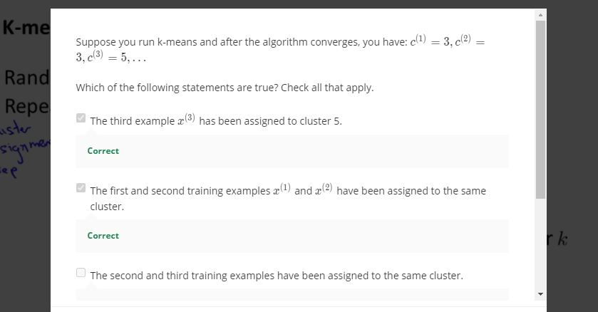

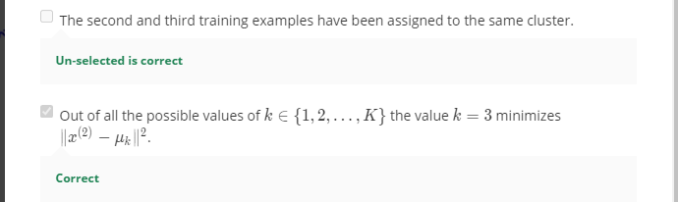

1. 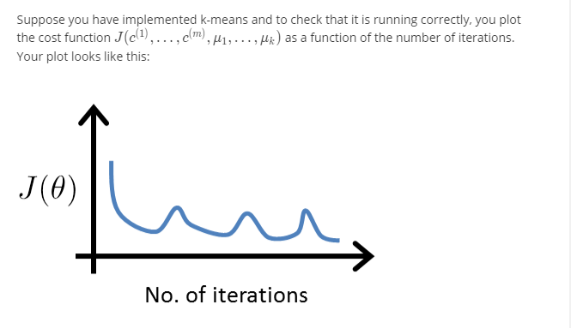
2. 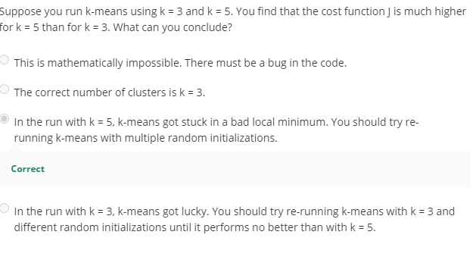
3. 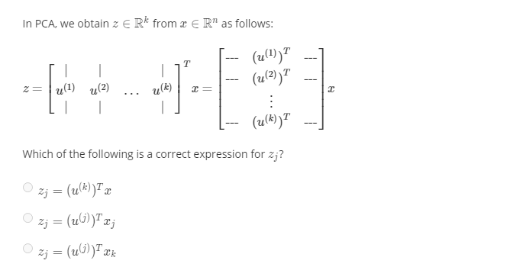
4. 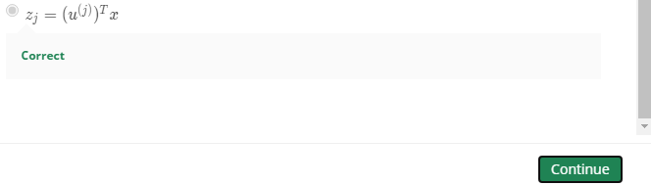
5. 