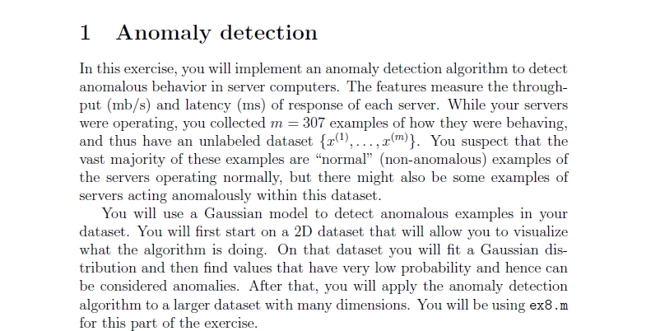

Visusliaze it :

**estimateGaussian.m :**

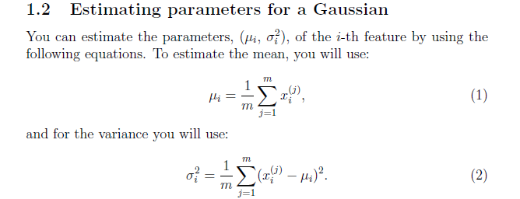

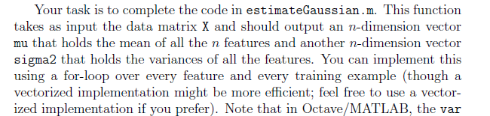

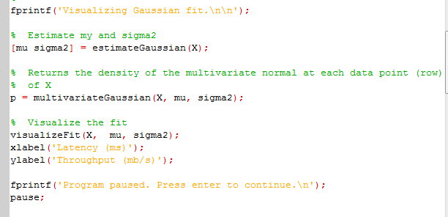

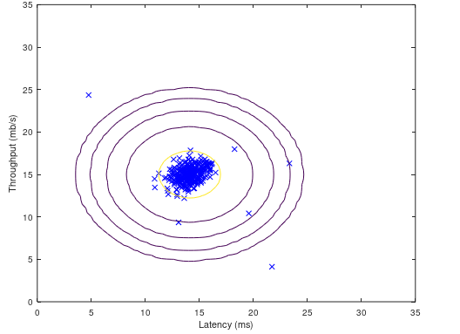

### selectThreshold.m :

**Selecting Epsilon so that probability is less than it**





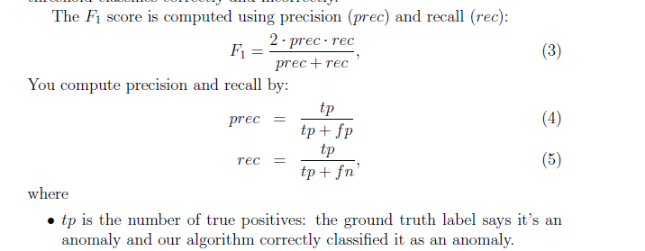

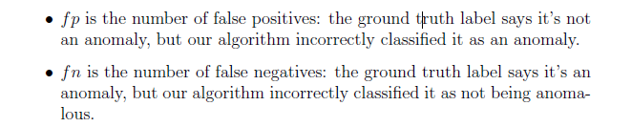

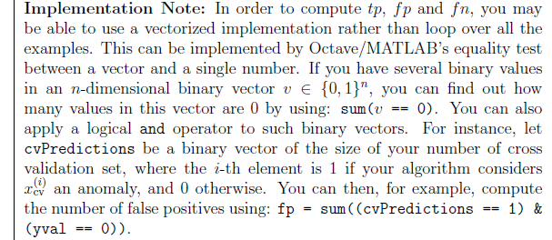

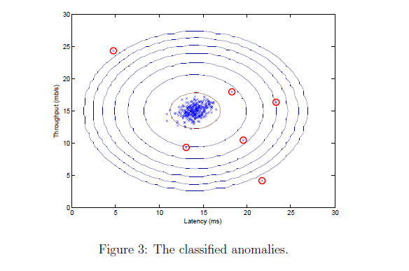

**Extra : (Already Coded )**

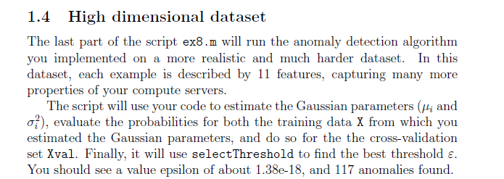

Output :

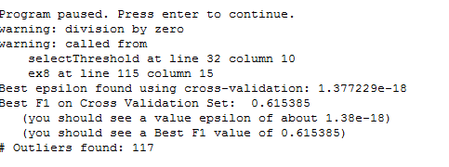

/*****************************Recommenders System ***************************/

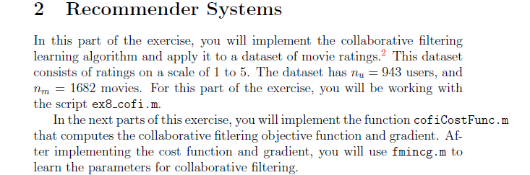

### cofiCostFunc.m :

*%% %%%%% WORKING: Without Regularization %%%%%%%%%%*

Error

J *Without Regularization*



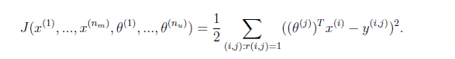

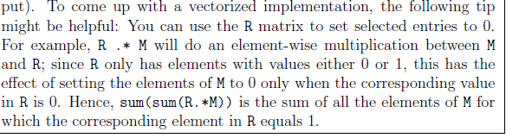

J = (1/2)*sum(sum(Error.^2.*R));

X_grad

Theta_grad

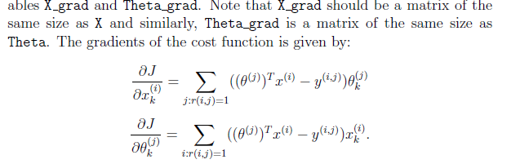

*%% %%%%% WORKING: With Regularization*

Reg_term_theta

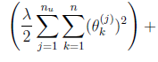

Reg_term_x

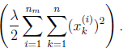

J with Regularization

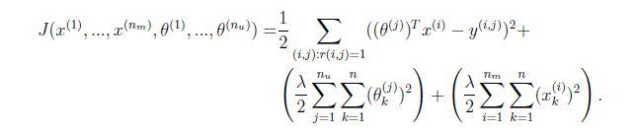

X_grad with regularization



Theta_grad with regularization

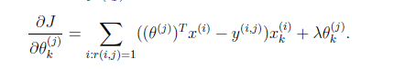

Grad Overall : Already Implemented

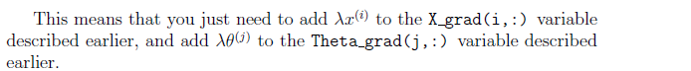

% Evaluate cost function

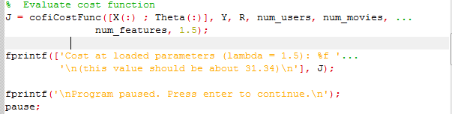



/************************Last Part ***********************/

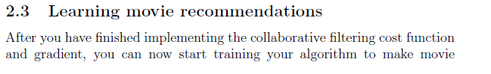

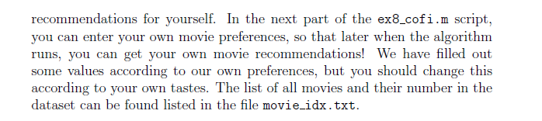

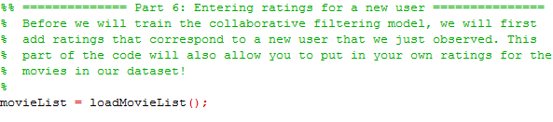

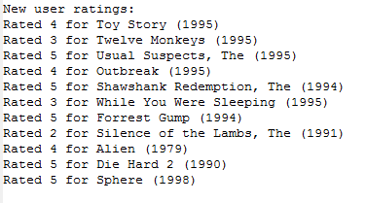

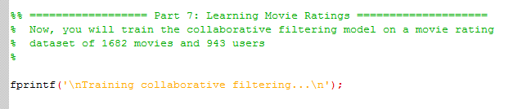



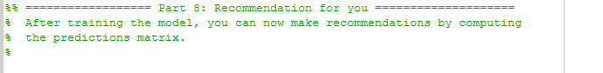

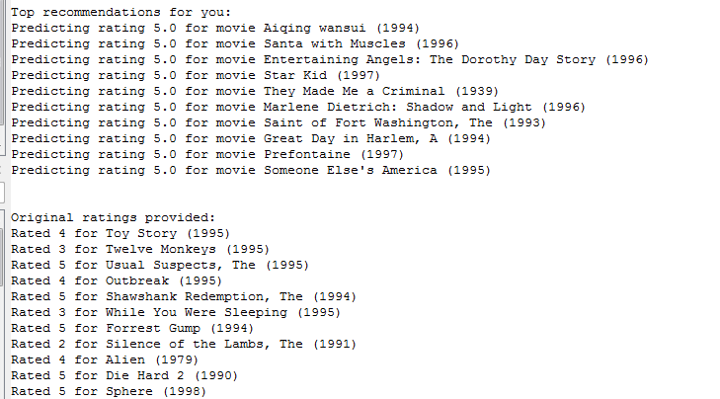

1. /**********************************Tests in Between ***************************/
2. 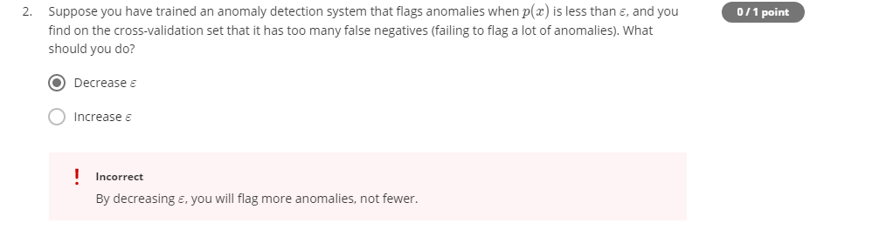
3. 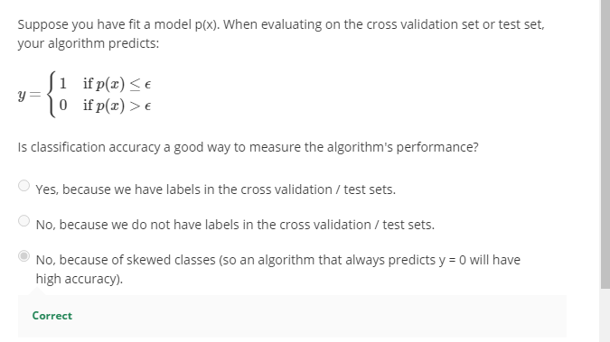
4. 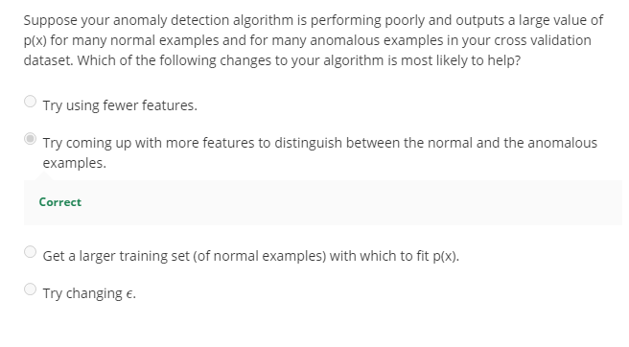
5. 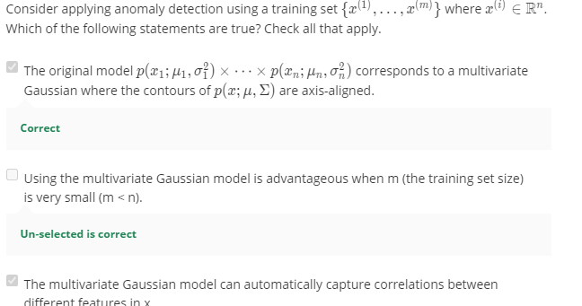
6. 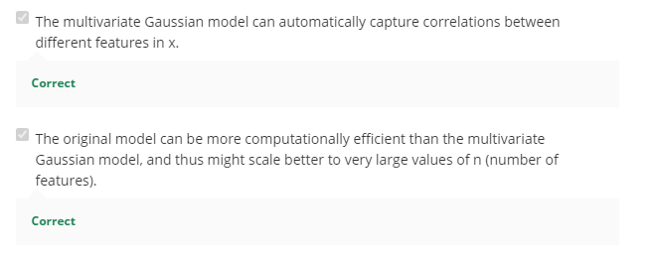
7. 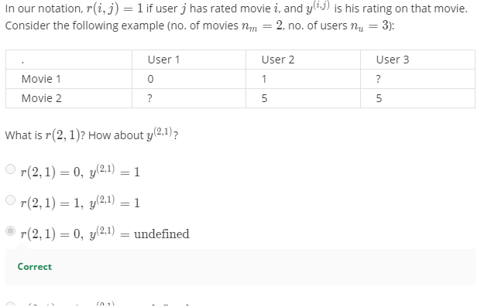
8. 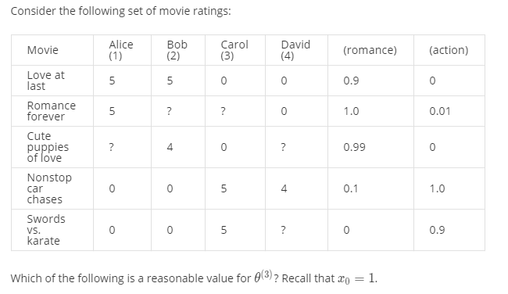
9. 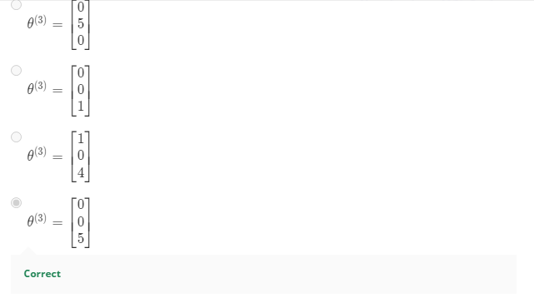
10. 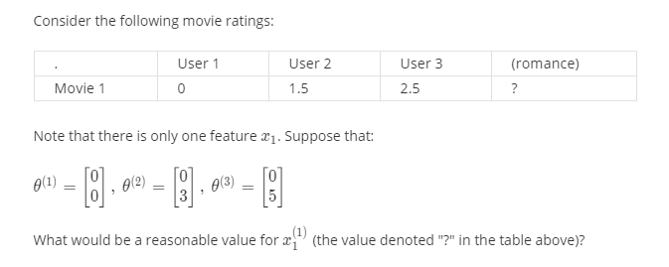
11. 
12. 