Section-A

1.(4)

2.(1,2,3,4)

3.(2)

4.(3)

5.(3)

6.(2)

7.(3,4,5)

8.(4)

9.(3)

10.(4)

11.(4)

12.(1,2,4)

13.(4)

14.(2)

15.(3)

16.(2)

17.(2)

18.(2)

19.(2)

20.(4)

Section-B

1. 1. **Validation Rules (15 Marks)**
2. Only Admins should be allowed to change the account owner.

Error Message : "You are not authorised to transfer the account."  **(5 marks)**

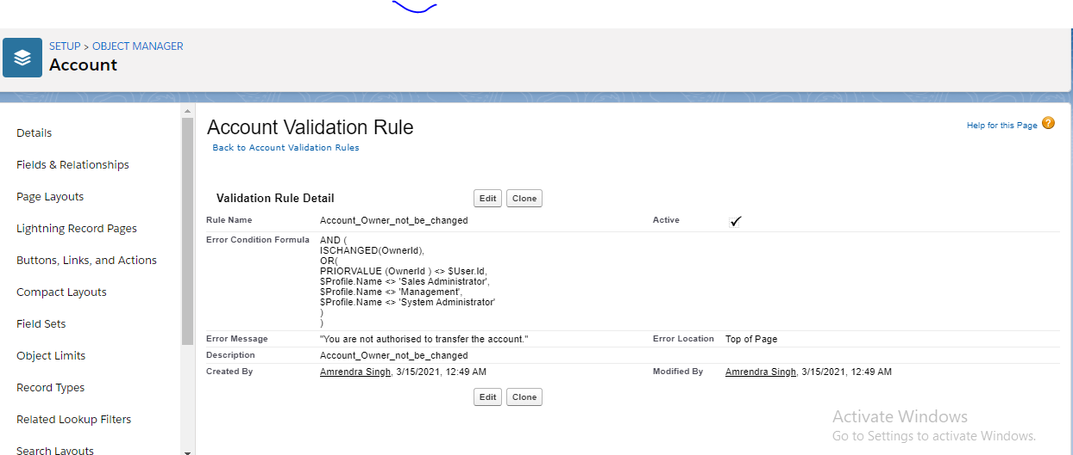

2. While closing the opportunity ( 'Closed Won') , an Opportunity Line Item should be present. If  opportunity line item is not present under a opportunity ,it should give the error message "Opportunity Line Item should be present while closing the opportunity." **(10 Marks)**

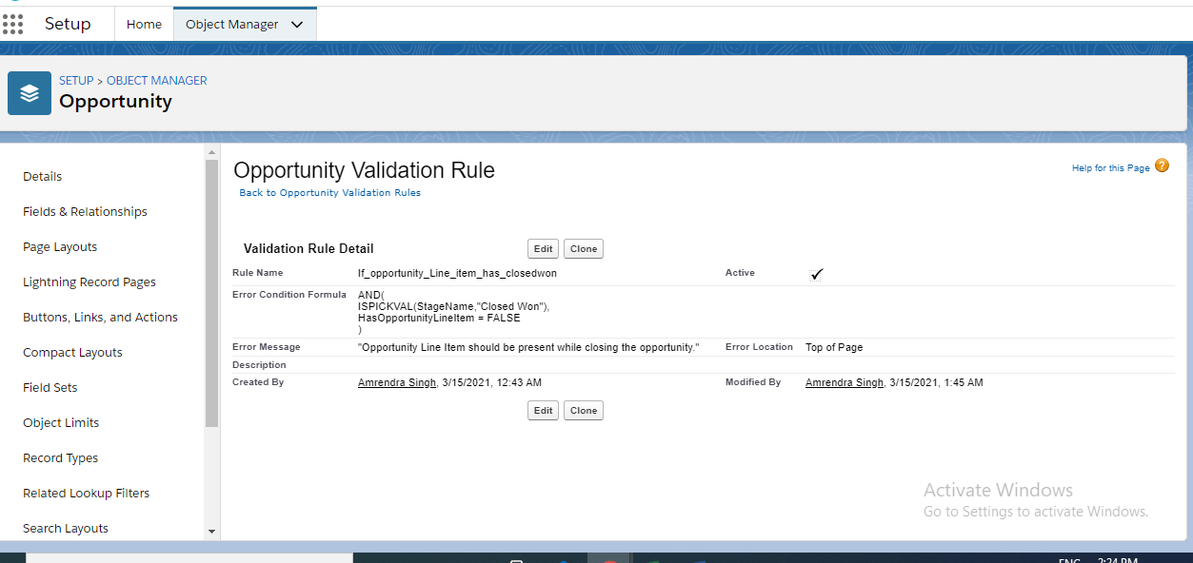

3. **Workflow Rule (5 Marks)**

If Amount > $10,000 send an email alert on opportunity **closed won (Stage field value)** to pgoyal@kloudrac.com and msharma@kloudrac.com

Email Template

Subject : Deal closed Alert - $Amount - Opportunity Name

Opportunity Name :

Account Name :

Account Owner :

Amount :

Close Date :

Best Regards

Salesforce Team – Kloudrac

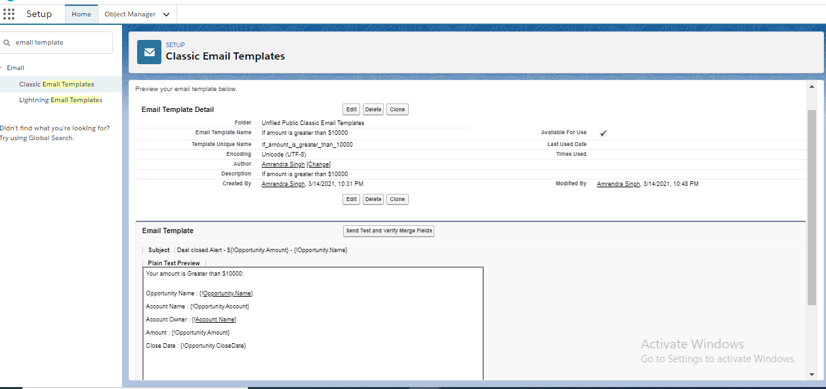

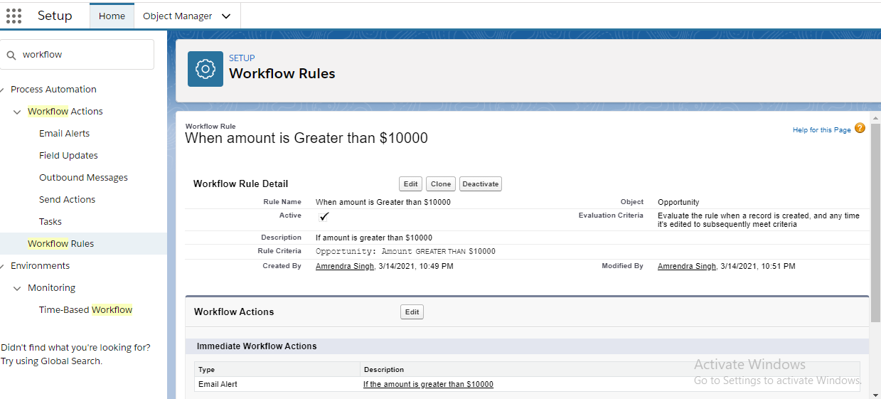

Section-c

1. 1. **Process Builder (10 Marks)**

Kloudrac Softwares would like to set up a process where an event will get created on opportunity creation and an automated approval will go to the opportunity owner's manager whenever discount > 20% on opportunity.

There is a field Discount, Approval Status on Opportunity.

Default value for Discount - "Approval Not Required".

When Discount is greater than your allowed matrix - "Approval Required"

When submitted for approval - "Approval Pending"

When Approved / Rejected - "Approved / Rejected”

Not completed process builder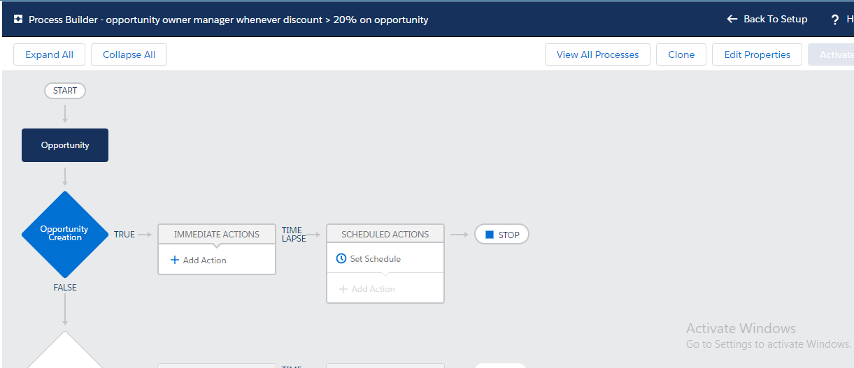

Section-c

1. While creating a new Opportunity then starting 5 Products should get automatically added under this Opportunity. **(15 Marks)**

**Solution:-**

**trigger CreateOLI on Opportunity (after insert) {**

**List<OpportunityLineItem> oliList = new List<OpportunityLineItem>();**

**List<PriceBookEntry> priceBookList = [SELECT Id, Product2Id, Product2.Id, Product2.Name FROM PriceBookEntry**

**WHERE Product2Id='certain_id' AND PriceBook2.isStandard=true LIMIT 1];**

**for (Opportunity oppty: Trigger.new) {**

**for(integer i =1;i<=5;i++){**

**OpportunityLineItem oli = new OpportunityLineItem()**

**oli.OpportunityId=oppty.Id;**

**oli.PricebookEntryId=priceBookList[0].Id ;**

**oliList.add(oli);**

**}**

**}**

**insert oliList;**

**}**

1.Write a trigger for showing the Quote Line Item count on the related Quote Account. **(15 Marks)**

**Solution:-**

trigger TriggerOnrelatedAcc on QuoteLineItem (after insert) {

if(trigger.isafter && trigger.isinsert)

{

List<ID> QuoteLineitemIDs=new list<ID>();

for(Quotelineitem qli:trigger.new)

{

if(count of new field ==0){

}