Table of Contents

Setting up Jira 2

Creating a New Project 2

Creating a New Jira Board 3

▪ Creating a board 3

▪ Accessing a board 4

▪ Accessing a Backlog on a scrum board 6

▪ What can I do in the scrum backlog? 7

Running sprints in a Scrum Project 8

▪ Planning and Creating sprints 8

▪ Adding issues to a sprint 8

▪ Starting a Sprint 9

▪ Active Sprint 11

▪ What can I do in the Active sprints of a Scrum board? 12

▪ Completing a Sprint 13

Jira Issue Types 14

▪ Creating an issue 14

▪ Issue fields 16

▪ Defect/Issue life cycle 20

▪ What Jira issue must contain each stage? 21

# Setting up Jira

Address to the Production server is https://rockwellautomation.atlassian.net/. You can log in with your xxx@rockwellautomation.com account, if you already a CLM user.

# Creating a New Project

Jira applications with many different project templates created to suit your team's needs and workflow.

Note: Only Jira admins can create new projects.

To create a project:

1. Choose the Jira icon (https://confluence.atlassian.com/jiracorecloud/files/945101523/952074074/1/1527636065852/core.png or https://confluence.atlassian.com/jiracorecloud/files/945101523/952074075/1/1527636065378/jirafamily.png) > **Projects**.
2. Select **Create project**(top right).
3. Choose **Classic project**.
4. Give your project a name.
5. Double check that the project's template matches your team's needs. To view a list and choose from other templates, select **Change**.
6. Select **Create**.

Once create a New Project, it will appear here.

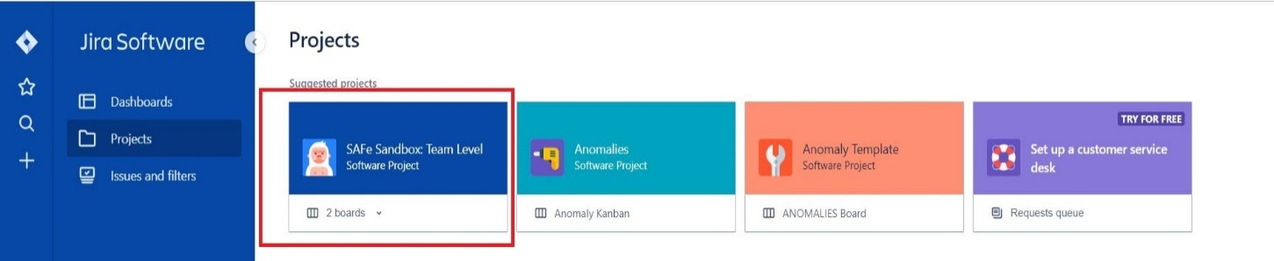

Project life cycle

**New project**    *→*   **BACKLOG**   *→*   **NEW VERSION**   *→*   **WORK**   *→*   **RELEASE**   *→*   **REPORTING**

# Creating a New Jira Board

A board displays issues from one or more projects, giving you a flexible way of viewing, managing, and reporting on work in progress. There are three types of boards in Jira Software.

Here we are using “Scrum Board”. Scrum board: For teams that plan their work in sprints. Includes a backlog. A project can have multiple boards.

## Creating a board

1. Click **Create board**at the top-right of the page,

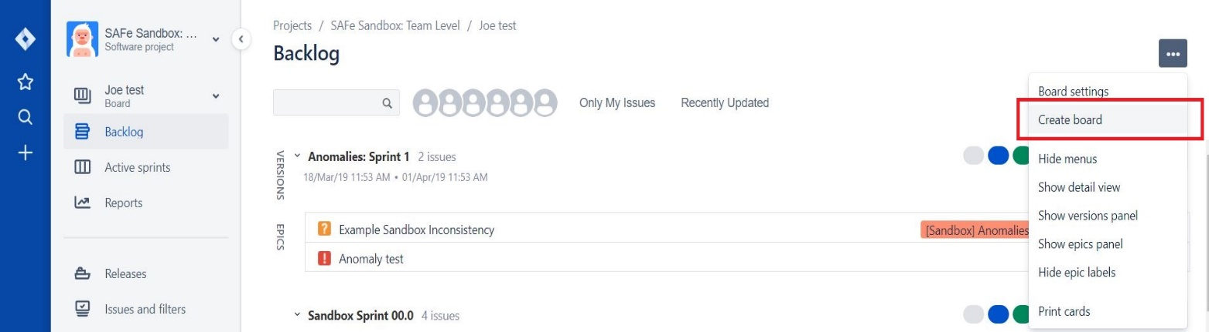

1. Choose whether to create an agility board, Scrum board, or Kanban board, as described below.

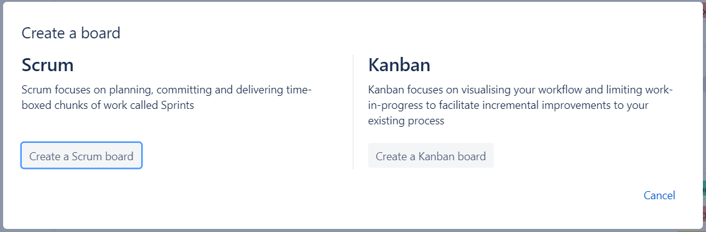

1. Enter a new Board name and click Create.

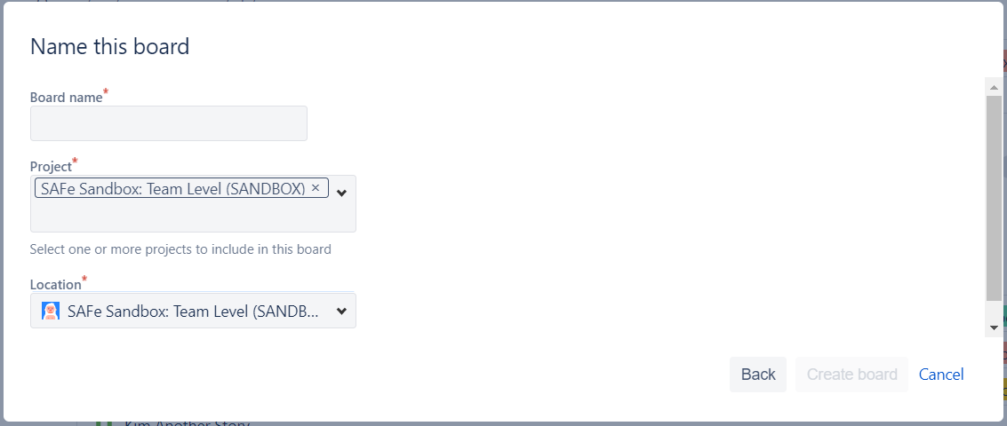

## Accessing a board

**To see all the boards in your Jira site:**

1. Under **Recent boards**, select **View all boards**.

To see boards that belong to you, choose **Your profile and settings** (https://confluence.atlassian.com/jirasoftwarecloud/files/952598546/952598547/1/1528762082768/person.png) > **Your boards**.

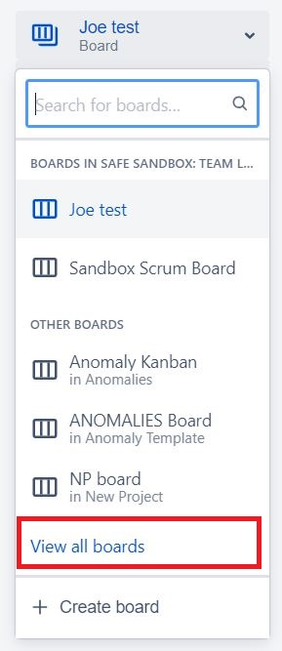

**To access a board that belongs to your project:**

1. Click your Jira icon (https://confluence.atlassian.com/jirasoftwarecloud/files/946603689/946609903/1/1520380827396/core.pnghttps://confluence.atlassian.com/jirasoftwarecloud/files/946603689/946609906/1/1520380827638/software.pnghttps://confluence.atlassian.com/jirasoftwarecloud/files/946603689/946609905/1/1520380827563/servicedesk.pnghttps://confluence.atlassian.com/jirasoftwarecloud/files/946603689/946609904/1/1520380827484/jirafamily.png) > **Projects**.
2. Select a project.
3. Navigate to the project's board (for Scrum, that'll be **Active Sprints**).

**To switch boards in a project that has multiple boards:**

1. Navigate to your project.
2. Select the board switcher, which you'll find under your project's name.

Ex :- As you can see the project “**SAFe Sandbox: Team Level**” has two scrum boards.

1. Joe test.
2. Sandbox Scrum Board.

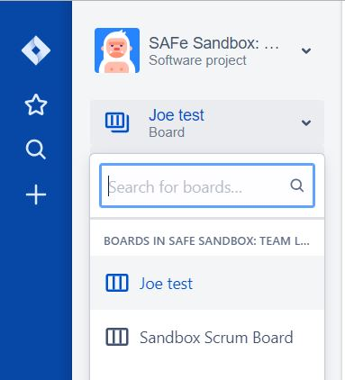

## Accessing a Backlog on a scrum board

A **backlog** is a list of outstanding work. Before starting new work (new sprint), you will build a new backlog or groom an existing backlog. This involves Creating, Ranking, and Estimating issues, so that you have a prioritized list of tasks to work from.

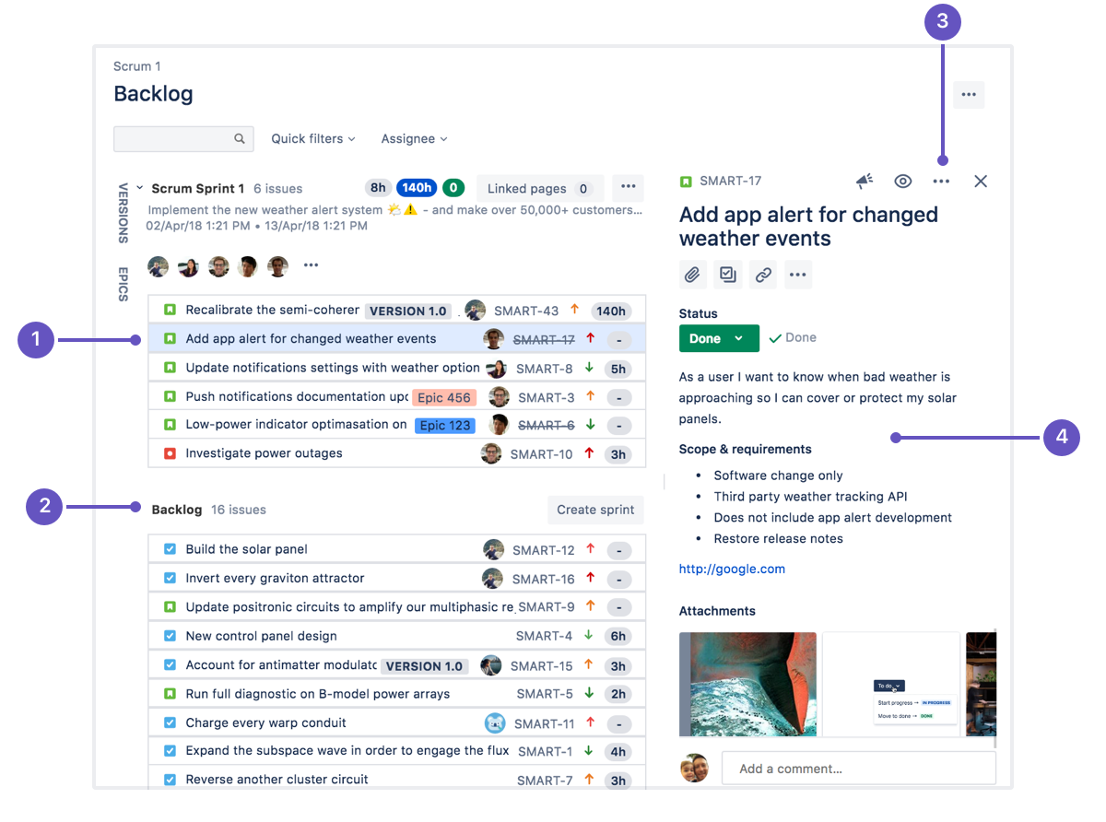

1. **Selected Jira tickets for the sprint:** Select an issue to view its details.
2. **Backlog:** Jira tickets that needs to take for the sprints.
3. **Issue actions:** Move an issue, clone it, log time spent working on it, and perform other actions.
4. **Issue details:** See the assignee and description, make comments, and add content to the issue.

## What can I do in the scrum backlog?

|  |  |
| --- | --- |
| Task | Instructions |
| Add issues to the backlog | Click the https://confluence.atlassian.com/jirasoftwarecloud/files/945104701/947850123/1/1522126362795/New+create.png icon in the global sidebar or click **“+ Create Issue”** in the backlog footer.  Fill in the issue details in the *Create issue* dialog, then click **Create**. The issue will be added to the backlog under the currently selected issue, or at the top of the backlog if no issue is selected.   * Check the **Create another** checkbox in the *Create issue* dialog to keep it open if you're creating multiple issues. * Quickly create issues using the inline issue create feature. Just click **+ Create issue**. |
| Prioritize the backlog | Drag and drop an issue to rank it. You can also right-click the issue to open a menu that allows you to send it to the top or the bottom of the backlog. |
| View and edit an issue's details | Click an issue on the board to view the [issue detail view](https://confluence.atlassian.com/jirasoftwarecloud/what-is-a-board-764477964.html) and edit issue details.  To open the issue in a separate tab or window, right-click on the issue key.  To view the details of an epic, click the epic lozenge on the issue itself. |
| Plan versions | Click **VERSIONS** (aligned vertically, left side of the board) to show the 'VERSIONS' panel. You can create and edit versions, assign issues to versions via drag-and-drop, and filter by versions via this panel. |
| Plan sprints | Click **Create sprint**, then drag and drop issues into your new sprint. You can also drag and drop the horizontal divider to add or remove multiple issues. The sprint footer will display the number of issues and total estimated work.  When you're happy with the issues for the sprint, click **Start sprint**, and the stories will move into the **Active sprints**.  While a sprint is active in the Active sprints, you can still plan subsequent sprints in the backlog, but you won't be able to start them until the active sprint is completed. |

# Running sprints in a Scrum Project

## Planning and Creating sprints

Every sprint starts with a **planning meeting**. When planning a sprint, your team would typically commit to deliver a set of stories that are pulled from the top of the backlog.

You can create a sprint for your current iteration, or multiple future sprints if you want to plan several iterations ahead.

1. Go to the **Backlog** of your Scrum project.
2. Click **Create sprint** at the top of the backlog.

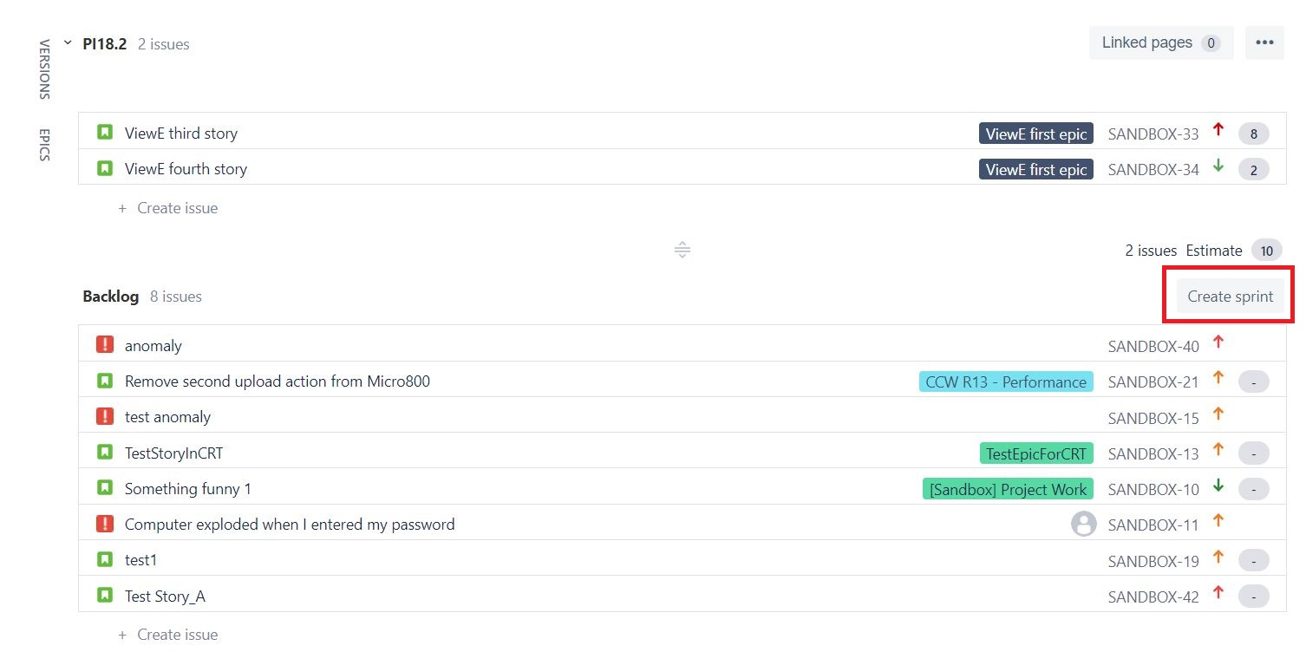

## Adding issues to a sprint

You need to know your team's capacity for work, as well as the amount of work they are committing to, when adding issues to a sprint. (Ex: how many story points to be taken)

Typically, team would estimate issues before adding them to the sprint, so that you can see the total estimated work for the sprint (in the sprint footer). You can match this against your team's capacity for work by looking at past sprints.

**Note:**

1. Sub-tasks cannot be moved independently of their parents.
2. An issue can only be assigned to one active sprint or future sprint. This means you can't add an issue to both an active sprint and a future sprint at the same time.
3. You can *add any issue to any active or future sprint*, even if the issue doesn't match the filter query of the board where the sprint was created. When you do this:

* the issue is assigned to the sprint but will not be visible on boards where the filter query excludes it.
* any sprint actions (e.g. start sprint, close sprint) that span multiple boards will also *affect the sprint in****all boards where the sprint is visible***.
* If the issue doesn't match the filter query of any agile board, the issue will be linked to the sprint but not appear in any board.

1. A sprint appears in any board — a single board or multiple boards — as long as the issues assigned to the sprint match the filter query of the board or boards. This also applies to completed sprints.

## Starting a Sprint

You can only start a sprint, if:

* You haven't started one already.
* The sprint is at the top of the backlog. If you want to start a planned sprint that is lower down, you will need to reorder your sprints to move it to the top. (Note, this doesn't apply if Parallel Sprints is enabled).

**To start a sprint:**

1. Go to the **Backlog** of your Scrum project.
2. Find the sprint that you want to start and click **Start sprint.**(If you haven't estimated your issues, you will receive a warning when starting the sprint (unless you are using Issue Count, as this is calculated automatically).
3. Update the **Sprint name** and add a **Sprint goal** if desired and select the **Start date** and **End date** for the sprint.

Note:

The default duration of a sprint is two weeks. If added, the sprint goal will also be displayed in the Sprint Report and Burndown Chart for that sprint.

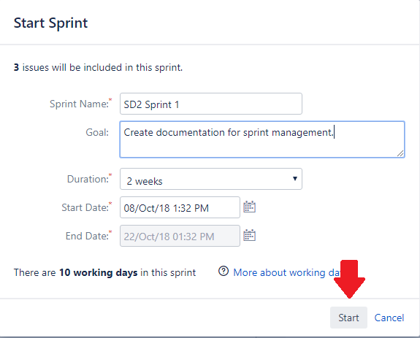

**Sprint life cycle**

Project

Backlog

New tickets

Existing tickets

Sprint 3

Sprint 2

Sprint 1

Work

Work

Work

Release

Release

Release

Reporting

Reporting

Reporting

Complete Sprint

Complete Sprint

Complete Sprint

## Active Sprint

* An issue will only be visible in Active sprints if:
* The issue's status maps to one of the board's columns
* The issue is in an active sprint (for Scrum boards), and
* The issue matches the board's saved filter.
* Each column maps to one or more Jira statuses.
* Subtasks are shown slightly indented, with their parent issue key shown above.

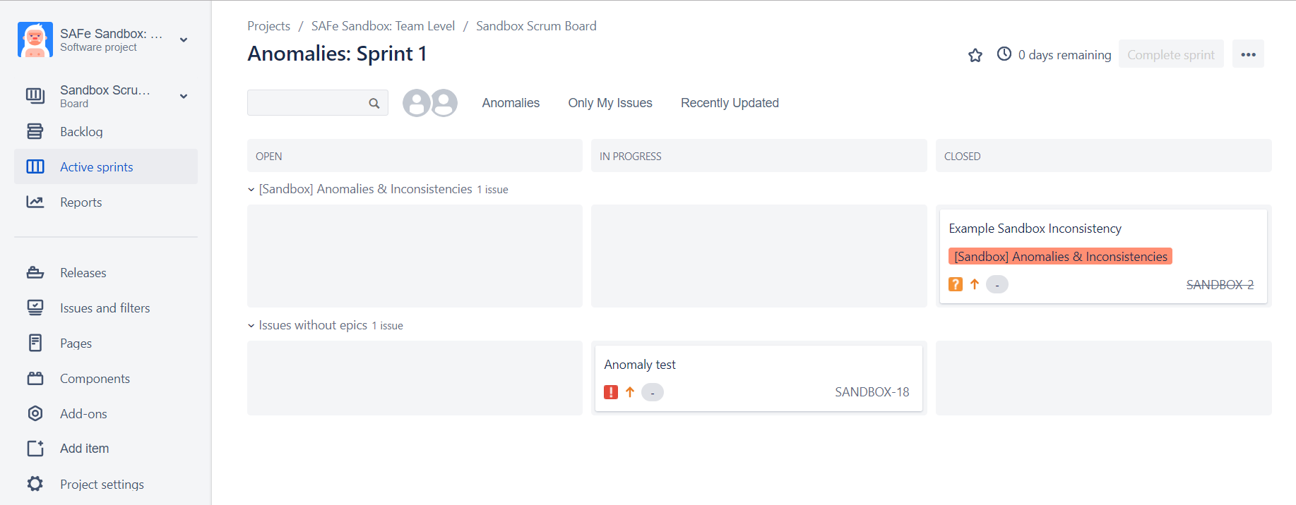

**Issue workflow**

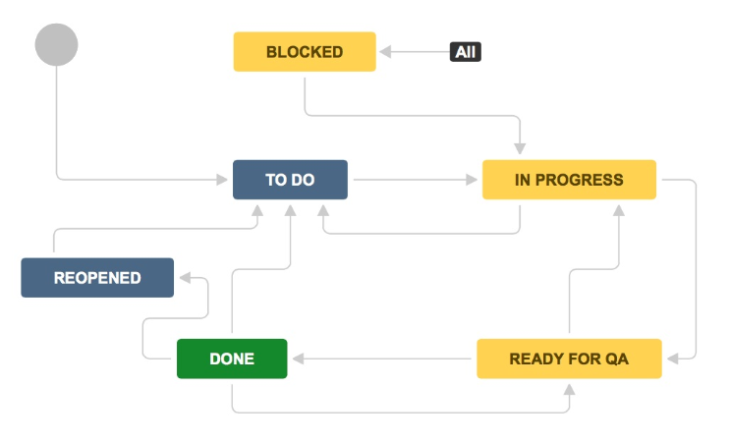

## What can I do in the Active sprints of a Scrum board?

|  |  |
| --- | --- |
| Task | Instructions |
| Add issues to the *To Do* column | Click the https://confluence.atlassian.com/jirasoftwarecloud/files/945104701/947850123/1/1522126362795/New+create.png icon in the global sidebar.  Fill in the issue details in the *Create issue* dialog, then click **Create**. The issue will be added to the *To Do* column.  Check the **Create another** checkbox in the Create Issue dialog to keep it open if you're creating multiple issues. |
| View and edit an issue's details | Select an issue to see the [issue detail view](https://confluence.atlassian.com/jirasoftwarecloud/what-is-a-board-764477964.html) and edit issue details.  To open an issue in a separate tab or window, right-click on the issue key on the card.  To view the details of an epic issue, click the epic lozenge on the card. |
| Transition an issue | Drag and drop an issue between columns.  Done  In Progress  To Do |

## Completing a Sprint

Completing the active sprint

1. Go to the **Active sprints** of your Scrum board.
2. If necessary, select the sprint you want to complete from the sprint drop-down.  
   Note that if you have multiple sprints in the Active sprints of your board, the 'Complete Sprint' button will not appear until you select one of the sprints.
3. Click **Complete Sprint**. All completed issues will move out of Active sprints.
4. If the sprint has incomplete issues, select from one of the following:

* **Backlog**, to move the issues to the backlog
* **Any future sprint**, to move the issues to any future sprint that's already created
* **New sprint**, to create a new sprint and then move the issues to the new sprint

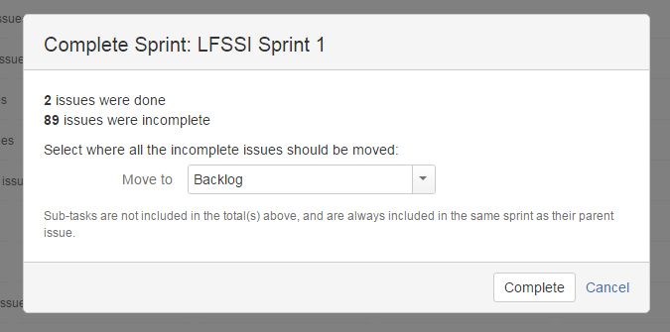

# Jira Issue Types

Jira Core default issue types

* **Task** – Task that needs to be done
* **Subtask**– Smaller task within a larger piece of work

Jira Software default issue types

* **Story** – Functionality request expressed from the perspective of the user
* **Bug** – Problem that impairs product or service functionality
* **Epic** – Large piece of work that encompasses many issues

## Creating an issue

1. Click **Create** at the top of the screen to open the **Create Issue** dialog box.
2. Select the relevant **Project** and **Issue Type** in the Create Issue dialog box.
3. Type a **Summary** for the issue and complete any appropriate fields — at least the required ones that are marked by an **asterisk**.

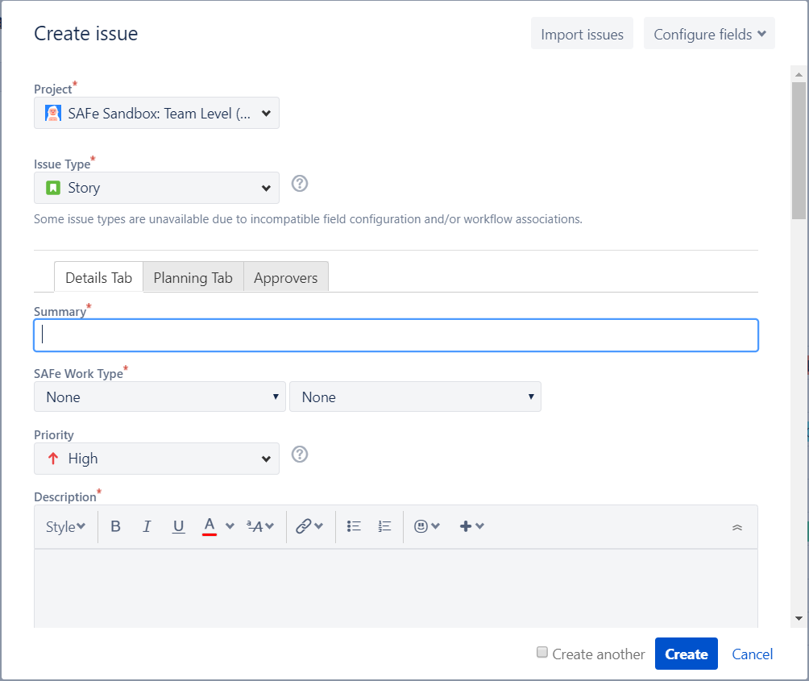

If you want to access fields that are not shown in this dialog box, or you want to hide existing fields:

* Click the **Configure Fields** button at the top right of the screen.
* Click **Custom** and select the fields you want to show or hide by selecting or clearing the relevant check boxes respectively or click **All** to show all fields.

Note: When you next create an issue, these selected fields will be displayed.

1. Optional: To create a series of similar issues – with the same **Project** and **Issue Type** – select the **Create another** checkbox at the bottom of the dialog. Depending on your configuration and the values you may have specified when creating previous issues, some of the fields in the new Create Issue dialog box may be pre-populated. Make sure you check they're all correct before creating the next issue.
2. When you are satisfied with the content of your issue, click the **Create** button.

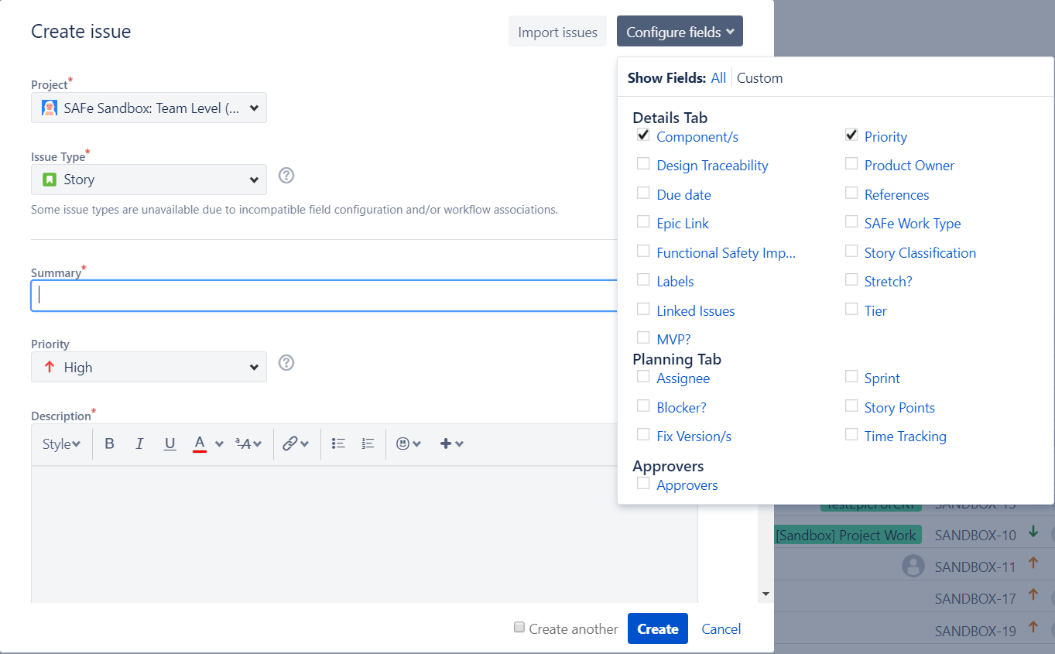

## Issue fields

|  |  |
| --- | --- |
| Field | Description |
| **Project** | The parent project to which the issue belongs. |
| **Key** | A unique identifier for this issue. For example, SANDBOX-304 (The characters to the left of the hyphen represent the project this issue belongs to). |
| **Summary** | A brief, one-line summary of the issue. Here we need to follow better format when we summarize the issue.  Story: - [REQ_PRIORITY] [REQ_ID] [COMPONENT] – summary  Ex: - [HIGH] [RQ-009] [GATEWAY] – Create File Gateway engine in application node.  Issue: - [ISSUE_PRIORITY] [TEST_CASE_ID] [ENV] [PHASE] [COMPONENT] – summary  Ex: - [HIGH] [TC-002,005] [QA] [REGRESSION] [GATEWAY] – File gateway engine is crashed. |
| **Issue Type** | A category for the issue, like "Story", "Anomaly", "Task" etc. |
| **Priority** | The importance of the issue in relation to other issues. Ex: - Highest, High, Medium, Low, Lowest |
| **Found in Build version *(****Specific to Anomaly****)*** | Build version of the release. |
| **Anomaly Classification *(****Specific to Anomaly****)*** | Software, Hardware, Firmware etc. |
| **Phase Detected *(****Specific to Anomaly****)*** | Requirements, Regression, Unit, Functional etc |
| **SAP Ticket *(****Specific to Anomaly****)*** | Identifies the SAP Ticket number for customer reported anomalies. |
| **Description** | A detailed description of the issue.   * SUMMARY * STEPS TO REPRODUCE: * EXPECTED RESULT: * ACTUAL RESULT: * ENVIRONMENT: * AFFECTS VERSION: * OTHER: (logs location, etc.) |
| **Target Release** | The release in which the team intends to release the issue type. |
| **Customer Severity *(****Specific to Anomaly****)*** | Criticality of the issue from the customer's perspective.  Ex: - Extreme, Critical, Major |
| **Customer Occurrence *(****Specific to Anomaly****)*** | Probability of occurrence based on the likelihood the behavior will occur in the overall product.  Ex: - High, Medium, Low |
| **Functional Safety Impact Analysis Required** | Field indicates whether or not an impact analysis is required for Functional Safety. |
| **Must be fixed *(****Specific to Anomaly****)*** | Determine if this Anomaly must be fixed or not. |
| **User Assistance Update Needed *(****Specific to Anomaly****)*** | Indicates whether updates to the Help are needed as a result of this anomaly. |
| **Release Notes Update Needed *(****Specific to Anomaly****)*** | Indicates whether updates to the Release Notes are needed as a result of this anomaly. |
| **Linked Issues** | A list of links to related issues.  Ex: - is blocked by, is duplicated by etc. |
| **Security Vulnerability *(****Specific to Anomaly****)*** | Defines if the anomaly has been flagged as a security vulnerability. Must be escalated to security SME and PSO. |
| **Product Safety Risk Assessment Required *(****Specific to Anomaly****)*** | Does the anomaly require a Product Safety Risk Assessment? YES or NO |
| **Component/s** | What are the components will be affected? |
| **Labels** | Begin typing to find and create labels or press down to select a suggested label.  Ex: - specific label type |
| **Impacted Functional Area *(****Specific to Anomaly****)*** | What are the impacted areas? |
| **Impacted Feature *(****Specific to Anomaly****)*** | What are the impacted features? |
| **Test ID** | Test case ID. |
| **Affects Version(s)**  *(if applicable)* | Project [version(s)](https://confluence.atlassian.com/adminjiracloud/managing-versions-776636296.html) for which the issue is (or was) manifesting. |
| **Fix Version(s)**  *(if applicable)* | Project [version(s)](https://confluence.atlassian.com/adminjiracloud/managing-versions-776636296.html) in which the issue was (or will be) fixed. |
| **Environment**  *(if applicable)* | The hardware or software environment to which the issue relates. |
| **Assignee** | The person to whom the issue is currently assigned. Note that you cannot assign issues to a user group. |
| **Reporter** | The person who entered the issue into the system. |
| **Story Points** | Measurement of complexity and/or size of a requirement.  Ex: - 1,1,2,3,5,8,13,21 |
| **Original Estimate** | The original estimate of how much work is involved in resolving this issue. |
| **Remaining Estimate** | An estimate of how much work remains until this issue will be resolved. |
| **Sprint** | Jira Software sprint field |
| **Epic Link** | Choose an epic to assign this issue to. |
| **Approvers** | Contains users needed for approval. This custom field was created by Jira Service Desk. |
| **Product Owner** | Product Owner’s name |
| **Tier** | Tier |

A proper Jira issue must have,

* A proper summary
* Priority and Severity
* Description with clear steps, actual output and expected output.
* Screenshots
* Logs, reports or any other sources to identify the issue.
* Environment and Affects versions
* Requirement documents or Story ID link to the issue.

## Defect/Issue life cycle

New

Assigned

Deferred

Rejected

Open

Duplicate

Fixed

Pending Retest

Reopened

Retest

Verified

Closed

Note: - Developers can Reject the issues when Testers are not including proper steps to reproduce the issue or proper sources to identify the issue area.

## What Jira issue must contain each stage?

|  |  |  |
| --- | --- | --- |
| NEW (OPEN) | RESOLVED | CLOSED |
| Reporter:   * A proper summary * Priority and Severity * Description with clear steps, actual output and expected output. * Screenshots * Logs, reports or any other sources to identify the issue. * Environment and Affects versions * Requirement documents or Story ID link to the issue. * Test case IDs. | **Developer:**   * RCA (Root Cause Analysis) for the issue. * Component/s that fix made. * Screenshots of the fix. * A separate code branch for the fix. (with the Jira ID) * Merge request to Development code base. (with the Approval comments) * Binary version for each component. * Release version. * Unit tests. | **Tester:**   * Tested binary version for each component. * Tested release version. * Tested environment version. * Screenshots. * Passed test case IDs. * Passed report. (Automation report) |