NorthStar Property Investment Consulting
Deterministic financial analysis joined to AI policy research that keeps itself current
Team 5 — Ashish Nath · Justin Kretschman | BUKD-X500 Agentic AI Systems, Design Studio | https://github.com/AsisNath/Real-Estate-Investment-Decision-Support
1. The problem, and the evidence it is real
A small real-estate investor decides with a spreadsheet and whatever a search engine returns. The financial modelling is the easy half. The hard half is that rental rules are hyper-local, change often, and the highest-ranking sources are property-management blogs that go stale silently. Getting one rule wrong invalidates everything downstream: model short-term-rental (STR) income on a property where STR is not permitted, and the IRR, the cash flow, and the recommendation are all fiction.
Our own research surfaced the sharpest possible illustration. Maryland Heights, MO 63043 allows an investor to operate an STR provided the owner OR a manager is within a one-hour drive. Ballwin, MO 63021 — two ZIP codes away, same county, same state statutes — requires the owner to reside on the property at least 180 days a year, which a non-owner-occupied investment cannot satisfy. Same question, opposite answers. No static dataset captures that; it has to be researched per address and kept fresh.
2. What we built and how it works
NorthStar is a local FastAPI web application. You enter an address and your assumptions, and it returns an investor report: financial metrics, market and policy context, ranked risks, a diligence checklist, and a rule-based recommendation. It is organised as two layers that never mix.
- Layer 1 — the arithmetic. NOI, DSCR, cash flow, cap rate, 5/10-year IRR, equity multiple and LTV are ordinary, unit-tested Python. No language model touches a number.
- Layer 2 — the rules. An Agent Skill researches STR ordinances, state landlord-tenant law, rent control, and HOA authority using live web search, verifies load-bearing facts against official .gov or statute sources, and writes a source-cited note into the knowledge bank.
- They meet at the decision. Researched findings become policy flags, diligence items, and assumption conflicts — the app tells you when your own rent-growth input exceeds a legal cap it has on file.
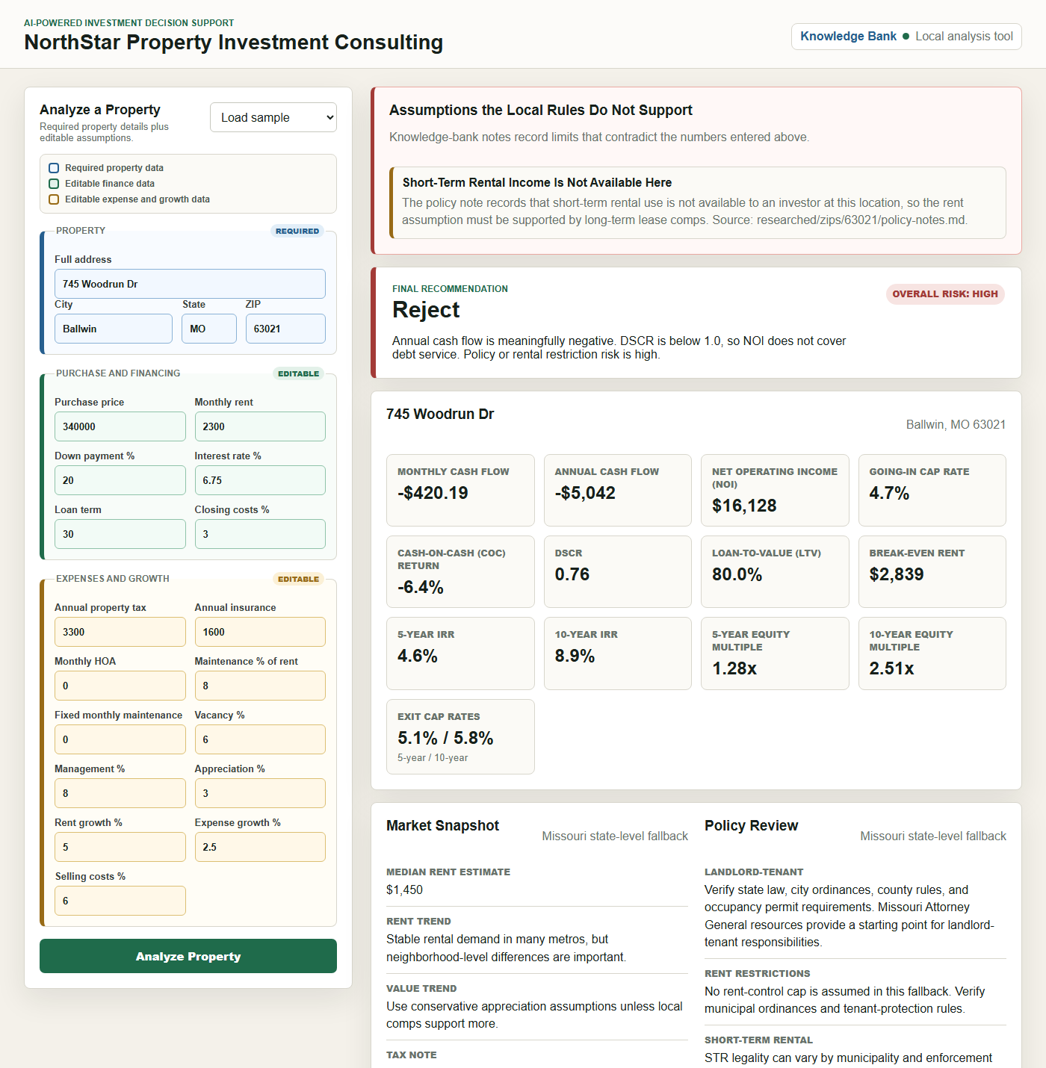
Figure 1 — Investor report for 745 Woodrun Dr, Ballwin MO. The researched note has flagged STR income as unavailable and contributed two HIGH policy risks, moving the recommendation to Reject.
3. Target users and use cases
The primary user is an individual or small-portfolio residential investor doing first-pass diligence on a specific property — someone who cannot justify a consultant for every listing, but for whom one missed ordinance is a five-figure mistake. A second is the advisor who must hand that person something defensible; the app generates a printable Policy Brief citing every source. Typical uses: screening a listing, checking whether an STR strategy is legal there at all, and building a diligence checklist before an offer.
4. Tools and platforms
Application | Python 3.11, FastAPI, Pydantic, Jinja2; vanilla HTML/CSS/JS front end with no build step
AI research | Agent Skill (SKILL.md) executed through a signed-in agent CLI (Codex or Claude Code), with the Anthropic API as a fallback backend
Data | GeoNames US postal-code dataset (41,488 ZIPs) bundled for offline address verification
Documents | python-pptx and python-docx generate this write-up and the deck; pypdf reads user-supplied PDFs
Testing | pytest — 138 automated tests
Delivery | Windows .bat launchers; Git/GitHub for version control

5. Design decisions, and the alternatives we rejected
- Keep the model out of the arithmetic. The obvious alternative was to let an LLM compute or sanity-check the financials. We rejected it because a hallucinated IRR is worse than no IRR — it is confident and wrong. Determinism is the feature; the AI is scoped to research, where it genuinely outperforms a static database.
- Make provenance structural, not a label. The knowledge bank has two roots: researched/ is written only by the Skill, user/ only by people. This is enforced in code — the in-app form physically cannot write into researched/ — rather than by naming convention, so an AI-verified badge cannot be faked by a typo.
- Delegate to an agent the user has already signed into. Our first design had the app call an LLM API directly, which meant every user needed their own key. That was the wrong shape: the Skill is plain instructions, so it can run inside a CLI the user is already authenticated with, which supplies its own credentials and web search. Setup went from “obtain an API key” to nothing at all.
- State missing data; never fill the gap. ZIP-level misses fall back to state, then national, and the report says which level it used. When an official page blocks automated access, the fact is tagged “confirm with the agency” rather than quietly replaced with a blog — the precise failure the tool exists to prevent.
6. Process flow
Enter address and assumptions → Pydantic validation → city/state/ZIP cross-check against the bundled ZIP dataset → deterministic financial model → market and policy lookup (ZIP → city → state → national) → knowledge-bank read for matching notes → report assembled with risks, conflicts and recommendation → analysis trail written to logs/. In parallel, if the ZIP has no researched note or its note is past the 120-day freshness window, a background thread runs the Skill, saves a cited note to knowledge_bank/researched/zips/<zip>/, and the next analysis picks it up. Research never blocks the report.
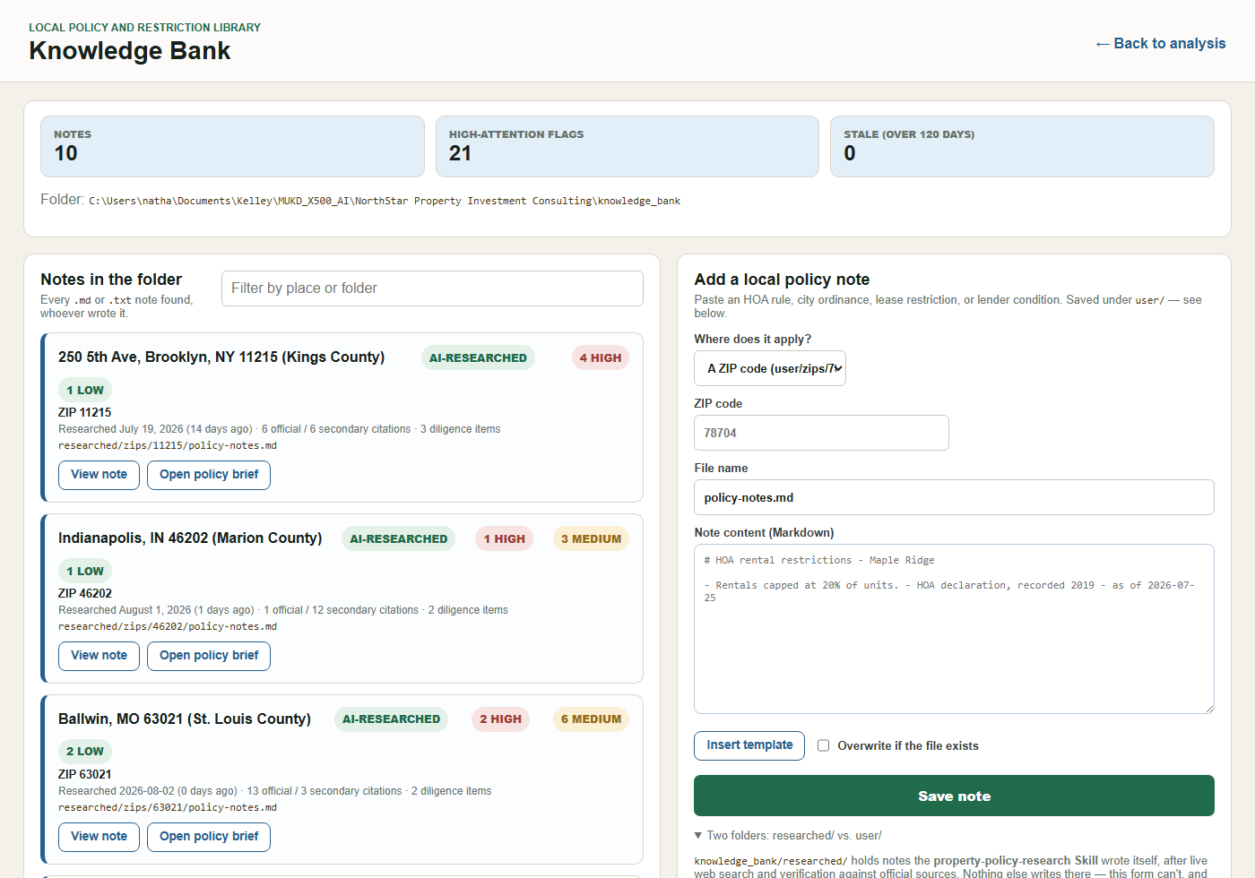
Figure 2 — The Knowledge Bank. Every note shows its scope, research date, citation counts, and whether it was AI-researched or added by a person. Each can be opened as a client-ready Policy Brief.
7. How we tested it, and the results
The suite is 138 automated tests across 9 application modules. The financial model is unit-tested against hand-computed values. Research quality was tested the way the Skill was built to be tested: on two near-opposite regulatory environments (Austin, TX — STR legal with a licence, rent control banned statewide; Los Angeles, CA — STR effectively closed to investors, two overlapping rent-control regimes). The Skill produced correct, differently-shaped output for both without edits to its instructions.
Three defects the tests and reviews caught, and what they taught us:
- A server-hanging deadlock. request_research called status() while holding a non-reentrant lock, so a second analysis of the same address during research hung the request thread. Caught by a test that re-entered mid-run.
- A stale note that blocked its own refresh. The app requested research when a note was missing or stale, but the researcher declined whenever a file existed — so the one case that most needed re-research could never happen.
- A silently disabled guardrail. A note the app researched unattended appended citations to its machine-readable summary lines, so values parsed as text instead of numbers and the assumption-conflict check stopped firing. Found by reading a real generated note rather than a fixture.
Strongest evidence the system works unattended: while preparing this submission we found a policy note in the repository that neither of us wrote by hand. A teammate had analysed 17723 Mueller Rd, Wildwood MO 63038; the app researched the ZIP on its own and saved a note carrying 20 official citations. The knowledge bank now holds 10 cited notes.
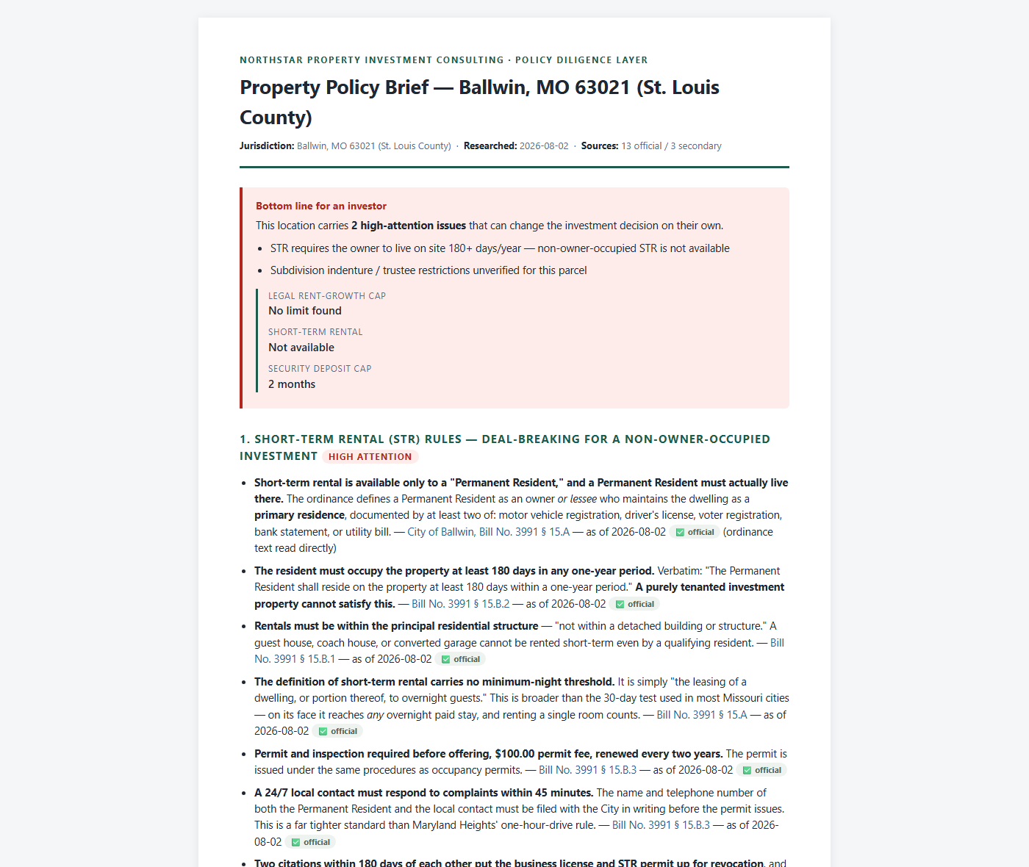
Figure 3 — A generated Policy Brief. Every fact carries a source link, an “as of” date, and an official-versus-secondary tag; the brief prints straight to PDF for a client.
8. Installation and adoption
Clone the repository and double-click Run_NorthStar.bat. It creates the virtual environment, installs requirements, runs the test suite, clears any stale server off port 8000, and opens the browser. Automatic research needs no configuration if a signed-in agent CLI (codex or claude) is on PATH; otherwise Setup_Research.bat creates a git-ignored .env for an API key. The app is fully functional offline without either — you simply get a ready-to-paste research prompt instead. Adoption for a small firm would be: run it locally, drop HOA declarations and leases into knowledge_bank/user/, and let researched notes accumulate as a shared, auditable asset.
9. Security considerations
This is a local, single-user application with no authentication surface and no inbound network exposure, so a remote attacker is not the realistic threat. The realistic threat is untrusted content: policy notes are assembled from the open web, and users drop PDFs they did not author into the knowledge bank — and that material is rendered into a document handed to a client. Defences we implemented:
- Path traversal blocked. Note paths resolve and must stay inside knowledge_bank/; '..', drive letters and absolute paths are refused, not reinterpreted.
- Output escaping. Note text is HTML-escaped before any markdown conversion, so a document cannot inject markup or script into a Policy Brief.
- Validate before persisting. The research agent runs read-only and only prints; the app decides what reaches disk, and a reply that is not a policy note is discarded rather than saved.
- Secret hygiene. Credentials live in a git-ignored .env, never in the repository. The preferred backend stores no secret at all.
- Cost safety. Tests force research off and disable CLI detection, so running the suite can never spend money or a user's quota.
10. Reflections
What worked: writing standards instead of steps. The Skill says what good research looks like — verify against official sources, tag every fact, date everything, say “unverified” rather than guess — and the agent worked out how, including recovering when a government site returned 403. That is closer to managing an analyst than programming a pipeline. Making provenance a code boundary rather than a naming convention also paid off immediately.
What did not: our first research architecture required an API key per user, which we only recognised as the wrong shape after asking why the Lab 5 Skill never had that problem — it ran inside tools people were already signed into. We also lost time to a stale server that made fixed code look broken, and we discovered that a user's HOA declaration was being silently ignored because it was a scanned PDF with no text layer; the app now surfaces that instead of dropping it.
What we would do differently: capture screenshots and generate documents from scripts from day one, so figures track the code. Next steps are OCR for scanned declarations, a comparison view across candidate properties, and scheduled re-research so notes refresh before they age out.

