Storyboard

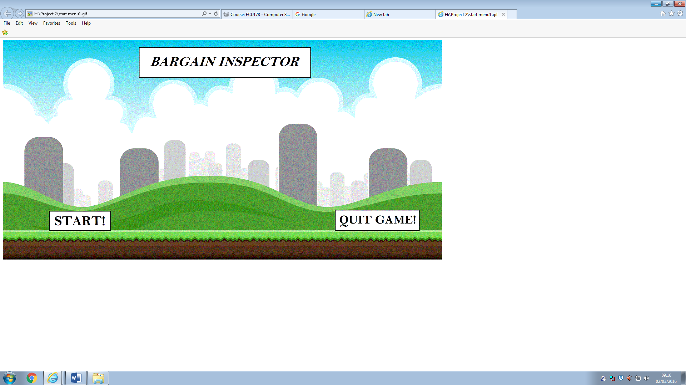

1. This will be the start page as you click on the game. When this window opens you will be able to start the game or exit the game if you wish to. The window will also display the name of the game.

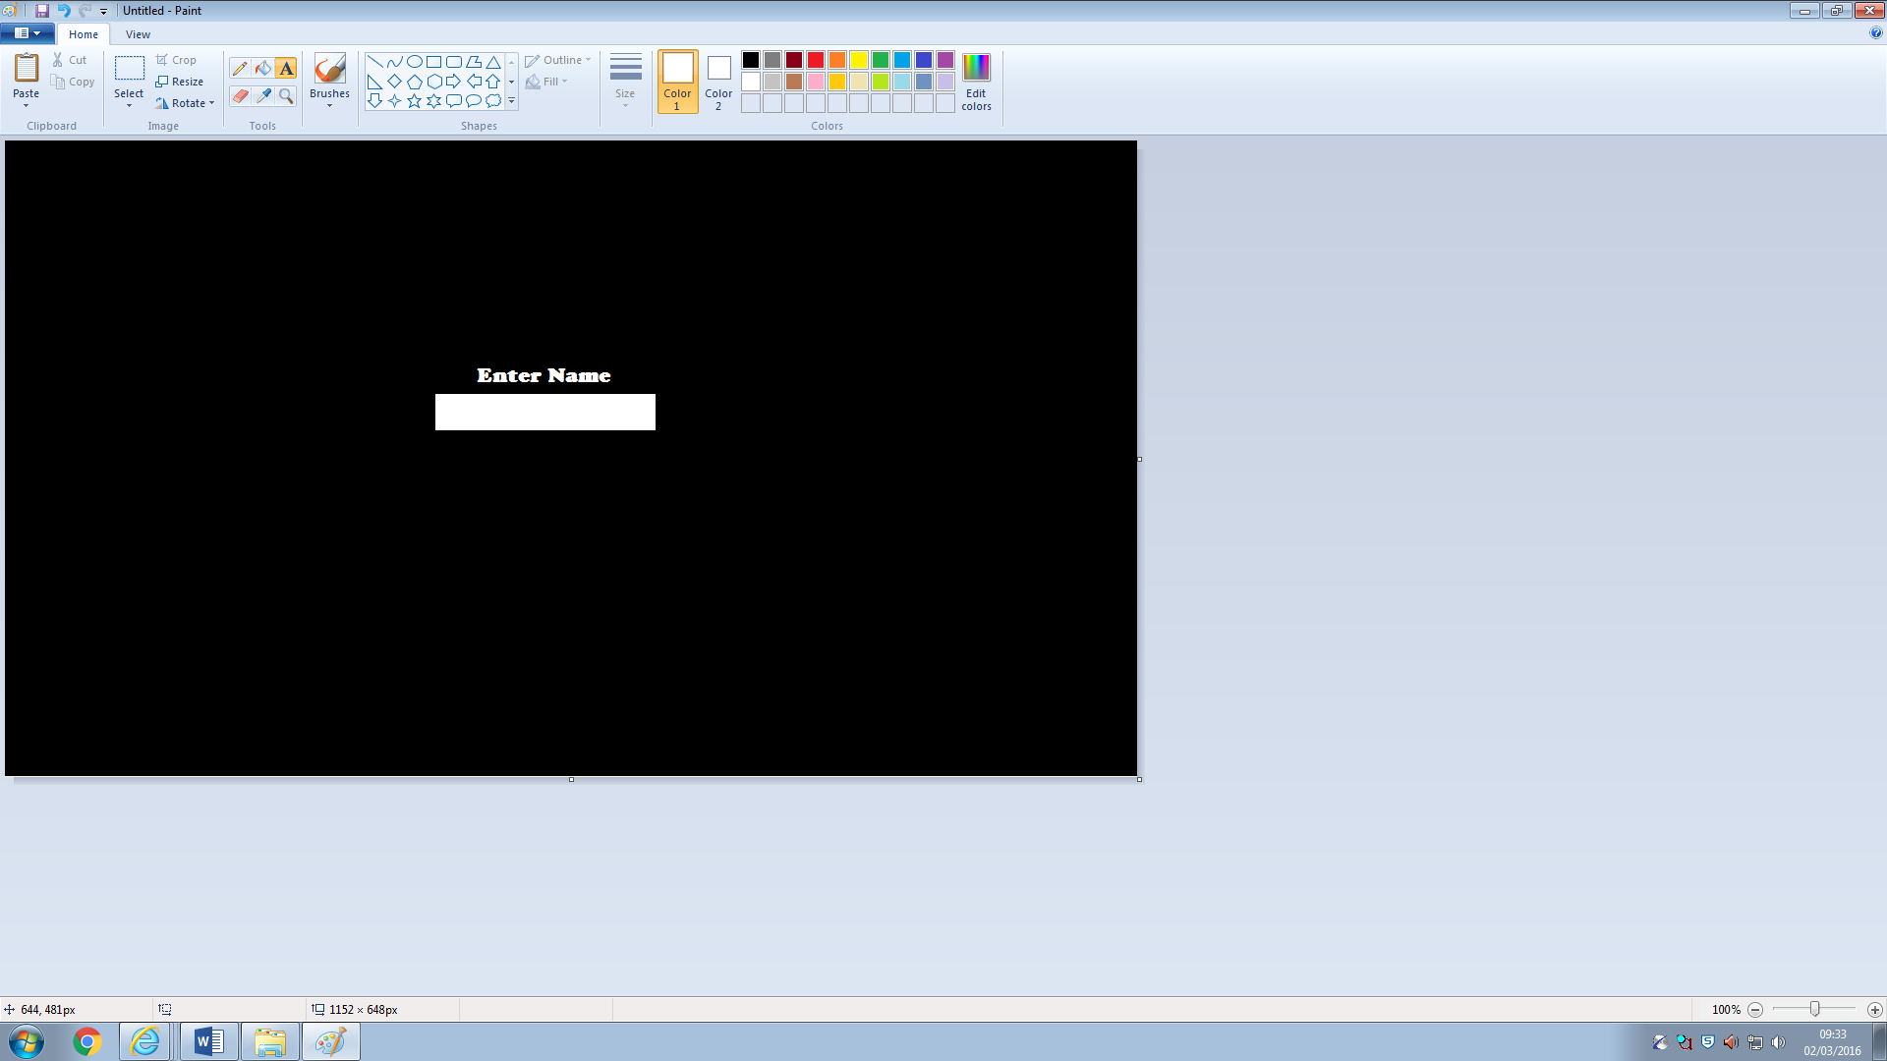2. The second window will display a bar that will ask the user to enter their name. The users name will be saved to show the results for the user when they carry out the search on the next window.

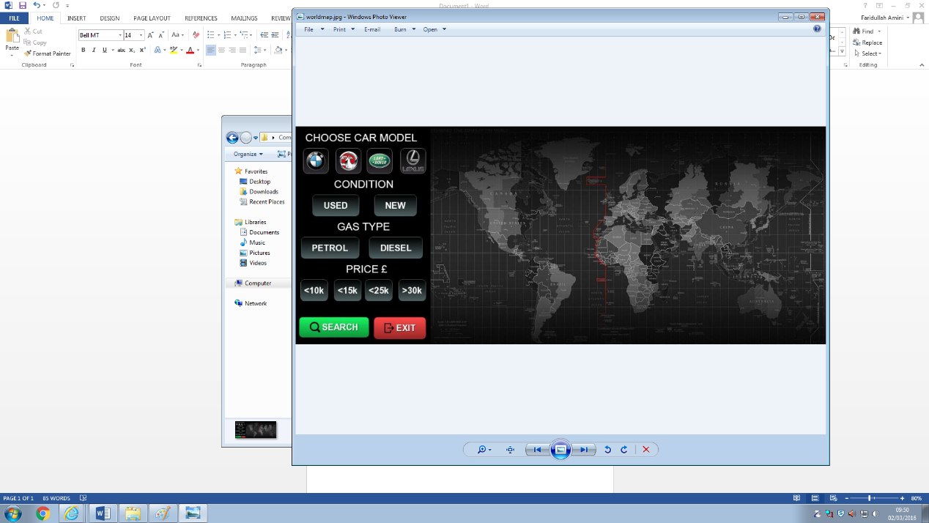3. This window will display the search engine on the left and an image of the world map on the right. This window will be used to carry out the search.

The user will be able to search for new or used cars. The user can search for four makes of cars: BMW, Vauxhall, Range Rover and Lexus. Also different fuel types: diesel and petrol. And the price range.

This window will also contain two buttons which are to search or exit.

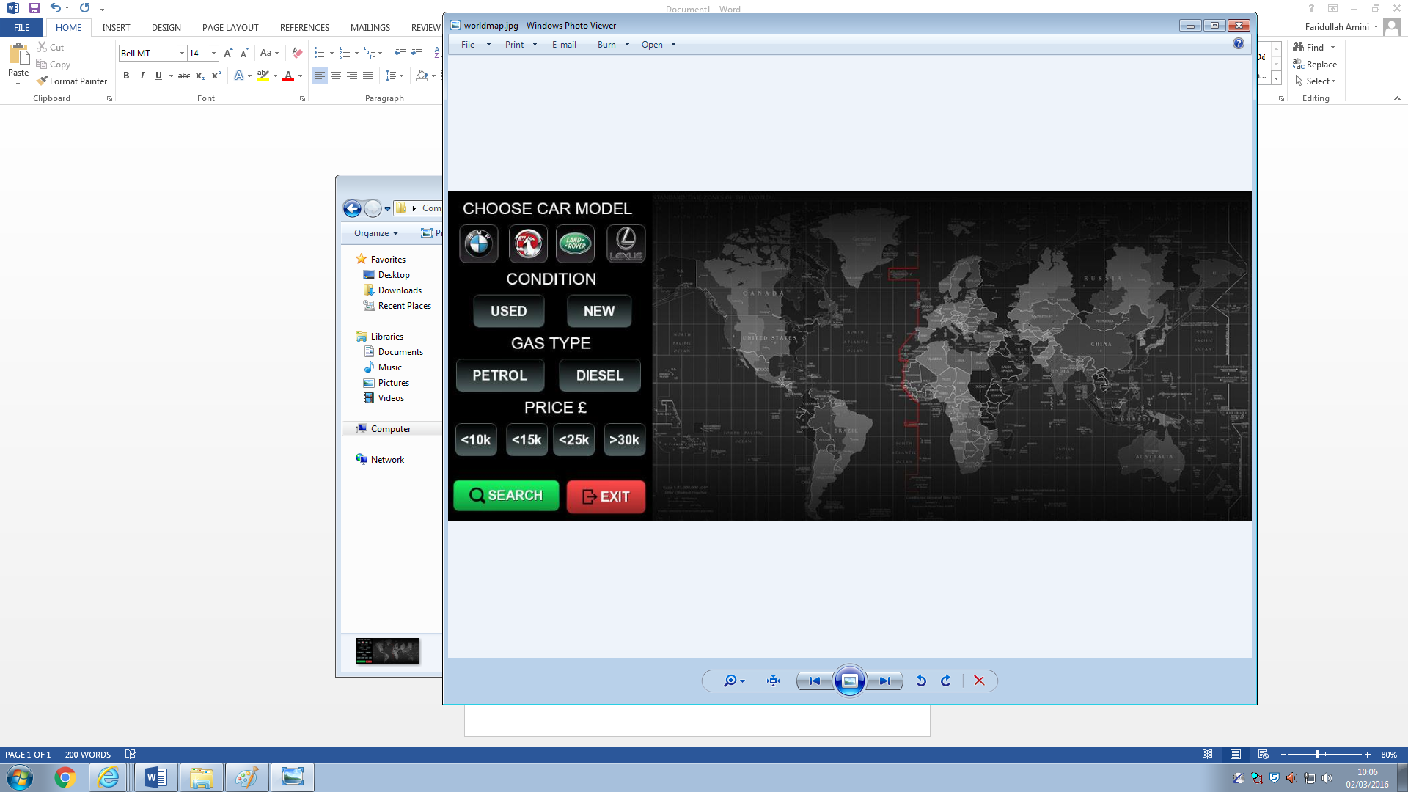

4. The last window will display an image of the world map which will show the robot moving around on the world image to find the location of the item and display the results.