Bone Fracture Detection & Captioning System
System Architecture Specification & Technical Block Diagram Document

1. Executive Summary & Architectural Overview
This engineering specification details the deep-learning bone fracture analysis platform. The solution combines multi-task deep convolutional representation learning (ResNet-50), dedicated spatial lesion localization (Faster R-CNN with MobileNetV3 Feature Pyramid Network), a zero-hallucination factual clinical captioning synthesizer, a high-throughput FastAPI REST microservice, and an interactive Streamlit diagnostic web dashboard.

2. System Architecture Block Diagram

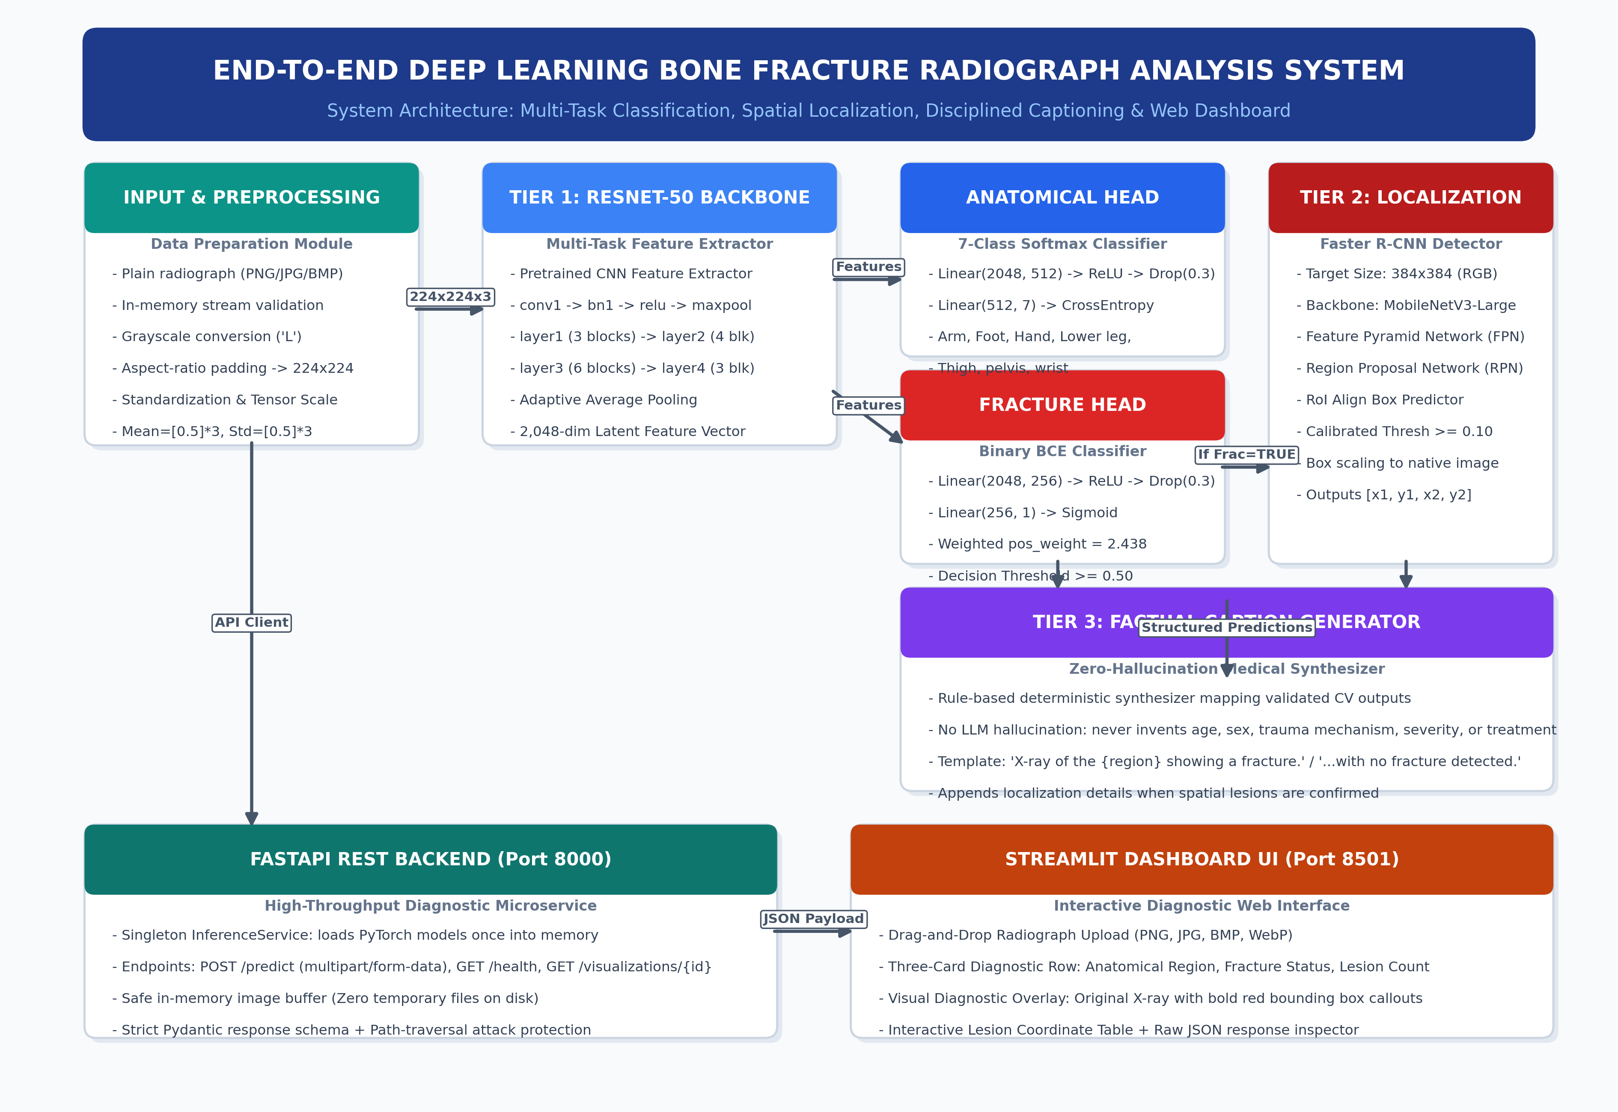

3. Component Specifications & Hyperparameters
Component | Base Architecture | Loss / Objective Function | Output Specification
Classifier Backbone | ResNet-50 (Stage 1 frozen, Stage 2 fine-tuned) | Transfer learning feature extractor | 2,048-dim feature representation
Anatomical Head | 2-Layer MLP (2048->512->7) + Dropout(0.3) | Multi-class Cross-Entropy Loss | 7 classes (Arm, Foot, Hand, Lower leg, Thigh, pelvis, wrist)
Fracture Head | 2-Layer MLP (2048->256->1) + Dropout(0.3) | BCEWithLogitsLoss (pos_weight = 2.438) | Fracture probability (Decision Threshold >= 0.50)
Spatial Detector | Faster R-CNN (MobileNetV3-Large FPN) | RPN Loss + Fast R-CNN Box Regression | Bounding boxes [x1, y1, x2, y2] (Threshold >= 0.10)
Caption Synthesizer | Deterministic rule engine template mapper | Structured output binding | Disciplined natural-language clinical description

4. How the Dashboard Works
• 1. Image Upload: Doctor or radiologist uploads plain bone radiograph (PNG, JPG, BMP) into the drag-and-drop file uploader.
• 2. Real-Time In-Memory Dispatch: Upon clicking 'Analyze X-ray', Streamlit sends raw bytes to FastAPI POST /predict without temporary file disk writes.
• 3. Multi-Task Deep Inference: ResNet-50 simultaneously computes 7-class anatomical probability and weighted binary fracture probability.
• 4. Spatial Localization & Overlay: When fracture is confirmed, Faster R-CNN identifies cortical fracture borders and generates an annotated diagnostic visual overlay.
• 5. Factual Caption Synthesis: The disciplined captioning engine synthesizes an explicit, non-hallucinatory description.
• 6. KPI Display & Coordinate Inspection: Dashboard presents three color-coded metric cards, natural language text, visual image overlay, and exact bounding box coordinate table.

