- Constructor first line either super or this. Default super()
- this() will call same class constructor
- super() super / parent class constructor
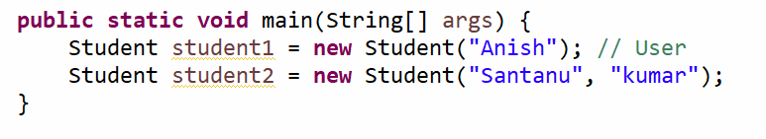

Static Init Block(SIB)
Instance Init Block(IIB)

