Pass command line args in an interactive way ?
Pls enter you name…
Kodewala
Pls enter you email….
Scanner sc = new Scanner()
Java.util
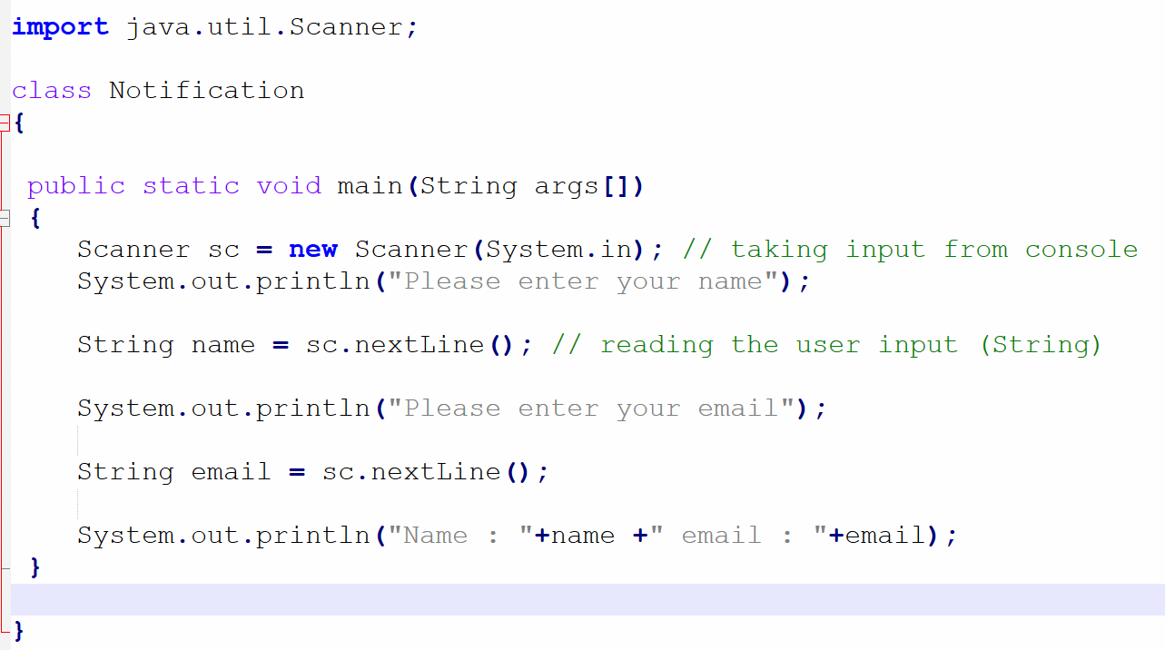

Method
- Block of code which perform the task(payment, creating user profile, login, search, update profile, send message……, add number)
- Method allow us to reuse the code
- Naming convention : checkBalance() , login() logout() , addTwoNumber()
