Private visible with in the class
Default with in the same package
Protected with in the same package + sub classes(child) in different package can use/access.
Public Anyone can access or use.

Private < default < protected < public
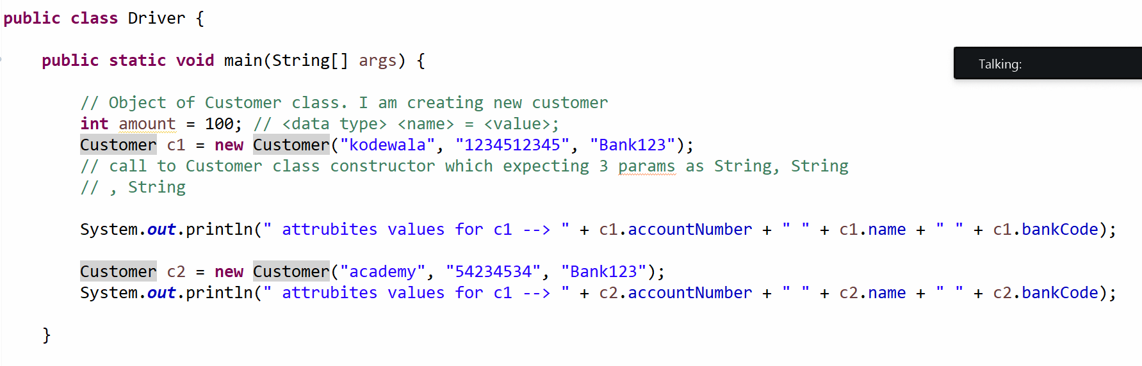
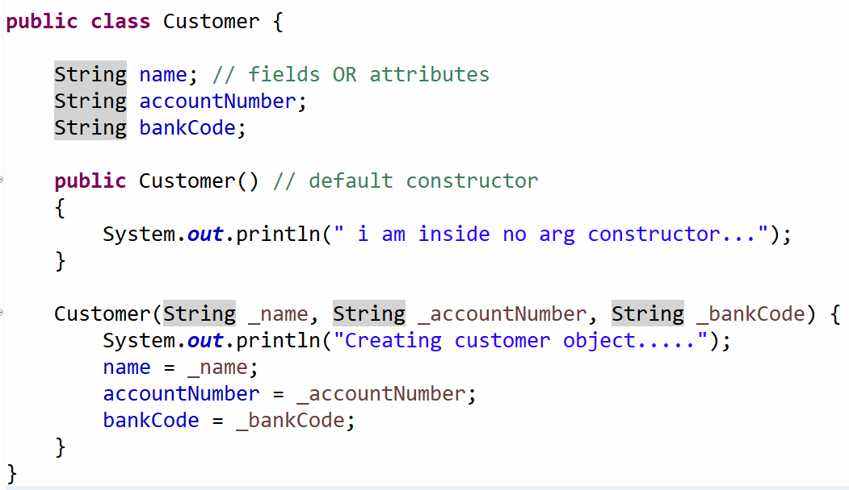

Write a program to create order for amazon e-com platform
- Order id
- Order status
- Item
- Qty
- Price etc..
You need to create 5 orders.
Note :
- Use proper java naming conventions
- Make use of constructors

