Constructor :
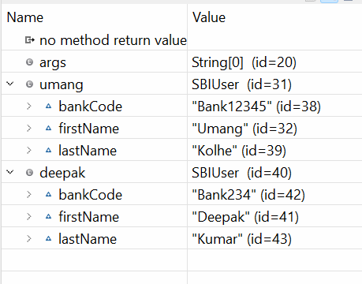
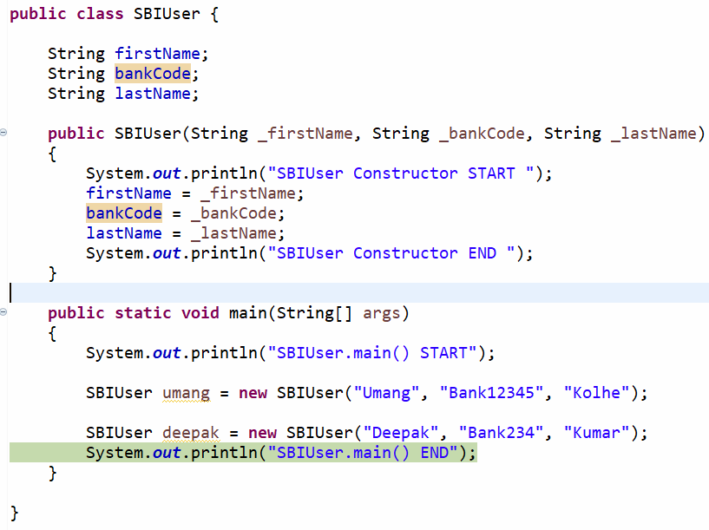

Write a program to create Rapido Booking class and create an object.
Fields / Attributes
- Source
- Destination
- Fare
- Booking type
You should be able to create two types of objects.
- Object with Source, Destination, Fare.
- Source and Booking type.

