- Create java file and provide some name(.java)
- Write java class
- Write method – Will perform the task/work. What is task here – printing “hello”
- Save the file AnyName.java (Source code)
- Compile the source code : javac AnyName.java O/p Byte code (.class file)
- Execution / Run java Hello output
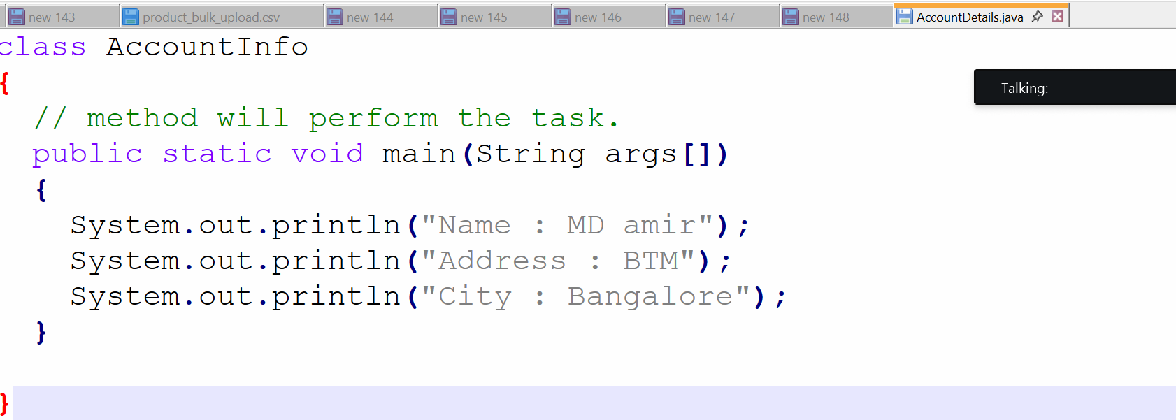

Write a java program to print order details(item name, price and delivery date etc..)
- Use proper java naming convention
- Add one more class – Delivery Information
- Run java program using newly added class.
- Add main method in Delivery Information class as well..

