Command Line Args : Args passed at the run time….
Purpose ?
Compile Test Deploy(move to prod)

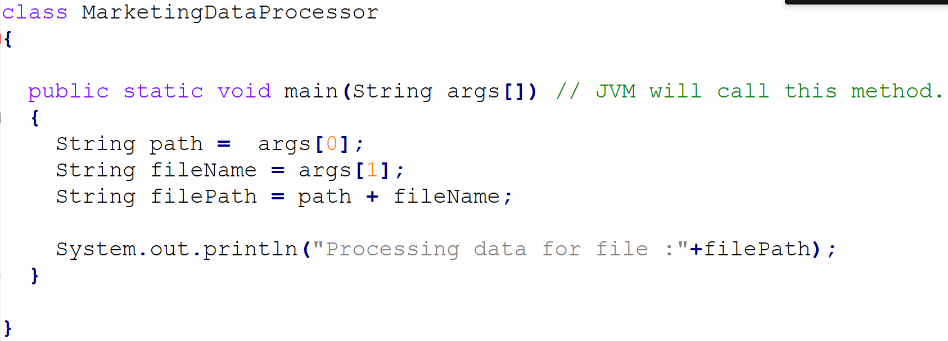

Write program to print the Item price of an Order (command line Args)
- Item name
- Qty
- Price
- GST

Use proper Java Naming convention.

Class ThisIsMyJavaClass
Variable : camelCase thisIsMy, firstName , lastName , email, myName

Java Identifier : Name given to class, method, variables etc….
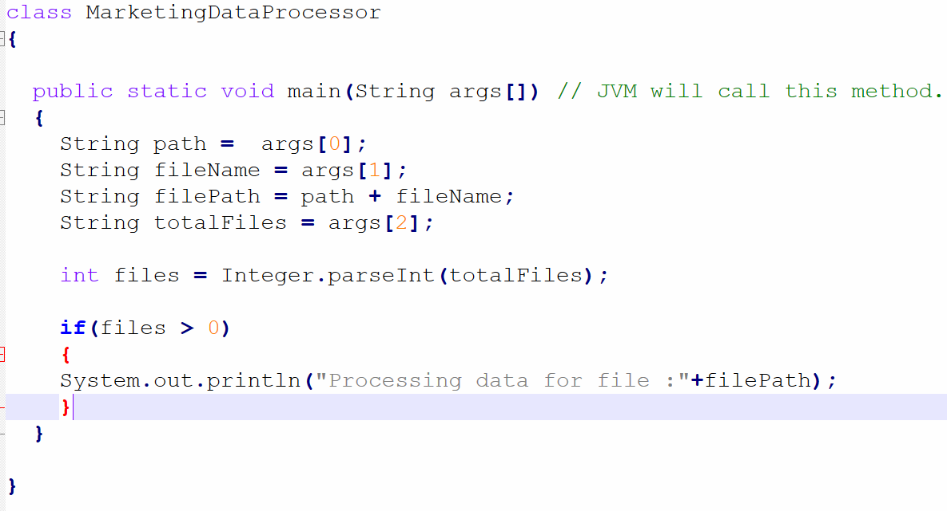

- [A-Z] , [a-z] [0-9]
- $ and _

MyClass

MyClass vs myclass

55+ reserved keyword
class int boolean float , double, byte, char, long, sorty, for while, void, static, private, protected, default, switch, if , else, throw throws, try catch finally , final, return, break, continue , case , abstract, interface, implements, extends, package, import etc….

55

Write a program to explore java identifiers.

[A-Z] , [a-z] [0-9]
$ and _

