- Local variable with in block or method
- Static variable
Static : Belongs to class…
To call static, we need to use class name.

- Instance variable
- Belongs to object. Each object will have separate copy of variable.
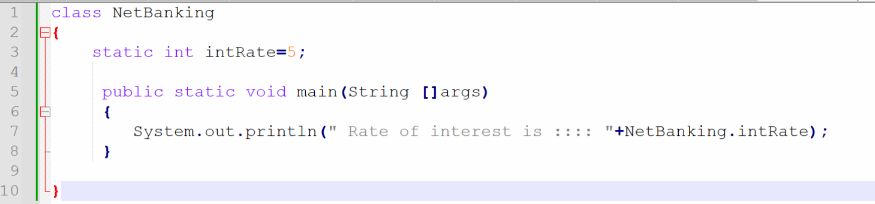

Write a program to explore static variables with proper use case.
5 examples…
