random_script.R

athanasm

2020-05-11

# Get an overview of the data  
gaminder_data <- gapminder::gapminder  
summary(gaminder_data)

## country continent year lifeExp   
## Afghanistan: 12 Africa :624 Min. :1952 Min. :23.60   
## Albania : 12 Americas:300 1st Qu.:1966 1st Qu.:48.20   
## Algeria : 12 Asia :396 Median :1980 Median :60.71   
## Angola : 12 Europe :360 Mean :1980 Mean :59.47   
## Argentina : 12 Oceania : 24 3rd Qu.:1993 3rd Qu.:70.85   
## Australia : 12 Max. :2007 Max. :82.60   
## (Other) :1632   
## pop gdpPercap   
## Min. :6.001e+04 Min. : 241.2   
## 1st Qu.:2.794e+06 1st Qu.: 1202.1   
## Median :7.024e+06 Median : 3531.8   
## Mean :2.960e+07 Mean : 7215.3   
## 3rd Qu.:1.959e+07 3rd Qu.: 9325.5   
## Max. :1.319e+09 Max. :113523.1   
##

# Plot the variables of interest  
library(ggplot2)  
ggplot(gaminder_data,   
 aes(year, pop)) +   
 geom_point() +  
 labs(title = "Example output")

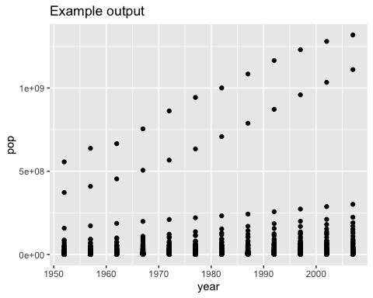

# Run a linear model  
model1 <- lm(pop ~ year, data = gaminder_data)  
library(broom)  
  
# Inspect the model summary table  
tidy(model1)

## # A tibble: 2 x 5  
## term estimate std.error statistic p.value  
## <chr> <dbl> <dbl> <dbl> <dbl>  
## 1 (Intercept) -972185807. 294031308. -3.31 0.000965  
## 2 year 506081. 148533. 3.41 0.000672