Backhoe loader and excavator detection
EXECUTIVE SUMMARY
This proof of concept tests whether a small YOLO object detector can locate backhoe loaders and excavators in construction-site photos. It returns bounding boxes, class labels and confidence scores. This is the image-detection stage of a possible equipment-monitoring workflow; unique machine identity and hire-time logging were outside this model.
DATA AND METHOD
Roboflow version 3 exported 131 images: 105 for training, 13 for validation and 13 for testing. The dataset has two classes (Backhoe Loader and excavator); 11 photos contain neither target. Selected images came from two Roboflow Universe datasets; the README and slides give their provenance and relabeling details. Within Roboflow, related views were grouped where identified, labels reviewed, an exclusion-tag filter applied, and images auto-oriented and resized to 640 × 640 with black padding. Export augmentation was off. A pretrained YOLO26n detector was fine-tuned for 30 epochs. Validation selected best.pt, which was then evaluated on the held-out test split.
HELD-OUT TEST RESULTS
0.812  Precision | 0.904  Recall | 0.938  mAP50 | 0.677  mAP50–95
The test includes only 13 photos and 12 labeled target objects. Scores can shift substantially with a few detections; they should be read with the example images rather than treated as a site-level performance guarantee.
TRAINING EVIDENCE
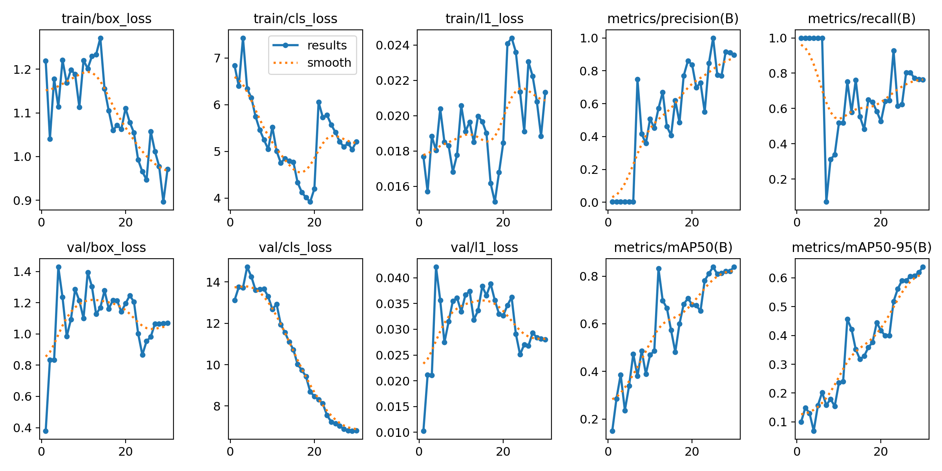
YOLO results.png: box loss trends down; validation mAP rises. Other losses fluctuate.

Errors, limitations and next steps
WHAT THE PREDICTIONS SHOW
True positives
The model localized a rear-view backhoe loader (0.85) and a site excavator (0.86) in the fixed test demonstration. The separate inference notebook also detected a partly visible backhoe loader.
False positives
One negative front-loader tractor received two incorrect target boxes: Backhoe Loader (0.37) and excavator (0.35). A single excavator also received an extra overlapping box. These are three false detections in two photos.
False negatives
At the displayed confidence threshold of 0.25, a sideways backhoe loader and a transported excavator were missed in test; a partly visible backhoe loader was missed in validation.
ONE FALSE NEGATIVE INVESTIGATED
Although Auto-Orient was enabled at export, the missed backhoe photo remained sideways. Rotating it upright and using the same checkpoint yielded Backhoe Loader at 0.81. Orientation therefore plausibly contributed to this one false negative. The original test result is unchanged; the slide pack shows both images.
PRIORITIZED IMPROVEMENTS
1. Correct accidentally rotated files and add independent, labeled tilted, partially obscured and transported targets to address the false negatives.
2. Add unboxed front-loader tractors and similar machinery as hard negatives to address the two tractor false positives.
3. Audit whole-machine box consistency and expand independent site scenes to investigate the duplicate prediction and small test set.
INTERPRETATION AND GOVERNANCE
This model supports preliminary image screening only. A person should review uncertain and missed detections before equipment decisions. The reviewed examples establish false positives and false negatives; they do not show a confirmed backhoe-versus-excavator class-confusion case or a measured localization error. The confusion matrix adds a “background” row and column for unmatched labels or predictions, not a third training class. The displayed grids use confidence 0.25, whereas Ultralytics evaluation may use a lower internal threshold.
REPRODUCIBILITY AND IMAGE RIGHTS
GitHub Release v1.0.0 freezes the YOLOv11-format ZIP (SHA256: 8e3645e885a7f4b3ec90c25cdf39b680a474448659397f123ac13a7d28ccab8a) and best.pt. The keyless inference notebook passed a fresh Colab Run all. The two Universe sources list CC BY 4.0 and are credited in the README and Release. Original code and prose use MIT; source image rights are separate.
Repository, notebooks, evidence and release: https://github.com/Asiya0555/Backhoe-Excavator-Site-Detection

