**Question #1.**

**Describe a chromosome that may be used for this problem. Give an example of a chromosome.**

We have used binary chromosome containing 0`s and 1`s. No of 1`s in these chromosomes represents the maintenance interval of units.

for example when Number of Intervals is 2 chromosome will be:

[0,1,1,0]

when Number of Intervals is 1 chromosome will be:

[0,1,0,0]

when Number of Intervals is 3 chromosome will be:

[1,0,1,1]

when Number of Intervals is 4 chromosome will be:

[1,1,1,1]

**Question #2.**

**Deﬁne the ﬁtness function that you used for this problem. Describe the function clearly by giving a mathematical expression or a procedure or algorithm.**

The fitness function used in this problem is very simple. It takes chromosomes as input and return the fitness of that chromosome by using this formula:

fitness_function = sum(chromosome)*20

After applying this fitness function we got output as below:

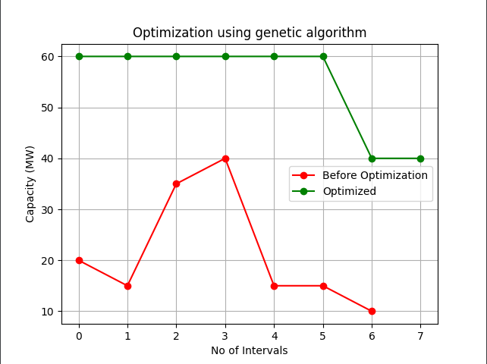

**Question #3.**

**Describe the selection function you used.**

Our Selection function takes sorted list of chromosomes and their fitness values and returns only top 4 best chromosomes according to their fitness.

This function is used in crossover function which takes top 4 best chromosomes and apply crossover on these chromosomes.

**Question #4.**

**Describe the hyper-parameters used (such as mutation rate) and how you chose them.**

**Hyper-parameters:**

1. **Mutation-rate:-**

We randomly mutated one gene in each chromosome. Given any random index we change the gene from 0 to 1.

Before Mutation: [1,0,0,1]

After Mutation: [1,1,0,1]

1. **Split-ratio:**

Split rate used is 2.

Example:

Chromosome no 1: **[1,0, 0, 0]**

Chromosome no 2: **[0,1, 1, 0]**

after crossover using specified split ratio chromosomes will be:

Chromosome no 1: **[1,0, 1, 0]**

Chromosome no 2: **[0,1, 0, 0]**