# “**First DAPP**”

Asjad Iftikhar

18L-0951

Blockchain

Assignment 2

**Task 1:**

-> Software Installation

* Install Virtual Box

* Install Ubuntu Linux

Solution: I use Pop-OS(Linux) as my primary OS of choice, so these steps are redundant and unnecessary for me:

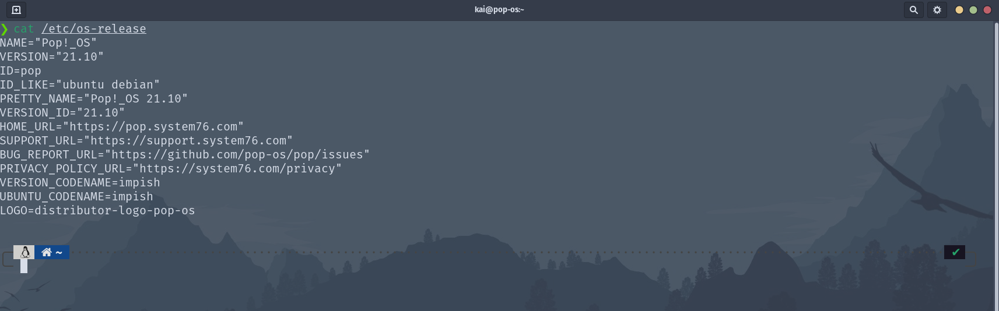

------------------------------------------------------------------------

**Task 2**:

-> Setting up the development environment:

Successfully  setup Development Environment [See Attached]

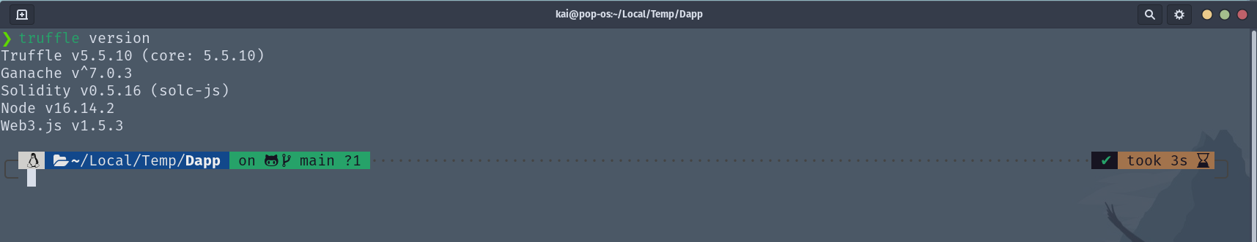

-> Creating a Truffle project using a Truffle Box

Truffle project created using Truffle Box [See Attached]

