CoreChain
B2B Inventory & Supply Chain Management System
Final Project Report
Course | Fundamentals of Software Engineering / DB Systems Lab
Members | Muhammad Asjad — L24-2570
 | Hamza Sheikh — L24-2500
 | M. Abuzar Rizwan — L24-2535
Submission | Sprint 3 — Final Report (May 2026)

a) Project Introduction

Project Title: CoreChain
CoreChain is a centralized, multi-tenant B2B Inventory and Supply Chain Management platform designed to help businesses optimize warehouse operations, manage product lifecycles, automate order processing, and maintain complete auditability of all inventory movements.

The system was developed over three iterative Agile sprints, progressively delivering fully functional modules from user authentication and business setup through to real-time inventory management, automated stock alerts, and warehouse stock transfers.

Problem Statement
Small and medium-sized B2B businesses typically rely on fragmented spreadsheets or disconnected tools to manage inventory, procurement, and supplier relationships. This leads to stock discrepancies, delayed order fulfillment, and a lack of accountability. CoreChain addresses this by providing a unified, role-based platform with real-time stock visibility and automated workflows.

Core Objectives
- Provide real-time inventory visibility across multiple warehouses
- Automate stock updates when purchase or sale orders change status
- Enable role-based access control for Owners, Managers, and Staff
- Maintain a complete, tamper-evident audit trail for all system actions
- Support multi-tenant isolation — each business operates in a fully separate data environment

Technology Stack
Layer | Technology
Backend | Node.js, Express.js — modular MVC (controllers / queries / routes)
Frontend | React (Vite), React Router, Axios
Database | MySQL — 20-table relational schema with foreign keys, soft-deletes, SQL Views
Auth | JWT (JSON Web Tokens), bcrypt password hashing
Dev Tools | Trello (sprint tracking), GitHub (version control), Postman (API testing)

Sprint Overview
Sprint | Period | Modules Delivered
Sprint 1 | March 2026 | User Authentication, Business Management, Supplier Management
Sprint 2 | April 2026 | Purchase Orders, Sale Orders, Warehouse Management, Product & Category Management, Staff Management
Sprint 3 | May 2026 | Inventory Management, Low-Stock Alerts, Warehouse Stock Transfer, Audit Log, System Testing & Quality Improvement

b) User Stories — All Sprints

Sprint 1 — March 2026
Modules: User Authentication, Business Management, Supplier Management

US-01 — User Authentication
Story Points: 13
As a new or returning user, I want to securely sign up and log in to CoreChain so that I can access the platform with my own account.
Sub-Story | Description | Points
SS-1.1 | As a new user, I want to register an account with my full name, email, and password. | 3 pts
SS-1.2 | As a registered user, I want to log in using my email and password to reach my dashboard. | 3 pts
SS-1.3 | As a new user, I want to verify my email address after signing up so my account is activated. | 3 pts
SS-1.4 | As a logged-in user, I want to be redirected based on my account state (verified / onboarding / dashboard). | 4 pts

US-02 — Business Management & Onboarding
Story Points: 11
As a verified user, I want to create or join a business so that I can begin managing inventory and operations under a business entity.
Sub-Story | Description | Points
SS-2.1 | As a new user, I want to register a business with a name and description to set up my workspace. | 3 pts
SS-2.2 | As a business owner, I want to update my business profile details. | 3 pts
SS-2.3 | As a user without a business, I want to submit a joining request to an existing business. | 3 pts
SS-2.4 | As a business owner, I want to approve or reject joining requests from other users. | 2 pts

US-03 — Supplier & Vendor Management
Story Points: 10
As a Business Manager, I want to manage supplier records so that I can maintain a reliable and auditable procurement network.
Sub-Story | Description | Points
SS-3.1 | As a Manager, I want to register a new supplier with contact details and business information. | 3 pts
SS-3.2 | As a Manager, I want to update existing supplier information. | 2 pts
SS-3.3 | As a Manager, I want to deactivate (soft-delete) a supplier while retaining historical data. | 2 pts
SS-3.4 | As a Manager, I want to search and filter the vendor directory to find specific suppliers. | 3 pts

Sprint 2 — April 2026
Modules: Purchase Order Management, Sale Order Management, Warehouse Management, Product & Category Management, Staff Management

US-04 — Purchase Order Management
Story Points: 14
As a Business Manager, I want to create and manage purchase orders from suppliers so that I can track inbound inventory efficiently.
Sub-Story | Description | Points
SS-4.1 | As a Manager, I want to create a new purchase order linked to a supplier and warehouse. | 3 pts
SS-4.2 | As a Manager, I want to add multiple line items (products, quantity, unit cost) to a purchase order. | 3 pts
SS-4.3 | As a Manager, I want to update the status of a purchase order (Pending, Approved, Received, Cancelled). | 3 pts
SS-4.4 | As a Manager, I want to view the full list of purchase orders with filters by status and supplier. | 3 pts
SS-4.5 | As a Manager, I want to cancel or soft-delete a purchase order while retaining audit history. | 2 pts

US-05 — Sale Order Management
Story Points: 14
As a Business Manager, I want to create and manage sale orders for customers so that I can track outbound inventory and revenue.
Sub-Story | Description | Points
SS-5.1 | As a Manager, I want to create a new sale order with customer information and warehouse source. | 3 pts
SS-5.2 | As a Manager, I want to add line items (products, quantity, unit price) to a sale order. | 3 pts
SS-5.3 | As a Manager, I want to update the status of a sale order (Pending, Confirmed, Shipped, Delivered, Cancelled). | 3 pts
SS-5.4 | As a Manager, I want to view and filter all sale orders by status and date range. | 3 pts

US-06 — Warehouse Management
Story Points: 11
As a Business Owner or Manager, I want to manage warehouse locations so that I can organize inventory across multiple physical sites.
Sub-Story | Description | Points
SS-6.1 | As an Owner, I want to register a new warehouse with a name, address, and business association. | 3 pts
SS-6.2 | As a Manager, I want to update warehouse details including name and address. | 2 pts
SS-6.3 | As a Manager, I want to assign or remove staff members from a warehouse with specific roles. | 3 pts
SS-6.4 | As a Manager, I want to deactivate a warehouse using a soft-delete while retaining historical data. | 3 pts

US-07 — Product & Category Management
Story Points: 13
As a Business Manager, I want to manage the product catalog and categories so that I can maintain accurate and organized inventory records.
Sub-Story | Description | Points
SS-7.1 | As a Manager, I want to create a new product with a unique SKU, price, and category assignment. | 3 pts
SS-7.2 | As a Manager, I want to update product information including price and category. | 2 pts
SS-7.3 | As a Manager, I want to link products to one or more suppliers for procurement flexibility. | 3 pts
SS-7.4 | As a Manager, I want to view real-time stock levels per product per warehouse. | 2 pts

US-08 — Staff Management
Story Points: 10
As a Business Owner, I want to manage my staff members and their roles so that I can control access and responsibilities within the platform.
Sub-Story | Description | Points
SS-8.1 | As an Owner, I want to view all active and inactive staff members in my business. | 2 pts
SS-8.2 | As an Owner, I want to update a staff member's assigned role within the business. | 3 pts
SS-8.3 | As an Owner, I want to deactivate a staff member's access without deleting their records. | 3 pts
SS-8.4 | As an Owner, I want to assign staff members to specific warehouses with designated roles. | 2 pts

Sprint 3 — May 2026
Modules: Inventory Management, Low-Stock Threshold Alerts, Warehouse Stock Transfer, Audit Log, System Testing & Quality Improvement

US-09 — Inventory Management & Stock Visibility
Story Points: 16
As a Business Manager, I want to view and manage real-time inventory levels across all warehouses so that I can make informed procurement and fulfillment decisions.
Sub-Story | Description | Points
SS-9.1 | As a Manager, I want to view current stock levels for all products in a selected warehouse so that I can assess available quantities at a glance. | 3 pts
SS-9.2 | As a Manager, I want to check stock availability for a specific product across all active warehouses so that I can identify the best fulfillment source. | 3 pts
SS-9.3 | As a Manager, I want inventory to automatically increase when a Purchase Order status is changed to Received, so that stock counts stay accurate without manual entry. | 4 pts
SS-9.4 | As a Manager, I want inventory to automatically decrease when a Sale Order is Confirmed, so that available stock is always reflected in real time. | 3 pts
SS-9.5 | As a Manager, I want to manually adjust inventory quantities with a reason note so that physical count discrepancies can be corrected and recorded. | 3 pts

US-10 — Low-Stock Threshold Alerts
Story Points: 11
As a Business Manager, I want to configure low-stock thresholds per product per warehouse so that I receive timely warnings before stock runs critically low.
Sub-Story | Description | Points
SS-10.1 | As a Manager, I want to set a minimum stock threshold for each product in each warehouse so that the system knows when to trigger an alert. | 3 pts
SS-10.2 | As a Manager, I want to see a low-stock warning banner or indicator on the dashboard whenever any product falls at or below its configured threshold. | 3 pts
SS-10.3 | As a Manager, I want to view a dedicated Low-Stock Alerts report listing all products currently at or below threshold, grouped by warehouse. | 3 pts
SS-10.4 | As a Manager, I want to update or remove a threshold for any product at any time so that alert sensitivity can be adjusted as business needs change. | 2 pts

US-11 — Warehouse Stock Transfer
Story Points: 13
As a Business Manager, I want to transfer stock between warehouses so that inventory can be redistributed to meet demand without placing a new purchase order.
Sub-Story | Description | Points
SS-11.1 | As a Manager, I want to initiate a stock transfer by selecting a source warehouse, a destination warehouse, a product, and a quantity. | 3 pts
SS-11.2 | As a Manager, I want the system to validate that the source warehouse holds sufficient quantity before allowing the transfer so that negative stock is never created. | 3 pts
SS-11.3 | As a Manager, I want the source warehouse inventory to be decremented and the destination warehouse inventory to be incremented atomically upon transfer confirmation. | 4 pts
SS-11.4 | As a Manager, I want to view a history of all past stock transfers with date, product, quantity, source, and destination so that movement is fully traceable. | 3 pts

US-12 — Audit Log
Story Points: 12
As a Business Manager, I want a complete audit trail of all system actions so that every change is traceable and accountable.
Sub-Story | Description | Points
SS-12.1 | As a Manager, I want to view a timestamped log of all actions (create, update, delete) performed across all entities. | 3 pts
SS-12.2 | As a Manager, I want to filter audit logs by entity type and action so I can quickly isolate relevant events. | 3 pts
SS-12.3 | As a Manager, I want each audit entry to show the actor, action, entity, and details so accountability is fully maintained. | 3 pts
SS-12.4 | As a Manager, I want to export audit logs as a CSV file for external reporting or compliance purposes. | 3 pts

US-13 — System Testing & Quality Improvement
Story Points: 12
As a development team, we want all previously implemented modules to be fully tested and refined so that the CoreChain platform is stable, reliable, and ready for production use.
Sub-Story | Description | Points
SS-13.1 | As a developer, I want to write and execute unit tests for all backend API endpoints across every module so that individual functions behave correctly in isolation. | 4 pts
SS-13.2 | As a developer, I want to perform integration testing across module boundaries — such as Purchase Order to Inventory and Sale Order to Inventory — to verify end-to-end flows. | 4 pts
SS-13.3 | As a developer, I want to identify and fix all known bugs, edge cases, and validation gaps discovered during testing so that the system handles errors gracefully. | 2 pts
SS-13.4 | As a developer, I want to review and improve frontend UX — including loading states, error messages, and form validations — so that the user experience is polished and consistent. | 2 pts

c) Design
The following UML diagrams were produced as part of the Sprint 2 design deliverables. They capture the structural and behavioral design of the CoreChain system.

Use Case Diagram
Five actors are identified: Guest, Registered User, Business Owner, Business Manager, and Employee. The diagram maps all use cases including authentication, supplier management, employee onboarding, and system-level operations such as JWT validation and multi-tenant isolation enforcement.

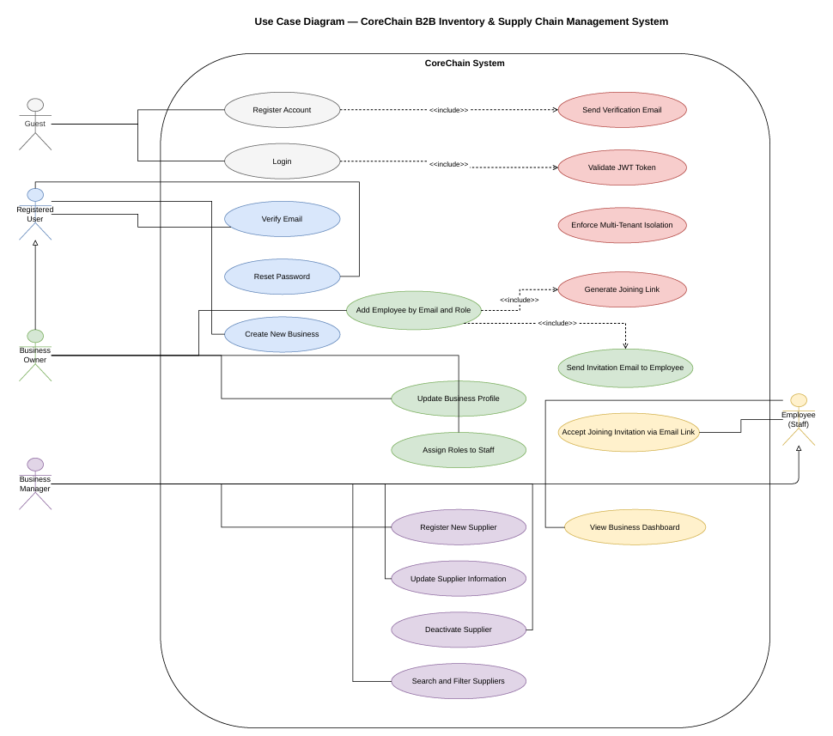
Figure 1: CoreChain Use Case Diagram

Class Diagram
Ten core classes are defined: User, Business, Staff, Role, JoiningRequest, Supplier, Warehouse, Product, Inventory, and AuditLog. Each includes attributes, methods, and their relationships (associations, ownership, and tracking links).

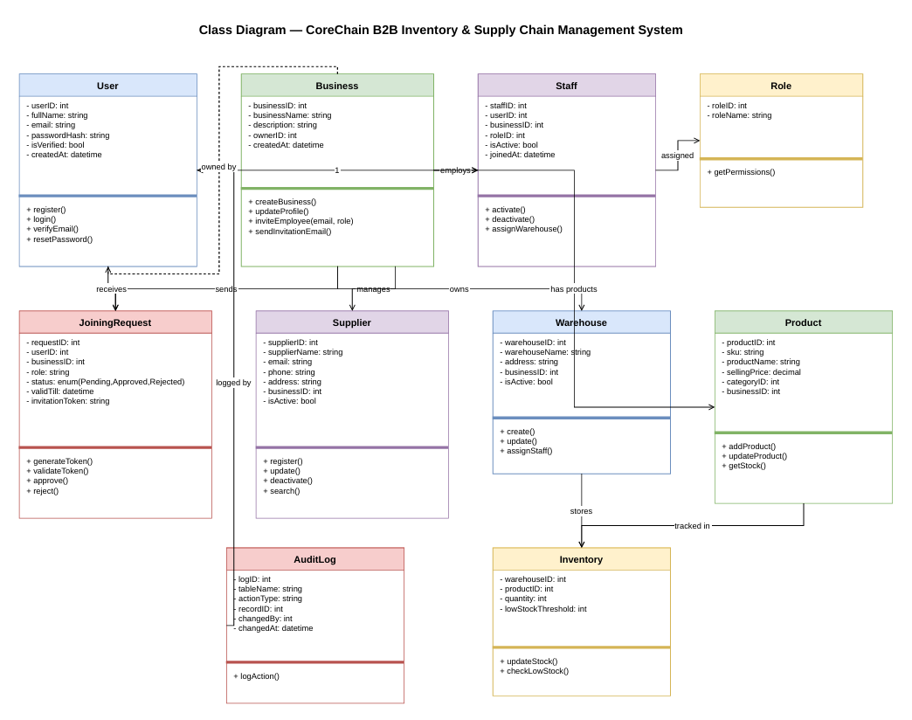
Figure 2: CoreChain Class Diagram

Activity Diagram — User Registration & Email Verification
Models the complete user registration flow from form submission through bcrypt hashing, account creation, token generation, and email verification redirect. Decision points cover invalid input, duplicate email, and expired token scenarios.

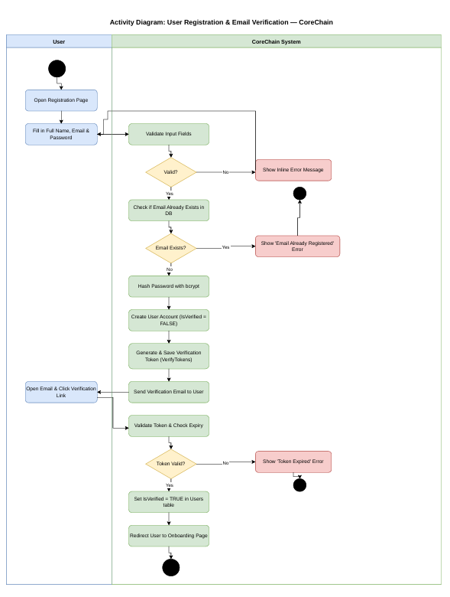
Figure 3: Activity Diagram — User Registration & Email Verification

Activity Diagram — Employee Invitation & Onboarding
Covers the employee onboarding flow: email lookup, duplicate staff check, JoiningRequest creation, token-based invite email, and employee token validation leading to Staff table activation.

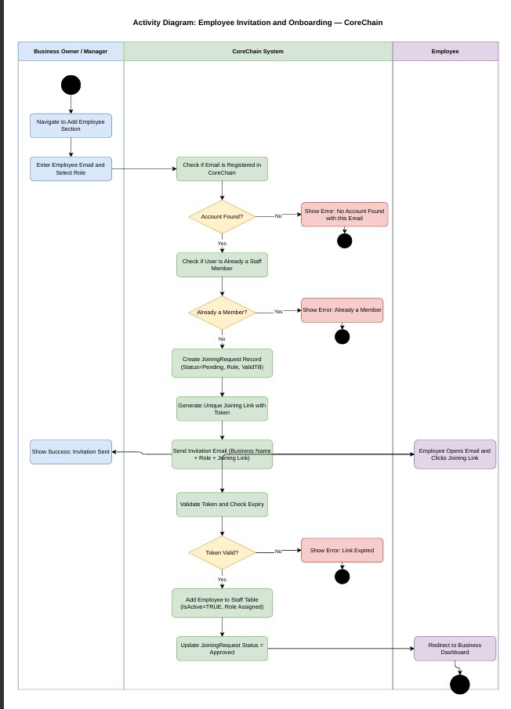
Figure 4: Activity Diagram — Employee Invitation & Onboarding

Sequence Diagram — User Registration & Email Verification
Two-phase interaction between User, Browser (React), Auth Controller, Database (MySQL), and Email Service. Phase 1 covers registration; Phase 2 covers email verification via token.

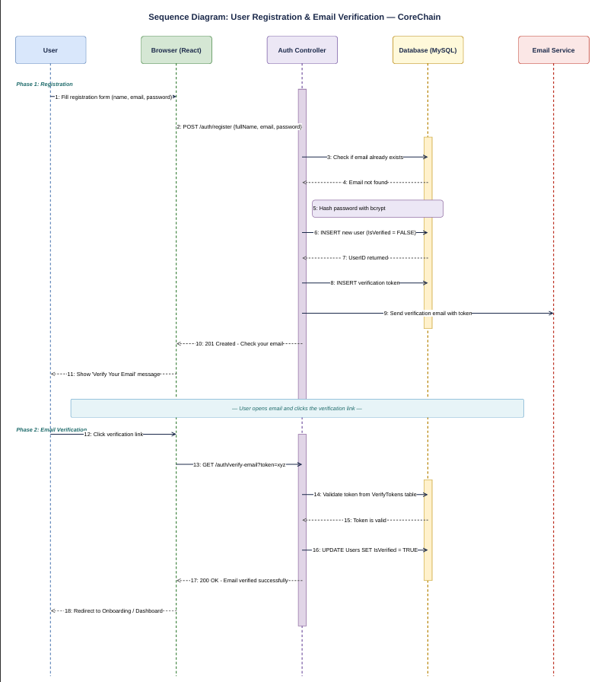
Figure 5: Sequence Diagram — User Registration & Email Verification

Sequence Diagram — Employee Invitation & Onboarding
20-step interaction flow from the Business Owner navigating to Add Employee through to the invited employee being redirected to the Business Dashboard upon accepting the invitation.

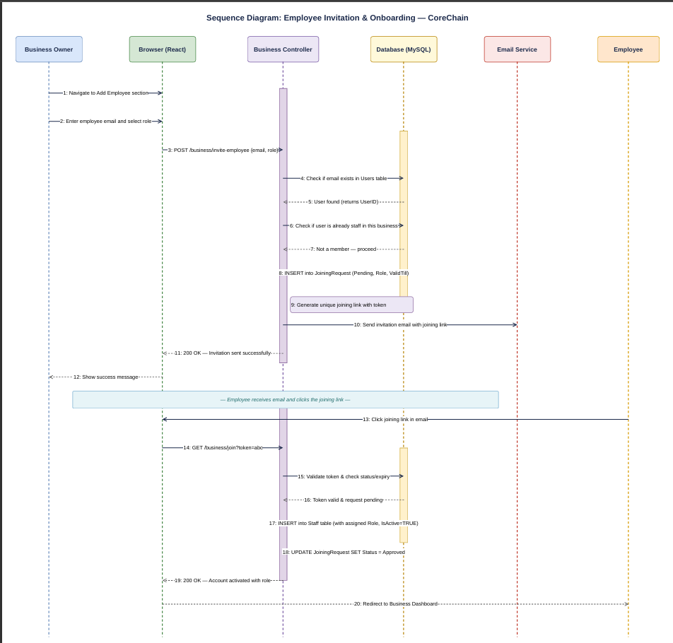
Figure 6: Sequence Diagram — Employee Invitation & Onboarding

Sequence Diagram — Supplier Registration
Three-phase flow: JWT authentication and BusinessID extraction, duplicate email check with 409 conflict handling, and supplier INSERT with AuditLog entry on success.

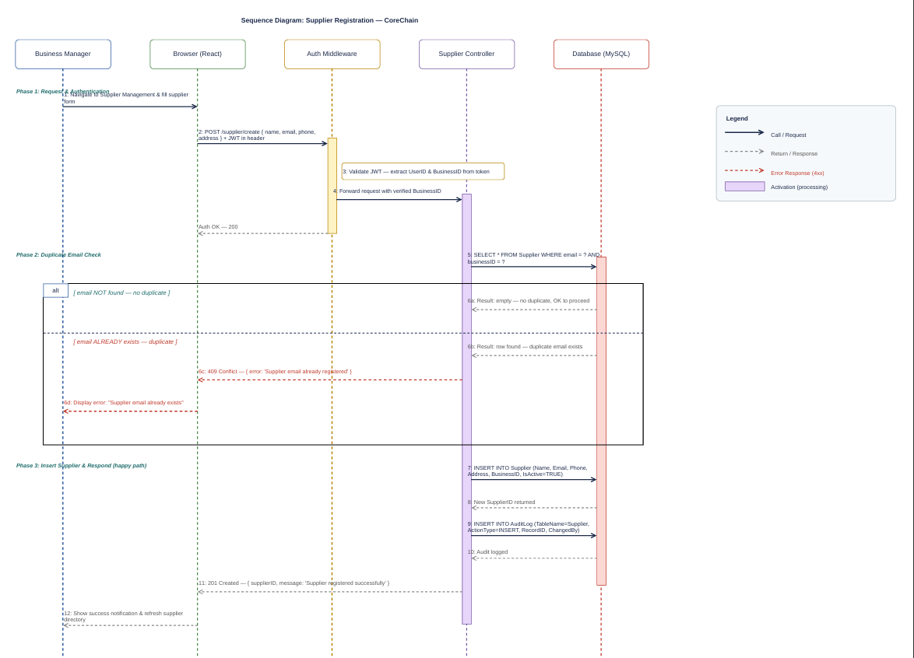
Figure 7: Sequence Diagram — Supplier Registration

d) Architecture

Pattern: MVC (Model-View-Controller)
CoreChain follows a strict MVC architecture applied separately on the backend and frontend layers, with a clear separation between data access, business logic, and presentation.

Backend — Node.js / Express MVC
Each module is organized into three files:
- Controller — handles HTTP requests, applies business logic, returns responses
- Queries — contains raw parameterized SQL statements (Model layer, interfaces with MySQL)
- Routes — defines Express endpoint paths and maps them to controller functions

JWT-based authentication middleware (auth.middleware.js) is applied globally to all protected routes. It extracts UserID and BusinessID from the token and enforces multi-tenant isolation server-side — no client-passed IDs are trusted.

Frontend — React (Vite) SPA
A single-page application built with React and Vite. React Router manages client-side routing with protected route wrappers that redirect unauthenticated users. Each module has dedicated page components communicating with the backend via Axios.

Database — 20-Table Relational Schema (MySQL)
- Soft-deletes via IsActive boolean flags to preserve historical audit data
- Composite primary keys on junction tables (Inventory, Staff_Warehouse, Product_Supplier)
- ENUM types for all status fields (Pending, Approved, Received, Cancelled, etc.)
- Three SQL views: vw_CurrentStock, vw_LowStockAlerts, vw_ProfitLoss

Architecture Diagram
The three-tier MVC architecture illustrates React frontend communicating via REST API to the Express/Node.js backend, which interfaces with the MySQL relational database.

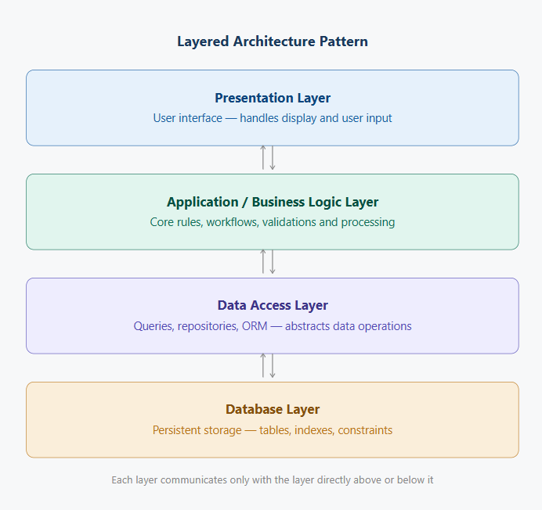
Figure 8: CoreChain Architecture Diagram

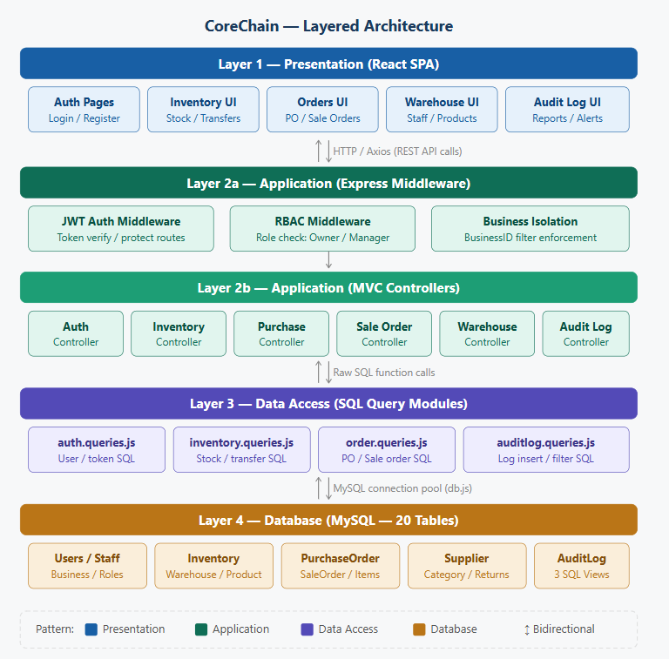
Figure 9: CoreChain Architecture — Detailed View

e) Actual Implementation Screenshots
The following screenshots demonstrate the working implementation of CoreChain across all three sprints, covering all major modules.

1. Overview Dashboard
The main business dashboard shows real-time summary stats: total products, pending purchase orders, pending sale orders, and team members. Recent purchase and sale orders are listed alongside a recent activity feed.

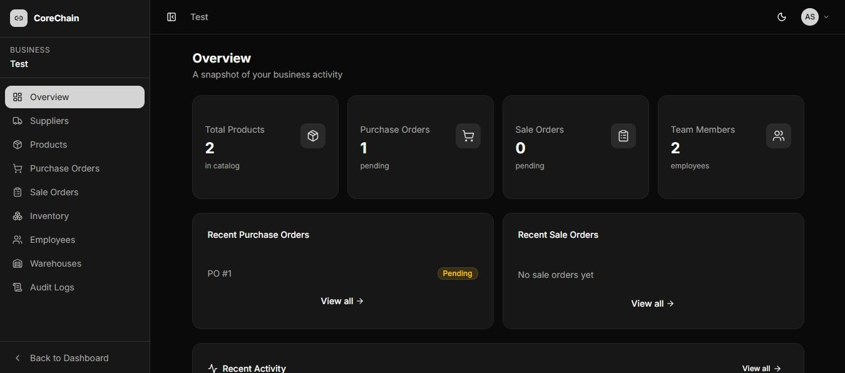
Figure 10: CoreChain Overview Dashboard — real-time business snapshot

2. Products & Categories
The Products page displays the product catalog with SKU, Category, Unit, and Price columns. Products can be searched and filtered by category. Inline edit and delete actions are available per row.

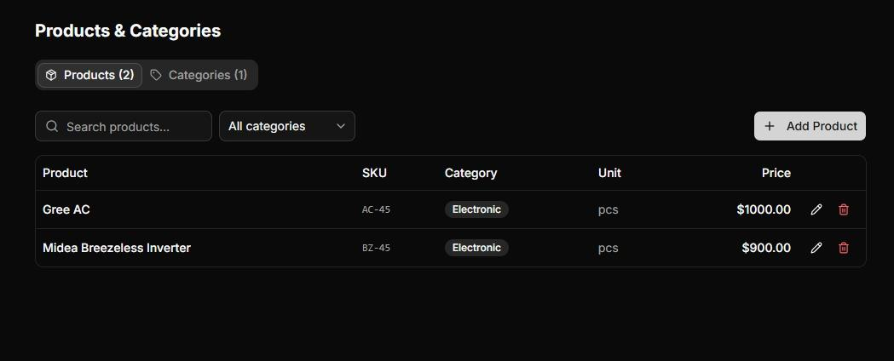
Figure 11: Products & Categories — product catalog with SKU and pricing

3. Purchase Orders
Lists all inbound procurement orders with PO number, Supplier, Warehouse, Date, Total, and Status. Tabs filter by All, Pending, Received, and Cancelled. Inline icons allow viewing details, marking as received, or cancelling.

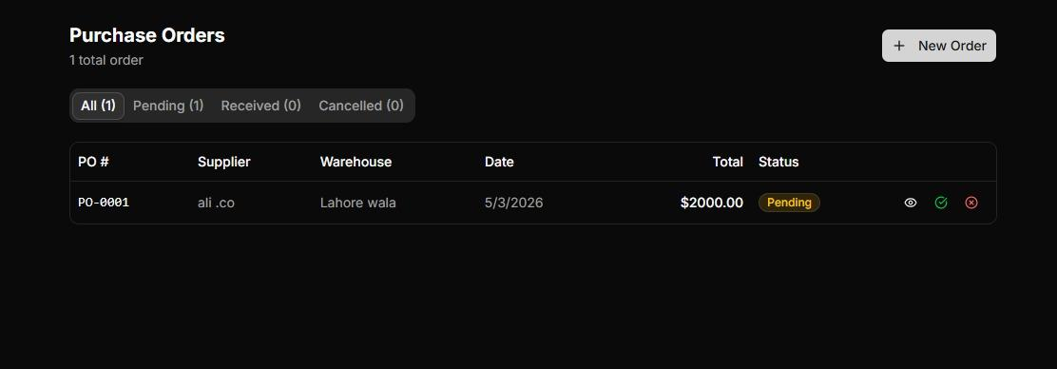
Figure 12: Purchase Orders — PO-0001 pending from supplier ali.co

4. Inventory
Real-time stock visibility across all warehouses. Each row shows Product, SKU, Category, Total Stock, Warehouse, and Status badge. The Low Stock amber badge triggers when quantity falls at or below the configured threshold. Inline Adjust and Transfer actions allow direct stock management.

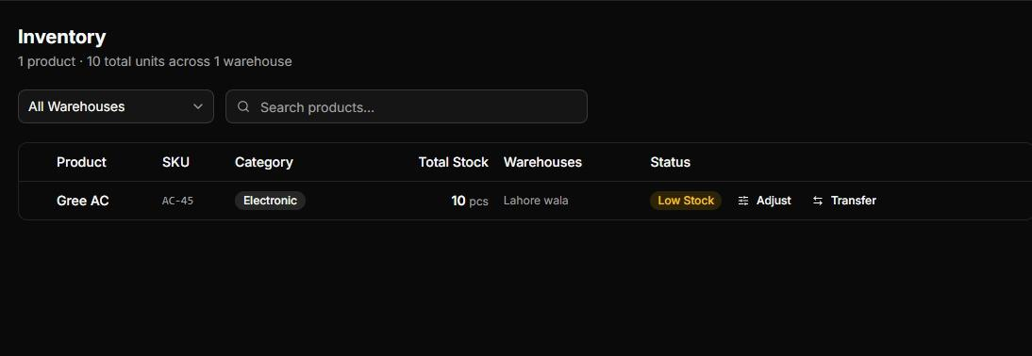
Figure 13: Inventory — Gree AC showing Low Stock status with Adjust and Transfer actions

5. Employees
Displays all staff with Name, Email, and Role badge. The Owner can invite employees by email, update roles, or deactivate staff. A Pending tab tracks outstanding invitations.

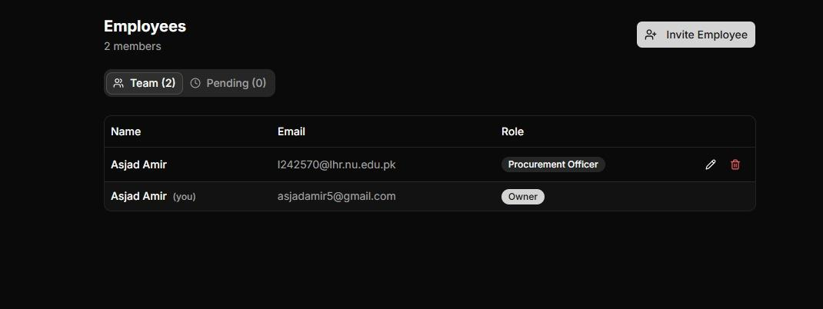
Figure 14: Employees — team of 2 with Owner and Procurement Officer roles

6. Audit Logs
A complete timestamped trail of all system actions. Each entry records Timestamp, Action type (RECEIVE_PO, CREATE_WAREHOUSE, LINK_SUPPLIER, ACCEPT_INVITE, etc.), Entity, and Details. Filterable by entity type and action. Exportable as CSV.

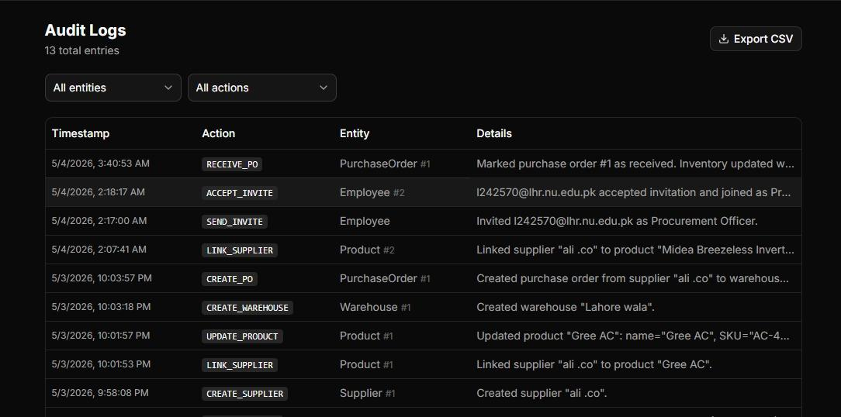
Figure 15: Audit Logs — 13 entries showing full system activity trail

f) Product Burndown Chart
Total story points across all three sprints: 116 points (Sprint 1: 34, Sprint 2: 48, Sprint 3: 34). The table tracks ideal vs actual remaining points across the sprint timeline.

Sprint / Checkpoint | Ideal Remaining Points | Actual Remaining Points
Project Start (Week 0) | 116 | 116
Sprint 1 — Week 1 | 97 | 100
Sprint 1 — Week 2 | 78 | 82
Sprint 1 End | 82 | 82
Sprint 2 — Week 1 | 58 | 63
Sprint 2 — Week 2 | 38 | 40
Sprint 2 End | 34 | 34
Sprint 3 — Week 1 | 17 | 20
Sprint 3 End | 0 | 0

The actual burndown closely tracks the ideal velocity. Sprint 1 had a minor overrun (Product Management carried forward) but recovered by sprint end. Sprint 2 and Sprint 3 completed all committed points within their windows.

g) Trello Board Screenshots
Trello was used throughout the project for sprint planning, task assignment, and progress tracking. Each board maintains four columns: Sprint Backlog, In Progress, Testing, and Completed. Tasks are color-coded by type (Frontend, Backend, Documentation) and assigned to team members. The screenshots below are from Sprint 3.

Sprint 3 Board — State 1
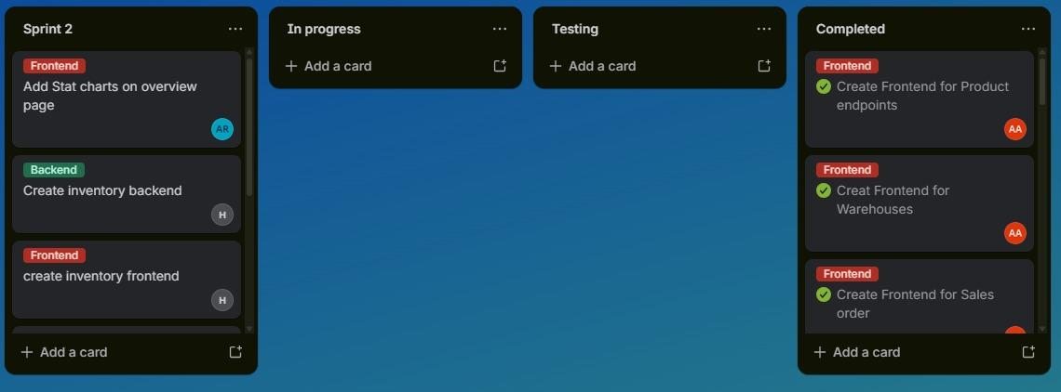
Figure 22: Trello Sprint 3 — Completed: documentation, UI enhancement, inventory backend

Sprint 3 Board — State 2
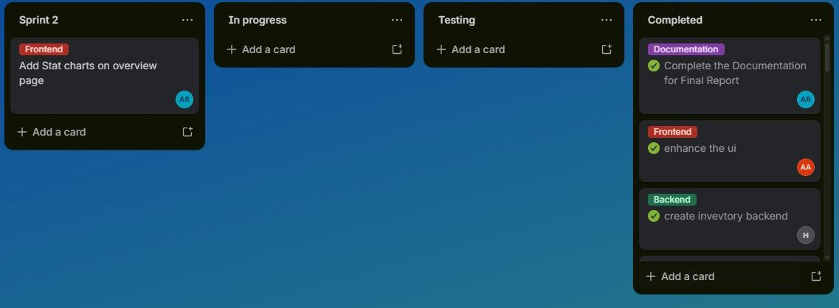
Figure 23: Trello Sprint 3 — Inventory frontend and backend in backlog, Products/Warehouses/Sale Orders frontend completed

Sprint 3 Board — State 3
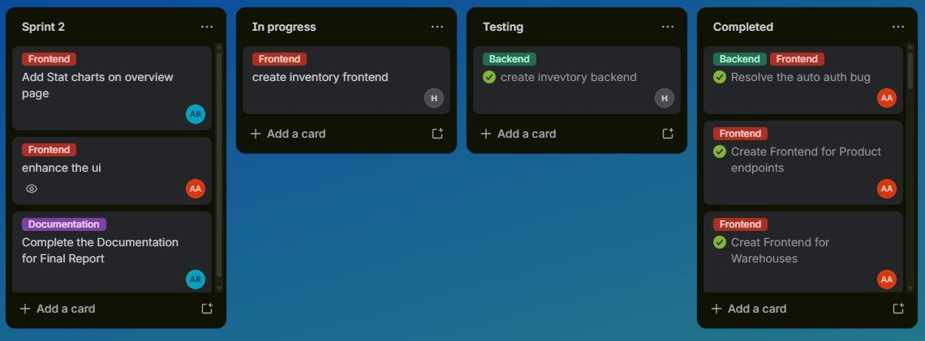
Figure 24: Trello Sprint 3 — Inventory backend in testing, inventory frontend in progress, auth bug resolved

h) Boundary Value Analysis Testing
Boundary Value Analysis (BVA) was performed on the Sign Up and Login interfaces. BVA tests input values at minimum, just-below-minimum, just-above-maximum, and maximum boundaries — the points where defects most commonly occur.

Sign Up Interface

Full Name Field (Min: 2 chars, Max: 50 chars)
Test Case | Input Value | Boundary Type | Expected Result | Actual Result | Status
TC-FN-01 | "" (empty) | Below Min | Error: Name is required | Error shown | Pass
TC-FN-02 | "A" (1 char) | Below Min | Error: Name too short | Error shown | Pass
TC-FN-03 | "Ab" (2 chars) | Min Boundary | Accepted | Accepted | Pass
TC-FN-04 | "Ali" (3 chars) | Just Above Min | Accepted | Accepted | Pass
TC-FN-05 | 50 characters | Max Boundary | Accepted | Accepted | Pass
TC-FN-06 | 51 characters | Above Max | Error: Name too long | Error shown | Pass

Email Field
Test Case | Input Value | Boundary Type | Expected Result | Actual Result | Status
TC-EM-01 | "" (empty) | Empty | Error: Email is required | Error shown | Pass
TC-EM-02 | "notanemail" | Invalid Format | Error: Invalid email format | Error shown | Pass
TC-EM-03 | "a@b.co" | Min Valid | Accepted | Accepted | Pass
TC-EM-04 | "user@domain.com" | Normal Valid | Accepted | Accepted | Pass
TC-EM-05 | 255-char email | Max Length | Accepted | Accepted | Pass
TC-EM-06 | 256-char email | Above Max | Error: Email too long | Error shown | Pass
TC-EM-07 | Duplicate registered email | Duplicate | Error: Email already registered | Error shown | Pass

Password Field (Min: 8 chars, Max: 128 chars)
Test Case | Input Value | Boundary Type | Expected Result | Actual Result | Status
TC-PW-01 | "" (empty) | Empty | Error: Password is required | Error shown | Pass
TC-PW-02 | "pass" (4 chars) | Below Min | Error: Password too short | Error shown | Pass
TC-PW-03 | "passwor" (7 chars) | Just Below Min | Error: Password too short | Error shown | Pass
TC-PW-04 | "password" (8 chars) | Min Boundary | Accepted | Accepted | Pass
TC-PW-05 | "password1" (9 chars) | Just Above Min | Accepted | Accepted | Pass
TC-PW-06 | 128-character string | Max Boundary | Accepted | Accepted | Pass
TC-PW-07 | 129-character string | Above Max | Error: Password too long | Error shown | Pass

Login Interface

Email Field — Login
Test Case | Input Value | Boundary Type | Expected Result | Actual Result | Status
TC-LG-01 | "" (empty) | Empty | Error: Email is required | Error shown | Pass
TC-LG-02 | "notanemail" | Invalid Format | Error: Invalid email format | Error shown | Pass
TC-LG-03 | Unregistered valid email | Not Found | Error: No account found | Error shown | Pass
TC-LG-04 | Registered valid email | Valid | Proceeds to password check | Proceeds | Pass

Password Field — Login
Test Case | Input Value | Boundary Type | Expected Result | Actual Result | Status
TC-LP-01 | "" (empty) | Empty | Error: Password is required | Error shown | Pass
TC-LP-02 | Correct password | Valid Match | Login success — JWT issued | Login success | Pass
TC-LP-03 | Wrong password | Invalid | Error: Invalid credentials | Error shown | Pass
TC-LP-04 | Correct password — unverified account | Unverified State | Error: Please verify your email | Error shown | Pass

i) Work Division Between Group Members

Member | Roll No. | Responsibilities
Hamza Sheikh | L24-2500 | Database schema design (20-table ERD), major backend structure and API architecture, SQL views (vw_CurrentStock, vw_LowStockAlerts, vw_ProfitLoss), backend implementation for core modules, inventory backend
Muhammad Asjad | L24-2570 | System testing and quality improvement, major frontend development (all modules), bug fixing and UX polish, resolution of auto-auth bug, frontend for Products, Warehouses, Inventory, Employees, Purchase Orders, Sale Orders
M. Abuzar Rizwan | L24-2535 | Documentation and final report, Scrum Manager (sprint planning, Trello board management), requirement engineering (user stories and structured specifications across all sprints), supporting backend development

j) Lessons Learnt

Technical Lessons
- Multi-tenant isolation must be enforced server-side on every query. Binding BusinessID directly from the JWT token — rather than trusting client-passed values — was a core architectural principle that prevented cross-tenant data leaks throughout all three sprints.
- Atomic inventory updates are non-negotiable. Stock changes tied to order status transitions (PO Received triggers stock increment, SO Confirmed triggers decrement) must succeed or fail as a single unit. A partial update creates irrecoverable inconsistencies.
- Soft-deletes are essential in a supply chain context. Hard-deleting suppliers, warehouses, or staff would break historical purchase order and audit trail references. Using IsActive = FALSE preserved all historical data without complicating active queries.
- SQL Views significantly reduced frontend complexity. Centralizing multi-table join logic in vw_CurrentStock and vw_LowStockAlerts at the database layer improved both query readability and dashboard load performance.
- JWT expiry handling must be airtight from day one. An auto-authentication bug in Sprint 2 allowed expired sessions to persist, granting access without re-authentication. This reinforced that stateless token validation must be consistent across every protected route.

Process & Collaboration Lessons
- Agile sprint planning with defined user stories and story points made scope management predictable. When the Product Management module slipped from Sprint 1 to Sprint 2, it was identified early, replanned, and completed without disrupting sprint velocity.
- Trello board discipline — moving every task through Backlog, In Progress, Testing, and Completed — gave daily visibility into sprint health and prevented tasks from being assumed done without proper testing.
- Dividing work by layer (backend, frontend, documentation) worked efficiently for a three-person team, but siloed knowledge created bottlenecks when one member was unavailable. Cross-training on both layers from the start would have improved team resilience.
- Writing structured specifications (actor, pre-conditions, post-conditions, main flow, alt flow) before coding caught several edge cases early — particularly around duplicate email handling, insufficient inventory checks, and the sole-owner deactivation constraint.

What We Would Do Differently
- Set up a shared staging environment from Sprint 1. Testing independently in local environments caused integration issues that only surfaced when modules were combined. A shared environment would have caught cross-module bugs much earlier.
- Define inventory auto-update logic in Sprint 1 so the schema triggers are in place before order modules are built. Retrofitting the PO-Received and SO-Confirmed stock update flows in Sprint 3 required changes across multiple already-built modules.
- Introduce API documentation (Postman collection or Swagger spec) from Sprint 1. The frontend developer repeatedly had to read controller code to understand endpoint contracts — a shared spec would have removed this friction significantly.
- Implement integration tests from Sprint 2 rather than Sprint 3. By the time cross-module testing was done in Sprint 3, fixing bugs was more costly than it would have been if caught incrementally during each sprint.

