BANK LOAN QUERY DOCUENT
- Bank Loan Report | Summary
KPI’s :
Total Loan Applications
SELECT COUNT(id) AS Total_Loan_applications FROM dbo.bank_loan_data;
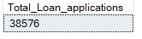
MTD Loan Applications
SELECT COUNT(id) AS MTD_Loan_applications FROM dbo.bank_loan_data
WHERE MONTH(issue_date) = 12 AND YEAR(issue_date) = 2021;
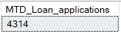
PMTD Loan Applications
SELECT COUNT(id) AS MTD_Loan_applications FROM dbo.bank_loan_data
WHERE MONTH(issue_date) = 11 AND YEAR(issue_date) = 2021;
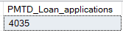

Total Funded Amount
SELECT SUM(loan_amount) AS Total_Funded_amount FROM dbo.bank_loan_data;
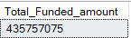
MTD Funded Amount
SELECT SUM(loan_amount) AS MTD_Funded_amount FROM dbo.bank_loan_data WHERE MONTH(issue_date) = 12 AND YEAR(issue_date) = 2021;
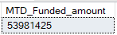
PMTD Funded Amount
SELECT SUM(loan_amount) AS PMTD_Funded_amount FROM dbo.bank_loan_data WHERE MONTH(issue_date) = 11 AND YEAR(issue_date) = 2021;
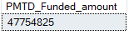

Total Amount Received
SELECT SUM(total_payment) AS Total_Amount_received FROM dbo.bank_loan_data;
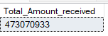
MTD Amount Received
SELECT SUM(total_payment) AS MTD_Amount_received FROM dbo.bank_loan_data WHERE MONTH(issue_date) = 12 AND YEAR(issue_date) = 2021;
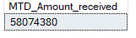
PMTD Amount Received
SELECT SUM(total_payment) AS PMTD_Amount_received FROM dbo.bank_loan_data WHERE MONTH(issue_date) = 11 AND YEAR(issue_date) = 2021;
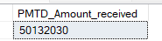
Average Interest Rate
SELECT AVG(int_rate)*100 AS Avg_interest_rate FROM dbo.bank_loan_data;
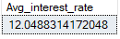
MTD Average Interest rate
SELECT AVG(int_rate)*100 AS MTD_avg_interest_rate FROM dbo.bank_loan_data WHERE MONTH(issue_date) = 12 AND YEAR(issue_date) = 2021;
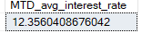
PMTD Average interest rate
SELECT AVG(int_rate)*100 AS PMTD_avg_interest_rate FROM dbo.bank_loan_data WHERE MONTH(issue_date) = 11 AND YEAR(issue_date) = 2021;
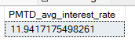

Average DTI
SELECT AVG(dti)*100 AS Avg_DTI FROM dbo.bank_loan_data;
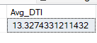
MTD Average DTI
SELECT AVG(dti)*100 AS AVG_DTI FROM dbo.bank_loan_data
WHERE MONTH(issue_date) = 12 AND YEAR(issue_date) = 2021;
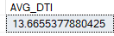
PMTD Average DTI
SELECT AVG(dti)*100 AS PMTD_AVG_DTI FROM dbo.bank_loan_data
WHERE MONTH(issue_date) = 11 AND YEAR(issue_date) = 2021;
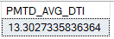

Good Loan Issued
Good Loan Percentage
SELECT
(COUNT(CASE WHEN loan_status = 'Fully Paid' OR loan_status = 'Current' THEN id END)*100)
/ COUNT(id) AS Good_loan_percentage FROM dbo.bank_loan_data;
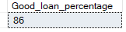
Good Loan Applications
SELECT COUNT(*) FROM dbo.bank_loan_data WHERE loan_status = 'Fully Paid' OR loan_status = 'Current';
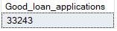
Good Loan Funded Amount
SELECT SUM(loan_amount) AS Good_Loan_Funded_Amount FROM dbo.bank_loan_data WHERE loan_status = 'Fully Paid' OR loan_status = 'Current';
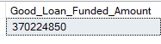
Good Loan Amount Received
SELECT SUM(total_payment) AS Good_loan_amount_received FROM dbo.bank_loan_data WHERE loan_status = 'Fully Paid' OR loan_status = 'Current';
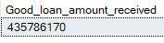
Bad Loan Issued
Bad Loan Percentage
SELECT
(COUNT(CASE WHEN loan_status = 'Charged off' THEN id END)*100)
/ COUNT(id) AS Bad_loan_percentage FROM dbo.bank_loan_data
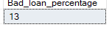
Bad Loan Applications
SELECT COUNT(id) AS Bad_loan_applications FROM dbo.bank_loan_data
WHERE loan_status = 'Charged off';
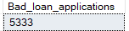
Bad Loan Funded Amount
SELECT SUM(loan_amount) AS Bad_loan_funded_amount FROM dbo.bank_loan_data WHERE loan_status = 'Charged off';
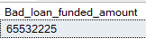
Bad Loan Amount Received
SELECT SUM(total_payment) AS Bad_loan_amount_received FROM dbo.bank_loan_data WHERE loan_status = 'Charged off';
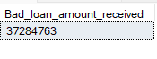

Loan Status
SELECT
loan_status,
COUNT(id) AS Total_Loan_Applications,
SUM(total_payment) AS Total_Amount_Received,
SUM(loan_amount) AS Total_Funded_Amount,
AVG(int_rate * 100) AS Interest_Rate,
AVG(dti * 100) AS DTI FROM dbo.bank_loan_data
GROUP BY loan_status;
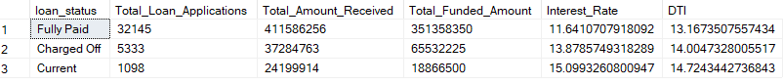

MTD Details
SELECT
loan_status,
SUM(total_payment) AS MTD_Total_Amount_Received,
SUM(loan_amount) AS MTD_Total_Funded_Amount
FROM dbo.bank_loan_data WHERE MONTH(issue_date) = 12 AND YEAR(issue_date) = 2021 GROUP BY loan_status;
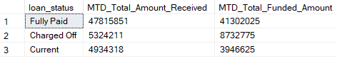

- BANK LOAN REPORT | OVERVIEW
MONTH
SELECT
MONTH(issue_date) AS Month_Number,
DATENAME(MONTH, issue_date) AS Month_Name,
COUNT(id) AS Total_Loan_Applications,
SUM(loan_amount) AS Total_Funded_Amount,
SUM(total_payment) AS Total_Amount_Received
FROM dbo.bank_loan_data
GROUP BY MONTH(issue_date), DATENAME(MONTH, issue_date)
ORDER BY MONTH(issue_date);
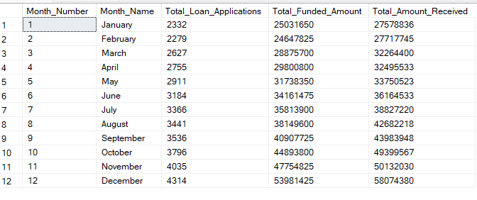

STATE
SELECT
address_state,
COUNT(id) AS Total_Loan_Applications,
SUM(loan_amount) AS Total_Funded_Amount,
SUM(total_payment) AS Total_Amount_Received
FROM dbo.bank_loan_data GROUP BY address_state ORDER BY address_state;
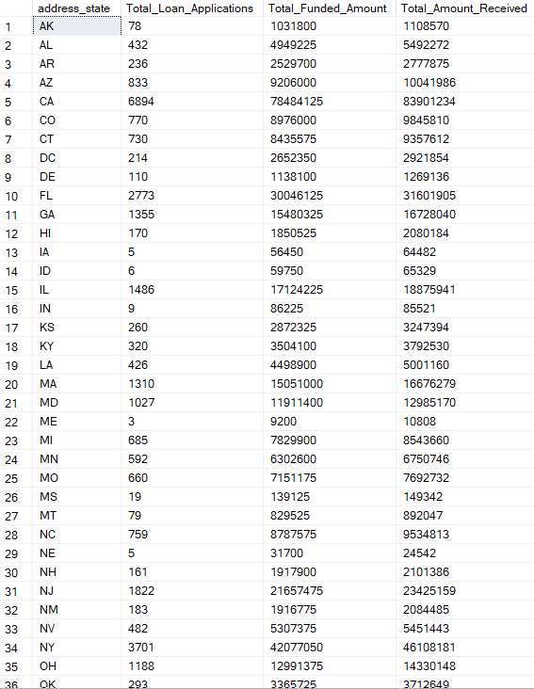

TERM
SELECT
term AS Term,
COUNT(id) AS Total_Loan_Applications,
SUM(loan_amount) AS Total_Funded_Amount,
SUM(total_payment) AS Total_Amount_Received
FROM dbo.bank_loan_data GROUP BY term ORDER BY term;
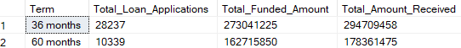
Employee Length
SELECT
emp_length AS Employee_Length,
COUNT(id) AS Total_Loan_Applications,
SUM(loan_amount) AS Total_Funded_Amount,
SUM(total_payment) AS Total_Amount_Received
FROM dbo.bank_loan_data GROUP BY emp_length ORDER BY emp_length;
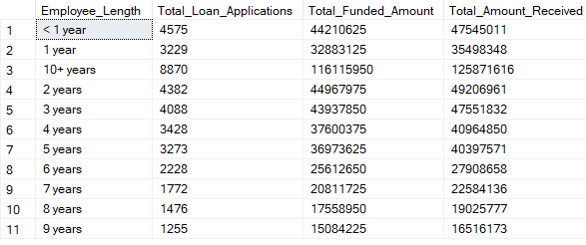
PURPOSE
SELECT
purpose AS Purpose,
COUNT(id) AS Total_Loan_Applications,
SUM(loan_amount) AS Total_Funded_Amount,
SUM(total_payment) AS Total_Amount_Received
FROM dbo.bank_loan_data GROUP BY purpose ORDER BY purpose;

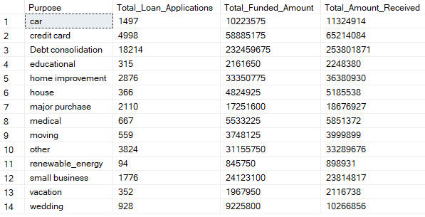
Home Ownership
SELECT
home_ownership AS Home_Ownership,
COUNT(id) AS Total_Loan_Applications,
SUM(loan_amount) AS Total_Funded_Amount,
SUM(total_payment) AS Total_Amount_Received
FROM dbo.bank_loan_data GROUP BY home_ownership ORDER BY home_ownership;
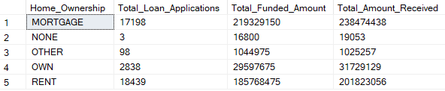

Note: We have applied multiple Filters on all the dashboards. You can check the results for the filters as well by modifying the query and comparing the results.
For e.g
See the results when we hit the Grade A in the filters for dashboards.
SELECT
purpose AS PURPOSE,
COUNT(id) AS Total_Loan_Applications,
SUM(loan_amount) AS Total_Funded_Amount,
SUM(total_payment) AS Total_Amount_Received
FROM bank_loan_data
WHERE grade = 'A'
GROUP BY purpose
ORDER BY purpose

