Assignment 6.

Advanced JavaScript and DOM Manipulation

**Members:** Asanali, Askhat, Asylkhan

Group: SE-2416

**Part 1. Advanced JS**

**1. DOM Manipulation and Styling**

**Selecting and Manipulating HTML Elements**

Used document.querySelectorAll to select rating stars (e.g., icons). Allowed users to click on a star to set their rating, changing its color to indicate selection.

"Read More" toggle: Each blog card has a hidden extra content paragraph and a button. The button toggles visibility and updates its text.(textContent/innerText)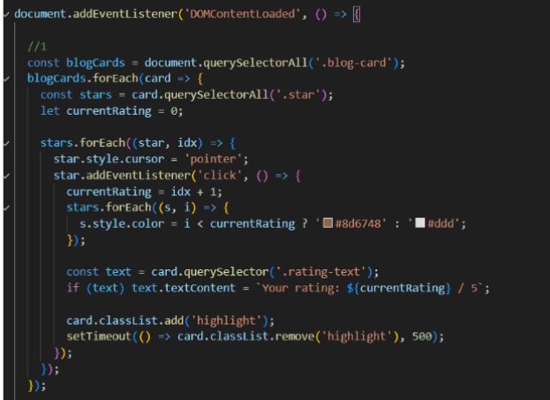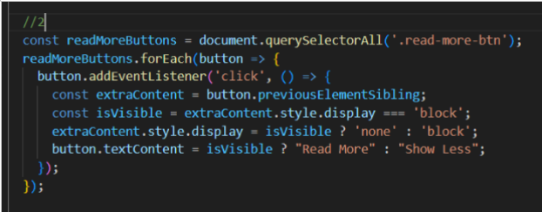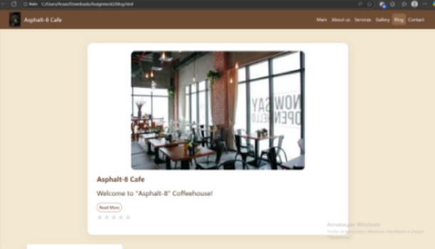

**Dynamic Style Changes**

Created a functional switch to toggle between Day and Night themes.

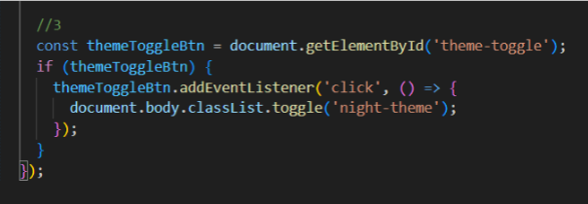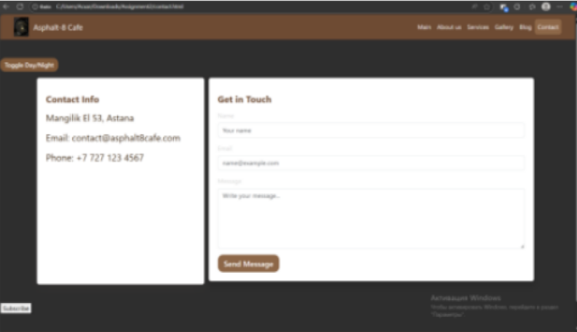

**Manipulating Attributes**

Used document.querySelectorAll to select rating stars (e.g., icons). Allowed users to click on a star to set their rating, changing its color to indicate selection.

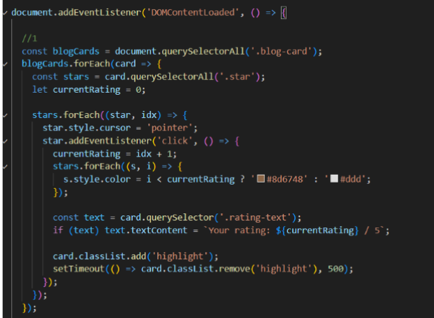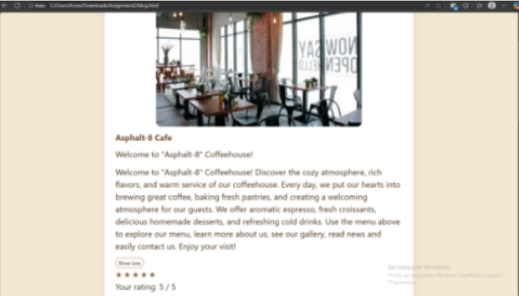

**2. Event Handling**

**Event Listeners on Buttons**

Added a button with a click event listener that displays the current time using new Date().toLocaleTimeString() in a styled output area

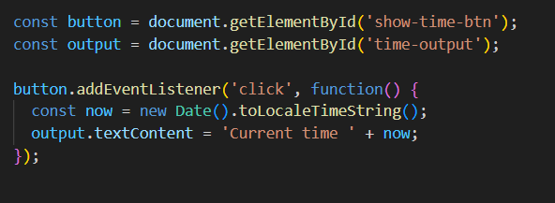



**Keyboard Event Handling**

Enabled arrow key navigation in the sidebar using the keydown event. Arrow keys move the highlight; pressing Enter activates the selected link by updating window.location.href

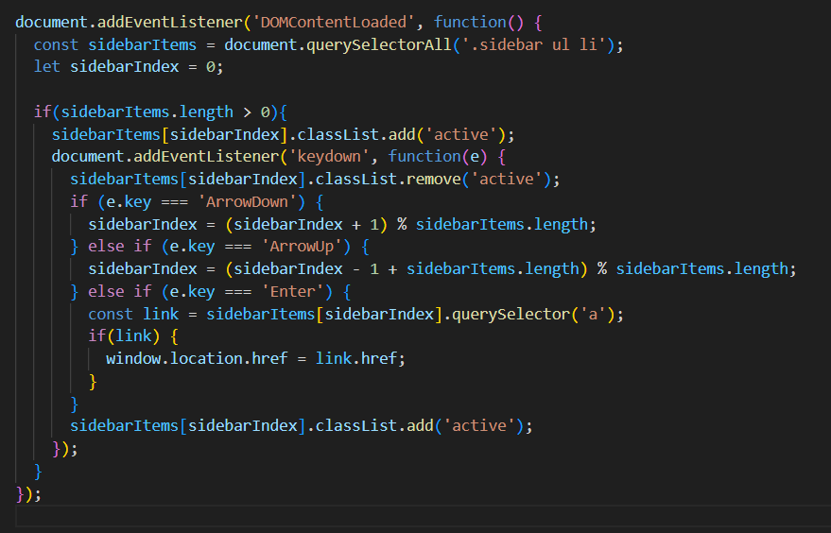

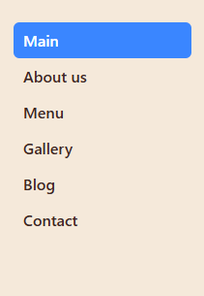

**4. Structure and Separation of Concerns**

**Separation of HTML, CSS, and JavaScript**

Ensured that the structure (HTML), style (CSS), and behavior (JavaScript) are clearly separated.

**Clean Code and Readability**

Writed well-organized, readable code.

**Proper Use of Functions and Variables**

We chosed meaningful variable names.

**5.Creativity and Engagement**

**Theme Integration**

The project reflects our team’s theme and be relevant to it.

**User Experience**

Ensured the project is easy to use and intuitive for the user.

**Fun and Interactivity**

Added fun or engaging elements, such as sounds, animations, or interactive content that encourage user engagement.

In this update, the Café Asphalt-8 website was improved with several new features. A language selector was added using a switch statement to let users change the site language between English, Russian, and Kazakh. A callback function was implemented for the contact form, allowing data submission with asynchronous fetch and displaying a success message without reloading the page.

The design was enhanced with a responsive layout, accordion animation, and media queries that change background color and layout on phones. These additions improve usability, interactivity, and overall user experience across devices.

<https://github.com/Askhat111/WEB_5Assignment>