

Analysis of Algorithms

Development of an Optimization Algorithm to Solve

2-TSP Problem

Yusuf İbrahim Matur

Mehmet Efe Selamet

Aşın Yavuz Tuna

1. Problem:

Travelling Salesman Problem (a.k.a TSP) is a popular optimization problem where a salesman is to visit all cities exactly once to find the shortest route between these set of cities that must be visited. It’s known to be in the category of NP-Hard problems, which is considered that there are no solutions in polynomial time.There are many variations of TSP problem that are solved by different optimization methods.One of the variations of TSP is called mTSP, where there are multiple number of salesmans that are supposed to visit a set of cities. In this study, for given sets of cities with different densities, an algorithm for approaching the optimal solution of mTSP problem where m=2 (for 2 salesmans) is developed.

1. Method

There are 2 methods developed for solving 2-TSP problem:

1. K-Means + Nearest Neighbors + 2-OPT Method
2. AYTUNA Method

2.a. K-Means + Nearest Neighbors + 2-OPT Method

2.a.1 K-Means Clustering Algorithm

K-means algorithm is used as an iterative clustering algorithm. It takes the distance as the measurement standard, gives the K clusters in the data set, calculates the average value of the distance, and then gives the initial centroid. Each cluster is described by the centroid [4]. The goal is to form the disjoint groups of n data points {x1,x2,…,xn} into k < n sets{S1,S2,…,Sk} to minimize the total average value (including the square distance from the point to the centroid). [https://www.javatpoint.com/k-means-clustering-algorithm-in-machine-learning]

2.a.2. Nearest Neighbors Algorithm

This algorithm was the first strategy that has been introduced and used for solving the TSP problem [15]. It starts with a randomly chosen city and repeatedly adds the closest unvisited city to the last city in the tour until all the cities have been visited [16]. The steps of the nearest-neighbour algorithm are given as: Step1: Randomly pick the initial city. Step2: Find the closest unvisited city and add to the current tour. Step3: Is the cardinality of the unvisited cities is ? If not, repeat Step2, otherwise go to Step4. Step4: Terminate the algorithm. Since the tours quality might depend on the starting city chooses, a better result can be obtained by repeating the procedures for different starting city [A COMPARATIVE STUDY BETWEEN THE NEAREST-NEIGHBOUR ALGORITHM AND ITS VARIANTS FOR SOLVING THE EUCLIDEAN TRAVELING SALESMAN PROBLEM Lilysuriazna Raya1 , Safaa Najah Saud2 1,2Faculty of Information Sciences and Engineering, Management & Science University, 40100 Shah Alam, Malaysia]

2.a.3. 2-OPT Algorithm

In optimization, the 2-opt algorithm is a straightforward local search method for addressing the traveling salesman problem (TSP). Originally introduced by Croes in 1958, with the underlying concept previously suggested by Flood, the 2-opt technique aims to improve an existing route by eliminating self-crossings. The core idea is to take segments of the tour that intersect and rearrange them to form a shorter, non-crossing path. A thorough 2-opt local search involves evaluating every feasible pair of edges and performing the swap if it results in a shorter tour. This method is not only applicable to the TSP but also extends to various related problems, such as the vehicle routing problem (VRP) and its capacitated version, with slight adjustments to accommodate specific constraints.

2.b. AYTUNA Method

1. Put first 3 point to arraylist.
2. Check between which points new point should be putted then put it between them.
3. Do this for every element

Put first 3 point to arraylist

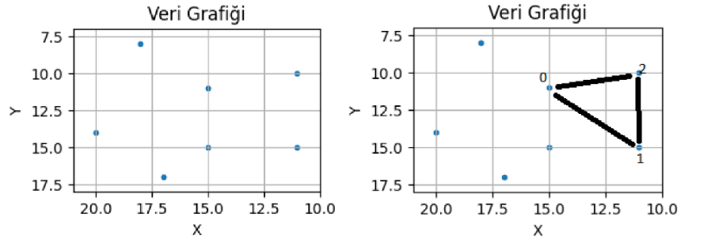

Check between which points new point should be putted

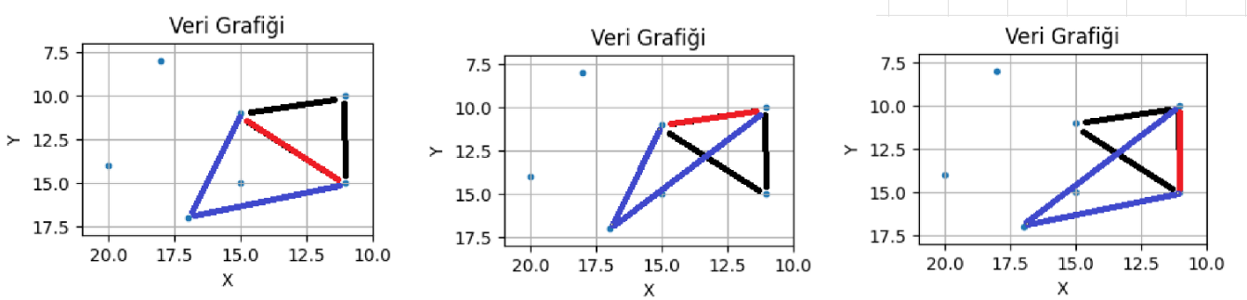

Pick the most optimal connection for the new point

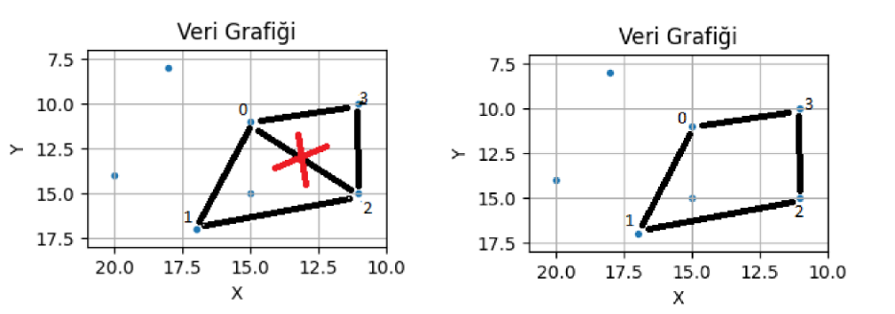

3.Tests

3 Test cases with different city numbers are used.

|  |  |  |
| --- | --- | --- |
| 318 cities | K Means + Nearest Neighbors  Distance: | K-Means_Nearest Neigbors_2-OPT  Distance: |

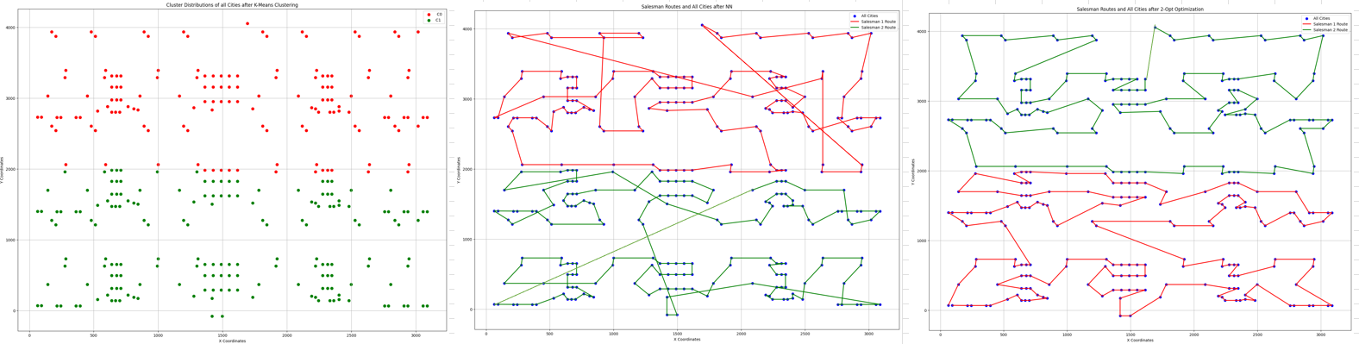

Second Test Case: 984 Cities

Method: K Means + Nearest Neigbors + 2-OPT

|  |  |  |
| --- | --- | --- |
| 984 cities | K Means + Nearest Neighbors  Distance: | K Means + Nearest Neigbours + 2Opt  Distance: |

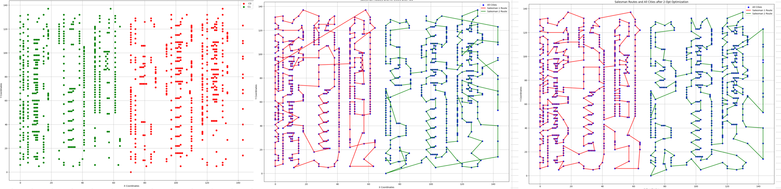

Fourth Test Case: 50000 Cities

Method: AYTUNA

|  |  |
| --- | --- |
| 50000 Cities | AYTUNA  Distance: 3820356 |

