All the assets you create must be placed in the appropriate folder. Scripts -> “Scripts”, Sprites -> “Sprites”, etc.

To make a level (NOTE: use sLevel3_1 as a guide here):

-Make sure you have a proper editor resolution/aspect ratio. Go to “Game” and select 16:9. Currently 4:3 also works, but 16:9 is better for development

-Make a new scene. Delete everything from it.

-Save it as “sLevel<stageNumber>_<levelNumber>” in “Levels” folder. Eg: “sLevel3_1”

-Put a camera prefab (Objects->Utils->Camera) into the scene hierarchy. Do not change its coordinates

-Every time you put a prefab on the scene make sure its coordinates are the multiples of 16 (eg: 0,16,32,48,64, etc) (basically they must be aligned on a 16-unit grid). To make that easier, set the snapping settings “Edit->Snap settings” as follows:

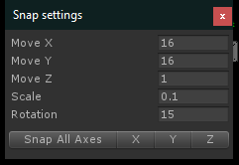

-For your own stage you MUST use the associated blocks from “Objects->Blocks->Stage<stageNumber>” that are named like “Block<stage_number>_<block_number”. Eg “Block3_9”.

-DO NOT make the actual sprites. I got them. Use the placeholders if you have to

-DO NOT place “Player” object onto the scene. Use “PlayerStart”.

-Warps by default will transition you to the next scene (use them at the end of each level)

-Use savepoints when needed (see sLevel3_1)

-When you play test, you must select sInit and only then press the play button. The game has to do initialization first

-Remember to add you scenes into the “File->Build Settings”, so level transitions work properly (sInit has to remain the first in the list)

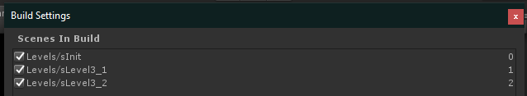

-Do not changes existing prefabs/scripts/sprites etc UNLESS you really have to

I suggest Luke make the first stage. Stage difficulty has to be easier than stage 3. The appropriate gimmick, I think, would be a triple jump OR jump refreshers (you pick them up – you can jump again in the midair, they respawn after some delay). Better if it uses both. That would get player to know the controls

Colin then can make a second stage. You can choose any gimmick out of the following list: Teleports/teleportation, gravity/screen flips, collectables to unlock the gate that blocks the warp, lights out (when you leave the savepoint the screen starts to dim)

Currently I’m working on stage 3 (also music/sound system and boss fight) which will use destructible blocks. If you guys finish your stages by Jan 5 (I really hope so), then I can finish the last stage (the hardest one in terms of difficulty) before the end of the break.

To import your own sprites (only placeholders):

-Make sure their size is a multiple of 16 (eg 32x32, 48x64)

-Select the sprite in the project view and set the settings as follows:

(pivot can be either of “Top Left” or “Center”)

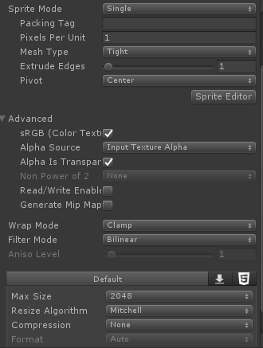

MOST IMPORTANT NOTE EVER: If the games gets stuck/doesn’t load/etc:

1. Make sure you are starting it from sInit
2. Delete the save file in project folder (literally called “save”)

Debug hotkeys:

S – Save at the players point

PgUp – Go to the next level

PgDn – Go to the previous level

Ctrl – teleport to where the mouse cursor is