ASTANA IT UNIVERSITY / COMPUTER GRAPHICS FUNDAMENTALS

Room interior with lamps
Topic 16 • Final project report • Academic year 2026–2027
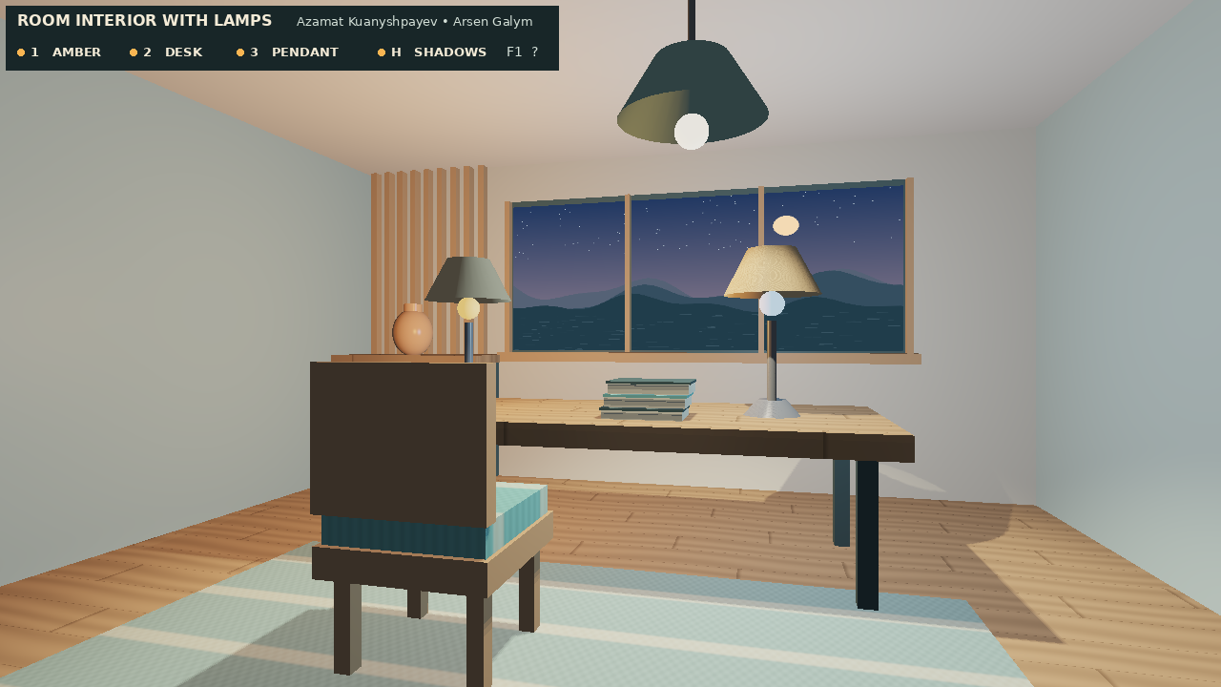
Figure 1. Starting view from the final executable.
Azamat Kuanyshpayev · IT-2514
Arsen Galym · IT-2510
Instructor Kamila Batkuldinova
Report date 6 November 2026

Contents
2 Introduction and project description
3 Literature review and background
4 Technical implementation
5 Graphics and rendering
6 Testing, evaluation and future work
7 Feature checklist, controls and contributions
8–9 References and asset credits

1 Introduction and project description
A desk lamp gives two distinct visual cues. Its bulb can glow, and its light can change what we see on the desk. This walkthrough separates the two effects so that each can be inspected. Switching off the amber lamp, for example, removes warm light from the wood and extinguishes its bulb while the cool desk lamp continues to illuminate the same surface. Figure 1 shows the starting view with all three fixtures enabled.

Objective
Build an explorable furnished room in which the user can identify each light by its effect on nearby surfaces, move the pendant and compare shadows from a fixed viewpoint.

Problem statement
Furniture beneath a lamp should block some of its light. A fragment that faces the source can still be hidden behind a chair or a desk. A local Phong calculation alone sees the surface normal and the light direction but has no information about objects between them. The renderer therefore calculates visibility from the pendant before shading the camera view.

Scope and midterm baseline
The Week 5 project supplied a C++ OpenGL window, a camera, procedural primitives, two desk fixtures, a cabinet and a checker pattern. The final version adds a furnished reading area, an illustrated dusk window, wood and fabric patterns, a movable third fixture, a depth map, an exposure control and an on-screen key guide. The walkthrough has no game score. Reproducing a lighting condition is its main interaction.
Only the pendant casts shadows. The two desk lamps use unshadowed point-light approximations. The window presents a fixed view and the ambient term approximates indirect illumination. These choices keep the lighting contribution of each fixture easy to isolate.

2 Literature review and background

Surface appearance
Phong (1975) makes the camera direction relevant to a highlight. This is visible on the cabinet vase when the camera turns. Cook and Torrance (1982) give a more physical account of reflection from rough surfaces. Our smaller model uses a shininess exponent and a separate specular weight to distinguish glazed ceramic from cloth. Blinn and Newell (1976) describe how texture and reflection can add detail to simple geometry. Here a sampled image supplies the landscape, while procedural patterns distinguish the wood and upholstery.

Light visibility and sampling
Whitted (1980) treats visibility as a separate light-transport question. Our forward renderer asks a narrower version of that question using stored depths. Scherzer et al. (2011) survey shadow-map sampling, depth precision and filtering. A 3 × 3 neighborhood softens our shadow boundary, although it still represents one light viewpoint. Hasenfratz et al. (2003) explain how extended sources create penumbrae. Yang et al. (2020) describe temporal antialiasing across frames. Our filter uses only neighboring texels from the current frame, which makes a paused comparison reproducible.

From scene intensity to display
Reinhard et al. (2002) motivate compressing a large range of scene intensities into display values. Durand and Dorsey (2002) preserve detail by separating image scales, while Fattal et al. (2002) compress gradients. The room uses a simpler global curve so the same incoming value maps to the same display value anywhere on the desk. A fixed exposure also lets users attribute a visible change to the lamp they switched.
Ward Larson et al. (1997) consider which contrasts remain visible on a display. Mantiuk et al. (2008) adapt tone mapping to display conditions, and Reinhard et al. (2012) address calibrated appearance. Aydın et al. (2008) distinguish contrast changes in images with different dynamic ranges. These studies motivate pairing images from the same camera rather than treating one image’s average brightness as a visual-quality score. Eilertsen et al. (2017) show why changes over time matter for HDR video. We leave exposure under manual control to avoid automatic brightness adaptation during a lamp toggle.

3 Technical implementation

Tools and development process
C++20 and CMake build the program. GLFW 3.5.1 creates the window and supplies input, GLAD loads OpenGL entry points, and GLM handles vectors and matrices. GLSL 330 source is loaded from files. The two changesets begin at the uploaded Week 5 Git revision d6688cc. The first extends the renderer. The second adds the interior, textures, bounded camera, help overlay and integration documentation.
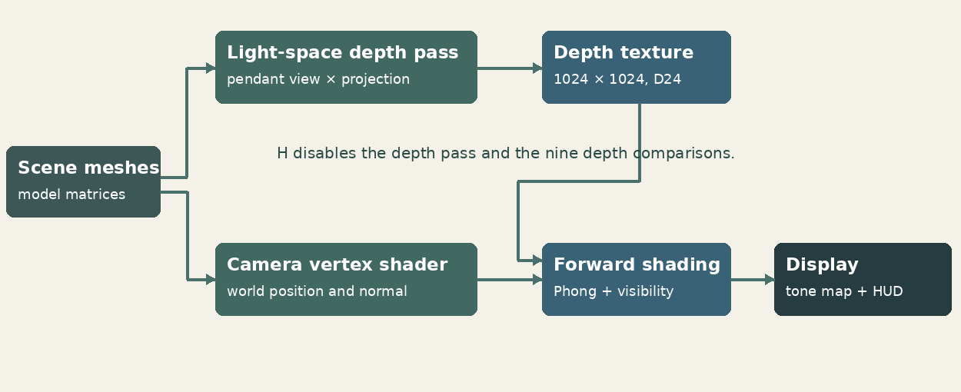
Figure 2. The pendant and camera use the same scene transforms.
Figure 2 shows where the two passes meet. First, the pendant renders scene depth into a 1024 × 1024 D24 texture. A 120° perspective frustum looks straight down with near and far distances of 0.1 and 10 scene units. The pendant bulb is omitted from its own depth pass. Next, camera-space triangles are rasterized to the window. The fragment shader looks up the depth map only for the pendant contribution.

Transforms and scene organization
For each vertex, clip position = projection × view × model × local position. Normals use the inverse transpose of the model matrix, which preserves their direction after nonuniform scaling. The room reuses indexed cube, cylinder, frustum and sphere meshes. DrawInterior places the same furniture in both passes. Back-face culling is active for closed geometry. Open shades are drawn from both sides, and the final screen overlay is drawn without depth testing.

4 Graphics and rendering

Lighting, materials and the actual equation
For light i, let N be the unit normal, Lᵢ the direction from the surface to the lamp, V the direction to the eye, Rᵢ = reflect(−Lᵢ, N), and dᵢ the light distance. All vectors are evaluated in world space. The fragment shader uses the following componentwise sum.
C = ambient × base + emission + Σᵢ Iᵢ × lightColorᵢ × wᵢ × (base × Dᵢ + kₛ × Sᵢ) / (1 + 0.10dᵢ + 0.032dᵢ²)
Dᵢ = max(N · Lᵢ, 0). When Dᵢ > 0, Sᵢ = max(Rᵢ · V, 0)ˢ. Otherwise Sᵢ = 0.
The two desk lamps use wᵢ = 1. For the pendant, wᵢ is a smooth cone falloff multiplied by the mean of nine depth comparisons. A tap is lit when receiver depth minus bias is at most the stored depth. Bias is max(0.00018, 0.0012 × (1 − N · L)). Moving the lamp updates both its mesh and its light-view matrix. Pressing H sets visibility to one and skips the entire depth pass.
The vase uses shininess 84 and specular weight 0.60. Fabric uses exponent 22 and weight 0.045. After adding emission, each channel x = exposure × C is displayed as (x / (1 + x))^(1/2.2). Exposure ranges from 0.25 to 3.0.

Textures and motion
The floor and desk use world-space plank seams and sinusoidal wood grain. Woven stripes are computed on the rug and upholstery. The window samples a project-authored RGB landscape. Space starts or pauses a linear pendant sweep between x = −2.3 and +2.3. J and L allow direct movement. The depth map is regenerated at the current light position.
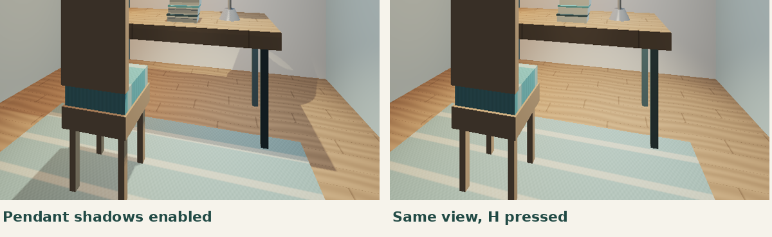
Figure 3. The pendant shadow is visible beneath the desk and chair.
Figure 3 isolates visibility by holding lamp intensities, geometry, camera and exposure fixed.

5 Testing, evaluation and future work
The final C++ scene, shader loader, mesh code and GLSL programs ran against Mesa 25.2.8 llvmpipe through an EGL core-profile context. A test adapter supplied framebuffer size and scripted GLFW inputs and read pixels from the application. This tests the renderer and input logic. Native GLFW window creation and physical input on the Windows lab PC remain a separate acceptance check.
Test | Observed result
Lamp sequence 1, 2, 3 | After each switch, mean RGB channel level outside the top 80 rows fell from 143.9 to 124.4, 76.6 and 57.4 on a 0–255 scale.
H from the reset view | 98,944 scene pixels changed by more than five levels in at least one channel. The fixture remained on.
R after all lamps were off | The scene pixels matched the original capture exactly.
Both stages / graphics errors | Both changesets compiled and ran. The final depth FBO and shader programs initialized, and captured frames returned GL_NO_ERROR.

Performance at the target resolution
At 1280 × 720, the camera and all three lamp settings were held fixed. Each run warmed up for 15 frames, then timed 80 frames with glFinish after each draw. These are whole-frame timings for the software renderer; the recording and image readback were disabled.
Mode | Time / 80 frames | Mean frame | FPS
Shadows on | 0.996 s | 12.45 ms | 80.3
Shadows off | 0.785 s | 9.81 ms | 101.9

In these runs the shadow pass and filtering added about 2.64 ms per frame. The depth image stores 1,048,576 samples, nominally 3 MiB at 24 bits before driver padding. Total GPU memory was not measured.

Debugging, conclusions and future work
With a depth map, comparing an unadjusted receiver depth can cause self-shadowing. A small slope-dependent bias reduces this error. A larger bias risks detaching a shadow from its caster. We also omit the pendant emitter from the depth map to keep it from blocking its own light. Next, compare these timings on the lab GPU and add separate shadow maps for the desk lamps if the frame budget permits.

6 Checklist, controls and contributions
Topic 16 must-implement item | Status and evidence
Furnished room the camera can walk or orbit through (desk, chair, window or door, floor, ceiling). | Done. WASD walkthrough of the furnished room in Figure 1.
At least three lamps / light fixtures that can be toggled and that actually light the room (point / spot / area approximation). | Done. Two point lights and one downward spotlight, keys 1–3.
Material variety: dielectric wood/fabric plus at least one glossy or emissive surface. | Done. Wood grain, woven cloth, glazed vase and emissive bulbs.
Shadows from at least one lamp (shadow map or other documented method). | Done. Pendant depth map and 3 × 3 visibility filter in Figure 3.
Tone mapping or exposure control so turning lamps on/off is visible and not clipped. | Done. Global tone curve and adjustable exposure.

Controls and best shot
R restores Figure 1. Use WASD to walk, mouse to look, wheel to zoom, and 1 / 2 / 3 to toggle amber / cool / pendant. Press H to compare shadows. J / L move the pendant, Space starts or pauses its travel, − / = adjust exposure, F1 opens help, and Esc exits. For the clearest shadow comparison, press R, switch off both desk lamps, leave 3 on, and press H while watching the rug under the desk.
Assigned ownership | Modules and defence responsibilities
Azamat Kuanyshpayev · IT-2514 | Initialization, shader loading, MVP, materials, Phong light calculation, pendant motion, exposure and shadow pass.
Arsen Galym · IT-2510 | Room and lamp geometry, furniture, window and surface textures, collision bounds, camera, controls and HUD.
Both members | Git integration, testing, report, slides and final demonstration. Both should be able to explain the depth comparison.

Repository: https://github.com/Askomm/OpenGLRoom
Backup video: Room_Demo.mp4 (60 seconds). Instructor-accessible YouTube or Google Drive URL: [insert after upload].

7 References
Aydın, T. O., Mantiuk, R., Myszkowski, K., & Seidel, H.-P. (2008). Dynamic range independent image quality assessment. ACM Transactions on Graphics, 27(3), Article 69. https://resources.mpi-inf.mpg.de/hdr/vis_metric/
Blinn, J. F., & Newell, M. E. (1976). Texture and reflection in computer generated images. Communications of the ACM, 19(10), 542–547. https://doi.org/10.1145/360349.360353
Cook, R. L., & Torrance, K. E. (1982). A reflectance model for computer graphics. ACM Transactions on Graphics, 1(1), 7–24. https://doi.org/10.1145/357290.357293
Durand, F., & Dorsey, J. (2002). Fast bilateral filtering for the display of high-dynamic-range images. ACM Transactions on Graphics, 21(3), 257–266. https://doi.org/10.1145/566654.566574
Eilertsen, G., Mantiuk, R. K., & Unger, J. (2017). A comparative review of tone-mapping algorithms for high dynamic range video. Computer Graphics Forum, 36(2), 565–592. https://doi.org/10.1111/cgf.13148
Fattal, R., Lischinski, D., & Werman, M. (2002). Gradient domain high dynamic range compression. ACM Transactions on Graphics, 21(3), 249–256. https://doi.org/10.1145/566654.566573
Hasenfratz, J.-M., Lapierre, M., Holzschuch, N., & Sillion, F. (2003). A survey of real-time soft shadows algorithms. Computer Graphics Forum, 22(4), 753–774. https://doi.org/10.1111/j.1467-8659.2003.00722.x
Mantiuk, R., Daly, S., & Kerofsky, L. (2008). Display adaptive tone mapping. ACM Transactions on Graphics, 27(3), Article 68. https://doi.org/10.1145/1360612.1360667

References and asset credits
Phong, B. T. (1975). Illumination for computer generated pictures. Communications of the ACM, 18(6), 311–317. https://doi.org/10.1145/360825.360839
Reinhard, E., Pouli, T., Kunkel, T., Long, B., Ballestad, A., & Damberg, G. (2012). Calibrated image appearance reproduction. ACM Transactions on Graphics, 31(6), Article 201. https://doi.org/10.1145/2366145.2366220
Reinhard, E., Stark, M., Shirley, P., & Ferwerda, J. (2002). Photographic tone reproduction for digital images. ACM Transactions on Graphics, 21(3), 267–276. https://doi.org/10.1145/566654.566575
Scherzer, D., Wimmer, M., & Purgathofer, W. (2011). A survey of real-time hard shadow mapping methods. Computer Graphics Forum, 30(1), 169–186. https://doi.org/10.1111/j.1467-8659.2010.01841.x
Ward Larson, G., Rushmeier, H., & Piatko, C. (1997). A visibility matching tone reproduction operator for high dynamic range scenes. IEEE Transactions on Visualization and Computer Graphics, 3(4), 291–306. https://doi.org/10.1109/2945.646233
Whitted, T. (1980). An improved illumination model for shaded display. Communications of the ACM, 23(6), 343–349. https://doi.org/10.1145/358876.358882
Yang, L., Liu, S., & Salvi, M. (2020). A survey of temporal antialiasing techniques. Computer Graphics Forum, 39(2), 607–621. https://doi.org/10.1111/cgf.14018

Implementation and asset sources
The starting source is the team’s OpenGLRoom Week 5 repository (revision d6688cc). The midterm report cites J. de Vries, LearnOpenGL (https://learnopengl.com). The existing project bundles GLFW (zlib/libpng, https://www.glfw.org/license), GLM (MIT, https://github.com/g-truc/glm) and GLAD (https://github.com/Dav1dde/glad).
All room meshes, the dusk landscape and surface patterns are project-generated. The status and help panels rasterize DejaVu Sans; its redistribution notice is included in textures/FONT-LICENSE.txt (https://dejavu-fonts.github.io/License.html). All report screenshots were captured from the final renderer.
AI assistance: OpenAI Codex was used to draft substantial C++ and GLSL additions, including the pendant depth pass, PCF visibility calculation, interior and test adapter, and to prepare documentation and defence materials. The module table identifies the responsibilities assigned to each teammate.

