(2nd program)
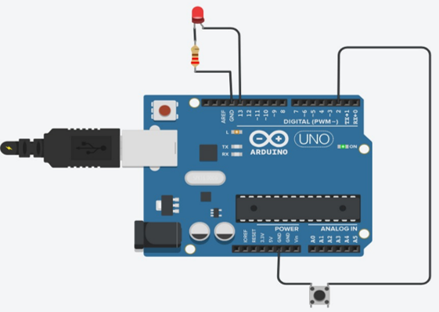
int buttonPin = 2;
int ledPin = 13;
bool buttonState = false;
void setup() {
pinMode(ledPin, OUTPUT);
pinMode(buttonPin, INPUT);}
void loop() {
buttonState = digitalRead(buttonPin);
if (buttonState == HIGH) {
digitalWrite(ledPin, HIGH);
} else {
digitalWrite(ledPin, LOW); }}
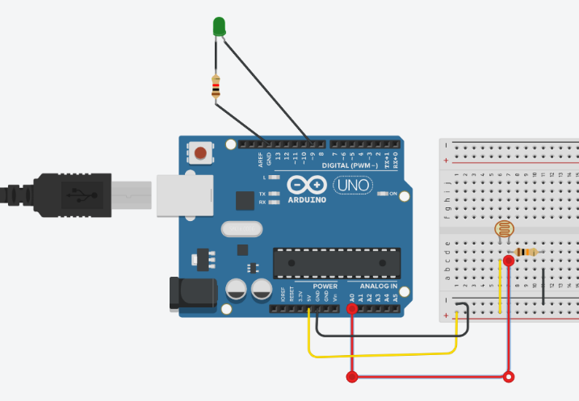
(3rd program)
const int ldrPin = A0;
const int ledPin = 9;
int ldrValue = 0;
int ledBrightness = 0;
void setup() {
Serial.begin(9600);
pinMode(ledPin, OUTPUT);}
void loop() {
ldrValue = analogRead(ldrPin);
ledBrightness = map(ldrValue, 0, 1023, 255, 0);
ledBrightness = constrain(ledBrightness, 0, 255);
analogWrite(ledPin, ledBrightness);
Serial.print("LDR Value: ");
Serial.print(ldrValue);
Serial.print(" | LED Brightness: ");
Serial.println(ledBrightness);
delay(200);
}
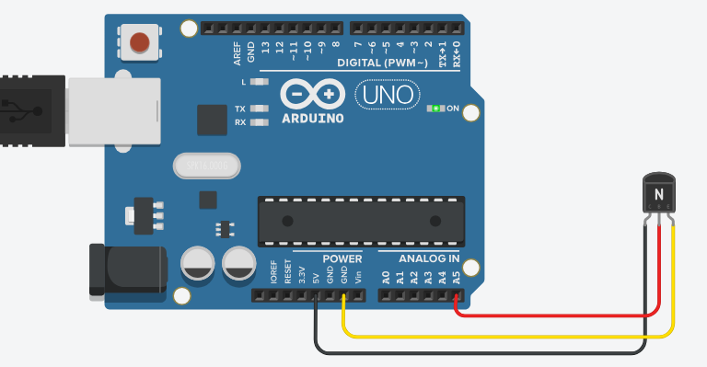
(4th program)
const int sensorPin = A0;
int sensorValue = 0;
float voltage = 0.0;
float temperatureC = 0.0;
void setup() {
Serial.begin(9600);}
void loop() {
sensorValue = analogRead(sensorPin);
voltage = sensorValue * (5.0 / 1023.0);
temperatureC = voltage * 100.0;
Serial.print("Temperature: ");
Serial.print(temperatureC);
Serial.println(" °C");
delay(1000);}
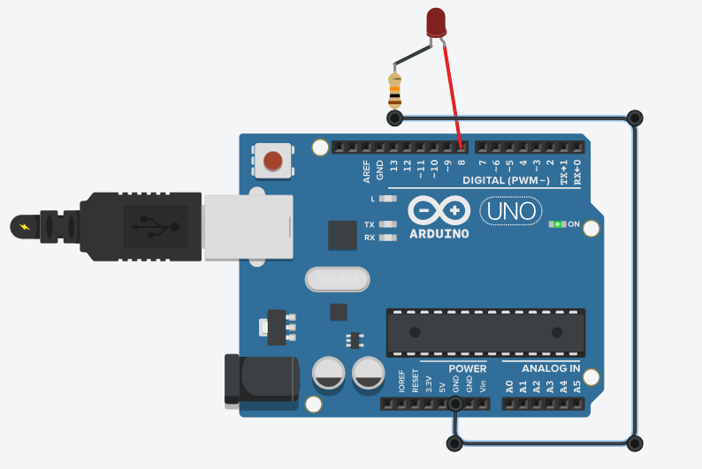
(5th program)
const int relayPin = 8;
int myCount = 1;
float myTemp = 101.0;
void setup() {
Serial.begin(9600);
pinMode(relayPin, OUTPUT);
digitalWrite(relayPin, LOW);
Serial.println("System Initialized");
Serial.println("RELAY OFF");}
void loop() {
Serial.print(myCount);
Serial.print(" Temp: ");
Serial.print(myTemp, 1);
Serial.println(" F");
if (myTemp > 100.0) {
digitalWrite(relayPin, HIGH);
Serial.println("RELAY ON");
delay(2000);
digitalWrite(relayPin, LOW);
Serial.println("RELAY OFF"); }
myCount++;
delay(5000);
}
(6th program)
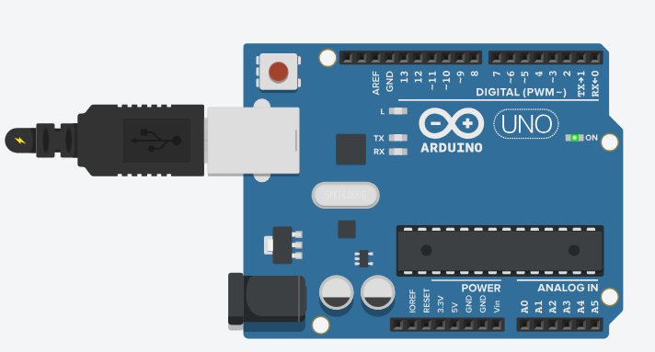
void setup() {
Serial.begin(9600);
Serial.println("System Initialized");
Serial.println("Connecting to WiFi...");
delay(1000);
Serial.println("WiFi Connected!");
Serial.println("IP Address: 192.168.1.100");}
void loop() {
Serial.println();
Serial.println("Sending HTTPS GET request...");
Serial.println("URL: https://api.quotable.io/random");
delay(500);
Serial.println("HTTP Response Code: 200");
Serial.println("JSON data received.");
Serial.println("JSON parsed successfully.");
Serial.println();
Serial.println("----- Retrieved Information -----");
Serial.println("Quote: The future depends on what you do today.");
Serial.println("Author: Mahatma Gandhi");
Serial.println();
Serial.println("----- NTP Time -----");
Serial.println("Date: Tuesday");
Serial.println("Time: 10:30:00");
delay(5000);}
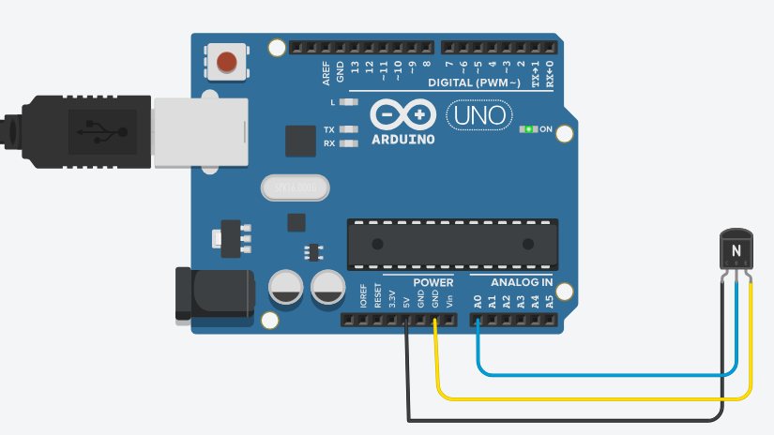
(7th program)
const int sensorPin = A0;
int sensorValue = 0;
float voltage = 0.0;
float temperatureC = 0.0;
void setup() {
Serial.begin(9600);
Serial.println("Environmental Monitoring System");
Serial.println("Temperature Sensor Initialized");
Serial.println("--------------------------------");
}
void loop() {
sensorValue = analogRead(sensorPin);
voltage = sensorValue * (5.0 / 1023.0);
temperatureC = (voltage - 0.5) * 100.0;
Serial.print("Temperature: ");
Serial.print(temperatureC, 1);
Serial.println(" C");
Serial.println("--------------------------------");
delay(2000);
}
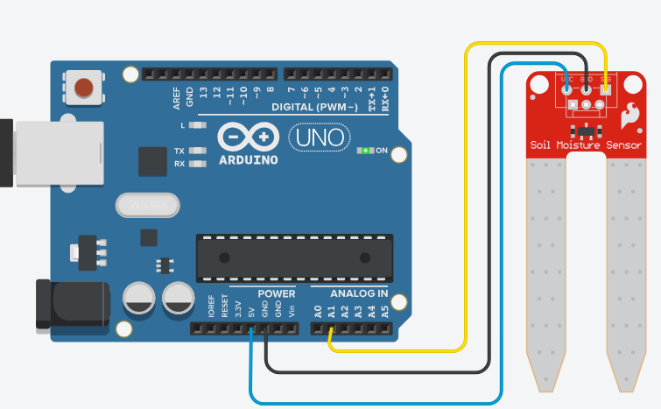
(8th program)
const int soilSensorPin = A0;
int soilValue = 0;
String moistureStatus = "";
void setup() {
Serial.begin(9600);
Serial.println("Soil Moisture Monitoring System");
Serial.println("--------------------------------");
}
void loop() {
soilValue = analogRead(soilSensorPin);
if (soilValue < 400) {
moistureStatus = "WET";
} else if (soilValue > 700) {
moistureStatus = "DRY";
} else {
moistureStatus = "OK";
}
Serial.print("Raw Sensor Value: ");
Serial.println(soilValue);
Serial.print("Soil Status: ");
Serial.println(moistureStatus);
Serial.println("--------------------------------");
delay(1000);
}

