HARAMAYA UNIVERSITY

COLLEGE OF COMPUTING AND INFORMATICS

PROJECT PROPOSAL & REQUIREMENTS SUMMARY

CCI Department-Choice Guidance System



Prepared for: ICT Center, Haramaya University
Prepared by:

- Nuri Irko
- Arafat Bule
- Burqa Jemal
- Usman Abdi
- Asledin Abdul-Qadir

Date: 8/6/2026

Introduction and Problem Statement

Every year, incoming students at the College of Computing and Informatics (CCI) at
Haramaya University must select a department from among Computer Science (CS),
Software Engineering (SWE), Information Technology (IT), and Information Systems (IS), and Information Science. This decision, made early in a student's academic life, shapes their coursework, skill development, and career direction for the following four or more years. Yet many students make this choice without a clear, department-specific understanding of what each option actually involves.
This project began from a firsthand experience: upon joining the university, one member of this team faced exactly this uncertainty, unable to find guidance specific enough to Haramaya's CCI structure. General web searches and AI tools returned only generic descriptions of these fields, not information grounded in the actual courses, career outcomes, and departmental character at this university. To verify that this was not an isolated experience, the team conducted a structured survey of current CCI students. The results, presented below, confirm that this challenge is widely shared.

Evidence Gathered: Student Survey Findings
A structured questionnaire was distributed to CCI students across departments and class years via official student communication channels. The survey received 43 valid responses, distributed as follows:

Respondent Department | Share of Respondents
Computer Science | 58.1%
Information Technology | 23.3%
Software Engineering | 18.6%
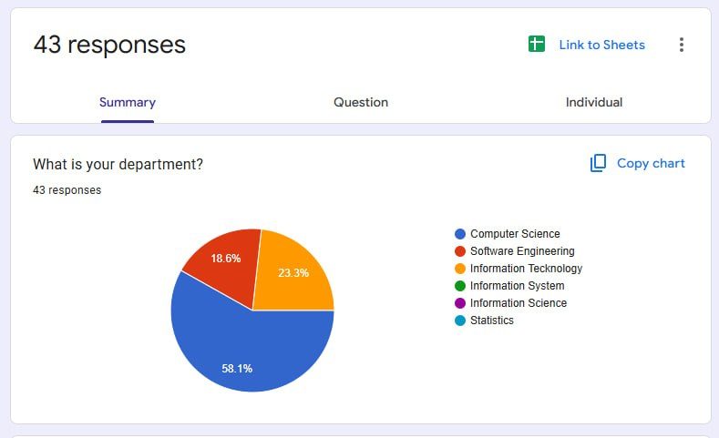

Respondents were predominantly upper-class students (46.5% third year, 39.5% fourth year, 11.6% second year, 2.3% first year), meaning most had already lived through the outcomes of their own department choice and could reflect on it meaningfully.

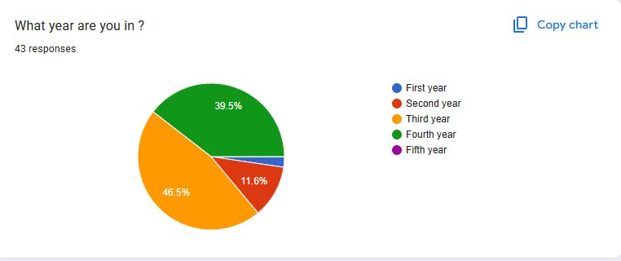

Confidence at the Time of Choosing
Only 55.8% of respondents felt fully confident they understood the differences between CS, SWE, IT, and IS before choosing their department, while 41.9% felt only “somewhat” confident and 2.3% felt not confident at all. In other words, close to half of surveyed students entered their department without a clear understanding of how it differed from the alternatives.

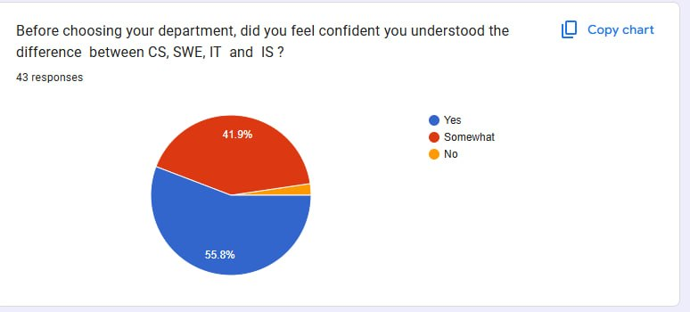

Demand for a Recommendation Tool
When asked whether they would have used a system that recommends a best-fit department based on their interests and skills, 67.4% said yes and 30.2% said maybe — meaning 97.7% of respondents were open to using such a tool, with only 2.3% opposed. This represents strong validated demand for the proposed system.

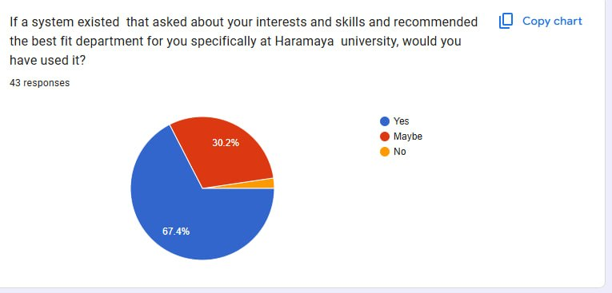

What Drives the Decision
Personal interest (65.1%) and job market considerations (39.5%) were the dominant factors students weighed when choosing a department, with family expectation (4.7%) playing a much smaller role. This directly informs the criteria the recommendation engine should weigh most heavily.
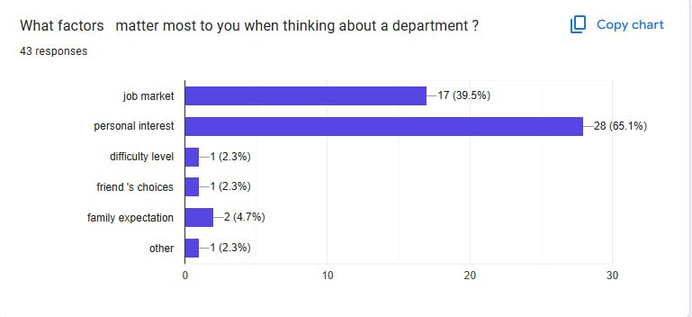
Common Themes in Open-Ended Responses
Reviewing the open-ended responses on what information students wished they had before choosing, several recurring themes emerged:
• Clearer information on career opportunities and job prospects for each department
• A clearer breakdown of the practical differences between CS and SWE specifically, which several respondents noted as the most confusing pair
• Awareness of which skills each department emphasizes, and how much practical/project work to expect versus theory
• A desire for information from current students or graduates, not just official descriptions
These themes map directly onto the functional requirements outlined in Section 4.

Department-Level Input
To ensure the system's recommendation logic reflects accurate, department-specific realities rather than assumptions, a structured questionnaire was sent to the heads of all four CCI departments. The Computer Science HOD has responded in full; responses from SWE, IT, and IS are pending and will be incorporated as they arrive. Key points from the CS HOD's response include:
• Computer Science is the oldest department in CCI, originally established under the Faculty of Business and Economics roughly two decades ago before CCI was formed; the Information Technology department later split off from what was then a combined “Computer Science and IT” unit.
• The department currently enrolls 90–100 new students per year, with 350–400 students across all batches, supported by 15 full-time instructors (2 PhD, 10 MSc, 3 graduate assistants) at roughly a 25:1 student-to-instructor ratio.
• The department's core focus is developing a problem-solving mindset through algorithmic thinking and software development, delivered across roughly 48 courses with a generally balanced mix of theory and practical work.
• Facilities include five computing labs (four active, one under construction) with 24/7 student access.
• According to the department's most recent tracer study (2016 E.C.), graduate employability exceeds 80%.
• The HOD noted that new students most commonly underestimate the department's creativity and high market demand — suggesting prospective students consistently receive an incomplete picture, which reinforces the core problem this project addresses.
The CS Department also shared its official orientation material, which will serve as a verified content source for the platform's Computer Science profile, ensuring the information presented to students matches what the department itself considers essential.

Proposed System Overview
The team proposes to design and develop a web-based Department-Choice Guidance System for CCI students. The system will present students with a short, structured questionnaire covering their interests, academic strengths, and priorities (e.g., theoretical vs. practical work, personal interest vs. job market focus). Based on department-specific criteria verified directly by each department's leadership, the system will generate a recommended best-fit department along with a clear explanation of why it was recommended — addressing the core gap identified in the survey, where generic search and AI tools fail to provide guidance specific to Haramaya's CCI structure.

Proposed Functional Requirements
• A structured onboarding questionnaire capturing student interests, strengths, and priorities.
• A weighted matching engine that scores each department against the student's responses, using criteria verified by department heads (e.g., theory/practice balance, career alignment, skill fit).
• A results page presenting the top-matched department together with a clear, specific explanation of the match — not a label alone.
• A department comparison view presenting verified information per department (focus areas, career paths, facilities, admission fit).
• An admin-accessible mechanism allowing CCI/ICT Center staff to update department criteria and content over time.

Data Collection Status
As of this proposal, 43 student survey responses have been collected via a structured Google Form distributed through official student channels, and data collection is ongoing. A structured written questionnaire has been sent to the heads of all four CCI departments; the Computer Science HOD has responded in full, and the team is following up with the SWE, IT, and IS departments to complete the remaining responses before the system's matching criteria are finalized.

Proposed Scope and Timeline (6 Weeks)
Phase | Weeks | Focus
Requirement Gathering & Analysis | Weeks 1–2 (current) | Problem validation (student survey), HOD data collection, proposal approval, finalized functional/non-functional requirements
System Analysis & Design | Week 3 | Department schema design (criteria stored as weighted, editable data), system architecture, UI wireframes, scoring algorithm designed on paper, LLM prompt design for explanation generation
Implementation — Backend Core | Week 4 | Express + MongoDB setup; Department schema built and seeded with real HOD data; weighted matching/scoring engine implemented and tested
Implementation — AI Layer + Frontend | Week 5 | LLM API integrated to generate personalized explanation text; React questionnaire UI built and connected to backend; results page and comparison view completed
Testing & Deployment Handover | Week 6 | Usability testing with real students, bug fixes/polish, documentation finalized, handover briefing for ICT Center

Request for Approval
The team respectfully requests the ICT Center's review and approval of the proposed project title and scope described above, so that the team may proceed into detailed system design and development within the proposed timeline. The team remains open to any adjustments in focus or functionality the ICT Center recommends.
Thank you for your continued guidance and support throughout this project.

