No. | Survey Question | Yes | No | Maybe | Total
1 | Is your child currently under a modular learning setup? | 20 | 0 | 0 | 20
2 | Do you personally assist your child in answering their modules? | 19 | 0 | 1 | 20
3 | Do you find it difficult to explain lessons in the modules to your child? | 17 | 2 | 1 | 20
4 | Does your household have a smartphone, tablet, or computer your child could use for learning? | 18 | 1 | 1 | 20
5 | Would you allow your child to use a mobile learning game as part of their studies? | 13 | 5 | 2 | 20
6 | Do you think a mobile learning game would make it easier for your child to understand lessons? | 10 | 3 | 7 | 20
7 | Do you believe your child would be interested in learning through a game-based app? | 15 | 1 | 4 | 20
8 | Do you think a mobile learning game could support the lessons in your child's printed modules? | 14 | 2 | 4 | 20
9 | Are you willing to monitor your child's use of a mobile learning application at home? | 20 | 0 | 0 | 20
10 | Do you feel that a mobile learning game would be a useful addition to your child's study routine? | 12 | 1 | 7 | 20
SURVEY QUESTIONNAIRE FOR PARENTS TALLY SHEET – BALUAN ELEMENTARY SCHOOL

Part I.
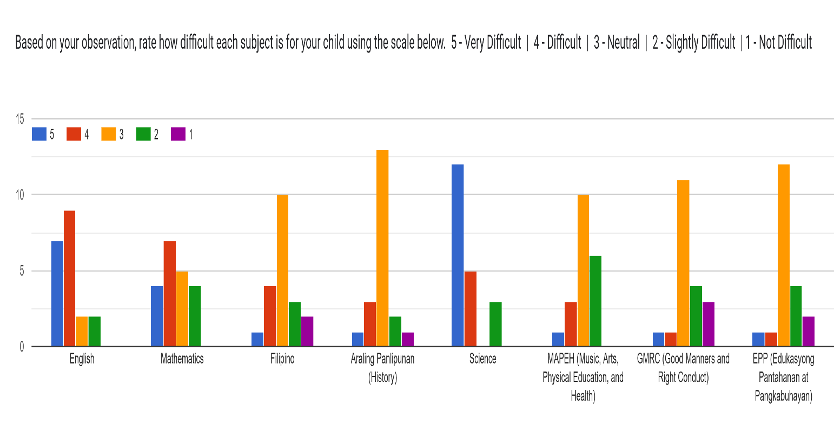
Part II.
Descriptive Statistics for Subject Difficulty Ratings (Parents)

Subject | Mean | SD | 1 | 2 | 3 | 4 | 5
Science | 4.3 | 1.1 | 0 | 3 | 0 | 5 | 12
English | 4.1 | 0.9 | 0 | 2 | 2 | 9 | 7
Mathematics | 3.6 | 1.1 | 0 | 4 | 5 | 7 | 4
Araling Panlipunan | 3.1 | 0.8 | 1 | 2 | 13 | 3 | 1
Filipino | 3.0 | 1.0 | 2 | 3 | 10 | 4 | 1
MAPEH | 3.0 | 0.8 | 0 | 6 | 10 | 3 | 1
EPP | 2.8 | 0.9 | 2 | 4 | 12 | 1 | 1
GMRC | 2.7 | 1.0 | 3 | 4 | 11 | 1 | 1

SURVEY QUESTIONNAIRE FOR TEACHERS TALLY SHEET – BALUAN ELEMENTARY SCHOOL

No. | Survey Question | Yes | No | Maybe | Total
1 | Are you currently implementing modular learning in your class? | 20 | 0 | 0 | 20
2 | Do you find modular learning effective in helping students understand lessons? | 7 | 8 | 5 | 20
3 | Does your classroom or school have access to a computer, projector, or stable internet connection? | 19 | 1 | 0 | 20
4 | Are you familiar with game-based learning as a teaching strategy? | 19 | 0 | 1 | 20
5 | Have you used any mobile or digital learning tool in your teaching before? | 16 | 3 | 1 | 20
6 | Do you think a mobile learning game could enhance your students' understanding of lessons when used alongside their printed modules? | 15 | 1 | 4 | 20
7 | Would you be willing to add a mobile learning game to your modular learning strategy? | 16 | 1 | 3 | 20
8 | Do you think students feel motivated to learn while playing games? | 18 | 1 | 1 | 20
9 | Do you believe a mobile app could help you track student performance more easily? | 9 | 1 | 10 | 20
10 | Would you recommend the use of a mobile learning game to other teachers? | 14 | 0 | 6 | 20
Part I.
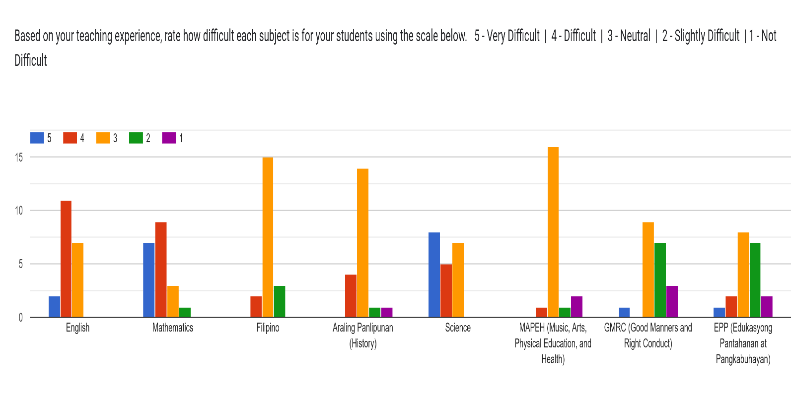
Part II.

Descriptive Statistics for Subject Difficulty Ratings (Teachers)

Subject | Mean | SD | 1 | 2 | 3 | 4 | 5
Mathematics | 4.1 | 0.9 | 0 | 1 | 3 | 9 | 7
Science | 4.1 | 0.9 | 0 | 0 | 7 | 5 | 8
English | 3.8 | 0.6 | 0 | 0 | 7 | 11 | 2
Araling Panlipunan | 3.1 | 0.7 | 1 | 1 | 14 | 4 | 0
Filipino | 3.0 | 0.5 | 0 | 3 | 15 | 2 | 0
MAPEH | 2.8 | 0.7 | 2 | 1 | 16 | 1 | 0
EPP | 2.7 | 1.0 | 2 | 7 | 8 | 2 | 1
GMRC | 2.5 | 0.9 | 3 | 7 | 9 | 0 | 1

For any subject you rated 4 (Difficult) or 5 (Very Difficult) in the table above, please specify the topics. At least 1 subject that learners struggle with.

Science Topics | Frequency
Speed | 3
Rocks / Kinds of Rocks / Rock Formation | 3
Evaporation | 2
Force | 2
Electricity / Electric Circuits | 2
Motion | 1
Movements | 1
Minerals | 1
Soil | 1
Landforms | 1
Total | 17

English Topics | Frequency
Grammar | 5
Subject-Verb Agreement | 1
Complex Sentences | 1
Reading | 1
Reading Comprehension | 1
Total | 9

Mathematics Topics | Frequency
Decimals | 3
Subtraction | 2
Fraction | 2
Word problems involving two or more operations | 2
Division | 1
Multiplication | 1
Problem Solving | 1
Ratio and Percentage word problems | 1
Total | 14

MAPEH Topics | Frequency
P.E. | 1
Notes | 1
Total | 2

Araling Panlipunan Topics | Frequency
Likas na Yaman | 1
Ekonomiya at Pamahalaan ng Pilipinas | 1
Total | 2

EPP Topics | Frequency
Entrepreneurship | 1
Technology | 1
Total | 2

