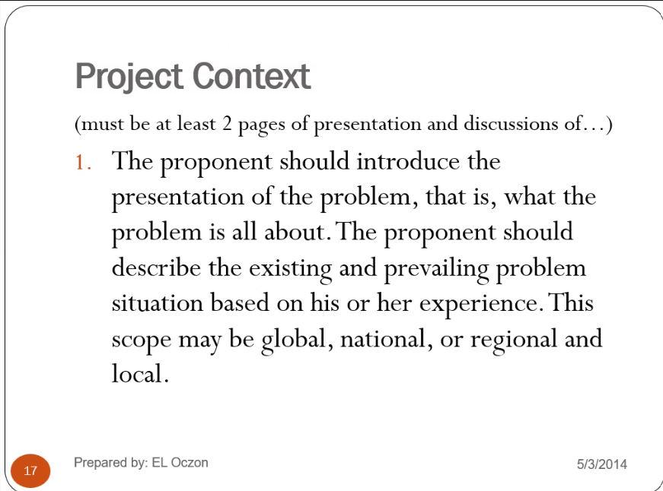

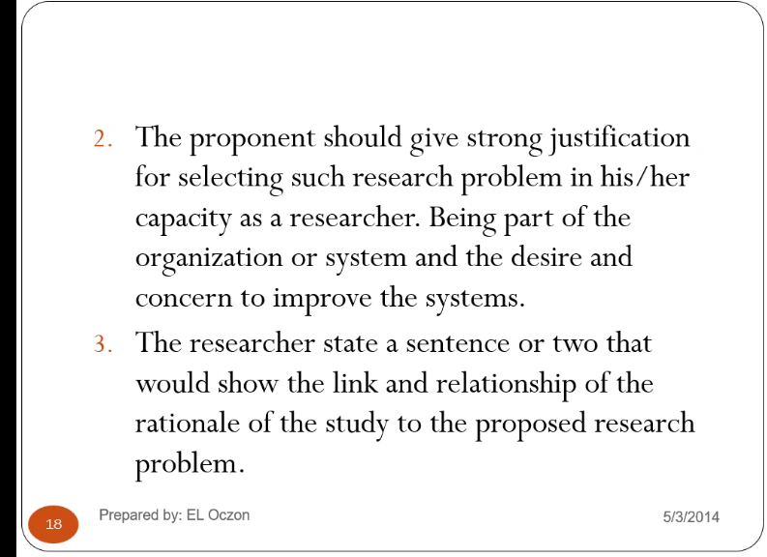

RULE: Introductory first in each section like Project Context, Purpose of the Project, etc.
PROJECT CONTEXT
Introductory first – sample – this section

Follow the Inverted Pyramid in Composing your introduction.
Eliminates the problem that cannot be solve by the proposed project
Global,
National,
Local – problems are in bullet form, atleast 4 problem
Last Paragraph – Urgency to conduct the study, why do I need to conduct to this propose study.
sample – This proposal has been conceptualized due to the urgency to address the problems stated above.

in the project context, this are the things that I remember,

first is Introductory, Global problem, National Problem, Local Problem, and the Last Paragraph – Urgency to conduct the study, why do I need to conduct to this propose study.
problem and objectives of the study should be align
if no.1 problem stated , then no.1 objective is the solution of the no.1 problem
PURPOSE AND DESCRIPTION OF THE PROJECT
what does it make unique? Also this game or project has not been implemented yet on this local or community

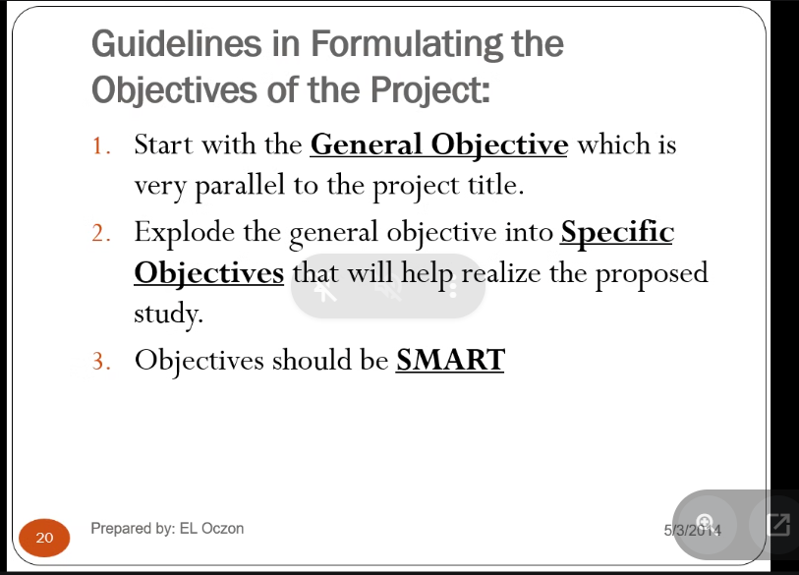

OBJECTIVES OF THE OBJECT
INTRODUCTORY PARAGRAPH
In bullet form same to the problems’’
Needed to be implemented in the System

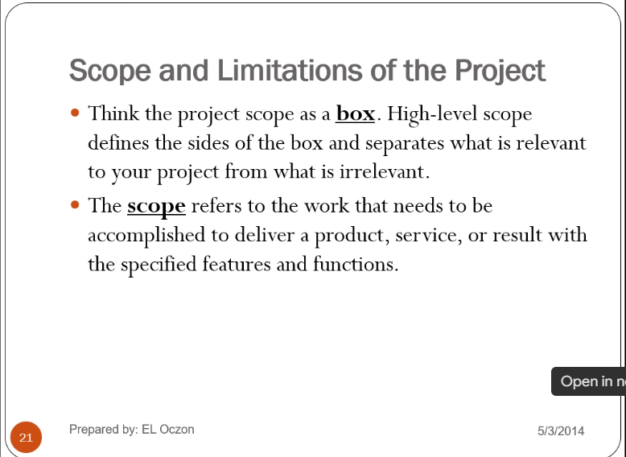
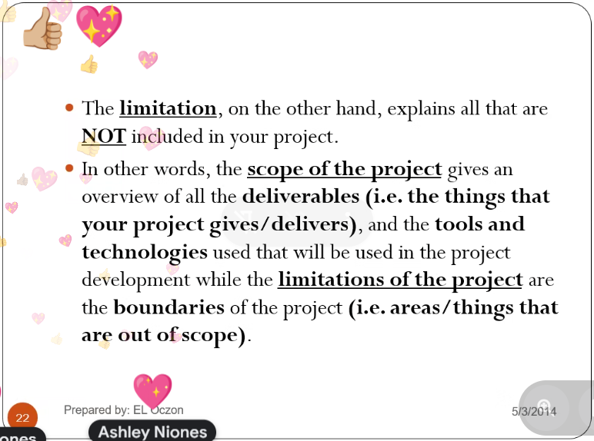

Download Zotero for Windows – bibliography

