**Name: aslam Mohamed Mohamed allam**

**B.N: 249**

**Topic:programming language**

**Githublink:**

**Githubpage :**

**Application brief:** After studying this topic and meaning or knowing the programming language and it is known as a set of commands, written according to rules defined by the programming language, and then these commands go through several stages until they are executed on the computer Based on its proximity to human languages, programming languages are divided into: A high-level language (close to the language human beings understand) such as: C-Sharp, Python, and Java. Low level language (close to machine language) such as: assembly language. Sometimes it is divided according to desired purposes from the language used. There are languages that are designed to work on specific devices, such as for a company to produce a computer or central processor (central processing unit), and to provide it with a user guide containing the commands that are executed on it, and there are other more general languages that work independently of the type of machine, that is, It works within a virtual machine, such as the Java language The programming language is basically a method that makes it easy for the programmer to write his program in the form of instructions and commands that the computer understands in order to carry out the required work. It is known that the computer converts the scripted language into a series of 0 and 1, on the basis of which it begins its work. And to write commands, the chosenprogramming

language provides a set of basic things to draw upon during the program’s creation process and a set of rules that enable you to handle and organize information for the purpose of performing the required work. These principles and rules are generally: Information and storage and Orders and organizing their conduct and Special design Programming languages can be classified in terms of how to build programs into procedural languages (Basic, Fortran), which are serial languages, the basis of

**Screenshot**

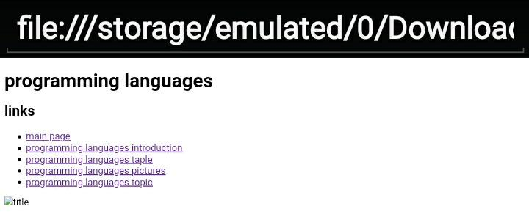

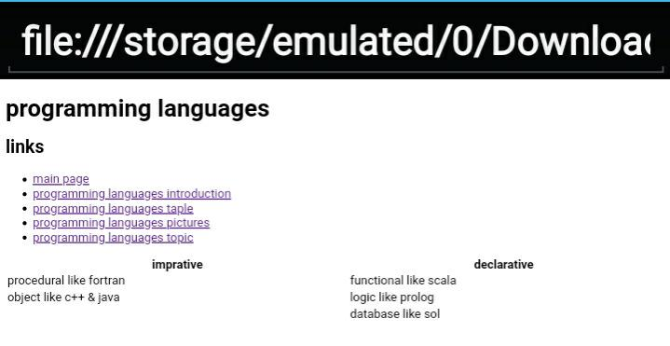

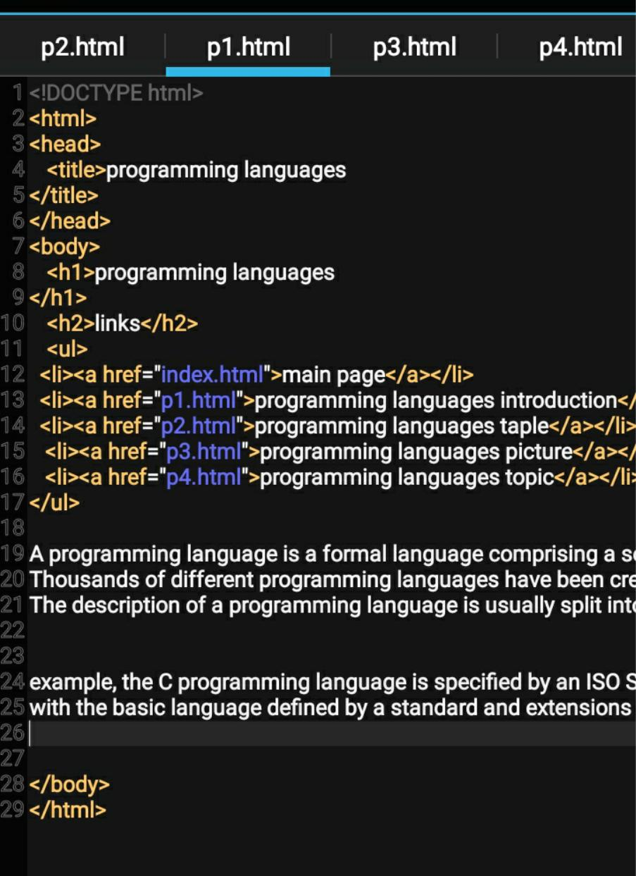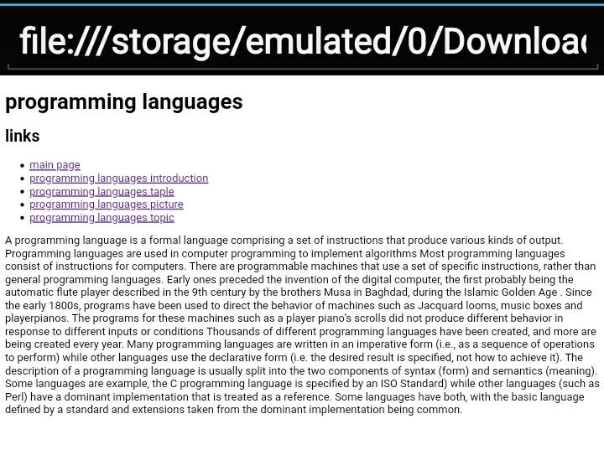**Source screen :**

