**Eltropy Assignment Specification**

Requirements

The regular user can perform the following operations:

* Add/update/view client information (name, identity card number, personal numerical code, address, etc.).
* Create/update/delete/view client account (account information: identification number, type, amount of money, date of creation).
* Transfer money between accounts.
* Generate Reports

The administrator user can perform the following operations:

* CRUD on employees’ information.

Generate reports for a particular period containing the activities performed by an employee.

Architecture

The system uses the layers architectural design pattern. It divides the application in three layers: the presentation layer, which is used to handle the front end of the application, the business layer which handles all the logic of the system (input handling, validations) and the data layer which handles the connection and access to the database

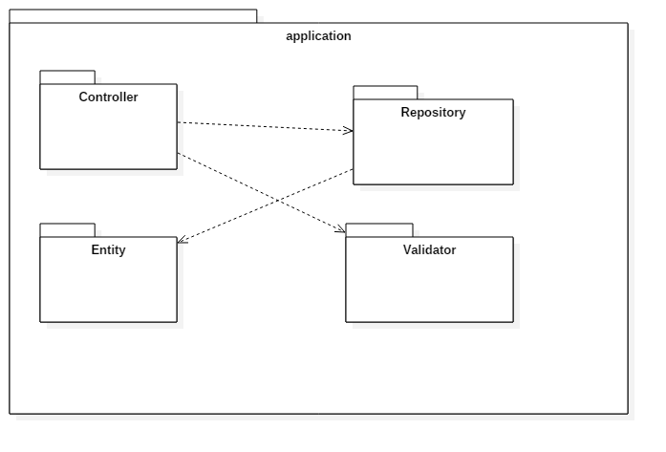

Sequence Diagram

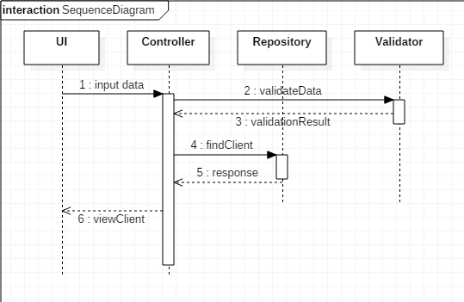

Class Digrams

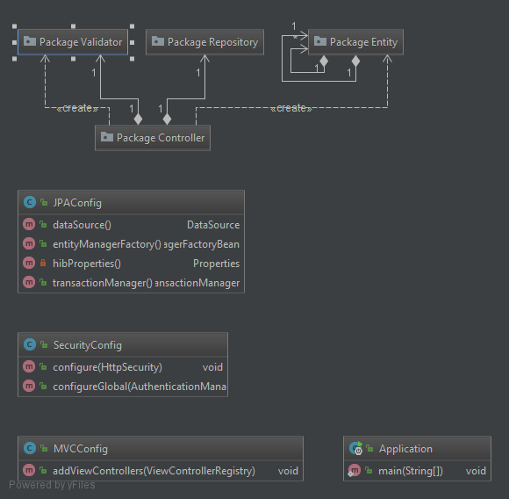

Data Model

The data model used for the application was derived from the problem specification. The classes created are the following: Account, Client, Employee, User, Role and Log. A client can have multiple accounts, while an account can have only one owner (Client). An employee is mapped using a one-to-one relationship to a user. A user can have one or two roles (User and/or Admin).

Application Setup and Execution

1. MySQL is used as DB (Install MySQL)
2. Create a DB by the name “banking”
3. Populate User, Role and User_Role with appropriate values to correspond to Normal User and Admin user.
4. Modify application.properties file to include appropriate db details like URL, UserName and Password
5. Execute the jar file using the command below

java -jar Banking-1.0-SNAPSHOT.jar

1. Open a browser and type the url as below

<http://localhost:8080/>

1. Navigate through the application after logging in to various flows as presented in the home screen.