INDUSTRY ANALYSIS REPORT
Healthcare & Pharmaceutical
Operations Management

A Deep-Dive into the Indian Pharmaceutical Industry
Featuring Sun Pharmaceutical Industries · Divi's Laboratories · Torrent Pharmaceuticals
Prepared exclusively for a single reader — not a template, not a syndicated note.
September 2026

What's Inside
01 Executive Summary
02 Industry Overview
03 Market Size, Growth & Demand Drivers
04 Competitive Landscape
05 Company Deep-Dive: Sun Pharma, Divi's Labs & Torrent Pharma
06 Company Comparison
07 Key Industry KPIs
08 Cost Structure & Raw Materials
09 Regulatory Landscape
10 Emerging Trends
11 Risks & Opportunities
12 Outlook & Strategic Takeaways

01 · Executive Summary
India's pharmaceutical industry has quietly become one of the most structurally important manufacturing sectors on the planet — and 2026 is shaping up to be an inflection year for it.
The domestic pharmaceutical market crossed Rs. 5.30 lakh crore (US$60 billion) in FY26, and every credible estimate — Bain & Co., the Department of Pharmaceuticals, IBEF — points to this more than doubling to roughly US$130 billion by 2030. That's not speculative biotech-style growth; it's driven by unglamorous, structural things: India makes 20% of the world's generic medicine supply, exports to over 200 countries, and remains the third-largest pharma producer globally by volume. Underneath that macro story sit thousands of operational decisions — plant capacity, API sourcing, cold-chain logistics, regulatory inspection readiness — which is exactly where operations management earns its keep in this industry.
$60Bn  Domestic market, FY26 | $130Bn  Projected by 2030 | $31Bn  Exports, FY26 | 3rd  Largest producer by volume, globally

This report zeroes in on the three companies that best represent the different operating models within Indian pharma today: Sun Pharma (India's largest, diversified across generics, branded and innovative medicines), Divi's Laboratories (the country's largest API manufacturer, now pivoting hard into high-value custom synthesis for global innovators), and Torrent Pharmaceuticals (a branded-generics specialist that just absorbed JB Chemicals in one of the sector's biggest recent M&A moves). Together they illustrate three distinct operating philosophies — scale and diversification, backward-integrated manufacturing excellence, and disciplined brand-building through acquisition.
The headline takeaway: this is a sector where cost leadership and regulatory discipline are no longer enough on their own. The companies pulling ahead — Sun Pharma's Innovative Medicines arm, Divi's shift toward custom synthesis and peptides, Torrent's semaglutide play — are the ones treating operations as a source of strategic differentiation, not just a cost centre to be minimised. That shift is the thread running through every section of this report.

02 · Industry Overview

What operations management means in this industry
In most industries, "operations" means efficiency. In pharmaceuticals, it means something closer to risk containment at scale. A single missed batch record or a contaminated cleanroom doesn't just cost money — it can trigger an FDA import alert that shuts a plant out of the US market for years. So operations management here sits at the intersection of four disciplines: manufacturing (API and formulation production), quality and regulatory compliance (GMP, USFDA, WHO-GMP), supply chain (often spanning solvents and intermediates sourced from China), and increasingly, R&D-to-commercial handoff for complex generics and biosimilars.

Structure of the sector
The Indian pharmaceutical value chain splits cleanly into two halves, each with a branded and a generic/commodity tier:
- Active Pharmaceutical Ingredients (APIs) / Bulk Drugs — roughly 35% of the market. This is the chemistry-heavy, capital-intensive layer where India built its early cost advantage. India's API exports reached US$4.91 billion in FY25, now exceeding imports — a meaningful signal of growing self-reliance after decades of China dependency.
- Formulations — the finished-dose medicines patients actually take (tablets, injectables, syrups). India is the largest exporter of formulations by volume (14% global market share) though only 12th by export value — the classic "volume leader, value laggard" position that every major Indian pharma company is now trying to escape through branded generics, specialty therapies, and biosimilars.
Segment map
Segment | Branded | Generic / Commodity
API / Bulk Drugs | Branded APIs for regulated markets | Commodity APIs (cardiovascular, anti-diabetic, anti-infective)
Formulations | Cardiovascular, anti-diabetic, gastro-intestinal, neurological | Anti-infectives, respiratory, pain, gynaecology
Source: Dun & Bradstreet, IBEF Pharmaceuticals Report, May 2026

India's position in the global supply chain
A handful of numbers tell the story better than any narrative: India supplies 55–60% of UNICEF's vaccines, meets 99% of WHO's DPT vaccine demand, and provides 52% of global BCG vaccines and 45% of measles vaccines. This is why the industry earned the nickname "Pharmacy of the World" — it isn't marketing spin, it's a fair description of how much of the planet's essential medicine supply actually runs through Indian factories.
Structurally, the industry is the fifth-largest contributor to India's manufacturing gross value added, drives roughly 4% of the country's total FDI inflows, sustains a trade surplus of about US$19 billion, and directly or indirectly supports 2.7 million livelihoods. It is, in other words, not a niche vertical — it's core national infrastructure.

03 · Market Size, Growth & Demand Drivers
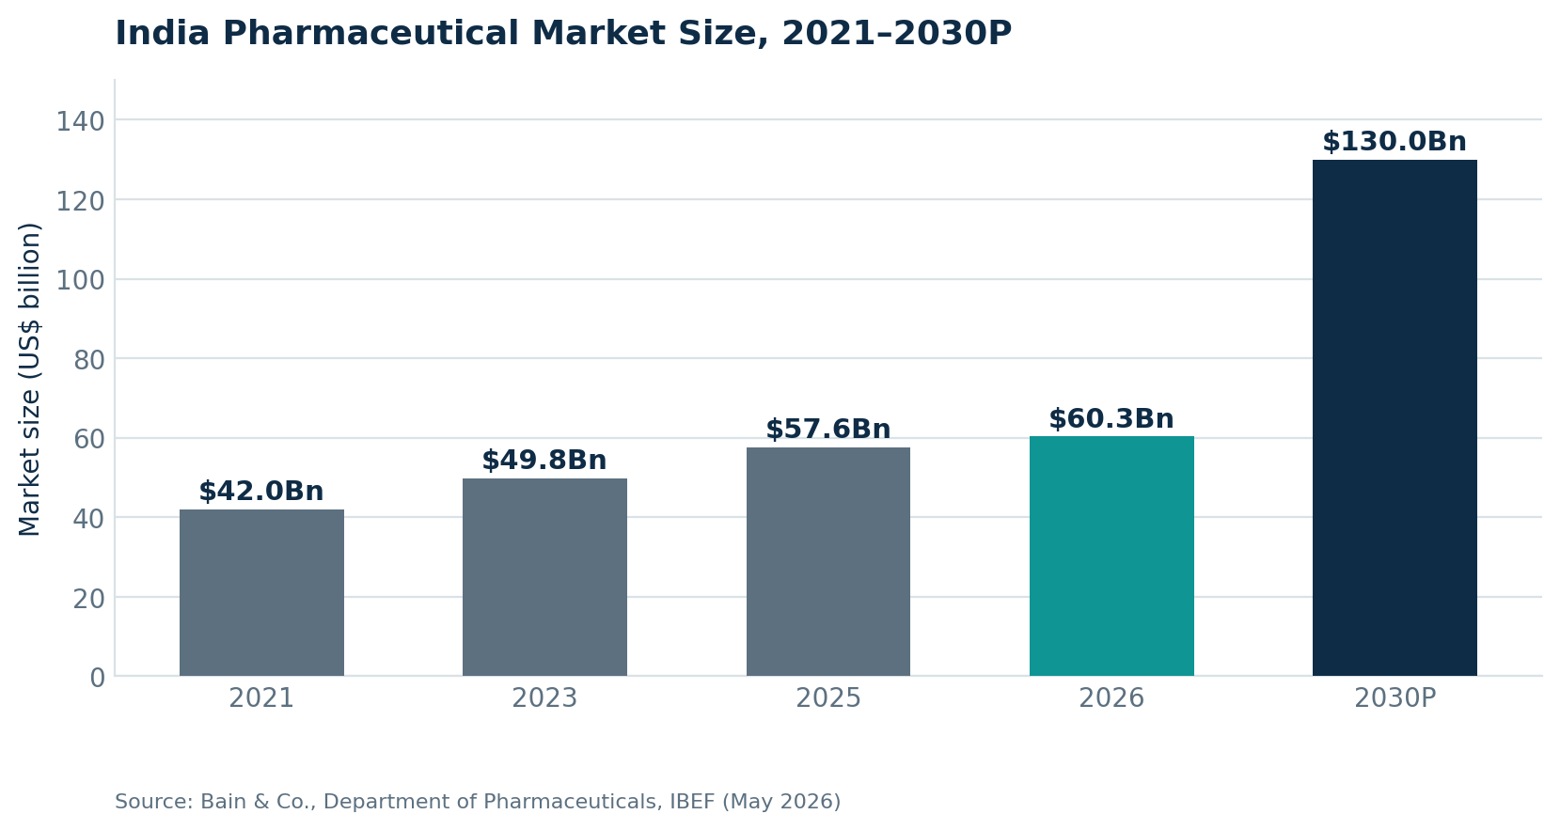
India's domestic pharmaceutical market is projected to more than double this decade.
Domestic market sales specifically (as distinct from the broader industry figure which includes exports) hit Rs. 2,46,000 crore (US$27.97 billion) in FY26, up 8.8% year-on-year from Rs. 2,26,000 crore in FY25, per Pharmarack data. Growth has been remarkably consistent — over 10% annually for the five years to 2025 — which is the kind of steady compounding that operations planners can actually build capacity roadmaps around, unlike the boom-bust cycles seen in some other manufacturing sectors.

Exports: the other engine
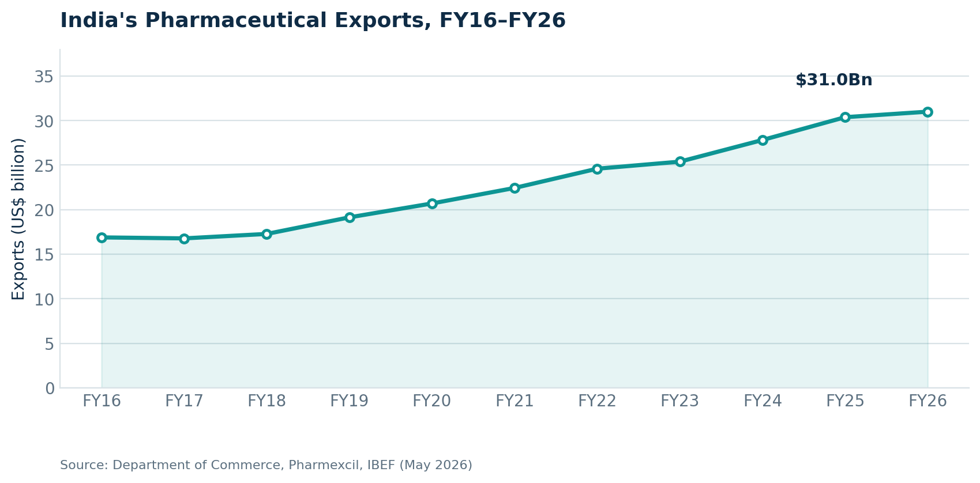
Exports have grown almost every single year for the past decade, reaching US$31 billion in FY26. Longer-range government projections (out to 2047, India's centenary of independence) put exports at US$350 billion — a 10–15x increase, which sounds aggressive until you remember this is a sector that already grew exports 83% over the past decade shown above.
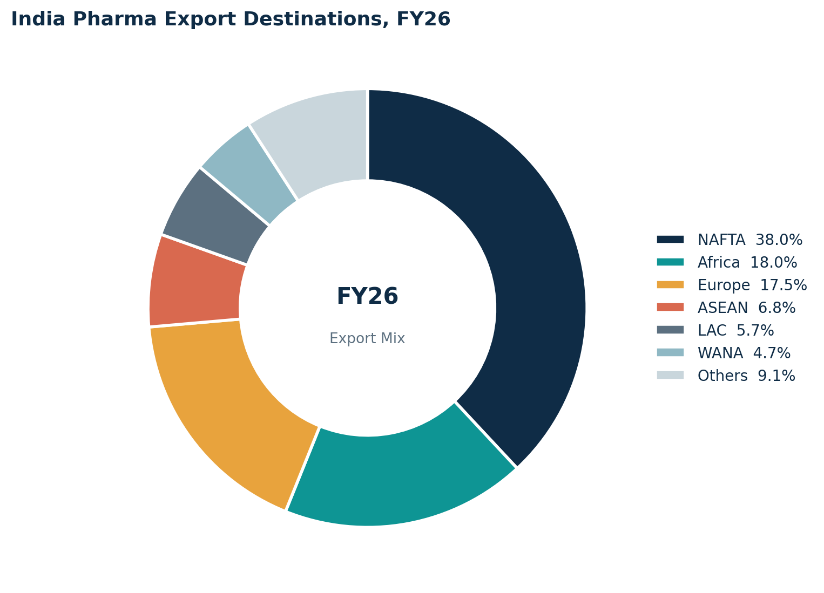
NAFTA (largely the US) remains the single most important destination, followed by Africa and Europe.
This concentration is a double-edged sword for operations planning: the US market pays the best margins for complex generics and specialty products, but it also means USFDA inspection outcomes at any single facility can move the needle on national export figures — which is precisely why every major player treats US regulatory compliance as a board-level operations priority, not a plant-level checkbox.

What's actually driving demand
- Accessibility — new business models are pushing into tier-2 and tier-3 cities; private hospitals are expected to add over 4,000 beds in FY26 alone (Rs. 11,500 crore investment).
- Acceptability — rising education levels are increasing self-medication and OTC uptake; the OTC drug market is projected to nearly double from Rs. 47,000 crore (US$5.68 billion) in 2024 to Rs. 98,000 crore (US$10.38 billion) by 2030.
- Affordability infrastructure — over 18,000 Pradhan Mantri Bhartiya Janaushadhi Kendras now sell generic medicines 50–80% cheaper than branded equivalents, with a target of 25,000 outlets by March 2027.
- Insurance penetration — India's life insurance market is projected to grow 10.5% annually over the next decade, and non-life (including health) gross direct premiums have climbed from US$14.71 billion in FY16 to US$38.04 billion in FY26 — more people with insurance means more people who can afford to actually fill their prescriptions.
- Global trade agreements — a prospective India–EU Free Trade Agreement would reduce trade barriers and align regulatory standards, directly expanding the addressable export market.

04 · Competitive Landscape
Indian pharma isn't a single competitive arena — it's four overlapping ones, and most large players compete in several simultaneously.

The four competitive arenas
Arena | What it rewards | Who leads
Branded Generics (India + Brazil + Germany) | Field-force scale, brand trust, therapy focus | Torrent, Sun Pharma, Cipla, Mankind
API / CRAMS / CRDMO | Backward integration, cost discipline, regulatory track record | Divi's Labs, Aurobindo, Laurus Labs
US Generics | ANDA filing velocity, first-to-file paragraph IV wins | Sun Pharma, Dr. Reddy's, Aurobindo, Lupin
Biosimilars & Complex Generics / Peptides | R&D depth, clinical + regulatory sophistication | Sun Pharma, Divi's (peptides), Biocon
Illustrative positioning based on company disclosures and industry coverage, 2026.

Consolidation is accelerating
The clearest recent signal of competitive intensity is Torrent Pharma's acquisition of JB Chemicals & Pharmaceuticals from KKR, consolidated into Torrent's books from January 2026. It pushed Torrent's Q4 FY26 revenue up 42% year-on-year and immediately made Torrent a meaningfully larger, more diversified competitor — while also loading its balance sheet (Net Debt/EBITDA now 2.3x). Expect more of this: scale is becoming the cheapest way to buy therapy-area depth and geographic reach in a market where organic R&D cycles take years.

A wave of new entrants: the IPO pipeline
Perhaps the most underrated signal of sector health is what's happening in the primary markets. Five companies with live or recently-completed Draft Red Herring Prospectus (DRHP) filings show where capital thinks the next growth pockets are — overwhelmingly, that's CRDMO, specialty API distribution, and injectable/CDMO manufacturing, not commodity generics.
Company | DRHP Filed | Segment | Fresh Issue | FY Revenue
Aragen Life Sciences | Aug 2026 | CRDMO (CRO + CDMO) | Rs. 800 cr | Rs. 2,178 cr (FY26)
Ujin Pharma | Jun 2026 | Pharma raw material distribution | Share-based | Rs. 1,523 cr (9M FY26)
Sudeep Pharma | Jun 2025 | Excipients & speciality ingredients | Rs. 95 cr | —
Hindustan Laboratories | Jan 2026 | Generic medicines (govt. supply) | Share-based | Rs. 113 cr (H1 FY26)
Sai Parenteral's | Sep 2025 (listed Apr 2026) | Formulations + CDMO (injectables) | Rs. 285 cr | Rs. 163 cr (FY25)
Source: Compiled from public DRHP filing coverage (Business Today, Business Standard, Angel One, IndMoney and others), 2026.
Aragen Life Sciences is the standout: a fully integrated CRDMO serving 591 global customers, including 16 of the top 20 Big Pharma companies, raising Rs. 800 crore to fund debt repayment and capex. Its DRHP alone is a strong proxy for how much global pharma outsourcing demand is flowing toward India's contract research and manufacturing ecosystem.

05 · Company Deep-Dive
PROFILE 1 OF 3

Sun Pharmaceutical Industries — Scale Through Diversification
NSE: SUNPHARMA · Market cap ~Rs. 4,060 billion (~US$45 billion), February 2026. Sun Pharma is India's largest pharmaceutical company by both revenue and market cap, operating in over 100 countries with 43,000+ employees across 40 global manufacturing facilities, many USFDA and UK MHRA approved. It is also the 13th-largest player in the entire US generics market — a scale advantage almost no domestic peer can match.
Revenue mix, FY25
Segment | % of Revenue | FY25 Sales
India Formulations | 33% | Rs. 169.2 Bn
US Formulations | 31% | Rs. 162.4 Bn
Emerging Markets | 18% | Rs. 94.2 Bn
Rest of World | 14% | Rs. 71.6 Bn
API & Others | 4% | —
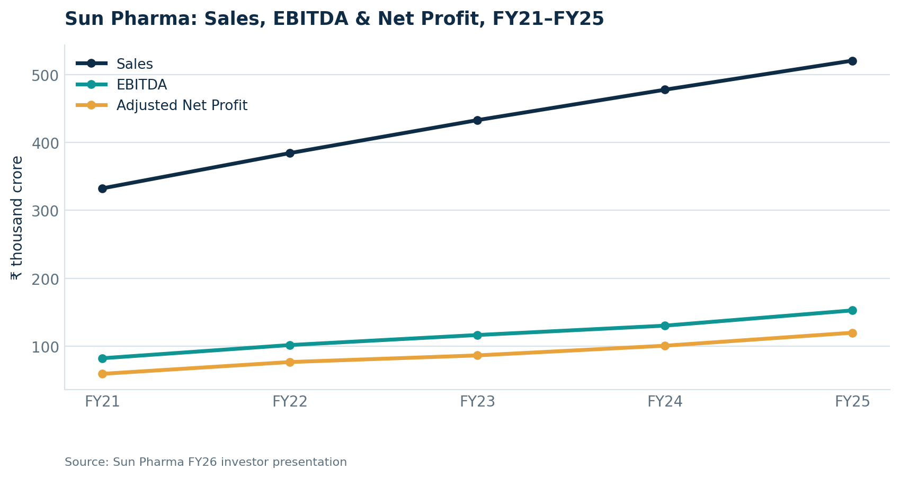
Consistent double-digit compounding: Sales grew at a 16% CAGR and EBITDA at 21% CAGR, FY10–FY25.
The most important strategic shift inside Sun Pharma isn't visible in the topline — it's in the mix. Innovative Medicines now make up 20% of FY25 sales, up from just 7.3% in FY18, growing at a 23% CAGR since FY20. The flagship product, Ilumya (a psoriasis biologic), did US$681 million in FY25 sales on its own. This is Sun Pharma deliberately climbing the value chain away from pure-generic economics — and profitability metrics confirm the strategy is working: gross margin expanded from 73.1% to 79.3% and ROCE from 16.4% to 20.4% between FY22 and FY25.
Momentum has continued into FY26 — Q3 revenue of Rs. 155.2 billion (+13.5% YoY) with a 31.9% EBITDA margin. Management's near-term focus: deepen the US innovative/branded mix, defend India leadership, and pursue selective, disciplined biotech M&A rather than large transformative deals.

PROFILE 2 OF 3

Divi's Laboratories — India's API Backbone, Pivoting to High-Value CDMO
NSE: DIVISLAB · HQ Hyderabad. Divi's occupies a different, quieter niche: it's India's largest API manufacturer, a "behind-the-scenes" supplier rather than a branded drugmaker, with roughly 70%+ global market share in pain-control and cough-suppressant APIs alone. It is also, notably, zero-debt and cash-rich — every expansion is funded through internal accruals, a rare balance-sheet discipline in a capital-intensive industry.
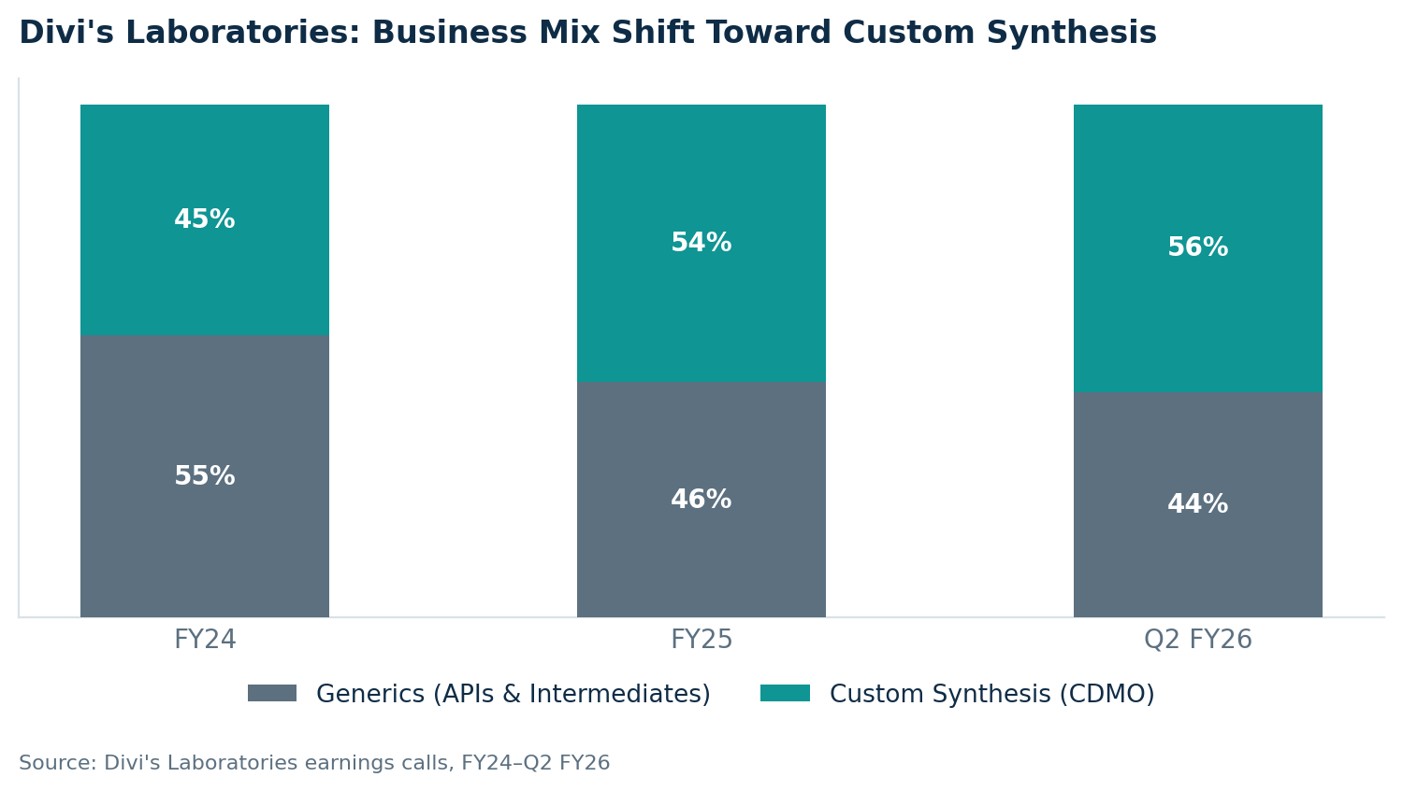
The structural story at Divi's: a deliberate shift from commodity Generics toward higher-margin Custom Synthesis (CDMO) work for global innovator pharma.
This mix shift shows up directly in the numbers: total operating income grew 20% to Rs. 9,875 crore in FY25, while PBILDT margin expanded by 373 basis points to 32.23% and PAT margin by 357 basis points to 25.38%. Divi's is also making a serious strategic bet on peptides — specifically GLP-1, GIP and GLP-2 analogs (the same drug class behind Ozempic and Wegovy) — working with innovators rather than competing as a generic peptide maker. The Kakinada plant (Phase I operational since Q4 FY25) is backward-integrating key starting materials, partly to protect against the West Asia sourcing and logistics disruptions that have periodically hit the industry.
The one watch-item flagged by rating agencies: product and customer concentration — CARE Ratings wants the top-5-product share below 30% of revenue before considering a ratings upgrade, which is exactly why diversifying into peptides and CDMO matters strategically, not just financially.

PROFILE 3 OF 3

Torrent Pharmaceuticals — Branded Generics, Built Through Disciplined M&A
NSE: TORNTPHARM. Torrent's identity is distinct from the other two: it sells finished medicines under its own brand names, not commodity generics, with deep therapy focus in cardiovascular, CNS, gastrointestinal and women's health. It holds the #1 prescription market share in both Germany and Brazil — the first Indian company ever to achieve that in two international markets simultaneously — built almost entirely through a string of disciplined acquisitions (Elder Pharma, Unichem, Pfizer's German subsidiary, and most recently JB Chemicals).
FY26 snapshot
Metric | FY26 | YoY Change
Consolidated Revenue | Rs. 13,980 cr | +21%
Net Profit | Rs. 2,138 cr | +12%
EBITDA Margin | 32.7% | Maintained
EPS (Consolidated) | Rs. 63.92 | Up from Rs. 56.47
Net Debt / EBITDA | 2.3x | Elevated post-JB acquisition
The JB Pharma acquisition (from KKR, consolidated from January 21, 2026) is the dominant story in Torrent's recent numbers — it alone drove Q4 FY26 revenue up 42% year-on-year, contributing Rs. 424 crore of operating EBITDA at a 35.3% margin in its first reported quarter. Integration synergies (targeted at Rs. 450 crore by year three) are tracking ahead of schedule. Separately, Torrent has captured 38% market share in India's Generic Semaglutide market (oral + injectable combined) — a direct, well-timed beneficiary of the Ozempic/Wegovy patent cliff opening up in India.
The company's oncology facility at Bileshwarpura cleared a USFDA inspection with zero observations in April 2026 — a clean audit result that matters more than it might sound, given how much of the sector's export credibility rides on maintaining spotless US regulatory standing.

06 · Company Comparison
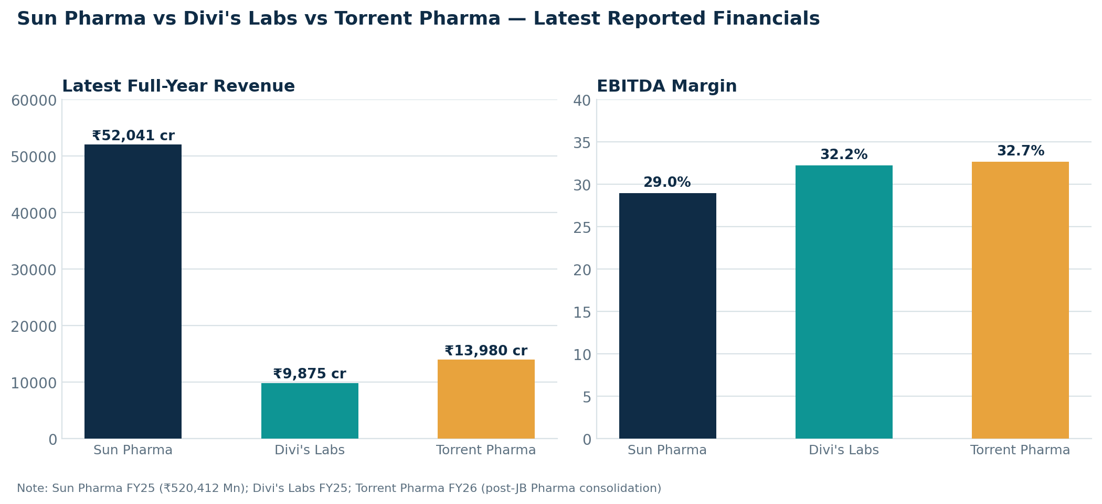

 | Sun Pharma | Divi's Laboratories | Torrent Pharma
Business model | Diversified generics + branded + innovative medicines | API / CDMO — behind-the-scenes manufacturer | Branded generics — finished medicines
Latest FY revenue | Rs. 520 Bn (FY25) | Rs. 9,875 cr / ~Rs. 98.75 Bn (FY25) | Rs. 13,980 cr / ~Rs. 139.8 Bn (FY26)
EBITDA margin | 29.0% (FY25) | 32.23% (FY25) | 32.7% (FY26)
Key growth driver | Innovative Medicines (US) + India leadership | Custom Synthesis + Peptides | JB Pharma merger + Semaglutide + Brazil
Debt position | Near-zero (Rs. 18.7 Bn gross debt vs Rs. 722 Bn equity) | Zero debt, cash-rich | Leveraged (2.3x Net Debt/EBITDA)
Export orientation | Global — 100+ countries | ~90% export-driven | Mixed — domestic + Brazil + US + Germany
Operating philosophy | Scale & portfolio diversification | Backward-integrated manufacturing discipline | Brand equity via disciplined M&A
Compiled from company investor presentations, earnings calls, and rating agency reports, 2026.

The takeaway for operations management specifically: all three companies are optimising a different variable. Sun Pharma optimises for portfolio breadth and geographic risk-spreading; Divi's optimises for manufacturing depth and balance-sheet resilience; Torrent optimises for brand equity acquired at speed. None of these is "the right" operating model in isolation — they're rational responses to each company's starting position, and the fact that all three are currently performing well suggests the Indian pharma industry has room for multiple winning operational strategies simultaneously.

07 · Key Industry KPIs
A handful of metrics matter more than the rest when judging operational health in this industry. Here's how the three companies — and the broader sector — stack up.

Profitability & efficiency benchmarks
KPI | Sun Pharma | Divi's Labs | Torrent Pharma | Why it matters
EBITDA Margin | 29.0% | 32.23% | 32.7% | Higher-value mix (innovative, CDMO, branded) shows up directly here
ROCE | 20.4% (FY25) | Strong / rising | Improving post-JB | Capital efficiency — critical given how capex-heavy plant expansion is
ROE | 17.4% (FY25) | Strong | Improving | Shareholder return on the equity actually deployed
R&D as % of sales | 6.2% (FY25) | Embedded in CDMO capex | Lower (brand-led model) | Signals long-term pipeline investment intensity
Net Debt / EBITDA | Near zero | Zero (net cash) | 2.3x | Balance-sheet capacity to fund the next plant, acquisition or downturn

R&D intensity across the sector
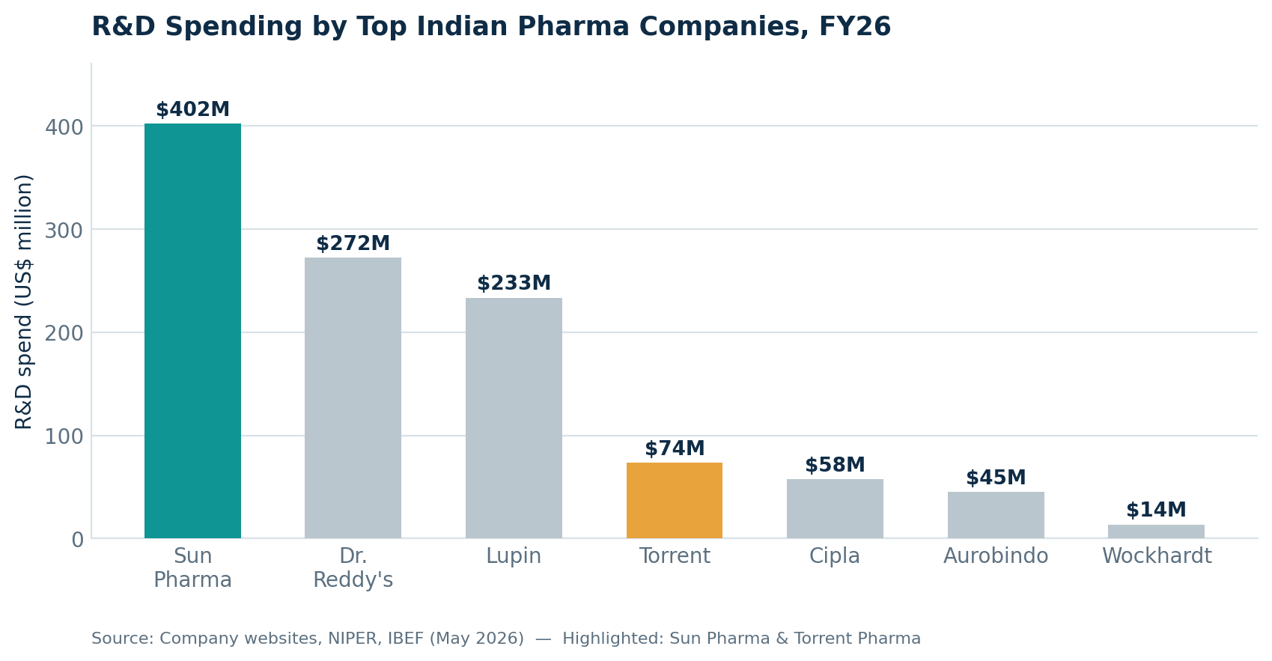
Sun Pharma's R&D spend of US$402 million in FY26 dwarfs the rest of the sector — nearly 1.5x Dr. Reddy's and almost 30x Wockhardt's. That gap is a reasonable proxy for how seriously each company is playing the innovative-medicines and complex-generics game versus sticking to commodity generics. Industry-wide, R&D investment is projected to reach Rs. 17,000 crore (US$2 billion) by FY28, supported by Union Budget allocations for bulk drug parks, medical device parks, and the new Biopharma SHAKTI mission.

Operational scale metrics
- Manufacturing footprint: 40+ facilities globally for Sun Pharma alone; India has the second-highest number of USFDA-approved plants outside the US.
- Field force: Sun Pharma deploys 15,000+ medical representatives in India alone; Torrent fields ~7,100 (excluding JB Chemicals reps) — a reminder that in branded generics, distribution muscle is as much an operational asset as any factory.
- ANDA pipeline (Sun Pharma, US market): 666 ANDAs filed / 550 approved; 71 NDAs filed / 57 approved — a pipeline depth few global generics players can match.
- Working capital discipline: Divi's runs a deliberate 3-month rolling inventory strategy specifically to buffer against West Asia sourcing and logistics disruption — a textbook operations-management risk mitigation choice.

08 · Cost Structure & Raw Materials

The API dependency problem — and India's push to fix it
For years, the uncomfortable truth about "the Pharmacy of the World" was that a large share of its own raw materials — key starting materials, intermediates, and even some APIs — were imported, heavily from China. That's now visibly changing: India's API exports (US$4.91 billion in FY25) have overtaken API imports (US$4.64 billion) for the first time in recent memory, and API imports declined a further 17% between April and December 2025.
The government is backing this shift aggressively — a Rs. 60,000 crore (US$7 billion) API-push announced in December 2025 specifically targets import substitution, on top of the existing Production Linked Incentive (PLI) scheme, which envisages domestic manufacturing of 41 bulk drugs with a cumulative outlay of Rs. 6,940 crore through 2030. Three bulk drug parks and three medical device parks are already under development as of March 2026, alongside 199 land allotments and shared testing facilities.

Where the money actually goes
- Raw materials & intermediates — the largest single cost line for API and formulation manufacturers; solvents, chemicals, and fermentation-based starting materials dominate. Ujin Pharma's DRHP, for instance, shows a business built entirely around distributing solvents, speciality chemicals and pharmaceutical raw materials — illustrating just how much specialised infrastructure exists purely to feed this input layer.
- Manufacturing & capex — USFDA-grade facilities are expensive to build and even more expensive to maintain in inspection-ready condition; Divi's FY26 capex guidance alone was raised above Rs. 2,000 crore.
- R&D — ranges from roughly 4–6% of sales for generics-led players to considerably higher for companies chasing biologics, biosimilars and complex generics.
- Field force & distribution — a structurally large, semi-fixed cost for branded generics players (Sun Pharma: 15,000+ reps in India alone) that smaller commodity API players simply don't carry.
- Compliance & quality systems — increasingly significant given the frequency and rigour of USFDA, WHO-GMP, and now UAE MOHAP/Saudi SFDA inspections across export markets.

Manufacturing geography
Production is heavily clustered in a handful of states, each specialising by capability:
State / Region | Notable facilities
Himachal Pradesh (Baddi) | Wockhardt, Cipla formulations manufacturing
Gujarat (Dholka, Ankleshwar, Panoli) | Cadila (100+ acre facility), Sun Pharma API sites
Maharashtra (Tarapur) | Lupin's USFDA-approved fermentation-capability plant
Telangana / Andhra Pradesh (Hyderabad, Rajahmundry) | Piramal (USFDA-approved), GlaxoSmithKline; Mylan, Albany Molecular, Cambrex CMOs
Madhya Pradesh (Mandideep, Indore) | Lupin cephalosporin/ACE-inhibitor hub; Cipla formulations
Source: Company websites, compiled via IBEF Pharmaceuticals Report, May 2026.

09 · Regulatory Landscape
Regulation isn't a side constraint in this industry — for operations planning, it's arguably the single biggest variable. Understanding how it evolved explains why Indian pharma operates the way it does today.

How we got here
Period | What changed
1970–1990 | Indian Patent Act (1970) enabled process-patent-only regime; domestic industry and production infrastructure took root.
1990–2010 | Market liberalised; Indian firms began launching foreign operations; Patents (Amendment) Act 2005 introduced product patents.
2010–2013 | Surge in patent filings; National Pharmaceutical Pricing Policy (2012) and Drug Pricing Control Order (2013) cut drug prices by up to 80%.
2013–2015 | Aggressive M&A funding by leading players; Patent Act amended again in 2015.
2016–onward | PLI scheme launched (US$1.8 billion outlay); India becomes a top global vaccine supplier; Biopharma SHAKTI mission launched (2026).
Source: TechSci Research, Press Information Bureau.

Policy levers currently in play
- Production Linked Incentive (PLI) — Rs. 15,000 crore outlay (2020-21 to 2028-29) to boost manufacturing, investment and product diversification; FY26 allocation raised 14% to Rs. 2,444.9 crore.
- Biopharma SHAKTI — a new Rs. 10,000 crore, five-year outlay (announced in the Union Budget 2026-27) aimed at strengthening India's biopharmaceutical ecosystem, including establishing 1,000+ accredited clinical trial sites.
- Strengthening of Pharmaceutical Industry (SPI) Scheme — financial support for pharma clusters and MSMEs to upgrade common facilities and technology.
- Scheme for Promotion of Research and Innovation in Pharma MedTech (PRIP) — Rs. 5,000 crore outlay (FY24–FY28), Cabinet-approved, targeting pharma-MedTech R&D specifically.
- Medical Devices Parks — aiming to elevate the medical devices industry from Rs. 1,02,564 crore (2023-24) to Rs. 4,27,350 crore (US$50 billion) by 2030.
- Ayushman Bharat Digital Mission — a nationwide digital health record system; over 863 million ABHA health IDs created as of March 2026, directly supporting pharmaceutical delivery traceability and interoperability.
- FDI policy — 100% FDI allowed via the automatic route for greenfield pharma projects; 74% automatic for brownfield projects (beyond that requires government approval). Cumulative FDI inflow into Drugs & Pharmaceuticals: US$25.33 billion (April 2000–March 2026).
- India–US medicines partnership — as of February 2026, the Indian Pharmaceutical Alliance is actively pushing to strengthen this relationship to reduce tariffs and expand export access — a live policy risk and opportunity simultaneously, given how tariff-sensitive the US export channel is.

10 · Emerging Trends
1. CRDMO is the fastest-growing segment in the industry
India's Contract Research, Development & Manufacturing Organisation (CRDMO) industry is projected to double to Rs. 1,21,282 crore (US$14 billion) by 2028 according to Macquarie. This isn't abstract — it's showing up directly in IPO activity (Aragen Life Sciences' Rs. 800 crore DRHP) and in incumbent strategy (Divi's structural pivot toward Custom Synthesis, now 56% of its business mix as of Q2 FY26).
2. Biosimilars are scaling fast
The domestic biosimilars market is growing at a 22% CAGR, on track to represent roughly 20% of the total pharmaceutical market. India and Brazil expanded biosimilars cooperation in February 2026, with exports to Brazil rising over 18% to Rs. 6,727 crore (US$778 million) in FY25 alone.
3. The GLP-1 / peptide opportunity is being seized in real time
The Ozempic/Wegovy patent cliff has triggered a genuine land-grab: Torrent has already captured 38% share of India's Generic Semaglutide market, while Divi's is investing specifically in peptide manufacturing capability (GLP-1, GIP, GLP-2 analogs) to serve global innovators. Sun Pharma's own pipeline includes GL0034, a GLP-1 receptor agonist for diabetes. Few therapeutic categories globally are moving this fast right now.
4. Consolidation through M&A, not just organic growth
Torrent–JB Chemicals is the marquee example, but it fits a broader pattern of Indian pharma majors buying scale and therapy depth rather than waiting for it to develop organically — a rational response to how long internal R&D and brand-building cycles typically take.
5. Digital health infrastructure is maturing
The Ayushman Bharat Digital Mission's 863 million+ health IDs are quietly building the data backbone that will eventually make pharmaceutical demand forecasting, distribution, and even personalised medicine delivery far more precise than today's largely manual, retailer-relationship-driven distribution model.
6. Rural and OTC penetration
With 70% of India's population in rural areas and the OTC drug market on track to nearly double by 2030, distribution-network investment in tier-2/3 and rural markets is becoming a genuine competitive battleground, not just a compliance-driven "access" initiative.
7. Patent cliff windfall approaching
Indian pharmaceutical firms face a Rs. 85,690 crore (US$10 billion) opportunity by 2029, as 15 blockbuster drugs with combined revenue of roughly US$112 billion go off-patent globally between 2023 and 2029 — precisely the kind of event Indian generics manufacturers have built their entire operating model to exploit quickly.

11 · Risks & Opportunities

Risks
- Regulatory / inspection risk — a single adverse USFDA inspection outcome can trigger an import alert and shut a facility out of the US market for years; this is the single largest tail risk in the sector.
- Pricing controls — India's Drug Pricing Control Order and National Pharmaceutical Pricing Policy can compress domestic margins with little warning, as seen historically with the 80% price cut episode in 2013.
- Product & customer concentration — flagged explicitly by rating agencies at Divi's Labs; a small number of blockbuster products or customers driving outsized revenue share is a recurring structural vulnerability across the API/CDMO segment.
- Geopolitical & supply disruption — West Asia sourcing and logistics issues have already forced Divi's into a defensive 3-month rolling inventory strategy; JB Pharma's international CDMO business faced comparable headwinds from Middle East disruptions in 2026.
- Forex exposure — with export revenue often 74–90%+ of sales for API/CDMO players, currency volatility flows straight through to margins.
- Leverage from M&A — Torrent's Net Debt/EBITDA sits at 2.3x post-JB Pharma; integration execution risk remains real even when synergies are tracking ahead of plan.
- Country-specific supply shocks — Torrent's Germany business saw a ~1% full-year constant-currency decline in FY26 due to a supplier disruption — a reminder that even mature, regulated markets aren't immune to operational hiccups.

Opportunities
- Patent cliff windfall — US$10 billion opportunity by 2029 as blockbuster drugs worth ~US$112 billion in combined revenue go off-patent globally.
- Export re-rating — government's own long-range target of US$350 billion in pharma exports by 2047 implies a 10–15x increase from current levels — even hitting half of that would be transformative for every company profiled in this report.
- CRDMO / CDMO outsourcing wave — global innovator pharma companies are increasingly outsourcing research, development and manufacturing to India; the segment is set to double by 2028.
- Peptides and GLP-1 — a fast-growing, high-margin therapeutic category where Indian players are moving early rather than playing catch-up, unusually for this industry.
- Rural and OTC market penetration — still meaningfully under-penetrated relative to India's population base and rising incomes.
- India–EU FTA — if concluded, would meaningfully reduce trade barriers and align regulatory standards, opening up one of the world's largest regulated pharma markets further.
- Medical tourism & cost leadership — India's position as a global medical tourism hub, combined with the lowest-cost HIV treatment and vaccine supply chains in the world, remains a durable structural advantage competitors can't easily replicate.

12 · Outlook & Strategic Takeaways
If there's one sentence to take away from this entire report, it's this: Indian pharma is in the middle of a genuine shift from being the world's low-cost generic supplier to being a serious partner in complex, high-value pharmaceutical development and manufacturing — and the operations function is where that shift either succeeds or stalls.
Every company profiled here is chasing the same underlying prize — moving up the value chain — but through different operational levers. Sun Pharma is doing it through R&D-funded innovative medicines. Divi's is doing it through backward-integrated manufacturing depth and a bet on peptides. Torrent is doing it through disciplined, brand-accretive M&A. For anyone evaluating this sector — as an investor, an operator, or someone building a career in it — the practical implication is the same: watch operational execution metrics (EBITDA margin trajectory, R&D-to-sales ratio, regulatory inspection track record, debt discipline) as closely as revenue growth, because in this industry, growth without operational discipline has historically been the fastest way to a USFDA warning letter, not a re-rating.
Three things are worth watching most closely over the next 12–24 months:
- 1. Whether the API self-reliance push (Rs. 60,000 crore initiative, PLI scheme) actually narrows China dependency, or whether it remains a policy target more than an operational reality by 2028.
- 2. How fast the CRDMO IPO wave (Aragen and peers) converts into real, sustained order books versus proving to be a capital-markets-driven fad riding current sentiment.
- 3. Whether Torrent's JB Pharma integration delivers the promised synergies on schedule — a clean execution here would be a strong signal that scale-through-M&A is a repeatable playbook for other mid-sized Indian pharma companies, not a one-off.

Bottom line: this is a sector with genuine structural tailwinds — demographics, export demand, policy support, and a widening patent-cliff opportunity — but the winners over the next five years will be decided less by who has the biggest factory footprint, and more by who runs the tightest, most compliant, most strategically-differentiated operation on top of it.

Sources & Disclaimer
Primary sources used in this report
- IBEF (India Brand Equity Foundation) — Pharmaceuticals sector report, May 2026 (Department of Pharmaceuticals, DPIIT, PIB, Bain & Co., EY, Pharmarack, Pharmexcil, Global Trade Atlas, KPMG data).
- Sun Pharmaceutical Industries — investor presentation (February 2026) and Q3 FY26 results.
- Divi's Laboratories — FY25/FY26 earnings calls and CARE Ratings report (August 2025).
- Torrent Pharmaceuticals — Q4 FY26 earnings call and ICICI Direct research note.
- DRHP filing coverage for Aragen Life Sciences, Ujin Pharma, Sudeep Pharma, Hindustan Laboratories and Sai Parenteral's, compiled from Business Today, Business Standard, Bajaj Broking, Angel One, HDFC Sky, IndMoney and related financial news coverage.

Disclaimer
This report is compiled from publicly available company disclosures, investor presentations, government and industry-body data, and financial news coverage current as of the dates cited. Figures, projections and guidance are as disclosed by the respective companies and government sources, and are subject to revision. This document is for informational and analytical purposes only — it is not investment advice, and does not constitute a recommendation to buy, sell, or hold any security. DRHP terms (price bands, issue dates) can change before final listing. For complete and current information, refer to each company's investor relations page, SEBI, or the BSE/NSE filings sections directly. Consult a qualified financial advisor before making any investment decisions.

