**Homework#1**

**ACS575 Database Systems, Spring 2024**

**Q4. Read the “Mountain View Community Hospital” case study provided.**

**(1) List all possible entity types and give a short description of each entity type.**

**Ans:**

| **Entity Type** | **Description** |
| --- | --- |
| Patient | A person who is either admitted to the hospital or registered as an patient. Each patient has an identifier, the medical record number (MRN), and a name. |
| Physician | A member of the hospital medical staff who may admit patients to the hospital and administer medical treatments. Each physician has a physician ID (identifier) and name. |
| Bed | A hospital bed that may be assigned to a patient who is admitted to the hospital. Each bed has a bed number identifier and a room number. |
| Nurse | Each nurse has an employee number (identifier) and name. |
| Diagnoses | A patient’s medical condition diagnosed by a physician. Each diagnosis has a diagnosis ID/code and diagnosis name. |
| Treatment | Any test or procedure ordered by and/or performed by a physician for a patient. Each treatment has a treatment ID/treatment code and treatment name using standard codes. |
| Order | Any order issued by a physician for treatment such as diagnostic tests, therapeutic procedures, or drugs and devices. Each order has an order ID, order date, and order time. |

**(2) Per each entity type, list all possible attribute types. For attribute characteristics, indicate only**

**composite, complex, multi-valued, derived, and required. If any, indicate the key attribute type(s) of the**

**entity type. Also if available, give other specifications (e.g., domain, constraint) of the attribute type.**

**Ans :**

| **Entity type** | **Attribute type** | **Attribute characteristic (composite, complex, multivalued, derived, required)** | **Key (Simple/Composite)** | **Other Specification** |
| --- | --- | --- | --- | --- |
| Patient | MRN | Required | Simple | MRN is a unique identifier for each patient |
| Name | Required | Simple | No specific requirements |
| Admitted/Outpatient | Required | Simple | No specific requirements |
| Physician | Physician ID | Required | Simple | Physician ID is a unique identifier for each physician |
| Name | Required | Simple | No specific requirements |
| Bed | Bed Number | Required | Simple | Bed Number is a unique identifier for each bed |
| Room Number | Required | Simple | No specific requirements |
| Nurse | Employee Number | Required | Simple | Employee Number is a unique identifier for each nurse |
| Name | Required | Simple | No specific requirements |
| Diagnosis | Diagnosis ID/Code | Required | Simple | Diagnosis ID/Code is a unique identifier for each diagnosis |
| Diagnosis Name | Required | Simple | No specific requirements |
| Treatment | Treatment ID/Code | Required | Simple | Treatment ID/Code is a unique identifier for each treatment |
| Treatment Name | Required | Simple | No specific requirements |
| Order | Order ID | Required | Simple | Order ID is a unique identifier for each order |
| Order Date | Required | Simple | No specific requirements |
| Order Time | Required | Simple | No specific requirements |

**(3) List all possible relationship types and their degree. List the participation entity types of each relationship type. Also describe the maximum cardinality and maximum cardinality of each relationship type.**

**Ans :**

| **Relationship type** | **Degree** | **Participation entity type** | **Cardinality (min, max)** |
| --- | --- | --- | --- |
| Patient referred by Physician | 1 to many | Patient, Physician | (1, many) |
| Patient admitted by Physician | 1 to many | Patient, Physician | (1, many) |
| Nurse records vital signs for Patient | 1 to many | Nurse, Patient | (1, many) |
| Patient assigned to Bed | 0 to 1 | Patient, Bed | (0, 1) |
| Physician diagnoses Patient | 1 to many | Physician, Patient | (1, many) |
| Physician performs Order | 0 to 1 | Physician, Order | (0,1) |
| Order includes Treatment | 1 to many | Order, Treatment | (1, many) |
| Treatment performed on Patient | 1 to many | Treatment, Patient | (1, many) |

**(4) Develop an (E)ER-diagram on the given details of the case study.**

**Ans:**

| **Code : https://github.com/Asm3515/Database_Systems/tree/main/Assignment%201%20Diagram%20code**  **Tool : https://www.gleek.io/** |
| --- |

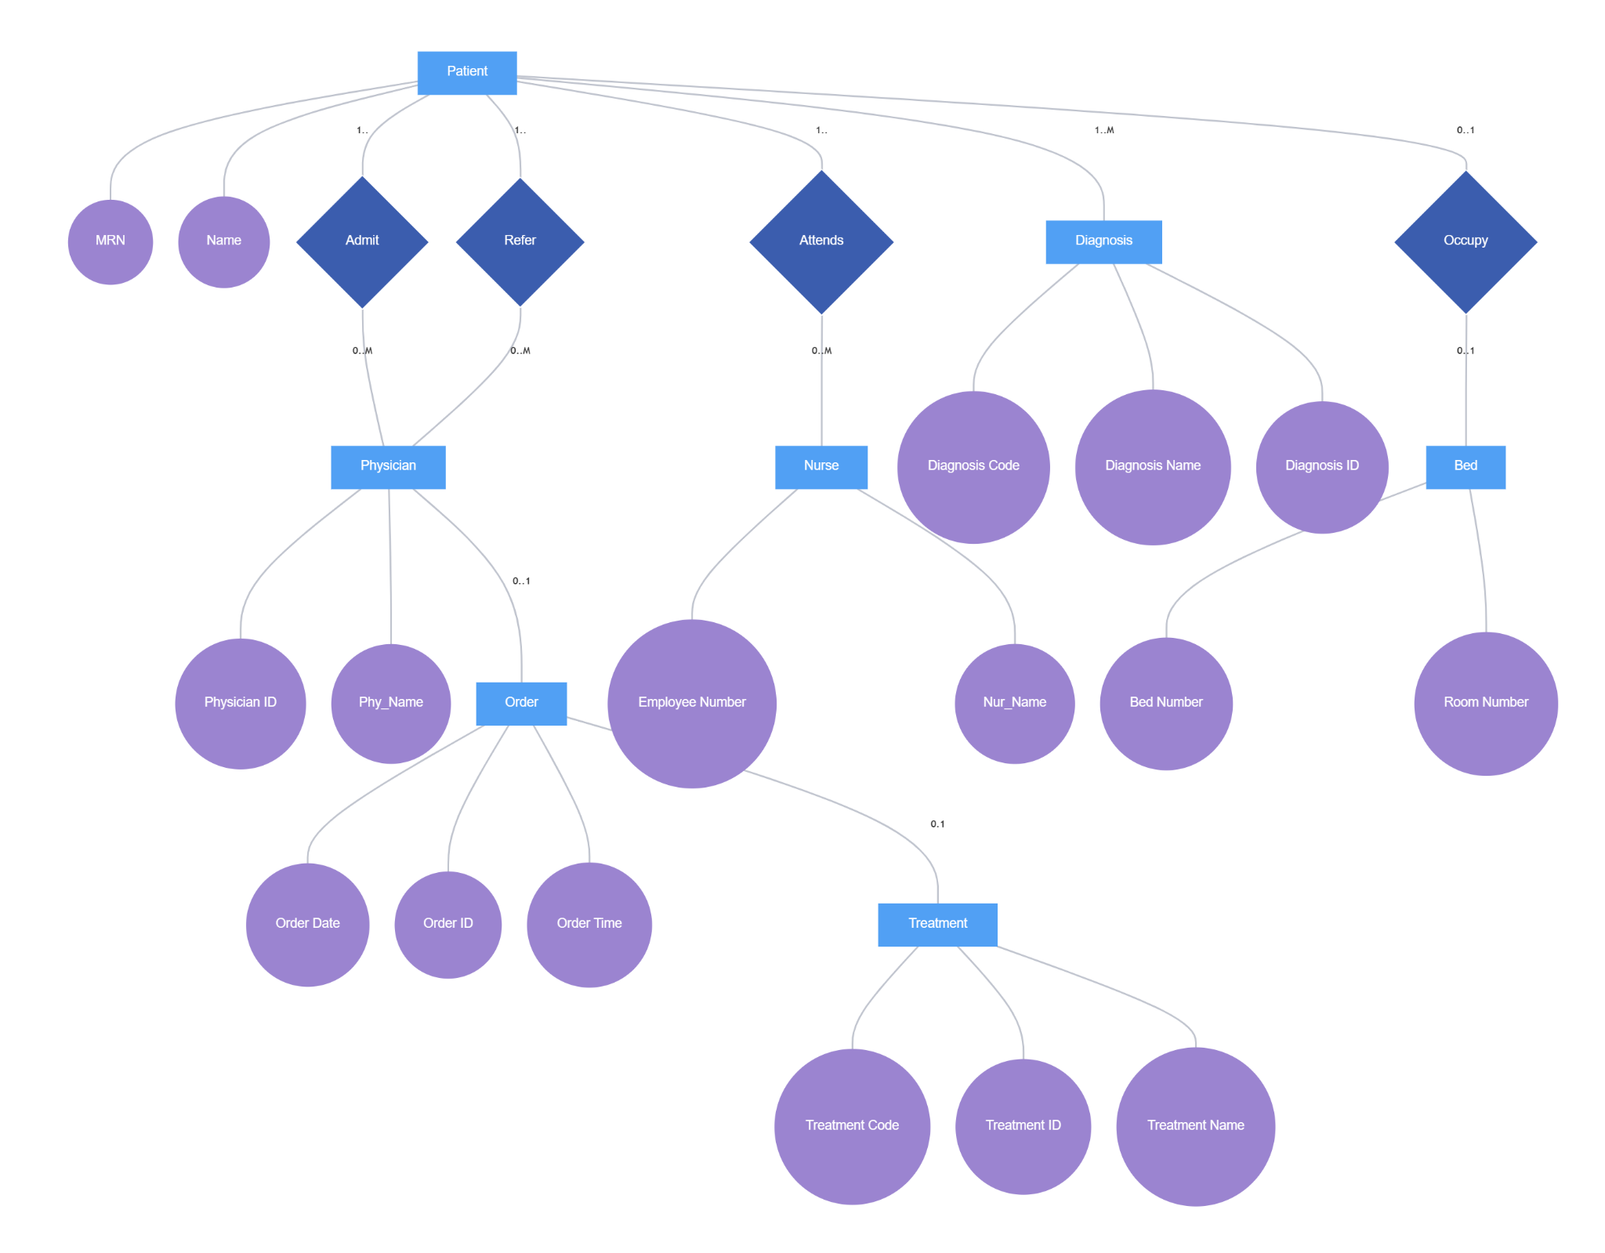

**Fig : Mountain View Community Hospital ER**

**Q5. Read the “Musicmatic” case study provided.**

**(1) Develop an (E)ER-diagram on the given details of the case study.**

**Ans :**

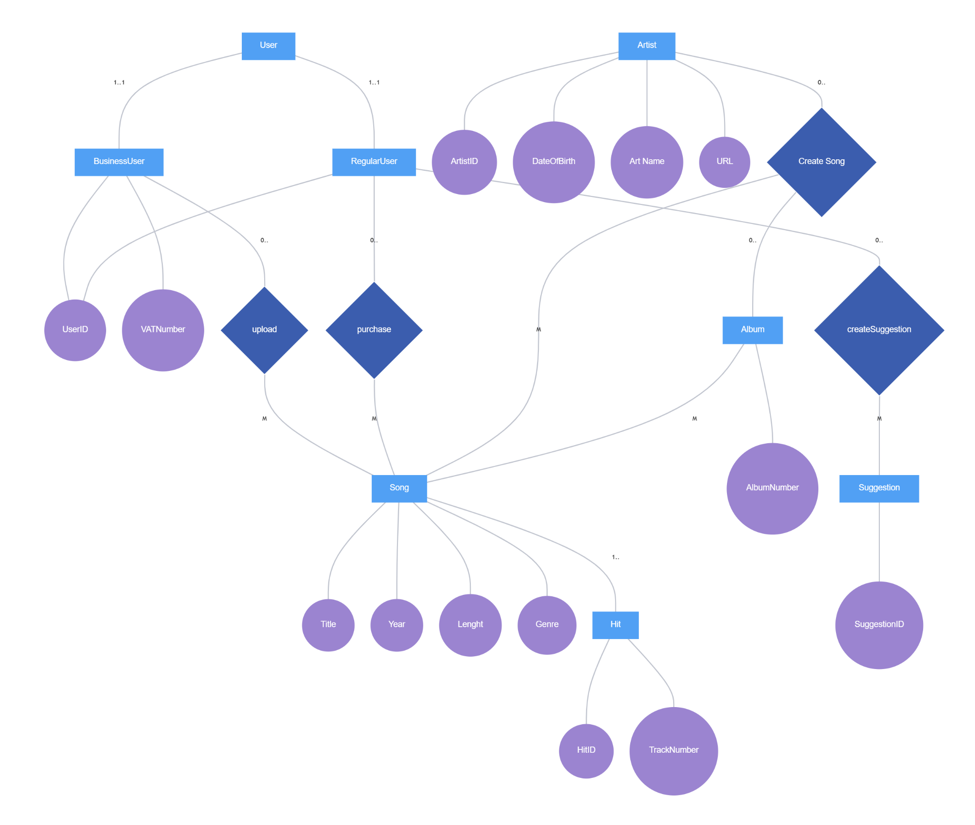

**Fig : Musicmatic ER Diagram**

**(2) Present the conceptual database schema of the case study using a UML class diagram.**

**The diagram includes not only attributes but also behaviors (methods) for each entity. Include the following methods in the classes associated with them. For the Song class, methods include: - getDetails(): Retrieve the song's details like title, year, length, and genre. - isSingle(): Check if the song is a single. The Artist class methods are: - createProfile(): Set up a new artist profile. - getBio(): Fetch the artist's biographical data. - listSongs(): List all songs by the artist. For only business users, the following methods include: - registerBusiness(): Register a new business account with a VAT number. - getUploadedSongs(): Retrieve a list of songs uploaded by the business user.**

**Ans:** 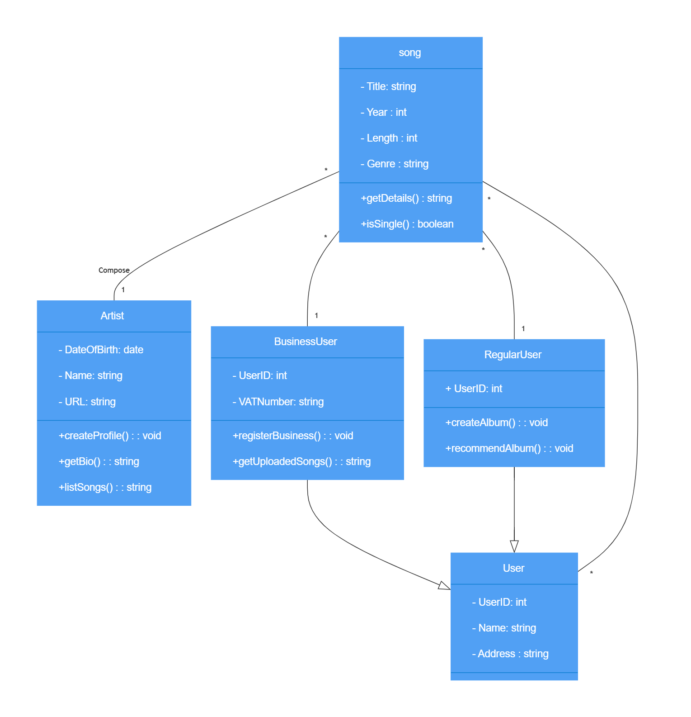

**Fig: UML class diagram Musicmatic**