1. **ABOUT PROJECT**

* **Task**: Automation Engineer
* **Description** - Create an automated test suite to test all the CRUD operations for the APIs
* **Repository** - <https://github.com/Asma-1994/QATask_Karate.git>
* **Language/Tools** –

***Language*** *: Java*

***Framework****: Karate*

***Test Report*** *: Cucumber Report and Surefire Report*

***Project Management and Build tool*** *- Maven*

***CI/CD Tool*** *– Jenkins*

* **Test Performed** –

Please note the API provided for PUT,POST and delete wasn't working on dummy restapi link provided hence different API used to test this operation

|  |  |  |  |  |  |
| --- | --- | --- | --- | --- | --- |
| Sr.No | Method | API | Feature File | Resource | Result |
| 1 | GET | http://dummy.restapiexample.com/api/v1/employees |  |  | PASS |
| 2 | GET | http://dummy.restapiexample.com/api/v1/employees/1 |  |  | PASS |
| 3 | PUT | https://reqres.in/api/users/2 |  |  | PASS |
| 4 | POST | https://reqres.in/api/users |  |  | PASS |
| 5 | DELETE | https://reqres.in/ /api/products/3 |  |  | PASS |

### Prerequisites

We need to install software -

* IDE – preferred Eclipse
* Java SE Development Kit – JDK 1.8
* Maven plugin in Eclipse
* Jenkins

### Installation -

All above pre-requisite software can be installed from official website

### Usage –

1. **Project structure –**

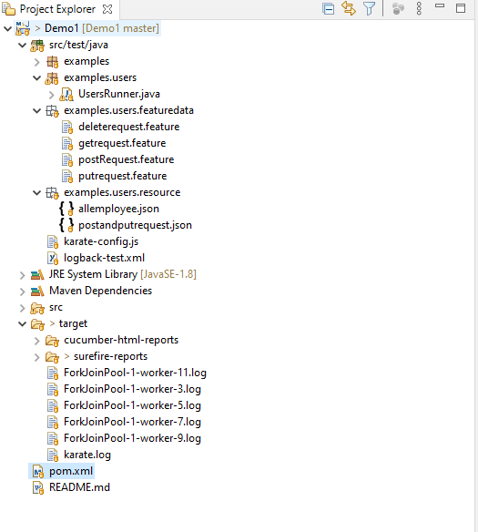

**2.Maven Dependency to be included in POM.xml**

<dependency>

<groupId>com.intuit.karate</groupId>

<artifactId>karate-apache</artifactId>

<version>0.9.6</version>

<scope>test</scope>

</dependency>

<dependency>

<groupId>com.intuit.karate</groupId>

<artifactId>karate-junit5</artifactId>

<version>0.9.6</version>

<scope>test</scope>

</dependency>

<dependency>

<groupId>net.masterthought</groupId>

<artifactId>cucumber-reporting</artifactId>

<version>5.3.1</version>

</dependency>

**3.Execute case from Command line/Eclipse run configuration –**

Run all the above 5 cases can be run as Regression suite with below maven command

**>** **mvn test -Dkarate.options="--tags @Regression"**

Run individual with below maven command

**>** **mvn test -Dkarate.options="—tags @scenario_tagname"**

**4.Execute case with Test Runner –**

Execute the Test Runner as JUnit Test

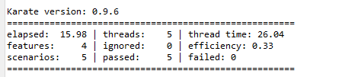

**5.Test Summary -**The Test summary generate in html format and can be shared - 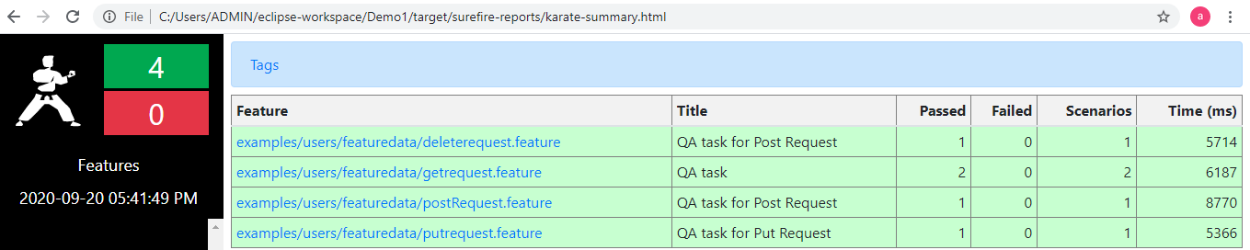

**6.Git Repository -**   
The maven project code is pushed in public Git Repository

**Repository** - <https://github.com/Asma-1994/QATask_Karate.git>

**7.Jenkins Pipeline integration -**   
(a) – Project build can be trigger with parameter(based on tags) –

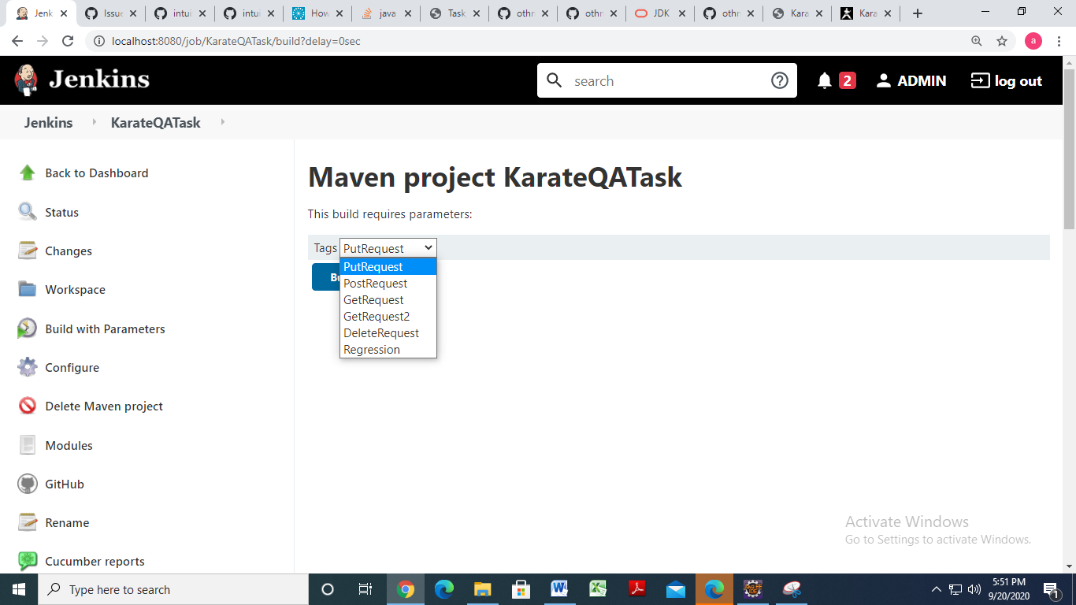

(b)Regression suites gets triggered daily based on below Configuration -   
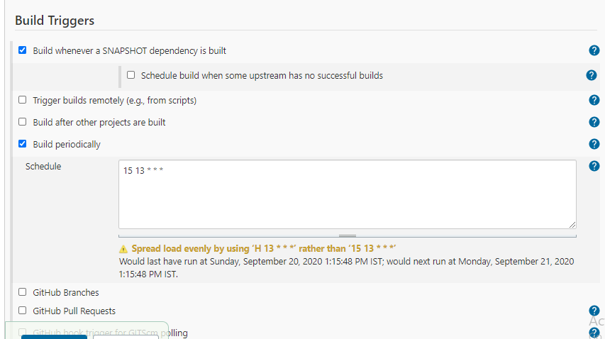

c ) Cucumber report generation with both eclipse and job run –

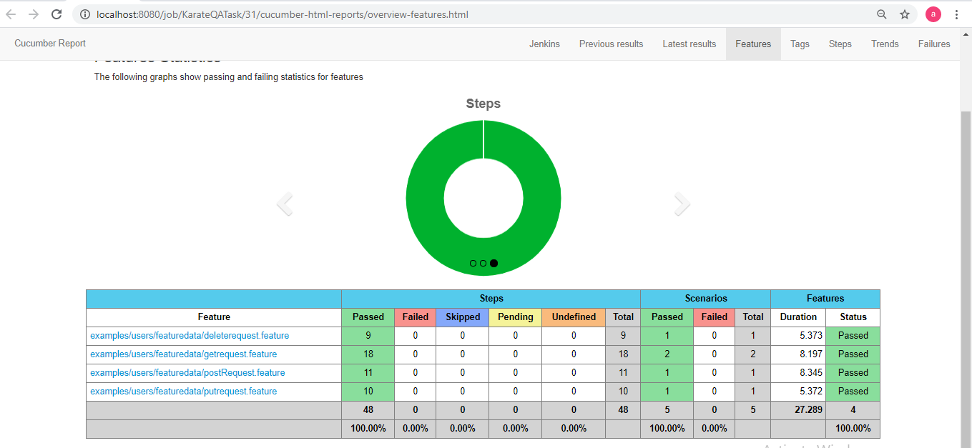

d)Email notification send out for failed build(Need to enhance with formatting and test report attachment) -   
