Online Games Popularity Prediction
Milestone 1 Technical Report
Team ID: CHP_2
Team Members
Name | ID
Menna Ali Thabet | 2022170844
Asmaa Waleed Sayed | 20231700208
Yousef Samir Atia | 20231700263
Ali Mohamed Gaber | 20231700234
Abdullah Hany Ahmed | 20231700231
Esraa Mahmoud Khakifa | 20231700207

Prepared for the project: Online Games Popularity Prediction
Date: 26 April 2026

1. Project Overview
This milestone focuses on predicting the popularity of Steam games using structured metadata, text signals, image metadata, and community-generated information. The target variable is RecommendationCount, and the main goal of this phase was to understand which signals are most related to game popularity and which preprocessing steps were necessary before regression modeling.
The raw dataset contained 11,357 games and 88 columns. After cleaning, duplicate removal, feature construction, and dropping columns that were not useful for modeling, the working dataframe became 11,315 rows and 84 columns. After one-hot encoding and other transformations, the feature space expanded to 144 columns before feature selection.

2. Dataset Analysis
The notebook first examined the structure of the data and the target distribution. The target RecommendationCount was highly skewed, which means the problem is dominated by a small number of very popular games and a large number of low-popularity games. This makes simple linear assumptions weak and motivates careful preprocessing and model selection.
Feature | Spearman r | Interpretation
SteamSpyPlayersEstimate | 0.79 | Strongest relationship with popularity
SteamSpyOwners | 0.75 | Very strong positive signal
SteamSpyOwnersVariance | 0.75 | Ownership-related signal remains useful
Metacritic | 0.47 | Moderate positive association
AchievementCount | 0.33 | Useful but weaker than audience-size features
PriceFinal | 0.26 | Price matters, but less than player-estimate signals
These correlations show that popularity is not driven by a single feature. The strongest evidence comes from audience-size proxies such as SteamSpyPlayersEstimate and SteamSpyOwners. In comparison, quality proxies such as Metacritic and AchievementCount are positive but weaker.
The visual analysis in the notebook also showed several important patterns: more movies/trailers and screenshots tended to increase median recommendations, free games typically attracted more recommendations than paid games, price had a non-linear effect, and older games accumulated more recommendations over time. Release year therefore needed to be treated carefully as a time-related signal rather than a simple standalone feature.
A URL/domain analysis was also performed. SupportURL and Website values were parsed because many developers had no dedicated web presence, while others used recognizable domains such as social pages or official portals. This led to the Support_Tier and Website_Authority features, which capture professionalism and publication style in a more compact way than raw URLs.

3. Preprocessing and Feature Engineering
The preprocessing pipeline was extensive because the dataset contained a mix of booleans, numeric values, text, URLs, list-like strings, dates, and sparse support/requirements fields. The main principle was to convert noisy raw metadata into compact signals while keeping leakage under control.
Technique | How it was implemented | Why it helped
Blank strings -> missing values | Replaced whitespace-only strings with NaN before imputation. | Allowed consistent missing-data handling.
Row inconsistency cleanup | Used more reliable source columns where duplicates or mismatches existed. | Reduced noise from conflicting fields.
Release date parsing | Parsed ReleaseDate and created Release_Year, Release_Month, month sine/cosine, and game age. | Captured seasonality and age effects.
Unified description text | Merged DetailedDescrip, AboutText, and ShortDescrip into Game_Description. | Reduced fragmentation across text fields.
Sparse text flags | Created Has_* indicators for fields like SupportEmail and DRMNotice. | Kept presence/absence signal without sparse noise.
List-like cleanup | Normalized SupportedLanguages and PopularUserTags into tuples. | Made tag counts and language-based features possible.
Text normalization | Removed trademark markers and cleaned special symbols in ordinary text columns. | Standardized text before downstream processing.
Review sentiment | Used a DistilBERT sentiment model on Reviews to create Review_Sentiment. | Converted long review text into a compact polarity feature.
Missing-value imputation | Used IterativeImputer with BayesianRidge for numeric fields; mode fill for categorical fields. | Preserved information while filling gaps.
Outlier handling | Examined boxplots, applied log1p to skewed numeric columns, then winsorized remaining extreme values. | Reduced the impact of heavy-tailed variables.
Encoding | Applied ordinal encoding to Header_Size_Group and one-hot encoding to categorical fields. | Prepared features for regression models.
Scaling | Standardized the final numeric feature set after feature selection. | Helped linear and distance-sensitive models.
Feature engineering also added several higher-level signals: Has_discount and discount_amount, platform_count, category_count, genre_count, language_count_log, header/background image size features, and semantic description embeddings. The description embeddings were produced with all-MiniLM-L6-v2 and reduced with PCA to 30 components, capturing 0.427 of the variance in the notebook.

3.1 Dataset sizes and split strategy
The final modeling split used train_test_split with an 80/20 split on indices only, so the dataframe itself remained available during preprocessing. The resulting split sizes were 9,052 training rows and 2,263 test rows.
Set | Size
Training | 9,052
Testing | 2,263
Validation | No separate validation set; 5-fold CV was used inside GridSearchCV on the training set

3.2 Feature selection and discarded columns
To avoid modeling with the full 144-feature matrix, a RandomForestRegressor was first fitted on the training split to estimate feature importance. The cumulative-importance cutoff kept 43 features covering 95% of the total importance mass.
The strongest retained features were SteamSpyPlayersEstimate, SteamSpyPlayersVariance, tag_count, pc_min_word_count, AchievementCount, PriceFinal, several semantic description components, header/background image sizes, SteamSpyOwners, SteamSpyOwnersVariance, and Release_Year. After this step, all selected features were numeric, so the final scaling step applied to all of them.
Kept / engineered feature groups | Discarded raw inputs
Game popularity proxies, semantic embeddings, image metadata, tags, price/platform/category richness, language count, and requirement-derived features | QueryID, ResponseID, QueryName, SupportURL, Background, HeaderImage, Website, AboutText, DetailedDescrip, ShortDescrip, Reviews, ReleaseDate variants, ResponseName, SupportEmail, LegalNotice, raw PC/Mac/Linux requirement text, constant columns, duplicates, and very high-missing columns

4. Regression Models
The notebook compared at least two regression families, but in practice it tested several models: LinearRegression, Ridge, Lasso, DecisionTreeRegressor, RandomForestRegressor, GradientBoostingRegressor, ExtraTreesRegressor, and a separate XGBoost regressor. Hyperparameters were tuned with GridSearchCV using 5-fold KFold cross-validation on the training data.
The main difference between the models is how they learn relationships. Linear models assume an approximately linear relation and are easy to interpret. Ridge adds L2 regularization to reduce coefficient instability. Lasso adds L1 regularization and can shrink weak features toward zero. Tree models capture non-linear patterns and interactions: a single decision tree is interpretable but can overfit, while Random Forest, Extra Trees, and Gradient Boosting reduce error by combining many trees in different ways.
Model | Train MSE | Test MSE | Train R² | Test R²
Linear Regression | 3.4471 | 3.3742 | 0.6675 | 0.6771
Ridge | 3.4473 | 3.3760 | 0.6675 | 0.6769
Lasso | 4.7326 | 4.7095 | 0.5436 | 0.5493
Decision Tree | 2.2790 | 2.4038 | 0.7802 | 0.7699
Random Forest | 1.0430 | 2.1442 | 0.8994 | 0.7948
Gradient Boosting | 1.1855 | 2.0802 | 0.8857 | 0.8009
Extra Trees | 1.2930 | 2.1116 | 0.8753 | 0.7979
XGBoost | 1.5495 | 2.0999 | 0.8506 | 0.7990
Gradient Boosting achieved the best test R² in the notebook (0.8009) with the lowest test MSE among the compared models (2.0802). XGBoost was extremely close, with a test R² of 0.7990. Random Forest achieved the best train score, but its larger train-test gap suggests slightly more overfitting than Gradient Boosting. Lasso performed the worst of the tested models, which suggests that the data is not well explained by a heavily sparse linear fit.

5. Plots and Observations
The figures below summarize the model comparison and the residual behavior of the best model. They were taken from the notebook outputs and included here as evidence of performance.
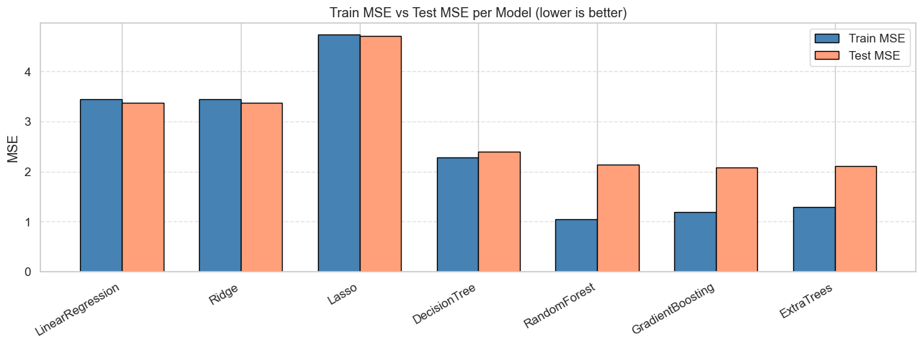
Figure 1. Train and test MSE per model.
Observation: linear models sit around the 3.4 MSE range, while tree ensembles reduce the error substantially. Gradient Boosting and XGBoost are the strongest generalizers among the tested models.
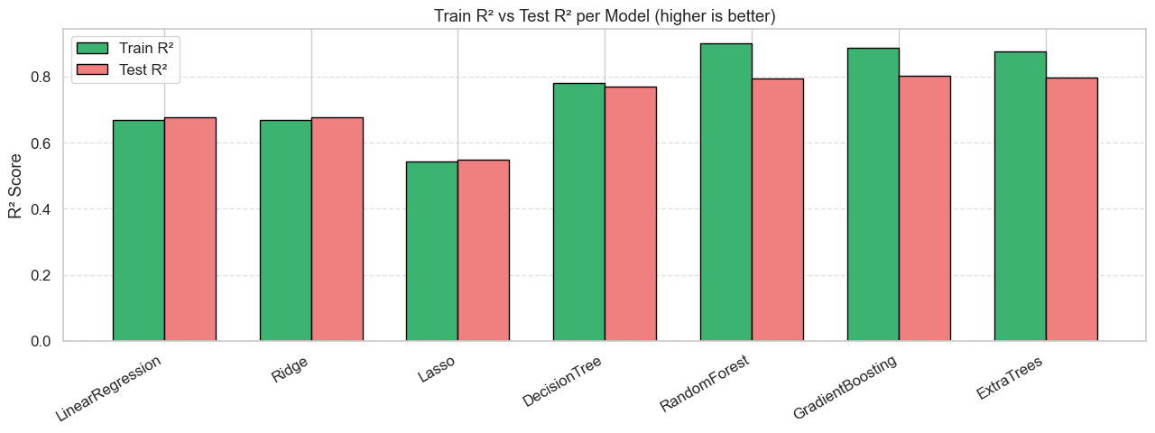
Figure 2. Train and test R² per model.
Observation: ensemble trees clearly outperform the linear baselines. Random Forest has the highest train R², but Gradient Boosting gives the best test R², which is the more important result for generalization.
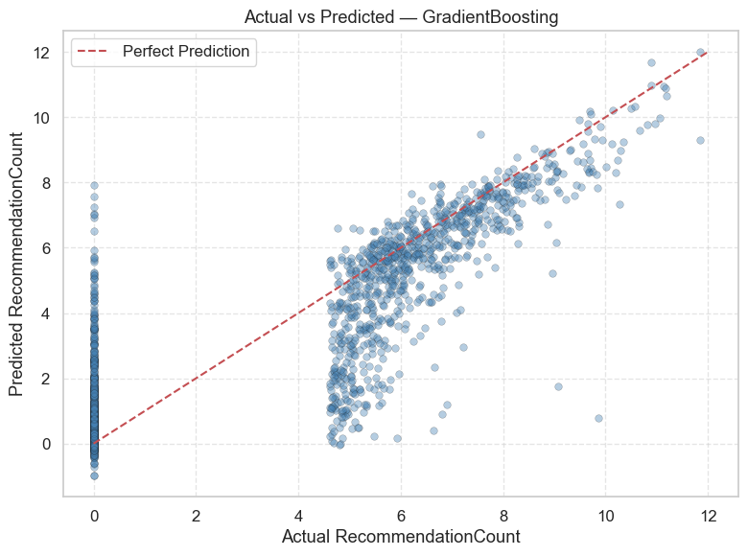
Figure 3. Actual versus predicted values for the best model.
Observation: predictions follow the diagonal trend closely, which means the model captures the overall ordering of popularity well. The spread becomes wider for extreme values, showing that very large recommendation counts are harder to predict precisely.
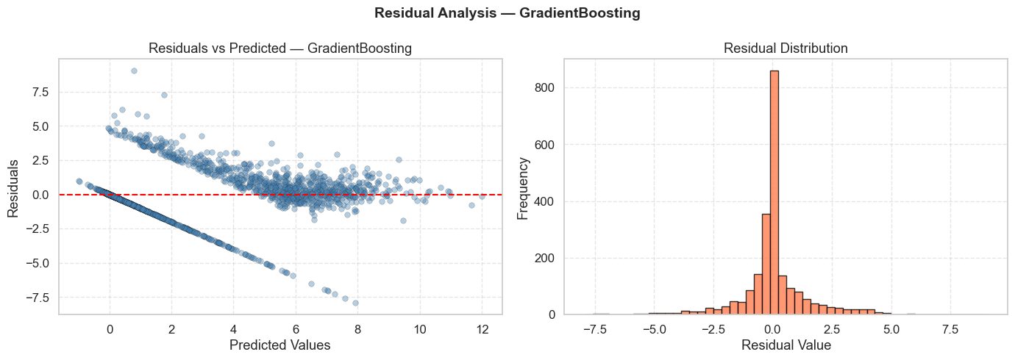
Figure 4. Residual analysis for the best model.
Observation: residuals are centered near zero and the histogram is concentrated around the middle, which is a good sign. The scatter still widens for larger predicted values, indicating that high-popularity games remain the hardest cases.

6. Conclusion
This milestone confirmed the main intuition behind the project: online game popularity is driven mostly by strong audience and visibility signals, not by a single raw field. SteamSpy player and owner estimates were the most important predictors, while price, achievements, media richness, semantic description features, and metadata about developer support and web presence contributed additional value.
The preprocessing work also proved that many raw columns were too noisy or too sparse to use directly. Converting text and list fields into compact engineered features, handling missing values carefully, and reducing the feature space to the most informative variables made the regression problem much easier for the models.
Overall, the linear models provided a useful baseline, but the tree-based ensemble models clearly performed better. Gradient Boosting was the best final choice in this milestone, with XGBoost very close behind. The results support the idea that game popularity depends on a mixture of structured metadata, community signals, and descriptive quality indicators.

