Capstone_progress
Asma Abbas
library(tidyverse)
Warning: package 'tidyverse' was built under R version 4.5.2
Warning: package 'ggplot2' was built under R version 4.5.2
Warning: package 'tibble' was built under R version 4.5.2
Warning: package 'tidyr' was built under R version 4.5.2
Warning: package 'readr' was built under R version 4.5.2
Warning: package 'purrr' was built under R version 4.5.2
Warning: package 'dplyr' was built under R version 4.5.2
Warning: package 'stringr' was built under R version 4.5.2
Warning: package 'forcats' was built under R version 4.5.2
Warning: package 'lubridate' was built under R version 4.5.2
── Attaching core tidyverse packages ──────────────────────── tidyverse 2.0.0 ──
✔ dplyr 1.2.0 ✔ readr 2.2.0
✔ forcats 1.0.1 ✔ stringr 1.6.0
✔ ggplot2 4.0.2 ✔ tibble 3.3.1
✔ lubridate 1.9.5 ✔ tidyr 1.3.2
✔ purrr 1.2.1
── Conflicts ────────────────────────────────────────── tidyverse_conflicts() ──
✖ dplyr::filter() masks stats::filter()
✖ dplyr::lag() masks stats::lag()
ℹ Use the conflicted package (<http://conflicted.r-lib.org/>) to force all conflicts to become errors
library(janitor)
Warning: package 'janitor' was built under R version 4.5.3
Attaching package: 'janitor'
The following objects are masked from 'package:stats':
chisq.test, fisher.test
library(cheapr)
Warning: package 'cheapr' was built under R version 4.5.3
Attaching package: 'cheapr'
The following object is masked from 'package:forcats':
as_factor
The following objects are masked from 'package:purrr':
list_assign, list_modify

Ingesting data
#step 1: importing the datasets
setwd("C:/Users/Saima Abbas/Desktop/CAPSTONE DOCS")
MD_counties <-read_csv("Maryland_Counties_Socioeconomic_Characteristics__ACS_5-yr_Estimates_2022_.csv")
Registered S3 methods overwritten by 'bit64':
method from
as.double.integer64 cheapr
as.integer.integer64 cheapr
Rows: 24 Columns: 41
── Column specification ────────────────────────────────────────────────────────
Delimiter: ","
chr (1): Jurisdictions
dbl (40): Total Households, Population 25 years and older, Less than 9th Gra...
ℹ Use `spec()` to retrieve the full column specification for this data.
ℹ Specify the column types or set `show_col_types = FALSE` to quiet this message.
MCPS <-read_csv("hs_demographic_other_information.csv")
Rows: 25 Columns: 23
── Column specification ────────────────────────────────────────────────────────
Delimiter: ","
chr (11): School Name, X, AM, AS, BL, PI, 2+, WH, EML, Graduation Rate?, Dro...
dbl (12): Total, Female, Male, HI, FARMS, Spec. Ed., Ever FARMS, Attendance ...
ℹ Use `spec()` to retrieve the full column specification for this data.
ℹ Specify the column types or set `show_col_types = FALSE` to quiet this message.

cleanign
MD_counties <- clean_names(MD_counties)
MCPS <- clean_names(MCPS)
colnames(MD_counties)
[1] "jurisdictions"
[2] "total_households"
[3] "population_25_years_and_older"
[4] "less_than_9th_grade"
[5] "high_school_no_diploma"
[6] "high_school_diploma"
[7] "some_college_no_degree"
[8] "associates_degree"
[9] "bachelors_degree"
[10] "graduate_or_professional"
[11] "employment_status_of_the_population_16_years_and_over"
[12] "civilian_labor_force_16_years_over"
[13] "employed"
[14] "unemployed"
[15] "unemployment_rate"
[16] "commute_workers_16_yrs_and_over"
[17] "percent_drove_alone"
[18] "percent_carpooled"
[19] "percent_public_transportation"
[20] "percent_walked"
[21] "percent_other"
[22] "percent_worked_at_home"
[23] "median_household_income"
[24] "families"
[25] "percent_families_in_poverty"
[26] "percent_civilian_population_w_health_ins_cov"
[27] "total_housing_units"
[28] "percent_occupied"
[29] "percent_vacant"
[30] "total_population"
[31] "voting_age_population"
[32] "male"
[33] "female"
[34] "white_alone"
[35] "black_alone"
[36] "asian_alone"
[37] "american_indian_alaska_native_alone"
[38] "native_hawaiian_pacific_islander_alone"
[39] "some_other_race_alone"
[40] "two_or_more_races"
[41] "hispanic_or_latino_of_any_race"
colnames(MCPS)
[1] "school_name" "total" "female"
[4] "male" "x" "am"
[7] "as" "bl" "hi"
[10] "pi" "x2" "wh"
[13] "eml" "farms" "spec_ed"
[16] "ever_farms" "attendance_rate" "graduation_rate"
[19] "dropout_rate" "mobility_rate" "stud_instr_staff_ratio"
[22] "english_class_size" "other_class_size"
MD_counties <- MD_counties |>
rename(
county = jurisdictions,
poverty_rate = percent_families_in_poverty,
median_income = median_household_income,
unemployment_rate = unemployment_rate
)
MCPS <- MCPS |>
rename(
school = school_name,
grad_rate = graduation_rate,
dropout_rate = dropout_rate,
attendance_rate = attendance_rate,
FARMS_rate = farms
)

More cleaning
MD_clean <- MD_counties |>
filter(!is.na(poverty_rate))
nrow(MD_clean)
[1] 24
sum(is.na(MCPS))
[1] 0
MCPS_clean <- MCPS |>
filter(!is.na(grad_rate), !is.na(FARMS_rate))
nrow(MCPS_clean)
[1] 25
##summary stats:
summary(MCPS_clean$grad_rate)
Length Class Mode
25 character character
summary(MCPS_clean$grad_rate)
Length Class Mode
25 character character
summary(MCPS_clean$FARMS_rate)
Min. 1st Qu. Median Mean 3rd Qu. Max.
6.40 22.00 44.80 39.17 55.50 65.90
summary(MD_clean$poverty_rate)
Min. 1st Qu. Median Mean 3rd Qu. Max.
2.800 4.475 6.250 6.721 8.150 15.600
summary(MD_clean$median_income)
Min. 1st Qu. Median Mean 3rd Qu. Max.
52149 68397 87513 90906 114182 140971
ggplot(MCPS_clean, aes(x = FARMS_rate, y = grad_rate)) +
geom_point(color = "blue", size = 2, alpha = 0.7) +
geom_smooth(method = "lm", color = "red", se = FALSE) +
labs(
title = "FARMS Rate vs Graduation Rate",
x = "FARMS (Proxy for Poverty)",
y = "Graduation Rate"
) +
theme_minimal()
`geom_smooth()` using formula = 'y ~ x'
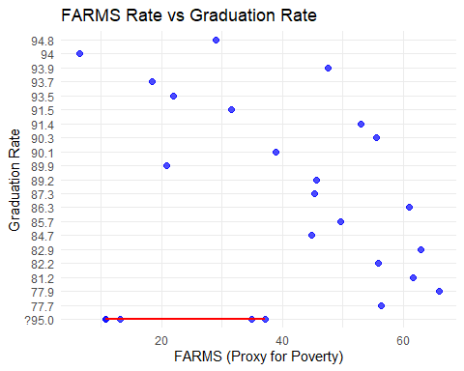
ggplot(MCPS, aes(x = attendance_rate, y = grad_rate)) +
geom_point(color = "purple", size = 2) +
geom_smooth(method = "lm", color = "black") +
labs(
title = "Attendance vs Graduation Rate",
x = "Attendance Rate",
y = "Graduation Rate"
) +
theme_minimal()
`geom_smooth()` using formula = 'y ~ x'
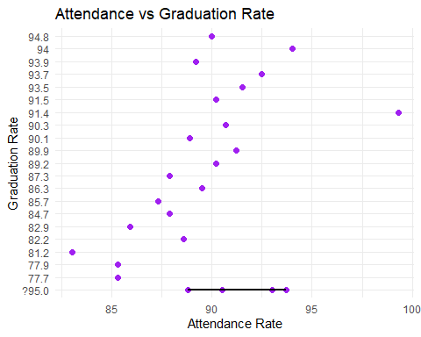
ggplot(MD_counties, aes(x = reorder(county, poverty_rate), y = poverty_rate)) +
geom_bar(stat = "identity", fill = "steelblue") +
coord_flip() +
labs(
title = "Poverty Rate by Maryland County",
x = "County",
y = "Poverty Rate (%)"
) +
theme_minimal()
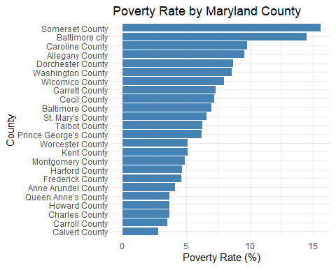
ggplot(MD_clean, aes(x = reorder(county, poverty_rate), y = poverty_rate)) +
geom_bar(stat = "identity", fill = "steelblue") +
coord_flip() +
labs(
color = "unemployment_rate",
title = "Poverty Rate by Maryland County",
x = "County",
y = "Poverty Rate (%)",
) +
theme_minimal()
Ignoring unknown labels:
• colour : "unemployment_rate"

ggplot(MD_clean, aes(x = median_income, y = poverty_rate)) +
geom_point(color = "darkblue", size = 2) +
geom_smooth(method = "lm", color = "black") +
labs(
title = "Income vs Poverty Rate",
x = "Median Income",
y = "Poverty Rate"
) +
theme_minimal()
`geom_smooth()` using formula = 'y ~ x'
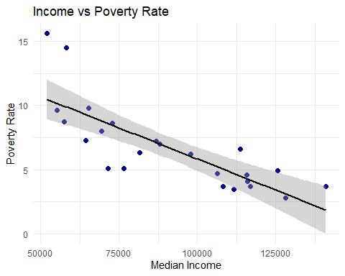
nrow(MCPS)
[1] 25
nrow(MCPS_clean)
[1] 25
ggplot(MCPS_clean, aes(x = FARMS_rate, y = grad_rate, color = attendance_rate)) +
geom_point(size = 3, alpha = 0.8) +
geom_smooth(method = "lm", color = "black", se = FALSE) +
scale_color_gradient(low = "blue", high = "red") +
labs(
title = "FARMS vs Graduation (Colored by Attendance)",
x = "FARMS Rate (Poverty Proxy)",
y = "Graduation Rate",
color = "Attendance Rate"
) +
theme_minimal()
`geom_smooth()` using formula = 'y ~ x'
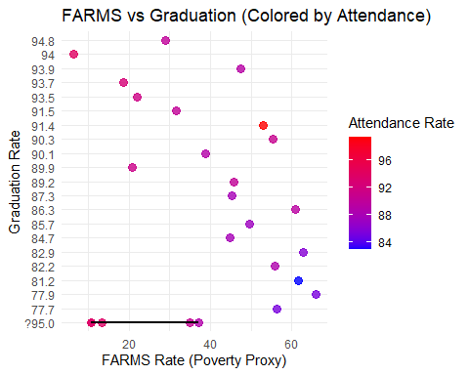
ggplot(MCPS_clean, aes(x = FARMS_rate, y = grad_rate, color = total)) +
geom_point(size = 3, alpha = 0.8) +
geom_smooth(method = "lm", color = "black", se = FALSE) +
scale_color_gradient(low = "lightpink", high = "darkred") +
labs(
title = "FARMS vs Dropout (Colored by Graduation Rate)",
x = "FARMS Rate",
y = "Dropout Rate",
color = "Graduation Rate"
) +
theme_minimal()
`geom_smooth()` using formula = 'y ~ x'
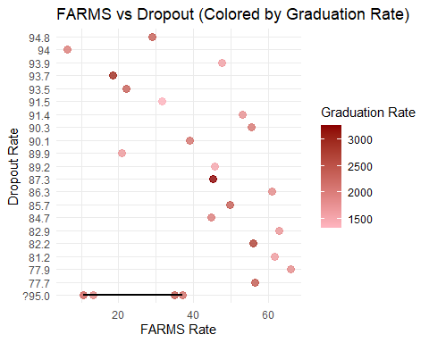
ggplot(MCPS_clean, aes(x = FARMS_rate, y = grad_rate)) +
geom_point() +
theme_minimal()
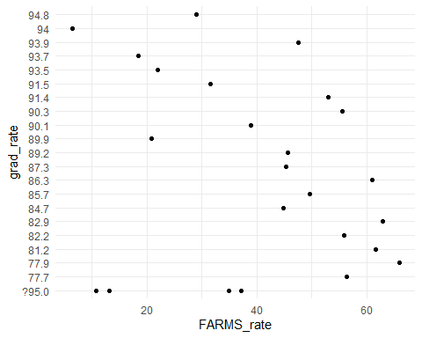
mcps_no_outliers <- MCPS_clean %>%
filter(grad_rate > 60) # adjust threshold
ggplot(mcps_no_outliers, aes(x = FARMS_rate, y = grad_rate,
color = attendance_rate)) +
geom_point(size = 3, alpha = 0.8) +
geom_smooth(method = "lm", color = "black", se = FALSE) +
scale_color_gradient(low = "blue", high = "red") +
labs(
title = "FARMS vs Graduation (Colored by Attendance)",
x = "FARMS Rate (Poverty Proxy)",
y = "Graduation Rate",
color = "Attendance Rate"
) +
theme_minimal()
`geom_smooth()` using formula = 'y ~ x'
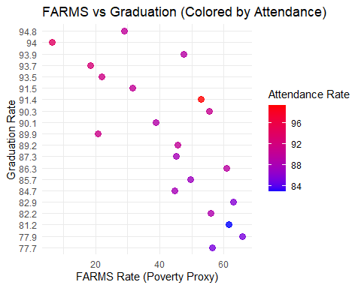
MCPS_clean <- MCPS_clean |>
mutate(
grad_rate = as.numeric(gsub("%", "", grad_rate)),
FARMS_rate = as.numeric(gsub("%", "", FARMS_rate)),
dropout_rate = as.numeric(gsub("%", "", dropout_rate)),
attendance_rate = as.numeric(gsub("%", "", attendance_rate))
)
Warning: There were 2 warnings in `mutate()`.
The first warning was:
ℹ In argument: `grad_rate = as.numeric(gsub("%", "", grad_rate))`.
Caused by warning:
! NAs introduced by coercion
ℹ Run `dplyr::last_dplyr_warnings()` to see the 1 remaining warning.
str(MCPS_clean)
tibble [25 × 23] (S3: tbl_df/tbl/data.frame)
$ school : chr [1:25] "Albert Einstein" "Bethesda-Chevy Chase" "Clarksburg" "Col. Zadok Magruder" ...
$ total : num [1:25] 2024 2368 2214 1620 1398 ...
$ female : num [1:25] 48.3 49.2 47.3 47.1 48.9 46.5 51.2 49.5 47 48.4 ...
$ male : num [1:25] 50.8 50.2 52.3 52.8 51.1 53.3 48.3 50.4 52.2 51.2 ...
$ x : chr [1:25] "?5.0" "?5.0" "?5.0" "?5.0" ...
$ am : chr [1:25] "?5.0" "?5.0" "?5.0" "?5.0" ...
$ as : chr [1:25] "6.2" "6.7" "24.4" "12" ...
$ bl : chr [1:25] "15.9" "16.7" "28.4" "19.4" ...
$ hi : num [1:25] 50.4 21 27.1 44.1 30.8 62 34.7 68.1 38.2 26.2 ...
$ pi : chr [1:25] "?5.0" "?5.0" "?5.0" "?5.0" ...
$ x2 : chr [1:25] "?5.0" "5.8" "5.2" "?5.0" ...
$ wh : chr [1:25] "22.5" "49.4" "14.5" "20.2" ...
$ eml : chr [1:25] "20.9" "9" "9.5" "16.7" ...
$ FARMS_rate : num [1:25] 44.8 22 37.1 47.5 31.6 56.4 53 65.9 45.3 35 ...
$ spec_ed : num [1:25] 14.3 6 9.4 13.2 15.9 11.1 7.1 10.5 7.6 7.9 ...
$ ever_farms : num [1:25] 61.9 28.9 50.1 62.6 41.8 76.6 66.7 82.1 55.1 47.9 ...
$ attendance_rate : num [1:25] 87.9 91.5 88.8 89.2 90.2 85.3 99.3 85.3 87.9 90.5 ...
$ grad_rate : num [1:25] 84.7 93.5 NA 93.9 91.5 77.7 91.4 77.9 87.3 NA ...
$ dropout_rate : num [1:25] 8.2 NA NA NA NA 16.7 6.8 18 11.1 NA ...
$ mobility_rate : num [1:25] 12.4 8.9 12.5 11.9 8.4 21.7 12.4 21.3 11.9 9 ...
$ stud_instr_staff_ratio: num [1:25] 10.1 14.7 12.1 11 10.9 9.9 13.5 10 13.3 12.6 ...
$ english_class_size : num [1:25] 26.7 21.8 18 25 25.7 22.8 27.3 21.6 21.6 24.8 ...
$ other_class_size : num [1:25] 21.3 17.4 16.6 21.6 22.5 21.2 24.9 21.8 22.3 23.8 ...
ggplot(MD_clean, aes(x = reorder(county, poverty_rate),
y = poverty_rate,
fill = median_income)) +
geom_bar(stat = "identity") +
coord_flip() +
scale_fill_gradient(low = "lightblue", high = "darkblue") +
labs(
title = "Poverty Rate by County (Colored by Income)",
x = "County",
y = "Poverty Rate (%)",
fill = "Median Income"
) +
theme_minimal()
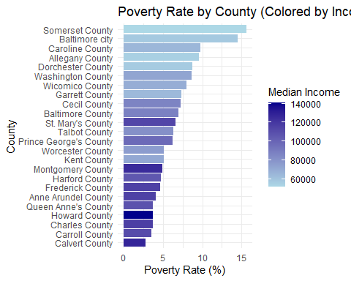
# Mean, median, sd
MCPS_clean |>
summarise(
mean_grad = mean(grad_rate, na.rm = TRUE),
median_grad = median(grad_rate, na.rm = TRUE),
sd_grad = sd(grad_rate, na.rm = TRUE),
mean_farms = mean(FARMS_rate, na.rm = TRUE),
median_farms = median(FARMS_rate, na.rm = TRUE),
sd_farms = sd(FARMS_rate, na.rm = TRUE)
)
# A tibble: 1 × 6
mean_grad median_grad sd_grad mean_farms median_farms sd_farms
<dbl> <dbl> <dbl> <dbl> <dbl> <dbl>
1 87.9 89.6 5.39 39.2 44.8 18.5
MD_clean
# A tibble: 24 × 41
county total_households population_25_years_…¹ less_than_9th_grade
<chr> <dbl> <dbl> <dbl>
1 Allegany County 27462 47914 1036
2 Anne Arundel Cou… 221704 409052 9100
3 Baltimore County 328611 589611 19201
4 Calvert County 33284 64176 730
5 Caroline County 12013 22837 1226
6 Carroll County 63318 120559 2089
7 Cecil County 39338 72203 1663
8 Charles County 59205 112613 2386
9 Dorchester County 13216 23327 810
10 Frederick County 99891 186771 5864
# ℹ 14 more rows
# ℹ abbreviated name: ¹​population_25_years_and_older
# ℹ 37 more variables: high_school_no_diploma <dbl>, high_school_diploma <dbl>,
# some_college_no_degree <dbl>, associates_degree <dbl>,
# bachelors_degree <dbl>, graduate_or_professional <dbl>,
# employment_status_of_the_population_16_years_and_over <dbl>,
# civilian_labor_force_16_years_over <dbl>, employed <dbl>, …
ggplot(MCPS_clean, aes(x = grad_rate)) +
geom_histogram(bins = 10, fill = "steelblue", color = "black") +
labs(
title = "Distribution of Graduation Rates",
x = "Graduation Rate",
y = "Count"
) +
theme_minimal()
Warning: Removed 5 rows containing non-finite outside the scale range
(`stat_bin()`).
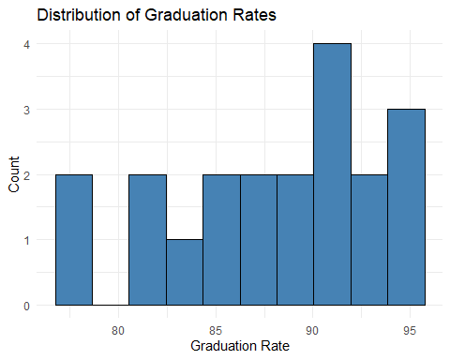
MD_clean <- MD_clean |>
mutate(
poverty_rate = as.numeric(gsub(",", "", poverty_rate)),
median_income = as.numeric(gsub(",", "", median_income)),
unemployment_rate = as.numeric(gsub(",", "", unemployment_rate))
)
summary(MD_clean)
county total_households population_25_years_and_older
Length:24 Min. : 8355 Min. : 13958
Class :character 1st Qu.: 18581 1st Qu.: 34205
Mode :character Median : 40575 Median : 74171
Mean : 96589 Mean :177504
3rd Qu.:104726 3rd Qu.:196392
Max. :385284 Max. :729862
less_than_9th_grade high_school_no_diploma high_school_diploma
Min. : 334.0 Min. : 987 Min. : 4502
1st Qu.: 713.2 1st Qu.: 2057 1st Qu.: 10198
Median : 2044.5 Median : 4371 Median : 24360
Mean : 6767.7 Mean : 9229 Mean : 42197
3rd Qu.: 5282.0 3rd Qu.: 7912 3rd Qu.: 44702
Max. :46553.0 Max. :37833 Max. :164184
some_college_no_degree associates_degree bachelors_degree
Min. : 2141 Min. : 780 Min. : 1965
1st Qu.: 6796 1st Qu.: 2615 1st Qu.: 6355
Median : 14962 Median : 5696 Median : 13548
Mean : 32192 Mean :12170 Mean : 39705
3rd Qu.: 34349 3rd Qu.:15605 3rd Qu.: 51688
Max. :131401 Max. :43084 Max. :198924
graduate_or_professional employment_status_of_the_population_16_years_and_over
Min. : 893 Min. : 16670
1st Qu.: 4720 1st Qu.: 38592
Median : 10305 Median : 86832
Mean : 35243 Mean :206554
3rd Qu.: 44453 3rd Qu.:228687
Max. :239200 Max. :843577
civilian_labor_force_16_years_over employed unemployed
Min. : 9594 Min. : 9279 Min. : 647
1st Qu.: 24177 1st Qu.: 22747 1st Qu.: 1150
Median : 57051 Median : 54088 Median : 2658
Mean :137516 Mean :130476 Mean : 4978
3rd Qu.:157990 3rd Qu.:152081 3rd Qu.: 4755
Max. :589278 Max. :560749 Max. :19079
unemployment_rate commute_workers_16_yrs_and_over percent_drove_alone
Min. :3.000 Min. : 9119 Min. :56.90
1st Qu.:4.000 1st Qu.: 22310 1st Qu.:72.28
Median :5.000 Median : 54292 Median :76.85
Mean :4.958 Mean :129212 Mean :74.27
3rd Qu.:6.250 3rd Qu.:150695 3rd Qu.:78.12
Max. :7.000 Max. :551214 Max. :81.50
percent_carpooled percent_public_transportation percent_walked
Min. : 5.200 Min. : 0.400 Min. :0.600
1st Qu.: 6.875 1st Qu.: 0.675 1st Qu.:1.325
Median : 7.700 Median : 1.150 Median :1.650
Mean : 7.854 Mean : 2.475 Mean :2.146
3rd Qu.: 8.900 3rd Qu.: 2.300 3rd Qu.:2.550
Max. :11.600 Max. :12.800 Max. :8.600
percent_other percent_worked_at_home median_income families
Min. :0.500 Min. : 5.00 Min. : 52149 Min. : 4989
1st Qu.:1.050 1st Qu.: 9.00 1st Qu.: 68397 1st Qu.: 13249
Median :1.300 Median :12.00 Median : 87513 Median : 28338
Mean :1.633 Mean :11.71 Mean : 90906 Mean : 63544
3rd Qu.:2.125 3rd Qu.:14.00 3rd Qu.:114182 3rd Qu.: 75714
Max. :4.400 Max. :22.00 Max. :140971 Max. :266286
poverty_rate percent_civilian_population_w_health_ins_cov
Min. : 2.800 Min. :90.00
1st Qu.: 4.475 1st Qu.:94.75
Median : 6.250 Median :96.00
Mean : 6.721 Mean :95.17
3rd Qu.: 8.150 3rd Qu.:96.00
Max. :15.600 Max. :97.00
total_housing_units percent_occupied percent_vacant total_population
Min. : 10320 Min. :41.60 Min. : 3.00 Min. : 19289
1st Qu.: 20955 1st Qu.:83.38 1st Qu.: 5.00 1st Qu.: 47153
Median : 51032 Median :90.90 Median : 9.50 Median : 108845
Mean :105461 Mean :87.20 Mean :12.92 Mean : 256738
3rd Qu.:109020 3rd Qu.:95.03 3rd Qu.:17.00 3rd Qu.: 288375
Max. :403643 Max. :96.60 Max. :58.00 Max. :1056910
voting_age_population male female white_alone
Min. : 191 Min. : 10320 Min. : 15837 Min. : 199
1st Qu.: 1200 1st Qu.: 20955 1st Qu.: 36381 1st Qu.: 1248
Median : 3979 Median : 51032 Median : 81539 Median : 2848
Mean : 8604 Mean :105461 Mean :183802 Mean : 20387
3rd Qu.:11216 3rd Qu.:109020 3rd Qu.:206781 3rd Qu.: 15928
Max. :35915 Max. :403643 Max. :685027 Max. :180066
black_alone asian_alone american_indian_alaska_native_alone
Min. : 18389 Min. : 364 Min. : 12785
1st Qu.: 44740 1st Qu.: 5978 1st Qu.: 38481
Median :103075 Median : 13776 Median : 76068
Mean :228700 Mean : 75662 Mean :124542
3rd Qu.:262880 3rd Qu.: 69172 3rd Qu.:158573
Max. :845424 Max. :578048 Max. :459907
native_hawaiian_pacific_islander_alone some_other_race_alone two_or_more_races
Min. : 4.0 Min. : 120.0 Min. : 0.00
1st Qu.: 33.5 1st Qu.: 539.8 1st Qu.: 0.00
Median : 100.5 Median : 2755.5 Median : 26.50
Mean : 353.3 Mean : 16541.0 Mean : 87.71
3rd Qu.: 398.8 3rd Qu.: 13849.8 3rd Qu.:122.75
Max. :2033.0 Max. :160373.0 Max. :389.00
hispanic_or_latino_of_any_race
Min. : 374
1st Qu.: 1965
Median : 4773
Mean : 21821
3rd Qu.: 18661
Max. :166989
MD_clean |>
summarise(
mean_poverty = mean(poverty_rate, na.rm = TRUE),
median_poverty = median(poverty_rate, na.rm = TRUE),
sd_poverty = sd(poverty_rate, na.rm = TRUE),
mean_income = mean(median_income, na.rm = TRUE),
median_income = median(median_income, na.rm = TRUE),
sd_income = sd(median_income, na.rm = TRUE),
mean_unemployment = mean(unemployment_rate, na.rm = TRUE),
median_unemployment = median(unemployment_rate, na.rm = TRUE),
sd_unemployment = sd(unemployment_rate, na.rm = TRUE)
)
# A tibble: 1 × 9
mean_poverty median_poverty sd_poverty mean_income median_income sd_income
<dbl> <dbl> <dbl> <dbl> <dbl> <dbl>
1 6.72 6.25 3.26 90906. 87513 NA
# ℹ 3 more variables: mean_unemployment <dbl>, median_unemployment <dbl>,
# sd_unemployment <dbl>
summary(MCPS_clean)
school total female male
Length:25 Min. :1332 Min. :42.30 Min. :47.60
Class :character 1st Qu.:1745 1st Qu.:46.70 1st Qu.:50.40
Mode :character Median :2042 Median :47.90 Median :51.70
Mean :2085 Mean :47.74 Mean :51.91
3rd Qu.:2385 3rd Qu.:49.20 3rd Qu.:52.80
Max. :3260 Max. :52.00 Max. :57.60
x am as bl
Length:25 Length:25 Length:25 Length:25
Class :character Class :character Class :character Class :character
Mode :character Mode :character Mode :character Mode :character
hi pi x2 wh
Min. : 8.8 Length:25 Length:25 Length:25
1st Qu.:21.0 Class :character Class :character Class :character
Median :34.7 Mode :character Mode :character Mode :character
Mean :34.9
3rd Qu.:45.9
Max. :68.1
eml FARMS_rate spec_ed ever_farms
Length:25 Min. : 6.40 Min. : 5.90 Min. : 8.40
Class :character 1st Qu.:22.00 1st Qu.: 7.90 1st Qu.:31.20
Mode :character Median :44.80 Median : 9.80 Median :55.10
Mean :39.17 Mean :10.04 Mean :51.53
3rd Qu.:55.50 3rd Qu.:11.60 3rd Qu.:73.30
Max. :65.90 Max. :17.20 Max. :82.10
attendance_rate grad_rate dropout_rate mobility_rate
Min. :83.00 Min. :77.70 Min. : 5.800 Min. : 3.00
1st Qu.:87.90 1st Qu.:84.25 1st Qu.: 6.825 1st Qu.: 8.40
Median :90.00 Median :89.55 Median : 9.300 Median :11.90
Mean :89.92 Mean :87.91 Mean :10.407 Mean :11.88
3rd Qu.:91.50 3rd Qu.:92.00 3rd Qu.:13.875 3rd Qu.:14.80
Max. :99.30 Max. :94.80 Max. :18.000 Max. :23.20
NA's :5 NA's :11
stud_instr_staff_ratio english_class_size other_class_size
Min. : 9.70 Min. :18.00 Min. :16.60
1st Qu.:10.80 1st Qu.:21.80 1st Qu.:21.40
Median :12.00 Median :24.00 Median :22.40
Mean :11.89 Mean :23.66 Mean :22.66
3rd Qu.:13.10 3rd Qu.:25.60 3rd Qu.:24.60
Max. :14.70 Max. :27.70 Max. :27.40

