

Kingdom of Saudi Arabia

Ministry of Education

Imam Abdulrahman bin Faisal University

Computer Science department

College of Science and Humanities

**CS 411 – Software Engineering**

**Term 1 – 2022/2023**

For

[Goodreads Application

Development Project]

Version [xx]

[Name of Team] ..example: CIS Year 4, G1

[Dr.Norah Alnaim]

*Date of preparation*

This Software Project Management Plans (SPMP) was prepared and provided as a deliverable for [Course Name, number, term], and it will be used by [name of end user].

This document is based in part on the IEEE Recommended Practice for SPMP Descriptions.

[Team Members]

|  |  |
| --- | --- |
| **Name** | **Id** |
| **Shahad Emad Aljiaan** | **2200003861** |
| **Amal Mohammed Alotaibi** | **2200001746** |
| **Wadha Naif Alsheddi** | **2200003246** |
| **Asma Zaher Alshehri** | **2200000484** |

**Table of Content**

Revision History 4

Table of Tables 5

Table of Figures 6

1. Project Overview 7

1.1 Purpose, Scope, and Objectives 7

1.2 Assumptions, Constraints and Risks 7

1.3 Project Deliverables 7

1.4 Schedule and Budget Summary 7

1.5 Evolution of the Plan 8

1.6 References 8

1.7 Definitions and Acronyms 8

1.8 Document Structure 8

2. Project Organization 9

2.1 External Interfaces 9

2.2 Internal Structure 9

2.3 Roles and Responsibilities 9

3. Managerial Process Plans 10

3.1 Start‑up Plan 10

3.1.1 Estimates 10

3.1.2 Staffing 10

3.1.3 Project Staff Training 10

3.2 Work Plan 11

3.2.1 Work Breakdown Structure 11

3.2.2 Schedule Allocation 11

3.2.3 Resource Allocation 11

3.2.4 Budget Allocation 12

3.3 Project Tracking Plan 12

3.3.1 Requirements Management 12

3.3.2 Schedule Control 12

3.3.4 Quality Control 13

3.3.5 Reporting 13

3.3.6 Project Metrics 13

3.4 Risk Management Plan 13

3.5 Project Closeout Plan 14

4. Technical Process Plans 15

4.1 Process Model 15

4.2 Methods, Tools, and Techniques 15

4.3 Infrastructure 15

4.4 Product Acceptance 15

5. Supporting Process Plans 17

5.1 Documentation 17

6. Additional Plans 18

# Revision History

|  |  |  |  |
| --- | --- | --- | --- |
| **Name** | **Date** | **Reason For Changes** | **Version** |
| All members | Sep 30, 2013 | Prepared initial version | 0.1 |
| All members | Oct. 30, 2013 | Updated section 3 | 0.2 |
| … |  |  |  |
| All members | Nov. 14, 2013 | Complete review - Final version | 1.0 |

# Table of Tables

Table 1.2 Assumptions, Constraints and Risk…………………..…………………. 7

Table 2 Risks ………...…………………………………..……………….…….…. 8

Table 1.4 A Summary of the Schedule………………………………….……………8

Table 2.3 Roles and Responsibilities………………………………….……….……..11

Table 2.3 Roles and Responsibilities……………………………….…………….…..11

Table 3.1.1 Estimates…………………………………………………..………….….12

Table 3.1.2 Staffing……………………………………………………..…………….12

Table 3.1.3 Project Staff Training…………………………………….…………..…..13

Table 3.2.3 Resource Allocation…………………………………….………………...14

Table 3.3.4 Quality Control…………………………………….……………….……..16

Table 3.3.5 Reporting…..………………………………………….…………………..16

Table 3.3.5 Reporting…..…………………………………………..…………………..17

Table 3.4 Risk Management Plan…..…………………………………………………..18

# Table of Figures

# Figure 1 Project Budget ……………………………………………………….9

Figure 2.1 External Interfaces………………………………………………..10

Figure 2.2 Internal Structure………………………………………………….10

Figure 3.2 Work Plan……………………………………………………...…13

Figure 3.2.2 Schedule Allocation…………………………………………….14

Figure 3.2.4 Budget Allocation…………………………………………….….15

# Project Overview

This project is for developing Goodreads application. It is an American social cataloging application that allows individuals to search its database of books, annotations, quotes, and reviews. Users can sign up and register books to generate library catalogs and reading lists. The app is designed to help readers discover new books by searching titles or authors, and it provides curated recommendations from the books you have read and reviewed.

## Purpose, Scope, and Objectives

As part of this project, we will develop and design Goodreads application to enhance reading quality experience, serve readers and listeners needs by discovering new books and recommendations based on special algorithms within the frame of predefined budget and timely professionals’ manner that will satisfy the end users’ requirements.

## Assumptions, Constraints and Risks

* Describe the assumptions on which the project is based.

|  |  |
| --- | --- |
| Assumptions: | **Impact if False:** |
| resources available as/when required. | Will lead to schedule delay, not satisfying the customers and the need of constant maintenance. |
| All team members shall accomplish tasks within scheduled time. | The program schedule delay will be. |
| All team members will have all the technical skills. | In the development process, they might encounter things out of their skill range  Members will need to attend technical courses to enhance the needed skills |
| The total accreditation on one plan. | Some situations will lead to the use of the backup plans. |
| receiving the feedback from stakeholders during the scheduled time. | Will cause a huge delay in the schedule that will effect all departments. |
| Not extending the program budget. | Unexpected situations will cause the budget program to fall off the range. |

**Constraints:**

* Committing to the announced timescale.
* specifying the programming languages which will be used.
* Customer satisfaction.
* The quality of the delivered product.
* Identify the needed resources.

**Risks:**

|  |  |  |
| --- | --- | --- |
| # | Risk | Recommended Action |
| R1 | Staff turnover. | educating all the staff on the project different accepts. |
| R2 | Hardware unavailability. | Ongoing maintenance and configuration for all devices. |
| R3 | Requirements change. | advising the client on how lot of changes might effect the quality of the final outcome. |
| R4 | Specification delays. | ensuring to have regular weekly meetings with client to discuss project needs. |
| R5 | CASE tool underperformance. | Following the changes in the digital world to manage the potential risk. |

Table 2

## Project Deliverables:

The time of delivery of the project will be on the first day of the new year 01/2023 according to the client’s desire. The delivery location will be determined later.

## a Summary of the Schedule:

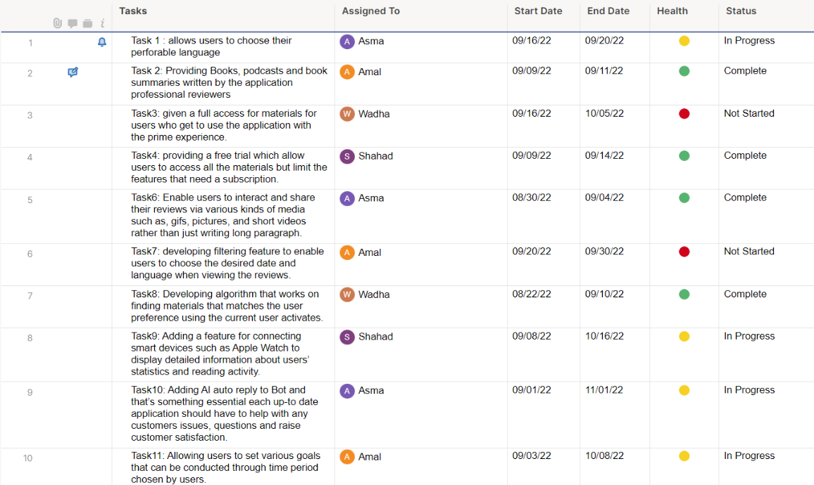

## 

## Budget Summary:

## Evolution of the Plan

The studio infrastructure will be assigned and considered during the cycle of project development, some team members that works on sensitive data such as, operations require accessing the database that contains all information of users, while other team member will access a common studio server for conducting simple tasks. All needed equipment is available in the ICU facilities in addition for other resources such as meeting rooms, cafeteria, and all other standard equipment.

## References

* Provide a complete list of all documents and other sources of information referenced in this Plan.
* Identify each referenced document by title, report number, date, author and publishing organization.
* Identify other referenced sources of information, such as electronic files, using unique identifiers such as path/name, date and version number.
* Identify and justify any deviations from the referenced standards or policies.

## Definitions and Acronyms

* Define, or provide references to documents or annexes containing the definition of all terms and acronyms required to properly understand this Plan.

# Project Organization

## 2.1 External Interfaces

## 2.2 Internal Structure

## 2.3 Roles and Responsibilities

|  |  |  |  |  |  |  |  |  |  |
| --- | --- | --- | --- | --- | --- | --- | --- | --- | --- |
| Rules & REsponsiabilty | | Devolopers | | Managers | | Designers | | Sponsor | |
| 1. Plan, estimate, and manage resources and the project | |  | | yes | |  | |  | |
| 1. Develop the features laid out in the Sprint | | yes | |  | |  | |  | |
| 1. Identify necessary adjustments to the plan. | | yes | | yes | | yes | |  | |
| 1. Participate in the implementation of web and desktop interfaces. | |  | |  | |  | | yes | |
| 1. Generate prototypes for the validation of the proposal throughout the design process. | |  | |  | | yes | |  | |
| 1. Update the status of the software project to the Project Manager | | yes | |  | |  | |  | |
| 1. Evaluate the execution of processes and production of deliverables according to the defined software process | |  | |  | |  | | yes | |

# Managerial Process Plans

This section of the Project Management Plan specifies the project management processes for the project. This section defines the plans for project start‑up, risk management, project work, project tracking and project close‑out.

## 3.1 Start‑up Plan

### 3.1.1 Estimates

### 3.1.2 Staffing

### 3.1.3 Project Staff Training

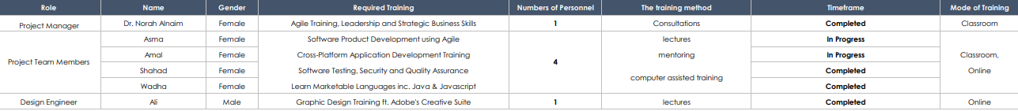

## 3.2 Work Plan

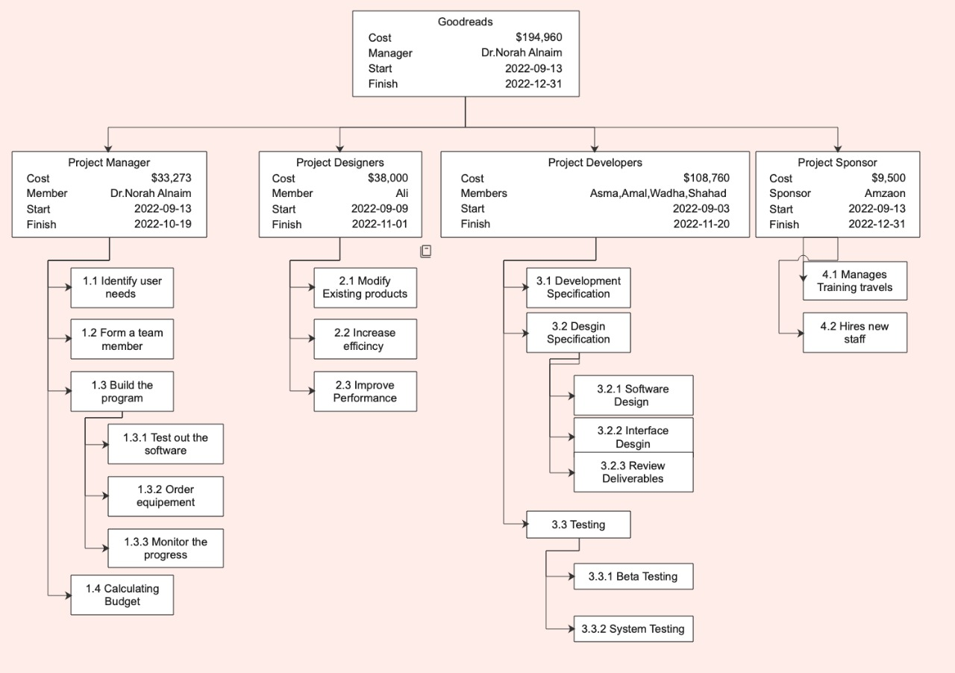

### 3.2.2 Schedule Allocation

The following figure shows the flow of work activities and how tasks is divided into subtasks, each task is handled by number of staff based on their skills and specialty. It can bee seen that the critical path which is contain the longest sequence of activities in the schedule is between the planning and the designing phase.

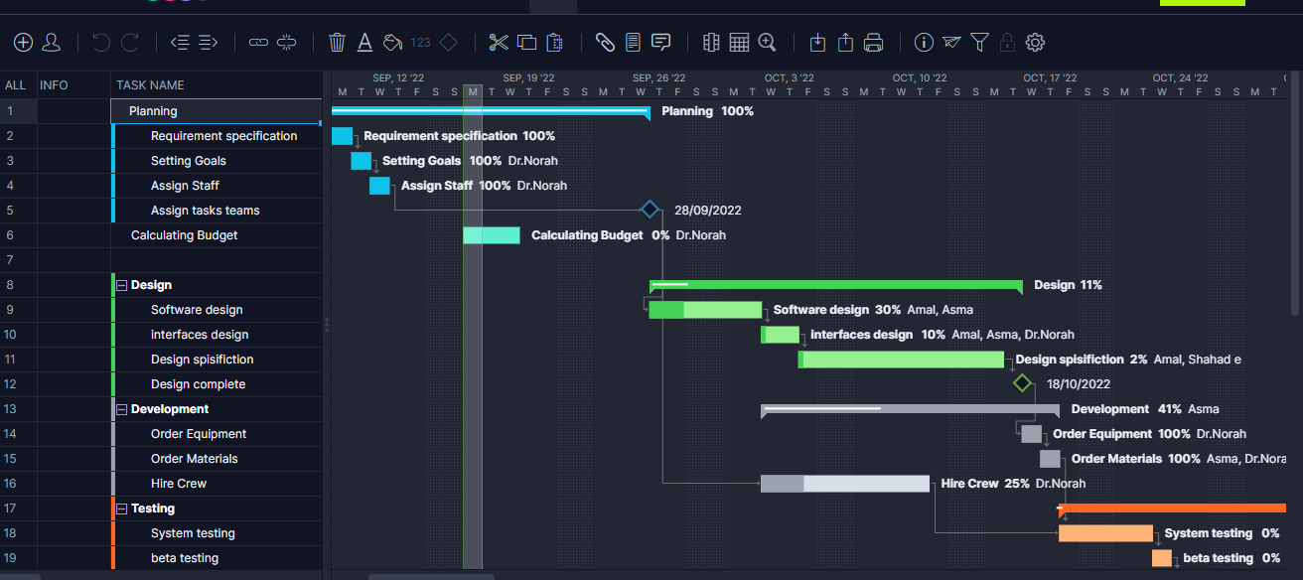

### 3.2.3 Resource Allocation

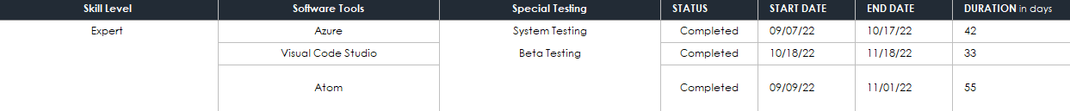

### 3.2.4 Budget Allocation

## 3.3 Project Tracking Plan

### 3.3.1 Requirements Management

Since requirements change during the development process is inevitable, a stable approach is needed to handle these changes so can the developed system meets the customer expectation. Requirements management tools have been developed to manage unstable requirements and large amount of data collected during requirements engineering process. Requirements management tools collect with the system requirements in a database or repository and provide a range of facilities to access the information about the requirements [4]. Also, it supports secure and concurrent co-operative work between team members. In the configuration management process. To manage the requirements, we need a baseline that tells if the requested changes will have an impact on the current schedule and budget. The first step in the process in managing the change is going to be identifying the need of change, next thing comes is assembling change control board for review, in this stage workers will meet to define the outcome and the goal and start to create any needed documentation to match the changes with project goals. If the change got approved, it will get followed by of stages of testing and creation of prototypes and tracing the life of the agreed upon changes.

### 3.3.2 Schedule Control

The project manger will be responsible for assembling the induvial assigned tasks and it will keep the schedule documented and will make the status update according to that. If the schedule is not on track, then the manager will make a control meeting with the team.

### 3.3.4 Quality Control

The following table illiterate the procedures which will be established to improve the quality of the developed software.

|  |  |
| --- | --- |
| Quality Control | |
| Activity | Procedures |
| Check data integrity | Confirm that the data relationship is represented correctly |
| Compare previous estimate to current resulting outcome | The current result of each task must be compared to the previous estimation. If there is |
| Check that the criteria and data are documented | Cross-check description od data to ensure that it is archived properly |

In addition, the quality assurance procedures will be utilised beside QC procedures. The procedure will follow the IEEE 730-2014 standard for software quality assurance processes [] which will provide many techniques such as, validation and varication procedure.

### 3.3.5 Reporting

During the life cycle of the project report must be passed to everyone who’s involved to acknowledge the development progress to measure progress and manage the deliverables’ preparation or potential risk in the Project[]. The following table shows how report

|  |  |  |  |
| --- | --- | --- | --- |
| Type of report | Frequency of use | Tools of communication | detail of communications |
| Project status report | 0-12 | -Email | -A list of action items |
| Progress report | 0-10 | -Email  -discussions in weekly meetings | -The work that’s been completed |
| Risk reports | 0-8 | -Online collaboration platforms  -Monthly meetings discussions | -Risk register |
| Financial report | 0-5 | -Email  -Weekly meetings  discussions | -Change in the current budget |
| Gap Analysis Report | 0-5 | -Email | -Identify the gaps between processes and performance |
| Final report | 0-17 | -Final meeting | -The full outcome |

### 3.3.6 Project Metrics

* Specify the methods, tools, and techniques to be used in collecting and retaining project metrics.
* Specify the following metrics process information:
* identification of the metrics to be collected,
* frequency of collection, and
* processes for validating, analyzing, and reporting the metrics.

## 3.4 Risk Management Plan

|  |  |  |  |  |  |  |
| --- | --- | --- | --- | --- | --- | --- |
|  | | | Analyzing | |  | |
| # | Risk | Recommended Action | Probabilities | Effect | Contingency Plan | Tracking Risks Factors |
| R1 | Staff turnover | Educating all the staff on the project different accepts. | Low | Serious | Seek backup staff from the parent organization | Regular Check-ups should be conducted by the manager for the convenience of the employee |
| R2 | Hardware unavailability | Ongoing maintenance and configuration for all devices. | Moderate | Catastrophic | Obtain new hardware or use a virtual machine if funds are limited | Hardware should be assessed weekly by the manager |
| R3 | Requirements change | Advising the client on how lot of changes might affect the quality of the final outcome. | High | Tolerable | Fast adapting to the ongoing changes | Reports to inform the workers of the updates on a weekly basis |
| R4 | Specification delays | Ensuring to have regular weekly meetings with client to discuss project needs. | Moderate | Serious | The worker should complete the coworker's task and move on to the next stage to avoid further delays | Monitor the progress of the worker’s work by the manager |
| R5 | Financial shortage | Ensure that the deposit has been transferred prior to starting the project. | Low | Catastrophic | Budget reminders and requirements must be compromised | Take into account the budget allocation for each flow |
| R6 | Organization restructured | Workers should be informed in advance that the organization may be restructured. | High | Serious | Compensation to the affected workers | Keep an eye on the employee’s adaption to the new structure and the progress of their work |

|  |  |  |  |
| --- | --- | --- | --- |
|  | Technological risk |  | Risks in development |
|  | Budget risk |  | Risk caused by the size of the product |
|  | Contractual risk |  | Risk to Schedule |

## 3.5 Project Closeout Plan

Project closeout is the successful completion of a project and the final transfer of assets to the client. It

includes heavy oversight to ensure the project is ready, like checking specifications, collecting

documents and closing out existing contracts for equipment rentals or subcontractors.

Project Closeout Process in Steps

1. Collect Necessary Documents:

keeps track of ongoing tasks so contractors and managers know the status of each action item. This list

will help you determine if you should address any loose ends before looping in the client to review.

• Design approvals

• Requests for information

• Certificates for any inspections

• Certificate of Occupancy

• Certificate of Substantial Completion

• Pay submittals for contractors

2. Review Changes and Modifications

review all change orders to confirm their completion or indicate why they may remain incomplete.

3. Ensure Order Specifications Are Met

This step is when you’ll verify for the last time that the building has an effective safety

4. Present to the Client

Once you make sure that your deliverables meet client expectations, it’s time for you to deliver the

goods. This step hinges on the client’s pre-established understanding of project goals and timelines

5. Address All Client Feedback

note any final requests along with a timeline for completion of those requests.

6. Close Any Open Contracts

Client approval is a green light to move ahead with finalizing the closeout process. Once you know that

work is complete.

# 4. Technical Process Plans

## 4.1 Process Model

* Define the relationships among major project work activities and supporting processes.
* Describe the flow of information and work products among activities and functions.
* Specify the timing of work products to be generated.
* Identify the reviews to be conducted.
* Specify the major milestones to be achieved.
* Define the baselines to be established.
* Identify the project deliverable to be completed.
* Specify the required approvals within the duration of the project.
* In the process model for the project, include project initiation and project termination activities.
* Use a combination of graphical and textual notations to describe the project process model.
* Indicate any tailoring of your organization's standard process model for a project.

## 4.2 Methods, Tools, and Techniques

development methodologies:

• Agile development methodology

programming languages:

• Java, C++, HTML, Perl

Technical tools:

• Customer’s feedback used for design n build and modify of the

product (deliverable)

• User onboarding used for testing and modifying (deliverable)

• Roadmapping used strategic process for all processes (work

product)

• Communication used for building, testing, modifying and

minting of the project, both (deliverable) and (work product)

Techniques:

• Rapid application development

• Computer-aided software engineering: CASE tools

• Object oriented programming

Technical standards.

we have chosen the International Organization for Standardization

(ISO) develops innovation management standards.

technical policies:

Usage: use of the company’s computer systems, hardware,

software, peripheral devices, and gadgets are allowed only if it’s

during the worker’s brake.

Security: no access shall be used/given for any purpose outside the

cooperate agreement.

Continuity: always attach the work on the cloud to ensure no data

is lost.

## 4.3 Infrastructure

The studio infrastructure will be assigned and considered during the cycle of project development, some team members that works on sensitive data such as, operations require accessing the database that contains all information of users, while other team member will access a common studio server for conducting simple tasks. All needed equipment is available in the ICU facilities in addition for other resources such as meeting rooms, cafeteria, and all other standard equipment.

## 4.4 Product Acceptance

plans for customer acceptance:

•creating a full list of all project deliverables

• Listing the standards for gaining consumer acceptance

•Putting in place, acceptance standards to be met

•Identifying the acceptance test methods

•Allocating acceptance test resources

•Scheduling acceptance evaluations with the client

•Gaining remaining acceptance of the deliverables

criteria for the acceptability of the deliverables:

•the criteria we choose is the scenario-oriented (drawn up as scenarios illustrating each criterion) This approach helps to overcome the requirements and involves manual and automated acceptance testing.

•

acceptance testing

we used agile testing for acceptance:

1.Provide continuous feedback.

2.Deliver value to the customer.

3.Enable face-to-face communication.

4.Have courage to make the change.

5.Keep it simple

Acceptance inspection.:

• all installation or alteration of equipment must be in accordance with the applicable ASME Code A17.1

# 5. Supporting Process Plans

## 5.1 Documentation

During the project's lifetime, several documents will be generated. Documents are the responsibility of the project team members and for that they will conduct reviewing controlling process and deciding which template to use Under version control, number of documents will be created and maintained, and it will include:

- Statement of work (SOW)

- Software requirement specification (SRS)

- Software project management plan

- System integration plan

- Acceptance conformation documentation

- Project budget

- Project Schedule

- status report

-Risk management statement

- Project Closure

# 6. Additional Plans

* Specify or reference any additional plans required to satisfy product requirements and contractual terms, which may include:
* plans for assuring that safety, privacy, and security requirements are met,
* special facilities or equipment specification,
* product installation plans,
* user training plans,
* integration plans,
* data conversion plans,
* system transition plans,
* product maintenance plans, or
* product support plans.