**COMPUTER ARCHITECTURE AND ORGANIZATION CEN-221**

**LAB-1 (Introduction To Visible Virtual Machine)**

**TASK-1:** Take two inputs and Subtract.

**Code:**

IN

Sto 85

IN

Sto 86

LDA 85

SUB 86

Sto 87

OUT

**Output:**

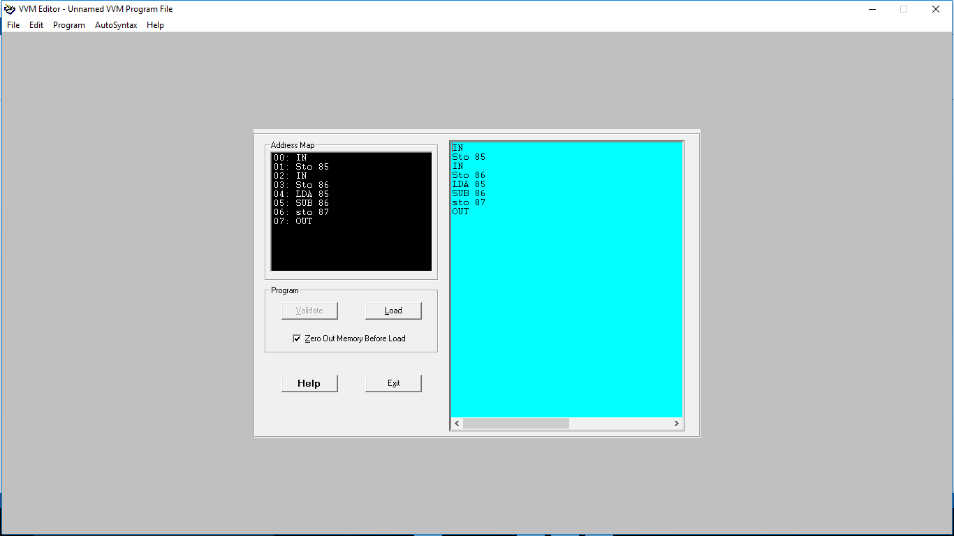

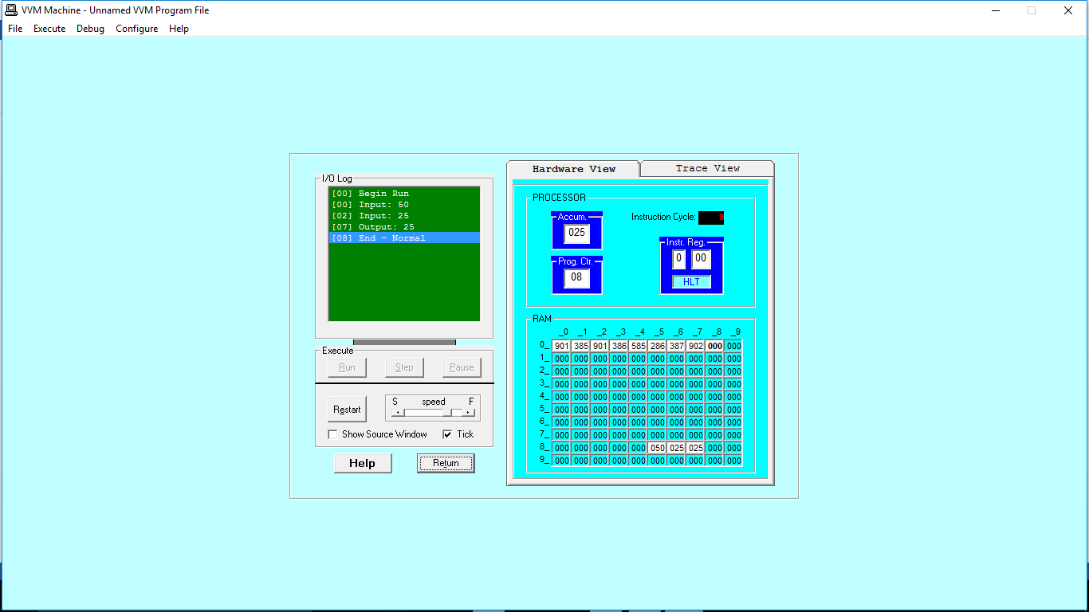

**TASK-2:** Take two hardcoded inputs and Add them.

**Code:**

LDA 70

ADD 71

OUT

*70

DAT 002

*71

DAT 012

**Output:**

