Bahria University,

Karachi Campus



LAB EXPERIMENT NO: 3

LIST OF TASKS

|  |  |
| --- | --- |
| TASK NO | OBJECTIVE |
| 1. | Write a VVM program which take an integer input and display table of that integer. |
| 2. | Take integer from User and print square of a number. |
|  |  |
|  |  |
|  |  |
|  |  |
|  |  |
|  |  |
|  |  |

**COMPUTER ARCHITECTURE AND ORGANIZATION CEN-221**

**LAB-3 (Instruction Set For Branch)**

**TASK 01:** **Write a VVM program which take an integer input and display table of that integer.**

**Code:**

IN

STO 99

LDA 99

ADD 98

STO 98

OUT

LDA 96

SUB 97

STO 96

BRZ 11

BR 02

HLT

*96

DAT 010

*97

DAT 001

*98

DAT 000

**Output:**

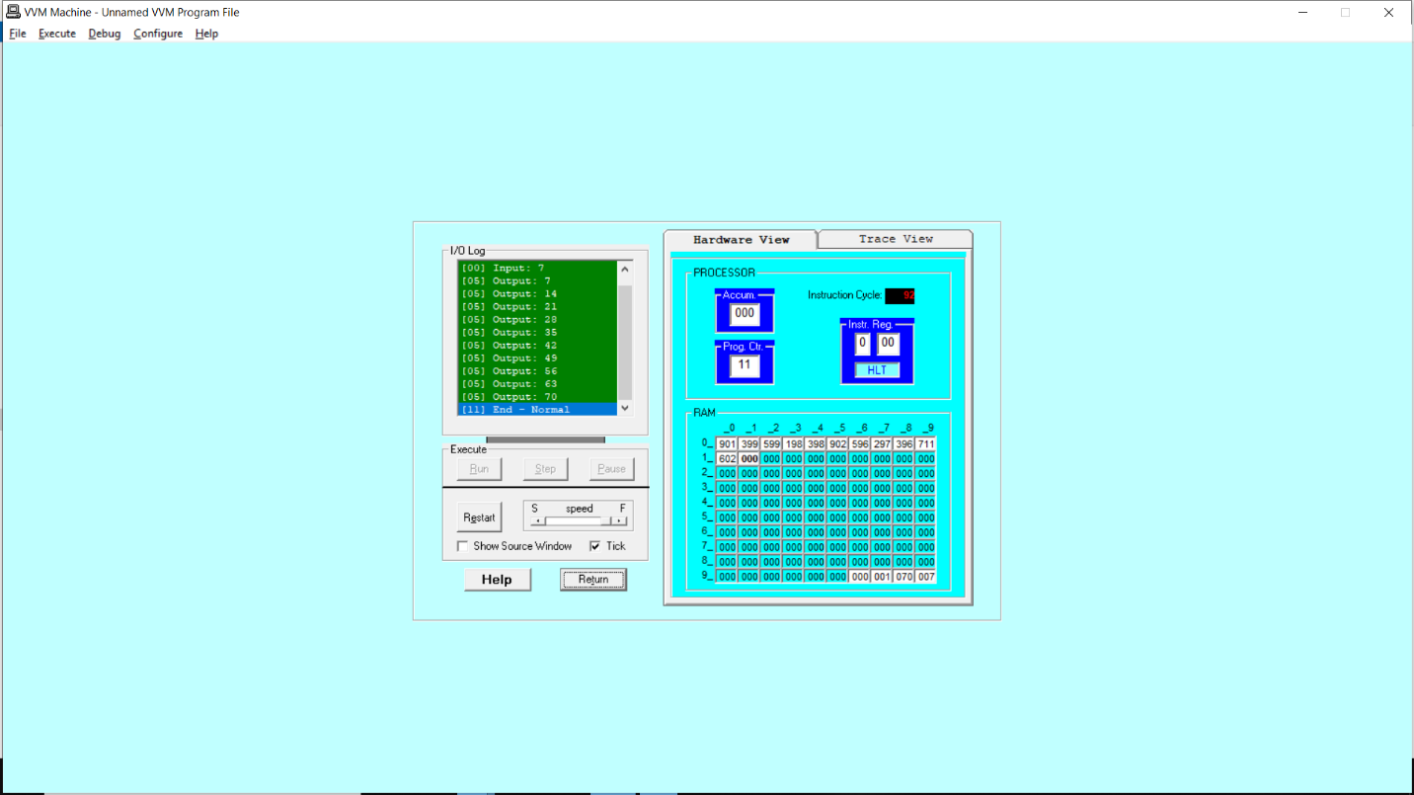

**Task-2:** Take integer from User and print square of a number.

**Code:**

IN

STO 50

STO 51

LDA 50

SUB 97

BRZ 13

LDA 96

ADD 97

STO 97

LDA 51

ADD 50

STO 51

BR 03

LDA 51

OUT

HLT

*96

DAT 001

DAT 001

**Output:**

