Bahria University,

Karachi Campus



LAB EXPERIMENT NO: 5

LIST OF TASKS

|  |  |
| --- | --- |
| TASK NO | OBJECTIVE |
| 1. | Write an assembly program that Read and Print Hello world. |
| 2. | Write an assembly program that add two numbers. |
| 3. | Write an assembly program that subtract two numbers. |
|  |  |
|  |  |
|  |  |
|  |  |
|  |  |
|  |  |

**COMPUTER ARCHITECTURE AND ORGANIZATION CEN-221**

**LAB-5 (MIPS Arithmetic Operations)**

**TASK 01:** Write an assembly program that Read and Print Hello world.

**Code:**

.data

String: .ascii "Hello World"

.text

li $v0,4

la $a0,String

syscall

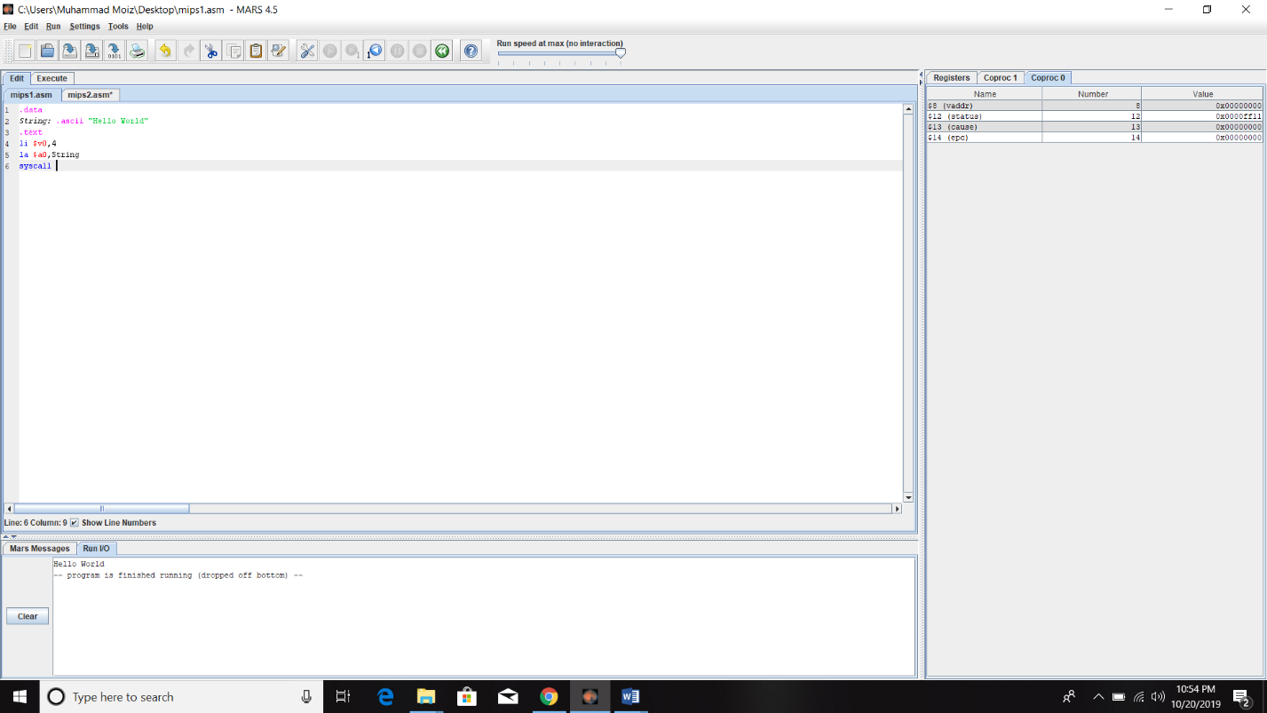**Output:**

**Task 2:** Write an assembly program that add two numbers.

**Code:**

.data

num1: .word 20

num2: .word 13

.text

lw $t0,num1

lw $t1,num2

add $t2,$t0,$t1

move $a0,$t2

li $v0,1

syscall

**Output:**

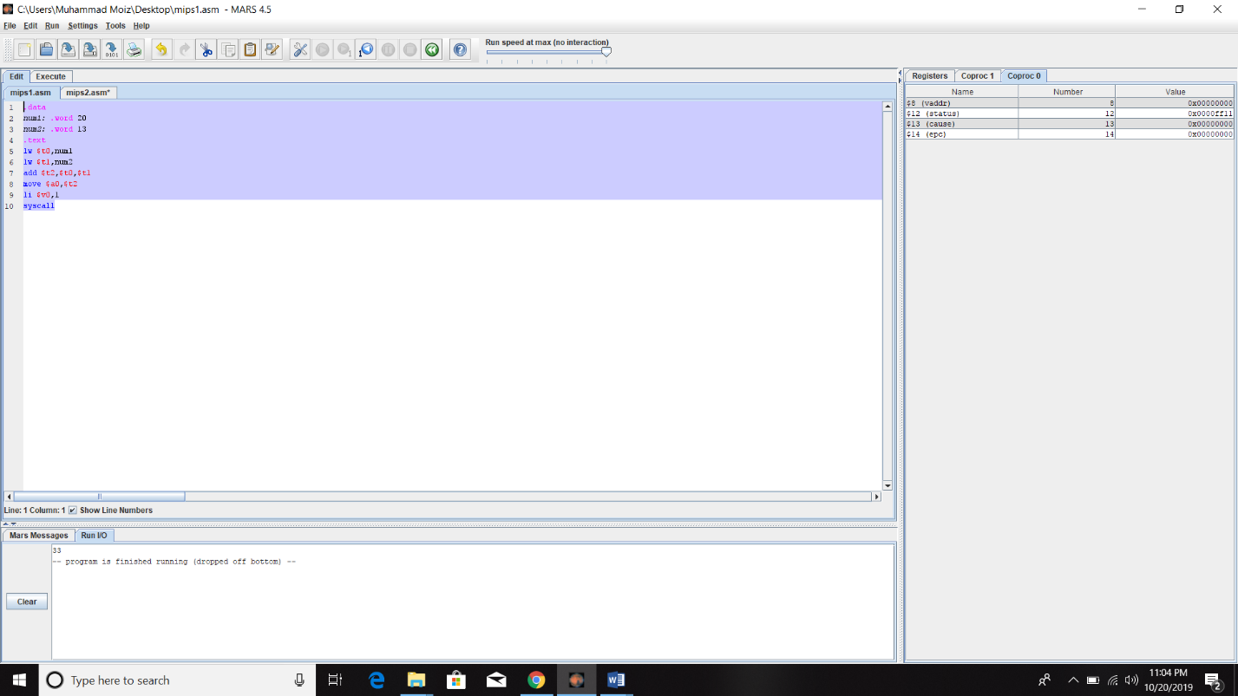

**Task 3: Write an assembly program that subtract two numbers.**

**Code:**

.data

num1: .word 20

num2: .word 13

.text

lw $t0,num1

lw $t1,num2

sub $t2,$t0,$t1

move $a0,$t2

li $v0,1

syscall

**Output:**

