AI-Driven-Development

AI-Driven Development_30-Days Challenge

Day Six 🚀
Student Name: Asma Akbar
Instructor: Sir Hamzah Syed
Class: Friday — 6:00 PM to 9:00 PM
Date: November 25, 2025
Submission Date: November 27, 2025
Status: Completed

Task 6: Connecting GitHub MCP Server with Gemini CLI

In this task, I successfully connected the GitHub MCP server with Gemini CLI
Step 1 – Generate GitHub Personal Access Token :
First, I generated a personal access token from GitHub .
- Open this link: https://github.com/settings/personal-access-tokens/new
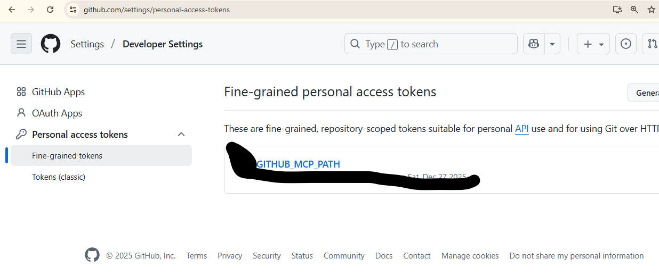
Step 2 – Token Store:
- .env
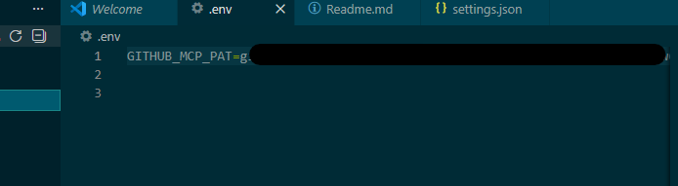
After generating the token, I saved it securely:
Step 3 - Connect GitHub MCP Server
I configured the GitHub MCP server with Gemini CLI using the generated token.
- .gemini/settings.json
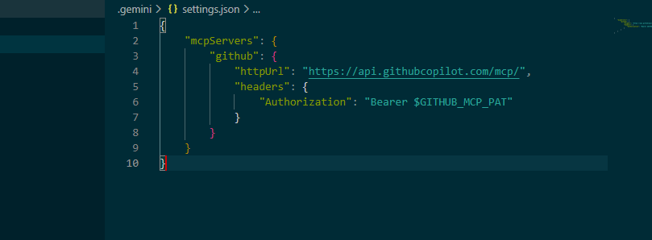
🔹 Step 4 - Restart Gemini CLI
- /restart …
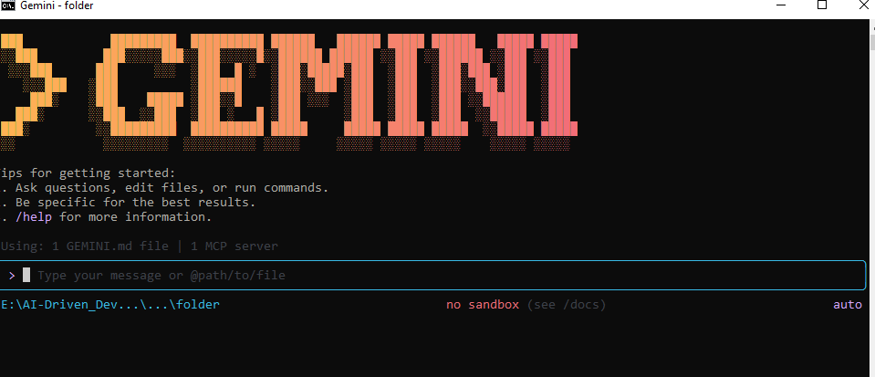
🔹 Step 5 - Verify Connection Run:
To verify the connection, I used the /mcp list command in Gemini CLI:
- /mcp list
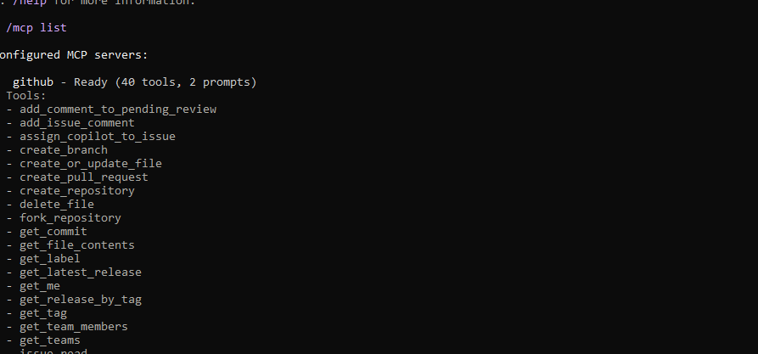
🔹 Step 6 - List GitHub Repositories
Ask: “List my GitHub repositories”
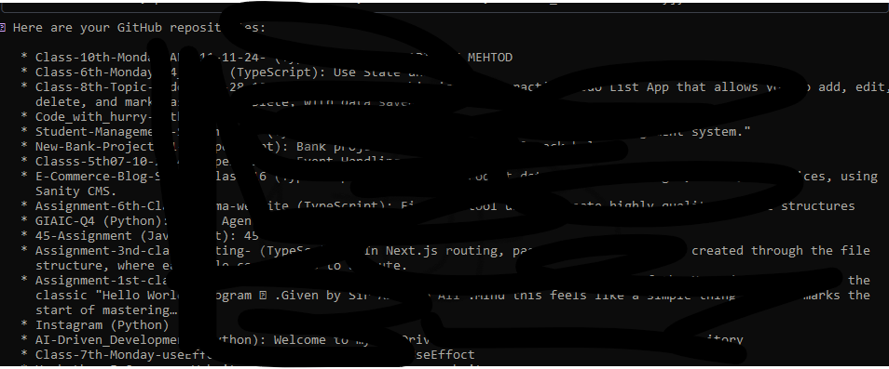

Conclusion
CLI ke through GitHub successfully connect ho gaya hai.

-----------------------------------------------------------------------------------------------------------------------------

