AI-Driven-Development

AI-Driven Development_30-Days Challenge

Day Two 🚀
Student Name: Asma Akbar
Instructor: Sir Hamzah Syed
Class: Friday — 6:00 PM to 9:00 PM
Date: November 20, 2025
Submission Date: November 22, 2025
Status: Completed

🌟 PART A — Research Questions (Short Answers)

Q1. Gemini 3.0 mein kya naye behtariyan aayi hain?
QUESTION 1: What new improvements were introduced in Gemini 3.0?
ANSWER:
Pehle AI aksar lambe sawaalon mein confuse ho jata tha, reasoning slow hoti thi, aur zyada information ek saath handle nahi kar pata tha.
Lekin ab Gemini 3.0 ka sochne ka system bohat mature ho gaya hai. Ye mushkil topics ko chain mein jor kar samajhta hai, lambe discussions ya documents ko yaad rakhta hai, aur video image text ko ek saath analyze karta hai. Iski safety bhi strong kar di gayi hai, isliye model ko mislead karna ya trick karna bohat mushkil ho gaya hai.
Example:
main Gemini 2.0 se poochti:
“Pichle 10 din ki sari classes ko combine karke aik clean summary bana do.”
Wo aada data bhool jata.
Gemini 3.0 ko bolo toh wo puri classes ko yaad rakh kar ekdum perfect aur connected summary banata hai jese koi bachpan ka dost tumhari diary padh kar tumhe samjha raha ho.
QUESTION 2: How does Gemini 3.0 improve coding & automation workflows?
Q2. Gemini 3.0 coding aur automation workflows kaise behtar karta hai?
ANSWER:
Pehle coding AI sirf choti snippets banata tha aur files manage nahi kar pata tha.Ab Gemini 3.0 coding ko professional level tak le aya hai.vibe coding se jo khayal aata hai wo seedha code mein convert ho sakta hai, matlab main seedha idea bolo aur model code bana dega.Gemini CLI aur tools se multi-file projects banane aur command line par tez madad milti hai, isse development jaldi hoti hai. bugs find aur fix karna behtar hua hai to coding kam error wali hoti hai. Aur automation mein ye lambe tasks khud arrange aur chalaye sakta hai, jaise emails sort karna ya step-by-step ek app banana.

Example:
tum ne kaha:
“Mere liye aik simple todo app bana do jisme add aur delete ka option ho.”
Pehle models sirf aik file ka rough code de dete the.
Gemini 3.0 tumhara idea sun kar khud hi poori app ka code bana deta hai, files create karta hai, galtiyan khud check karta hai, aur tumhe bas copy paste karke chalana hota hai. Tumhe coding ki tension nahi hoti.
Q3. Gemini 3.0 multimodal samajh ko kaise behtar banata hai?
3. How does Gemini 3.0 improve multimodal understanding?

ANSWER:
Pehle AI text theek samajh leta tha, par images, videos, tables aur layouts ko accurate tor par connect nahi kar pata tha.
Gemini 3.0 ne text, images, video, audio aur code ko saath milakar samajhta hai, matlab agar tumhare paas video recipe ho ya photo ke sath instructions ho to wo dono cheezen jod kar meaningful jawab dega. Iska matlab yeh bhi ke complex charts, screenshots aur layouts ko bhi analyze kar ke sahi nateeja nikal leta hai. Simple alfaaz mein, alag-alag type ki media ko ek saath samajh ke zyada useful aur accurate jawab deta hai.
Example:
Tum ek video bhejo jisme workout steps hon aur bolo:
“Is video ko dekh kar mera 1-week ka workout plan bana do.”
Gemini 2.0 sirf general reply deta.
Gemini 3.0 video ke moves dekh kar, unka timing count, difficulty, aur sequence samajh kar exact plan bana deta hai — bilkul trainer ki tarah.
Q4. Name any two developer tools introduced with Gemini 3.0.
Q4. Do developer tools kaun se naye diye gaye hain?
ANSWER:
Pehle developers ko AI ko alag-alag tools se connect karne mein bohat time lagta tha, aur coding help bhi limited hoti thi.
Lekin Gemini 3.0 ke sath do bohat powerful tools aaye hain jo development ko aikdum professional level ka bana dete hain.
- Google Antigravity hai, jo tumhari jagah multiple agents ko control karta hai. Ye agents tumhari taraf se browsing, coding, organizing, aur complex tasks ko ek system ki tarah handle kar lete hain ese tumhare paas aik chhoti development team ho.

- Gemini CLI / Gemini Code Assist hai, jisse tum command line par AI ko seedha use kar sakti ho. Ye coding ke dauran instant madad deta hai, files banata hai, code fix karta hai, aur pure projects ko structure kar deta hai. Tum bas aik command likhti ho, aur CLI poora kaam sambhal leta hai.

🌟 PART B — Practical Task (Screenshot Required)
Task:

- Update the Gemini 3.0
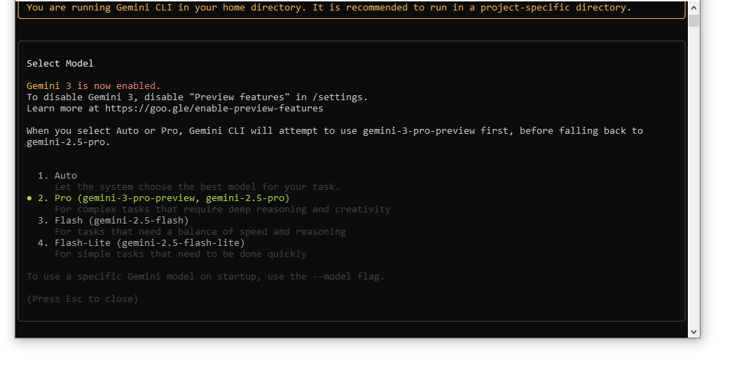

-------------------------------------------------------------------------------------------------------------------------------XXXXXXXXXXXXXXXXXXXXXXXXXXXXXXXXXXXXXXXXXXXXXXXXXXXXXXXXXXXXXXX--------------------------------------------------------------------------------------------------------------------------------

