The Open University of Sri Lanka
Faculty of Engineering Technology
Bachelor of Software Engineering Honors
Department of Electrical and Computer Engineering
EEX5362 - Performance Modelling
Academic Year 2023/2024
Mini Project
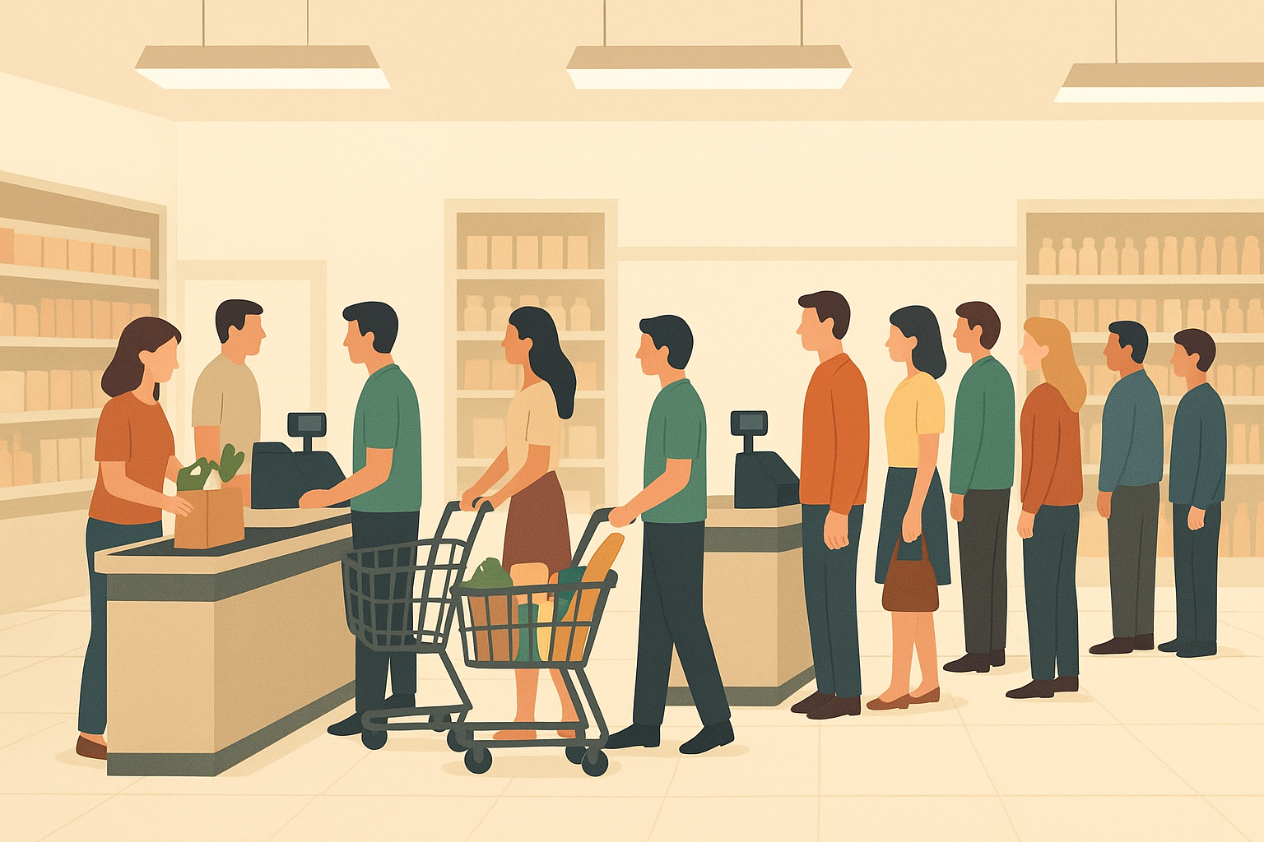

Deliverable 01
Supermarket Cashier Checkout System

Name: M.A. Asma
StudentID: S22010125
RegNo: 522513514

System Overview
The selected system is a supermarket checkout system. This system describes an actual queuing scenario where customers arrive randomly and wait to be served by any cashier who is free at that time. Each cashier is allowed to serve only one customer at a time, and customers may have to wait according to the number of cashiers, as well as the arrival rate and service rate.
The system includes (updated from CS Scenario) two types of checkout lanes that are, a normal lane and an express lane. The express lane is for customers who purchased with fewer items and generally it has a shorter queue, and the normal lane is for other customers. This helps simulate how supermarkets handle customers differently based on their needs.
Also, the system has customer impatience behavior. Not all customers are willing to wait indefinitely for long time. Some may leave the queue and shop if it takes too long. In this system, if a customer waits for more than 30 minutes, they will abandon the queue and leave the system. This behavior helps to study how long waiting times affect customer retention and satisfaction.
Such systems are suitable for performance modeling because it allows measurable analysis on waiting times, cashier utilization, and system throughput. It also makes it easier to see where there bottlenecks will occur when the supermarket is crowded.
System Flow:
The checkout process follows a First-In-First-Out (FIFO) approach, that mean the customers are served in the order they arrive but also with the flexibility of two queues. The flow can be as below:
- Customers arrive randomly at the supermarket checkout.
- Each customer decides whether to join the express or normal lane (usually 30% choose express and 70% choose normal).
- If there is a free cashier in the chosen lane, the customer is served immediately.
- If all cashiers in that lane are busy, the customer joins the queue.
- If the customer waits more than 30 minutes, they become impatient and leave the queue without being served (exit the shop without purchasing anything).
- Once a cashier finishes serving a customer, the next waiting customer in the same lane begins service.
- This process continues until the simulation ends.
This flow allows us to study how factors such as the arrival rate, service rate, and number of cashiers affect key performance measures like:
- Average waiting time
- Cashier utilization percentage
- Queue length variations
- Throughput (total customers served)
- Customer abandonment rate (due to impatience)

Parameters:
Parameter | Default Value | Explanation
Number of cashiers | 4 | Number of available checkout cashier
Arrival rate | 0.4 customer/min | Average number of customers arriving per minute
Average service time | 7.5 min | Average time taken per customer
Simulation time | 480 min | Total run time (8 hours)
Random seed | 42 | For reproducibility
Impatience limit | 30 min | Maximum waiting time before a customer leave the shop
Lane types | Normal, Express | Two queue categories for customers

High-Level Problem Description
In reality, long queues and slow checkout times are among the most common issues that affect both customer satisfaction and business efficiency. When customer arrivals suddenly increase, queues become longer, causing frustration and sometimes leading to customers leaving before making a purchase. On the other hand, if there are too many cashiers during quiet periods, resources go underused and operational costs increase.
The main challenge is to find a proper balance between staff allocation and customer flow management. In other words, to make sure that customers are served efficiently without wasting resources.
To analyze, the system will be simulated using random arrival and service rates, allowing observation of different scenarios such as:
  - Normal customer flow (baseline): Normal customer flow under typical working conditions
  - High traffic (peak hours): Double customer arrival rate to simulate peak hours
  - More cashiers added: Additional checkout counters to reduce waiting time
  - Faster service: Reduced service time to see its impact on system efficiency
By analysing these conditions, the performance of the system can be better understood and optimized.

Performance Objective
The main performance objective is:
- To minimize the average customer waiting time at the supermarket checkout counters.
This objective focuses on improving customer experience by reducing how long each customer has to wait before being served. Minimizing the waiting time will also indirectly improve throughput and overall system efficiency. By changing some variables (like number of cashiers, service speed), the simulation will let us find out what is the best configuration is that minimizes the time waiting in line while keeping the cashier utilization reasonable.

Data Set
The dataset for this project represents the performance records of the supermarket checkout system under multiple simulation scenarios. It was generated from the supermarket simulation program developed in case study (but a little updated version with a complex level up). The dataset captures detailed customer level information for each simulated checkout event, allowing analysis of system behavior, queue management, and cashier utilization.
Contents of the dataset include:
- CustomerID: Unique identifier for each customer.
- ArrivalTime: Time (in minutes) at which the customer arrives at the checkout.
- LaneType: Indicates whether the customer joined the Express lane or Normal lane.
- AssignedCashier: Number of the cashier serving the customer.
- WaitTime: Time (in minutes) the customer waited in the queue before being served.
- ServiceTime: Time (in minutes) taken to serve the customer.
- DepartureTime: Time (in minutes) when the customer finishes service and leaves the system.
- Scenario: The simulation scenario under which the customer was served (e.g., Baseline, High Traffic, More Cashiers, Faster Service).
- Status: Indicates whether the customer was successfully served or left the queue due to impatience.
The dataset provides measurable performance characteristics of the system, such as average waiting times, queue lengths, cashier utilization, and throughput, which are essential for analyzing system efficiency and identifying potential bottlenecks.
Sample Data:
CustomerID | ArrivalTime | LaneType | AssignedCashier | WaitTime | ServiceTime | DepartureTime | Scenario | Status
1 | 2.55 | Express | 1 | 0 | 1.89 | 4.44 | Baseline | Served
3 | 5.95 | Normal | 2 | 0 | 0.23 | 6.17 | Baseline | Served
4 | 6.17 | Normal | 2 | 0 | 0.2 | 6.38 | Baseline | Served
10 | 11.4 | Express | 1 | 0 | 0.76 | 12.16 | Baseline | Served
5 | 6.79 | Normal | 3 | 0 | 5.9 | 12.7 | Baseline | Served

The complete dataset can be accessed in the project repository at:
GitHub Link:
https://github.com/AsmaAmeenGeek/EEX5362-Performance-Modelling-Mini_Project/blob/main/Deliverable_01/supermarket_all_scenarios.csv

Project GitHub Repository Link:
https://github.com/AsmaAmeenGeek/EEX5362-Performance-Modelling-Mini_Project

