Assignmnet no 4  
Assign Date 6-12-2024

Due Date 20-12-2024

Name Asma Aslam(SP24-BSE-015)

Haniya Ubaid(SP24-BSE-038)

Main Screen

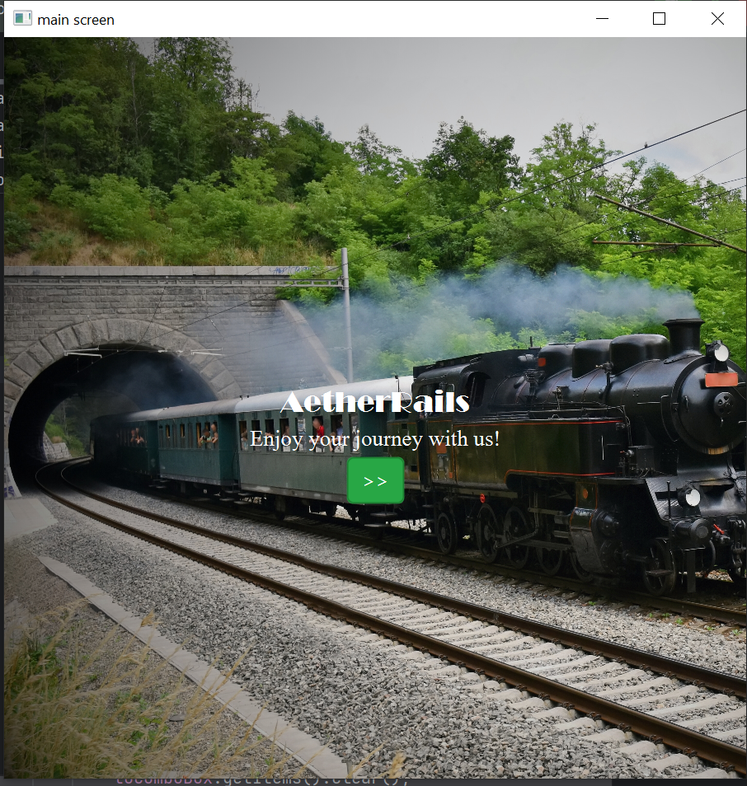

Login page

Forgot Password

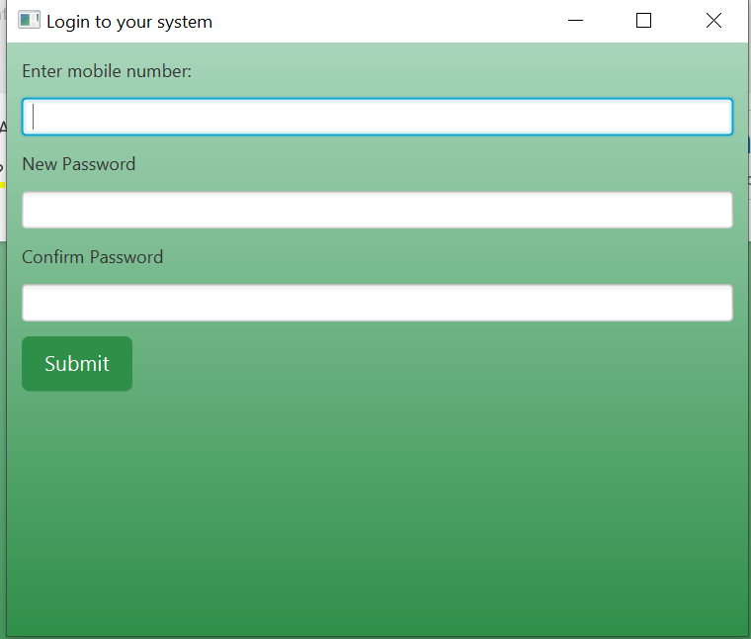

Sign up

Admin

Add train

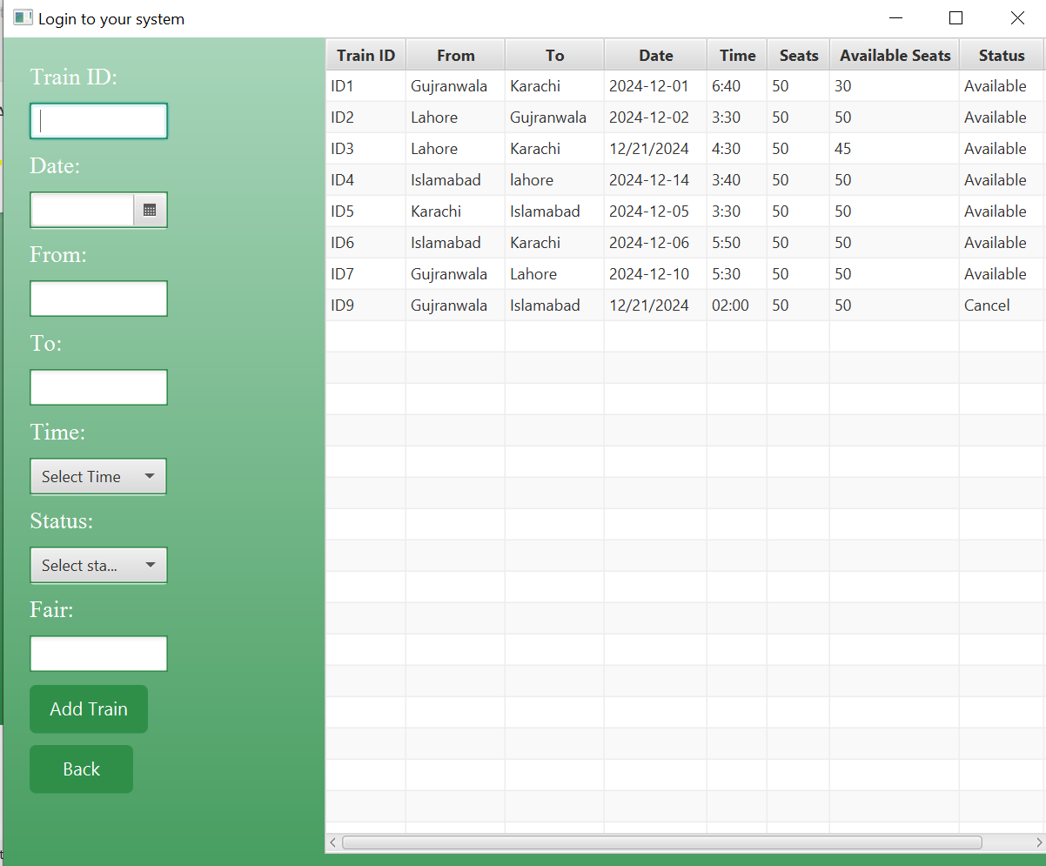

Cancel Train

Update Train

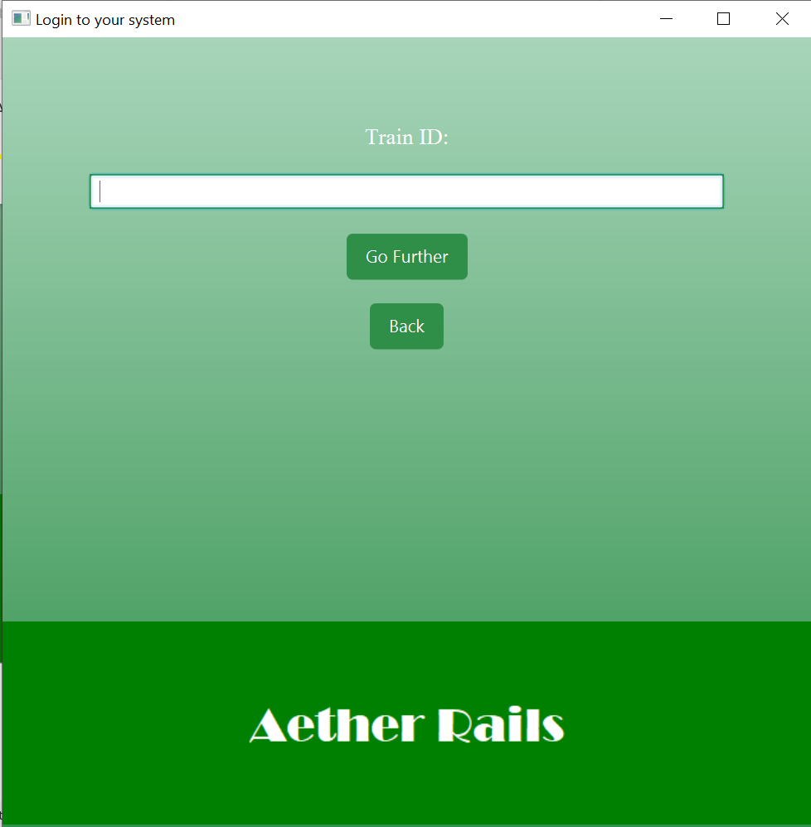

Start Location

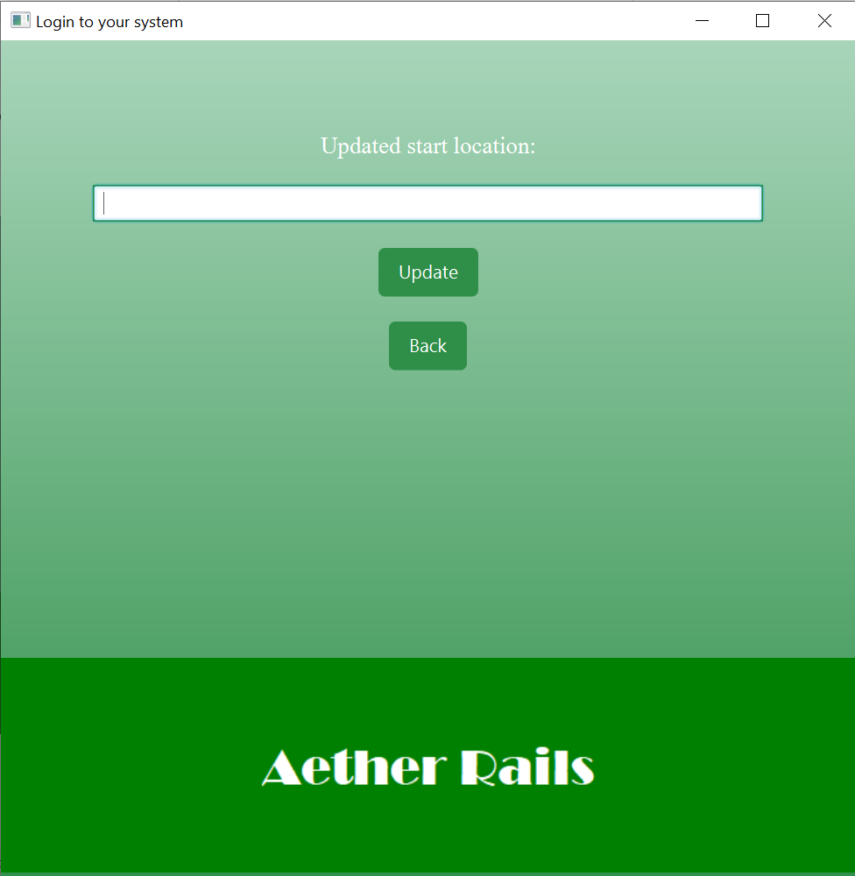

End location

Update time

Update Available seats

Update Date

Display

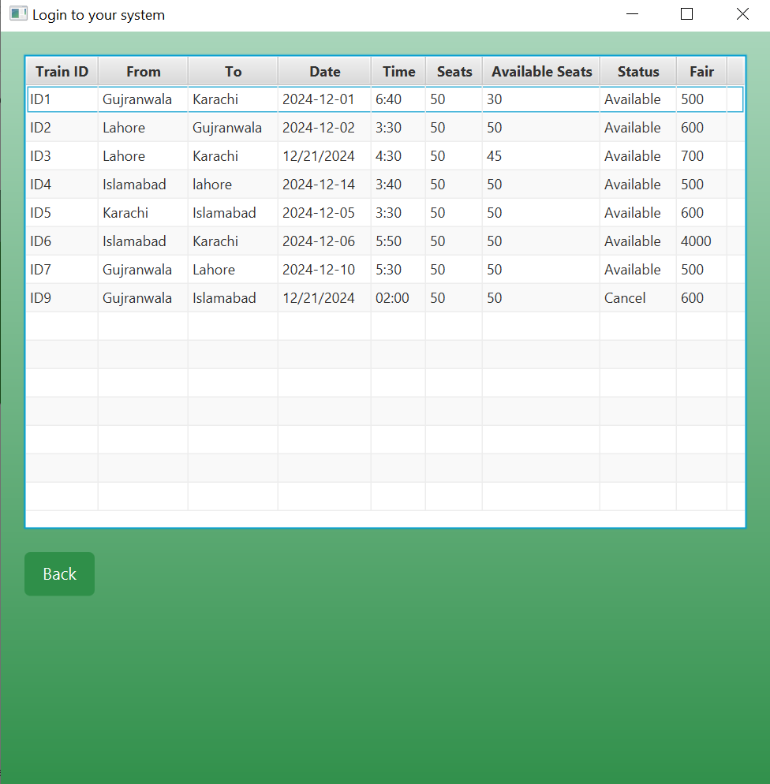

User

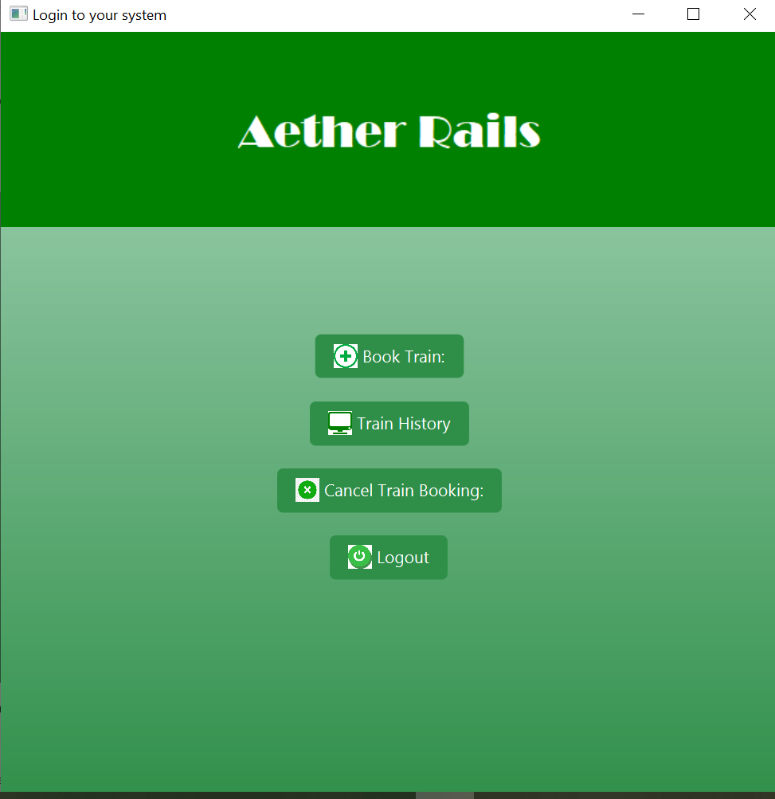

Book Train

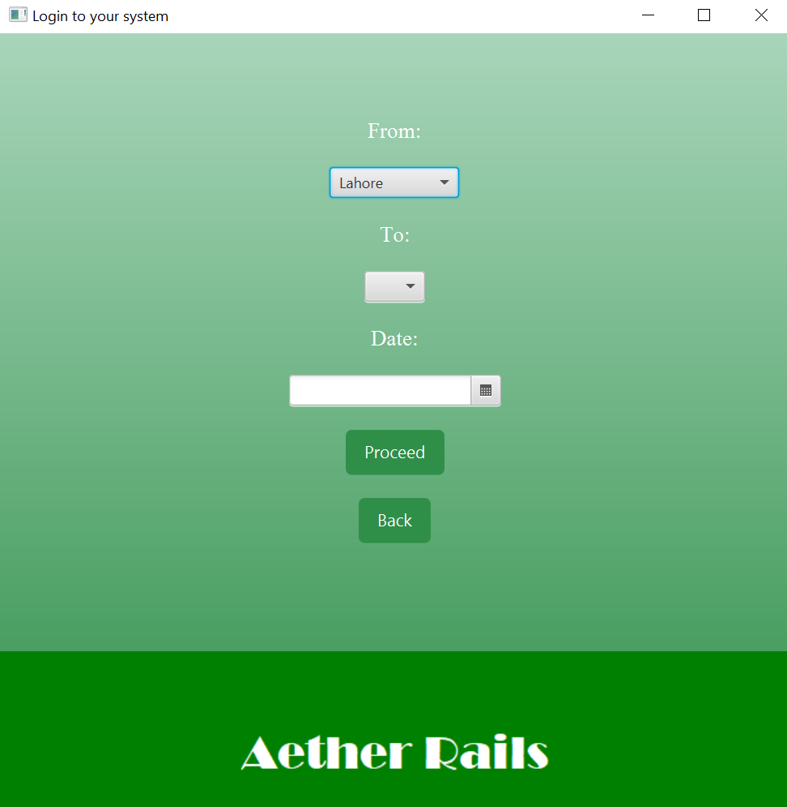

Proceed

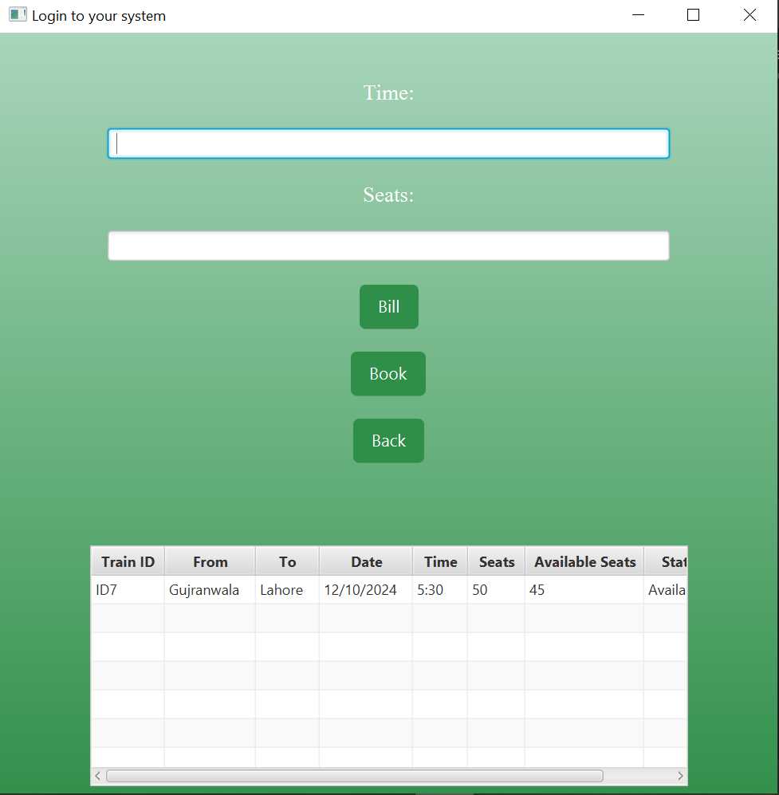

Bill generation

Train History

Cancel Train booking

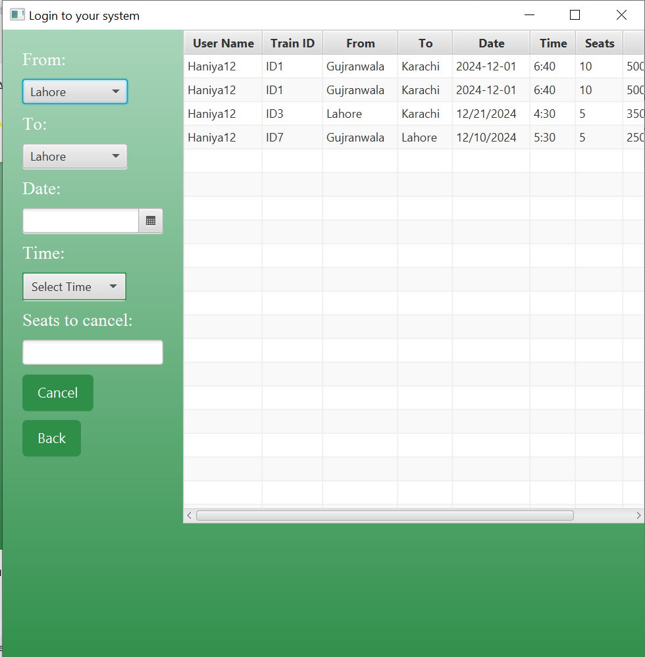

Code

Hello Application

package com.example.oopfinalproject;  
  
import javafx.application.Application;  
import javafx.collections.FXCollections;  
import javafx.collections.ObservableList;  
import javafx.geometry.Insets;  
import javafx.geometry.Pos;  
import javafx.scene.Scene;  
import javafx.scene.control.*;  
import javafx.scene.control.Button;  
import javafx.scene.control.Label;  
import javafx.scene.control.TextField;  
import javafx.scene.control.cell.PropertyValueFactory;  
import javafx.scene.layout.*;  
import javafx.stage.Stage;  
import javafx.scene.image.Image;  
import javafx.scene.text.Font;  
import javafx.scene.paint.Color;  
import javafx.scene.image.ImageView;  
  
  
  
import java.io.IOException;  
  
  
import java.io.*;  
import java.time.LocalDate;  
import java.time.format.DateTimeFormatter;  
import java.util.ArrayList;  
import java.util.List;  
  
import static java.awt.Color.*WHITE*;  
import static java.awt.Color.*getColor*;  
import static javafx.application.Application.*launch*;  
  
public class HelloApplication extends Application {  
  
 private Scene scene;  
 private Scene s1;  
 private Scene s2;  
 private Scene s3;  
 private Scene s6;  
 ObservableList<Train> busm;  
  
  
 @Override  
 public void start(Stage stage) throws IOException {  
 File file = new File("target/generated-sources/annotations/Data");  
 file.createNewFile();  
 File file1 = new File("target/generated-sources/annotations/Admin");  
 file1.createNewFile();  
 File file2 = new File("target/generated-sources/annotations/Busdetail");  
 file2.createNewFile();  
 File file3 = new File("target/generated-sources/annotations/Busbooking");  
 file3.createNewFile();  
  
 VBox root = new VBox();  
 Image backgroundImage = new Image("file:/C:/Users/user/IdeaProjects/FinalProject_3/src/main/resources/com/example/oopfinalproject/519fc39d-7c9b-4be5-a8fa-a8cf3eb24ea3.jpg");  
 BackgroundImage background = new BackgroundImage(  
 backgroundImage,  
 BackgroundRepeat.*NO_REPEAT*,  
 BackgroundRepeat.*NO_REPEAT*,  
 BackgroundPosition.*CENTER*,  
 new BackgroundSize(100, 100, true, true, true, true)  
 );  
 root.setBackground(new Background(background));  
  
 VBox centre=new VBox();  
 Label textLabel = new Label("AetherRails");  
 textLabel.setFont(Font.*font*("Broadway", 24)); // Correct way to set font  
 textLabel.setTextFill(Color.*WHITE*);  
  
 Label wlabel = new Label("Enjoy your journey with us!");  
 wlabel.setFont(Font.*font*("Times New Roman", 18)); // Correct way to set font  
 wlabel.setTextFill(Color.*WHITE*);  
  
 Button welcome=new Button(">>");  
 welcome.setStyle("-fx-background-color: #28a745; " + /* Green background */  
 "-fx-text-fill: white; " + /* White text */  
 "-fx-font-size: 16px; " + /* Font size */  
 "-fx-border-color: #1c7c30; " + /* Dark green border */  
 "-fx-border-radius: 5; " + /* Rounded corners */  
 "-fx-background-radius: 5;");  
 centre.getChildren().addAll(textLabel,wlabel,welcome);  
 centre.setAlignment(Pos.*CENTER*);  
 centre.setSpacing(5);  
 centre.setPadding(new Insets(280,0,00,0));  
 root.getChildren().add(centre);  
 welcome.setOnAction(e1->{  
  
 Image image=new Image("file:C:\\Users\\user\\IdeaProjects\\FinalProject_3\\src\\main\\resources\\com\\example\\oopfinalproject\\loginpic1.png");  
 ImageView imageView = new ImageView(image);  
 imageView.setFitWidth(600);  
 imageView.setFitHeight(300);  
 imageView.setPreserveRatio(true);  
 VBox imageBox=new VBox();  
 VBox vbox = new VBox();  
 vbox.setPadding(new Insets(10, 10, 0,0));  
 vbox.setSpacing(10);  
 imageBox.getChildren().add(imageView);  
  
  
 TrainManager TrainManager = new TrainManager();  
 busm = FXCollections.*observableArrayList*(  
 TrainManager.readfromfile(file2)  
 );  
  
 ObservableList<Person> list = FXCollections.*observableArrayList*();  
 ObservableList<Owner> list2 = FXCollections.*observableArrayList*();  
  
  
  
  
 RadioButton adminRadio = new RadioButton("Admin");  
 adminRadio.setFont(new Font("Times New Roman", 18));  
 adminRadio.setTextFill(Color.*WHITE*);  
 RadioButton userRadio = new RadioButton("User");  
 userRadio.setFont(new Font("Times New Roman", 18));  
 userRadio.setTextFill(Color.*WHITE*);  
 ToggleGroup Group = new ToggleGroup();  
 adminRadio.setToggleGroup(Group);  
 userRadio.setToggleGroup(Group);  
 HBox selectionBox = new HBox(10, adminRadio, userRadio);  
  
  
 // sign up button  
 Button b3 = new Button("Sign Up");  
 b3.setStyle("-fx-background-color: #2F8F49; -fx-text-fill: white; "+  
 "-fx-font-size: 14px; -fx-padding: 8 15 8 15; -fx-background-radius: 5;");  
  
 b3.setOnAction(e -> {  
 VBox signbox = new VBox();  
 signbox.setPadding(new Insets(20, 20, 20, 20));  
 signbox.setSpacing(20);  
 TextField username = new TextField();  
 username.setStyle("-fx-border-color: #2F8F49");  
 Label l = new Label("First name:");  
 l.setFont(new Font("Times New Roman", 18));  
 l.setTextFill(Color.*WHITE*);  
 TextField ID = new TextField();  
 ID.setStyle("-fx-border-color: #2F8F49");  
 Label l1 = new Label("ID:");  
 l1.setFont(new Font("Times New Roman", 18));  
 l1.setTextFill(Color.*WHITE*);  
 TextField Password = new TextField();  
 Password.setStyle("-fx-border-color: #2F8F49");  
 Label l2 = new Label("Password:");  
 l2.setFont(new Font("Times New Roman", 18));  
 l2.setTextFill(Color.*WHITE*);  
 TextField Number = new TextField();  
 Number.setStyle("-fx-border-color: #2F8F49");  
 Label l3 = new Label("Phone Number:");  
 l3.setFont(new Font("Times New Roman", 18));  
 l3.setTextFill(Color.*WHITE*);  
  
  
 Button b4 = new Button("SignIn");  
 b4.setStyle("-fx-background-color: #2F8F49; -fx-text-fill: white; " +  
 "-fx-font-size: 14px; -fx-padding: 8 15 8 15; -fx-background-radius: 5;");  
  
 if (Group.getSelectedToggle().equals(userRadio)) {  
 b4.setOnAction(submitevent -> {  
 String name = username.getText();  
 String id = ID.getText();  
 String password = Password.getText();  
 String number = Number.getText();  
 *write*(file, name, password, number, id);  
 // list.add(new Person(name, id, password, number));  
 stage.setScene(scene);  
 stage.show();  
 });  
 } else if (Group.getSelectedToggle().equals(adminRadio)) {  
 b4.setOnAction(submitevent -> {  
 String name = username.getText();  
 String id = ID.getText();  
 String password = Password.getText();  
 String number = Number.getText();  
 *write*(file1, name, password, number, id);  
 //list2.add(new Admin(name, id, password, number));  
 stage.setScene(scene);  
 stage.show();  
 });  
 }  
  
 signbox.getChildren().addAll(l, username, l1, ID, l2, Password, l3, Number, b4);  
 signbox.setStyle("-fx-background-color: linear-gradient(#A8D5BA, #2F8F49);");  
 Scene s1 = new Scene(signbox, 500, 500);  
 stage.setScene(s1);  
 stage.show();  
 username.clear();  
 ID.clear();  
 Password.clear();  
 Number.clear();  
 });  
  
 TextField nameField = new TextField();  
 nameField.setAlignment(Pos.*CENTER*);  
 nameField.setPrefWidth(50);  
 Label IDlabel = new Label("ID:");  
 IDlabel.setFont(new Font("Times New Roman", 18));  
 IDlabel.setTextFill(Color.*WHITE*);  
 PasswordField passwordField = new PasswordField();  
 passwordField.setPrefWidth(100);  
 passwordField.setStyle("-fx-alignment: center;");  
 Label passwordlabel = new Label("PASSWORD:");  
 passwordlabel.setFont(new Font("Times New Roman", 18));  
 passwordlabel.setTextFill(Color.*WHITE*);  
 VBox fieldbox = new VBox();  
 fieldbox.getChildren().addAll(IDlabel,nameField,passwordlabel,passwordField);  
 fieldbox.setAlignment(Pos.*CENTER*);  
 fieldbox.setPadding(new Insets(20,150,0,150));  
  
  
  
 // Submit button  
 Button b1 = new Button("Submit");  
 b1.setStyle("-fx-background-color: #2F8F49; -fx-text-fill: white;" +  
 "-fx-font-size: 14px; -fx-padding: 8 15 8 15; -fx-background-radius: 5;");  
  
 b1.setOnAction(e -> {  
 String ID = nameField.getText();  
 String password = passwordField.getText();  
 //User block  
 if (Group.getSelectedToggle().equals(userRadio)) {  
 if (*verify*(file, password, ID)) {  
 System.*out*.println("Username exist");  
 } else {  
  
 System.*out*.println("Username doesnot exist");  
 }  
 nameField.clear();  
 passwordField.clear();  
  
 TableView<Train> t1 = new TableView<>();  
 t1.setMaxWidth(500);  
 t1.setMaxHeight(500);  
 t1.setEditable(true);  
  
 TableColumn<Train, String> col1 = new TableColumn<>("Train ID");  
 col1.setCellValueFactory(new PropertyValueFactory<>("busId"));  
  
 TableColumn<Train, String> col2 = new TableColumn<>("From");  
 col2.setCellValueFactory(new PropertyValueFactory<>("From"));  
  
 TableColumn<Train, String> col3 = new TableColumn<>("To");  
 col3.setCellValueFactory(new PropertyValueFactory<>("To"));  
  
 TableColumn<Train, String> col4 = new TableColumn<>("Date");  
 col4.setCellValueFactory(new PropertyValueFactory<>("Date"));  
  
 TableColumn<Train, String> col5 = new TableColumn<>("Time");  
 col5.setCellValueFactory(new PropertyValueFactory<>("Time"));  
  
 TableColumn<Train, Integer> col6 = new TableColumn<>("Seats");  
 col6.setCellValueFactory(new PropertyValueFactory<>("seats"));  
  
 TableColumn<Train, Integer> col7 = new TableColumn<>("Available Seats");  
 col7.setCellValueFactory(new PropertyValueFactory<>("availableSeats"));  
  
  
 TableColumn<Train, String> col8 = new TableColumn<>("Status");  
 col8.setCellValueFactory(new PropertyValueFactory<>("status"));  
  
 TableColumn<Train, String> col9 = new TableColumn<>("Fair");  
 col9.setCellValueFactory(new PropertyValueFactory<>("fair"));  
  
 t1.getColumns().addAll(col1, col2, col3, col4, col5, col6, col7, col8, col9);  
 // t1.setItems(TrainManager.readfromfile(file2));  
  
 VBox vbox1 = new VBox();  
 Button logout = new Button("Logout");  
 ImageView logoutIcon = new ImageView(new Image("file:C:\\Users\\user\\IdeaProjects\\FinalProject_3\\src\\main\\resources\\com\\example\\oopfinalproject\\logout.png"));  
 logoutIcon.setFitHeight(20);  
 logoutIcon.setFitWidth(20);  
 logout.setGraphic(logoutIcon);  
 logout.setStyle("-fx-background-color: #2F8F49; -fx-text-fill: white;" +  
 "-fx-font-size: 14px; -fx-padding: 8 15 8 15; -fx-background-radius: 5;");  
 logout.setOnAction(submitresponse -> {  
 stage.setScene(scene);  
 stage.show();  
 });  
  
  
 TableView<History> t2 = new TableView<>();  
 t2.setMaxWidth(500);  
 t2.setMaxHeight(500);  
 t2.setEditable(true);  
  
  
 TableColumn<History, String> co1 = new TableColumn<>("User Name");  
 co1.setCellValueFactory(new PropertyValueFactory<>("Username"));  
  
  
 TableColumn<History, String> co2 = new TableColumn<>("Train ID");  
 co2.setCellValueFactory(new PropertyValueFactory<>("trainid"));  
  
 TableColumn<History, String> co3 = new TableColumn<>("From");  
 co3.setCellValueFactory(new PropertyValueFactory<>("from"));  
  
 TableColumn<History, String> co4 = new TableColumn<>("To");  
 co4.setCellValueFactory(new PropertyValueFactory<>("to"));  
  
 TableColumn<History, String> co5 = new TableColumn<>("Date");  
 co5.setCellValueFactory(new PropertyValueFactory<>("date"));  
  
 TableColumn<History, String> co6 = new TableColumn<>("Time");  
 co6.setCellValueFactory(new PropertyValueFactory<>("time"));  
  
 TableColumn<History, Integer> co7 = new TableColumn<>("Seats");  
 co7.setCellValueFactory(new PropertyValueFactory<>("seats"));  
  
  
 TableColumn<History, String> co8 = new TableColumn<>("Fair");  
 co8.setCellValueFactory(new PropertyValueFactory<>("fair"));  
  
 t2.getColumns().addAll(co1, co2, co3, co4, co5, co6, co7, co8);  
  
 Button history = new Button("Train History");  
 ImageView displayIcon = new ImageView(new Image("file:C:\\Users\\user\\IdeaProjects\\FinalProject_3\\src\\main\\resources\\com\\example\\oopfinalproject\\display.png"));  
 displayIcon.setFitHeight(20);  
 displayIcon.setFitWidth(20);  
 history.setGraphic(displayIcon);  
 history.setStyle("-fx-background-color: #2F8F49; -fx-text-fill: white;" +  
 "-fx-font-size: 14px; -fx-padding: 8 15 8 15; -fx-background-radius: 5;");  
 history.setOnAction(submitevent -> {  
  
 VBox vbox2 = new VBox();  
 vbox2.setPadding(new Insets(20, 20, 20, 20));  
 vbox2.setSpacing(20);  
 Button back = new Button("Back");  
 back.setStyle("-fx-background-color: #2F8F49; -fx-text-fill: white;" +  
 "-fx-font-size: 14px; -fx-padding: 8 15 8 15; -fx-background-radius: 5;");  
 back.setOnAction(k -> {  
 stage.setScene(s2);  
 stage.show();  
  
 });  
  
 t2.setItems(historylist(file3, ID));  
 vbox2.getChildren().addAll(t2, back);  
 vbox2.setStyle("-fx-background-color: linear-gradient(#A8D5BA, #2F8F49);");  
  
 Scene scene = new Scene(vbox2,650,650);  
 stage.setScene(scene);  
 stage.show();  
  
 });  
  
  
  
 Button cancel = new Button("Cancel Train Booking:");  
 ImageView cancelIcon = new ImageView(new Image("file:C:\\Users\\user\\IdeaProjects\\FinalProject_3\\src\\main\\resources\\com\\example\\oopfinalproject\\cancel.png"));  
 cancelIcon.setFitHeight(20);  
 cancelIcon.setFitWidth(20);  
 cancel.setGraphic(cancelIcon);  
 cancel.setStyle("-fx-background-color: #2F8F49; -fx-text-fill: white;" +  
 "-fx-font-size: 14px; -fx-padding: 8 15 8 15; -fx-background-radius: 5;");  
 cancel.setOnAction(submitevent -> {  
  
 VBox vbox2 = new VBox();  
 vbox2.setPadding(new Insets(20, 20, 20, 20));  
 vbox2.setSpacing(10);  
 ComboBox<String> fromComboBox = new ComboBox<>();  
 fromComboBox.getItems().addAll("Lahore", "Karachi", "Islamabad", "Gujranwala");  
 fromComboBox.setValue("Lahore");  
 Label l = new Label("From:");  
 l.setFont(new Font("TIMES NEW ROMAN",18));  
 l.setTextFill(Color.*WHITE*);  
  
  
 Label l1 = new Label("To:");  
 l1.setFont(new Font("TIMES NEW ROMAN",18));  
 l1.setTextFill(Color.*WHITE*);  
 ComboBox<String> toComboBox = new ComboBox<>();  
 toComboBox.getItems().addAll("Lahore", "Karachi", "Islamabad", "Gujranwala");  
 toComboBox.setValue("Lahore");  
  
  
 Label l2 = new Label("Date:");  
 l2.setFont(new Font("TIMES NEW ROMAN",18));  
 l2.setTextFill(Color.*WHITE*);  
 DatePicker d1 = new DatePicker();  
  
 Label l3 = new Label("Time:");  
 l3.setFont(new Font("TIMES NEW ROMAN",18));  
 l3.setTextFill(Color.*WHITE*);  
 ComboBox<String> time = new ComboBox<>();  
 time.setStyle("-fx-border-color: #2F8F49");  
 time.setPromptText("Select Time");  
 for (int hour = 0; hour < 24; hour++) {  
 for (int minute = 0; minute < 60; minute += 15) {  
 time.getItems().add(String.*format*("%02d:%02d", hour, minute));  
 }}  
  
 Label l4 = new Label("Seats to cancel:");  
 l4.setFont(new Font("TIMES NEW ROMAN",18));  
 l4.setTextFill(Color.*WHITE*);  
 TextField seats = new TextField();  
 Button book1 = new Button("Cancel");  
 book1.setStyle("-fx-background-color: #2F8F49; -fx-text-fill: white;" +  
 "-fx-font-size: 14px; -fx-padding: 8 15 8 15; -fx-background-radius: 5;");  
  
  
  
 book1.setOnAction(w -> {  
 String from = fromComboBox.getValue();  
 String to = toComboBox.getValue();  
 DateTimeFormatter formatter = DateTimeFormatter.*ofPattern*("MM/dd/yyyy");  
 String formattedDate = d1.getValue() != null ? d1.getValue().format(formatter) : "";;  
 String time1 = time.getValue();  
 String seats1 = seats.getText();  
 String trainID = verifybusinfo(from, to, formattedDate, time1, file2);  
 TrainManager.*Cancelseats*(trainID, seats1, file2);  
 canceltrainbooking(file3, ID, trainID,seats1);  
 time.setValue(null);  
 seats.clear();  
  
  
  
  
 });  
 Button back = new Button("Back");  
 back.setStyle("-fx-background-color: #2F8F49; -fx-text-fill: white;" +  
 "-fx-font-size: 14px; -fx-padding: 8 15 8 15; -fx-background-radius: 5;");  
 back.setOnAction(q -> {  
 stage.setScene(s2);  
 stage.show();  
 });  
 HBox hbox = new HBox();  
  
 t2.setItems(historylist(file3, ID));  
  
 vbox2.getChildren().addAll(l, fromComboBox, l1, toComboBox, l2, d1, l3, time, l4, seats, book1, back);  
 hbox.getChildren().addAll(vbox2, t2);  
 hbox.setStyle("-fx-background-color: linear-gradient(#A8D5BA, #2F8F49);");  
  
 Scene c1 = new Scene(hbox, 650, 650);  
 stage.setScene(c1);  
 stage.show();  
  
  
 });  
  
  
  
  
 Button book = new Button("Book Train:");  
 ImageView addIcon = new ImageView(new Image("file:C:\\Users\\user\\IdeaProjects\\FinalProject_3\\src\\main\\resources\\com\\example\\oopfinalproject\\download.png"));  
 addIcon.setFitHeight(20);  
 addIcon.setFitWidth(20);  
 book.setGraphic(addIcon);  
 book.setStyle("-fx-background-color: #2F8F49; -fx-text-fill: white;" +  
 "-fx-font-size: 14px; -fx-padding: 8 15 8 15; -fx-background-radius: 5;");  
 book.setOnAction(submitevent -> {  
  
 VBox vbox2 = new VBox();  
  
  
 ComboBox<String> fromComboBox = new ComboBox<>();  
 fromComboBox.getItems().addAll("Lahore", "Karachi", "Islamabad", "Gujranwala");  
 fromComboBox.setValue("Lahore");  
 Label l = new Label("From:");  
 l.setFont(new Font("Times New Roman", 18));  
 l.setTextFill(Color.*WHITE*);  
  
  
 ComboBox<String> toComboBox = new ComboBox<>();  
 Label l1 = new Label("To:");  
 l1.setFont(new Font("Times New Roman", 18));  
 l1.setTextFill(Color.*WHITE*);  
  
 fromComboBox.setOnAction(p -> {  
 toComboBox.getItems().clear();  
  
 if (fromComboBox.getValue().equals("Lahore")) {  
 toComboBox.getItems().addAll("Karachi", "Islamabad", "Gujranwala");  
 } else if (fromComboBox.getValue().equals("Karachi")) {  
 toComboBox.getItems().addAll("Lahore", "Islamabad", "Gujranwala");  
 } else if (fromComboBox.getValue().equals("Gujranwala")) {  
 toComboBox.getItems().addAll("Lahore", "Islamabad", "Karachi");  
 } else if (fromComboBox.getValue().equals("Islamabad")) {  
 toComboBox.getItems().addAll("Lahore", "Gujranwala", "Karachi");  
 }  
 });  
  
 Label l2 = new Label("Date:");  
 l2.setFont(new Font("Times New Roman", 18));  
 l2.setTextFill(Color.*WHITE*);  
 DatePicker d1 = new DatePicker();  
 Button d2 = new Button("Proceed");  
 d2.setStyle("-fx-background-color: #2F8F49; -fx-text-fill: white;" +  
 "-fx-font-size: 14px; -fx-padding: 8 15 8 15; -fx-background-radius: 5;");  
  
 d2.setOnAction(b -> {  
  
 String from = fromComboBox.getValue();  
 String to = toComboBox.getValue();  
 DateTimeFormatter formatter = DateTimeFormatter.*ofPattern*("MM/dd/yyyy");  
 String formattedDate = d1.getValue() != null ? d1.getValue().format(formatter) : "";  
  
  
 if (search(file2, from, to, formattedDate)) {  
  
 ObservableList<Train> filteredTrains = TrainManager.readfile(file2, from, to, formattedDate);  
  
 t1.setItems(filteredTrains);  
  
  
 Label l3 = new Label("Time:");  
 l3.setFont(new Font("Times New Roman", 18));  
 l3.setTextFill(Color.*WHITE*);  
 TextField time = new TextField();  
 Label l4 = new Label("Seats:");  
 l4.setFont(new Font("Times New Roman", 18));  
 l4.setTextFill(Color.*WHITE*);  
 TextField seats = new TextField();  
 Button book1 = new Button("Book");  
 book1.setStyle("-fx-background-color: #2F8F49; -fx-text-fill: white;" +  
 "-fx-font-size: 14px; -fx-padding: 8 15 8 15; -fx-background-radius: 5;");  
  
 book1.setOnAction(w -> {  
  
 String time1 = time.getText();  
 String seats1 = seats.getText();  
 String trainID = verifybusinfo(from, to, formattedDate, time1, file2);  
 System.*out*.println(trainID);  
 String trainfair = trainfair(from, to, formattedDate, time1, file2);  
  
 TrainManager.*Availseats*(trainID, seats1, file2);  
 historytrainbooking(file2, file3, ID, trainID, seats1);  
 });  
  
 Button bill = new Button("Bill");  
 bill.setStyle("-fx-background-color: #2F8F49; -fx-text-fill: white;" +  
 "-fx-font-size: 14px; -fx-padding: 8 15 8 15; -fx-background-radius: 5;");  
  
 bill.setOnAction(q -> {  
 VBox vbox3 = new VBox();  
 vbox3.setPadding(new Insets(20, 20, 20, 20));  
 vbox3.setSpacing(20);  
 String time1 = time.getText();  
 String seats1 = seats.getText();  
 String busID = verifybusinfo(from, to, formattedDate, time1, file2);  
 String busfair = trainfair(from, to, formattedDate, time1, file2);  
 int seatCount = Integer.*parseInt*(seats1);  
 int farePerSeat = Integer.*parseInt*(busfair);  
 int totalFare = seatCount * farePerSeat;  
  
 String billslip = "----- Booking Details -----\n" +  
 "From: " + from + "\n" +  
 "To: " + to + "\n" +  
 "Date: " + formattedDate + "\n" +  
 "Time: " + time1 + "\n" +  
 "Seats: " + seats1 + "\n" +  
 "Fare per Seat: " + farePerSeat + "\n" +  
 "Total Fare: " + totalFare + "\n";  
 Label label = new Label(billslip);  
 label.setTextFill(Color.*WHITE*);  
 Button back = new Button("Back");  
 back.setStyle("-fx-background-color: #2F8F49; -fx-text-fill: white;" +  
 "-fx-font-size: 14px; -fx-padding: 8 15 8 15; -fx-background-radius: 5;");  
  
 back.setOnAction(k -> {  
 stage.setScene(s6);  
 stage.show();  
 });  
 vbox3.getChildren().add(label);  
 VBox billbox = new VBox(vbox3, back);  
 billbox.setAlignment(Pos.*CENTER*);  
 billbox.setStyle("-fx-background-color: linear-gradient(#A8D5BA, #2F8F49);");  
  
 Scene scene1 = new Scene(billbox, 650, 650);  
 stage.setScene(scene1);  
 stage.show();  
  
 });  
  
  
 Button back = new Button("Back");  
 back.setStyle("-fx-background-color: #2F8F49; -fx-text-fill: white;" +  
 "-fx-font-size: 14px; -fx-padding: 8 15 8 15; -fx-background-radius: 5;");  
  
  
 back.setOnAction(q -> {  
 stage.setScene(s3);  
 stage.show();  
 });  
  
 VBox vBox5 = new VBox();  
 vBox5.setAlignment(Pos.*CENTER*);  
 vBox5.getChildren().addAll(t1);  
  
 VBox vBox6 = new VBox();  
 vBox6.setPadding(new Insets(20, 70, 70, 70));  
 vBox6.setSpacing(20);  
 vBox6.setAlignment(Pos.*CENTER*);  
 vBox6.getChildren().addAll(l3, time, l4, seats, bill, book1, back);  
  
  
 VBox vbox4 = new VBox();  
 vbox4.setPadding(new Insets(20, 20, 20, 20));  
 vbox4.getChildren().addAll(vBox6, vBox5);  
 vbox4.setStyle("-fx-background-color: linear-gradient(#A8D5BA, #2F8F49);");  
  
 s6 = new Scene(vbox4, 650, 650);  
 stage.setScene(s6);  
 stage.show();  
 }  
 else {  
  
 Alert alert = new Alert(Alert.AlertType.*ERROR*);  
 alert.setTitle("Train Search Failed");  
 alert.setHeaderText("No Trains Found");  
 alert.setContentText("We're sorry, but there are no trains available for the selected route and date. Please try selecting a different date or route.");  
 alert.showAndWait();  
 }  
 });  
  
  
  
 Button back = new Button("Back");  
 back.setStyle("-fx-background-color: #2F8F49; -fx-text-fill: white;" +  
 "-fx-font-size: 14px; -fx-padding: 8 15 8 15; -fx-background-radius: 5;");  
 back.setOnAction(q -> {  
 stage.setScene(s2);  
 stage.show();  
 });  
  
  
  
 Image image9=new Image("file:C:\\Users\\user\\IdeaProjects\\FinalProject_3\\src\\main\\resources\\com\\example\\oopfinalproject\\user_pic.png");  
 ImageView update2imageView = new ImageView(image9);  
 update2imageView.setFitWidth(700);  
 update2imageView.setFitHeight(300);  
 update2imageView.setPreserveRatio(true);  
 VBox vbox6 = new VBox();  
 vbox6.getChildren().addAll(update2imageView);  
  
 VBox vbox7 = new VBox();  
 vbox7.setSpacing(20);  
 vbox7.setPadding(new Insets(70, 70, 70, 70));  
 vbox7.setAlignment(Pos.*CENTER*);  
 vbox7.getChildren().addAll(l, fromComboBox, l1, toComboBox, l2, d1, d2, back);  
  
 vbox2.getChildren().addAll(vbox7,vbox6);  
 vbox2.setSpacing(20);  
 vbox2.setStyle("-fx-background-color: linear-gradient(#A8D5BA, #2F8F49);");  
  
 s3 = new Scene(vbox2, 650, 650);  
 stage.setScene(s3);  
 stage.show();  
  
 });  
  
 Image image6=new Image("file:C:\\Users\\user\\IdeaProjects\\FinalProject_3\\src\\main\\resources\\com\\example\\oopfinalproject\\user_pic.png");  
 ImageView userimageView = new ImageView(image6);  
 userimageView.setFitWidth(700);  
 userimageView.setFitHeight(300);  
 userimageView.setPreserveRatio(true);  
 VBox vbox3 = new VBox();  
 vbox3.getChildren().addAll(userimageView);  
  
 VBox vbox4 = new VBox();  
 vbox4.setPadding(new Insets(70, 70, 70, 70));  
 vbox4.setSpacing(20);  
 vbox4.setAlignment(Pos.*CENTER*);  
 vbox4.getChildren().addAll(book, history, cancel, logout);  
  
 vbox1.getChildren().addAll(vbox3,vbox4);  
 vbox1.setSpacing(20);  
 vbox1.setStyle("-fx-background-color: linear-gradient(#A8D5BA, #2F8F49);");  
  
  
 s2 = new Scene(vbox1, 650, 650);  
 stage.setScene(s2);  
 stage.show();  
 } //Admin block  
 else if (Group.getSelectedToggle().equals(adminRadio)) {  
 if (*verify*(file1, password, ID)) {  
 } else {  
 System.*out*.println("This ID does not exist or password is incorrect");  
 }  
  
 Image image5=new Image("file:C:\\Users\\user\\IdeaProjects\\FinalProject_3\\src\\main\\resources\\com\\example\\oopfinalproject\\user_pic.png");  
 ImageView adminimageView = new ImageView(image5);  
 adminimageView.setFitWidth(700);  
 adminimageView.setFitHeight(300);  
 adminimageView.setPreserveRatio(true);  
  
  
 //Table  
 TableView<Train> t1 = new TableView<>();  
 t1.setMaxWidth(625);  
 t1.setMaxHeight(625);  
 t1.setEditable(true);  
  
 TableColumn<Train, String> col1 = new TableColumn<>("Train ID");  
 col1.setCellValueFactory(new PropertyValueFactory<>("busId"));  
  
 TableColumn<Train, String> col2 = new TableColumn<>("From");  
 col2.setCellValueFactory(new PropertyValueFactory<>("From"));  
  
 TableColumn<Train, String> col3 = new TableColumn<>("To");  
 col3.setCellValueFactory(new PropertyValueFactory<>("To"));  
  
 TableColumn<Train, String> col4 = new TableColumn<>("Date");  
 col4.setCellValueFactory(new PropertyValueFactory<>("Date"));  
  
 TableColumn<Train, String> col5 = new TableColumn<>("Time");  
 col5.setCellValueFactory(new PropertyValueFactory<>("Time"));  
  
 TableColumn<Train, Integer> col6 = new TableColumn<>("Seats");  
 col6.setCellValueFactory(new PropertyValueFactory<>("seats"));  
  
 TableColumn<Train, Integer> col7 = new TableColumn<>("Available Seats");  
 col7.setCellValueFactory(new PropertyValueFactory<>("availableSeats"));  
  
  
 TableColumn<Train, String> col8 = new TableColumn<>("Status");  
 col8.setCellValueFactory(new PropertyValueFactory<>("status"));  
  
 TableColumn<Train, String> col9 = new TableColumn<>("Fair");  
 col9.setCellValueFactory(new PropertyValueFactory<>("fair"));  
  
 t1.getColumns().addAll(col1, col2, col3, col4, col5, col6, col7, col8, col9);  
 t1.setItems(TrainManager.readfromfile(file2));  
  
  
 //add button action  
 Button add = new Button("Add Train");  
 ImageView addIcon = new ImageView(new Image("file:C:\\Users\\user\\IdeaProjects\\FinalProject_3\\src\\main\\resources\\com\\example\\oopfinalproject\\download.png"));  
 addIcon.setFitHeight(20);  
 addIcon.setFitWidth(20);  
 add.setGraphic(addIcon);  
 add.setStyle("-fx-background-color: #2F8F49; -fx-text-fill: white;" +  
 "-fx-font-size: 14px; -fx-padding: 8 15 8 15; -fx-background-radius: 5;");  
 add.setOnAction(event -> {  
 VBox vbox1 = new VBox();  
 vbox1.setPadding(new Insets(20, 20, 20, 20));  
 vbox1.setSpacing(10);  
 TextField Train = new TextField();  
 Train.setStyle("-fx-border-color: #2F8F49");  
 Label l = new Label("Train ID:");  
 l.setFont(new Font("Times New Roman", 18));  
 l.setTextFill(Color.*WHITE*);  
 DatePicker tf1 = new DatePicker();  
 tf1.setStyle("-fx-border-color: #2F8F49");  
 Label l1 = new Label("Date:");  
 l1.setFont(new Font("Times New Roman", 18));  
 l1.setTextFill(Color.*WHITE*);  
 TextField tf2 = new TextField();  
 tf2.setStyle("-fx-border-color: #2F8F49");  
 Label l2 = new Label("From:");  
 l2.setFont(new Font("Times New Roman", 18));  
 l2.setTextFill(Color.*WHITE*);  
 TextField tf3 = new TextField();  
 tf3.setStyle("-fx-border-color: #2F8F49");  
 Label l3 = new Label("To:");  
 l3.setFont(new Font("Times New Roman", 18));  
 l3.setTextFill(Color.*WHITE*);  
  
 ComboBox<String> timePicker = new ComboBox<>();  
 timePicker.setStyle("-fx-border-color: #2F8F49");  
 timePicker.setPromptText("Select Time");  
 Label l4 = new Label("Time:");  
 l4.setFont(new Font("Times New Roman", 18));  
 l4.setTextFill(Color.*WHITE*);  
 for (int hour = 0; hour < 24; hour++) {  
 for (int minute = 0; minute < 60; minute += 15) {  
 timePicker.getItems().add(String.*format*("%02d:%02d", hour, minute));  
 }}  
 ComboBox<String> status =new ComboBox<>();  
 status.setStyle("-fx-border-color: #2F8F49");  
 status.setPromptText("Select status");  
 status.getItems().addAll("Available","Cancel");  
 Label l5 = new Label("Status:");  
 l5.setFont(new Font("Times New Roman", 18));  
 l5.setTextFill(Color.*WHITE*);  
  
 Label l6 = new Label("Fair:");  
 l6.setFont(new Font("Times New Roman", 18));  
 l6.setTextFill(Color.*WHITE*);  
 TextField fair = new TextField();  
 fair.setStyle("-fx-border-color: #2F8F49");  
 Button add1 = new Button("Add Train");  
 add1.setStyle("-fx-background-color: #2F8F49; -fx-text-fill: white;" +  
 "-fx-font-size: 14px; -fx-padding: 8 15 8 15; -fx-background-radius: 5;");  
  
 //Adding in the list  
 add1.setOnAction(p -> {  
 String id = Train.getText();  
 DateTimeFormatter formatter = DateTimeFormatter.*ofPattern*("MM/dd/yyyy");  
 String Date = tf1.getValue() != null ? tf1.getValue().format(formatter) : "";  
  
  
  
  
 String From = tf2.getText();  
 String To = tf3.getText();  
 String Time = timePicker.getValue();  
 final int seats = 50;  
 int availableSeats = 50;  
 String s = status.getValue();  
 String f = fair.getText();  
  
 Train b = new Train(id, From, To, Date, Time, seats, availableSeats, s, f);  
 TrainManager.getAllBuses().add(b);  
  
 writetraindetail(file2, id, From, To, Date, Time, seats, availableSeats, s, f);  
  
 t1.setItems(FXCollections.*observableArrayList*(TrainManager.getAllBuses()));  
 t1.setLayoutX(400);  
 t1.setLayoutY(400);  
 t1.refresh();  
  
 // Clear text fields  
 Train.clear();  
 tf1.setValue(null);  
 tf2.clear();  
 tf3.clear();  
 timePicker.setValue(null);  
 status.setValue(null);  
 fair.clear();  
 });  
 Button back = new Button("Back");  
 back.setStyle("-fx-background-color: #2F8F49; -fx-text-fill: white;" +  
 "-fx-font-size: 14px; -fx-padding: 8 25 8 25; -fx-background-radius: 5;");  
 back.setOnAction(submitaction -> {  
 stage.setScene(s1);  
 stage.show();  
  
 });  
  
 vbox1.getChildren().addAll(l, Train, l1, tf1, l2, tf2, l3, tf3, l4, timePicker, l5, status, l6, fair, add1,back);  
 HBox hBox=new HBox();  
 hBox.setSpacing(100);  
 hBox.getChildren().addAll(vbox1,t1);  
 Scene s1 = new Scene(hBox, 800, 800);  
 hBox.setStyle("-fx-background-color: linear-gradient(#A8D5BA, #2F8F49);");  
  
  
 stage.setScene(s1);  
 stage.show();  
  
 });  
  
  
 // delete button action change it to cancel for now  
 Button delete = new Button("Cancel Train");  
 ImageView cancelIcon = new ImageView(new Image("file:C:\\Users\\user\\IdeaProjects\\FinalProject_3\\src\\main\\resources\\com\\example\\oopfinalproject\\cancel.png"));  
 cancelIcon.setFitHeight(20);  
 cancelIcon.setFitWidth(20);  
 delete.setGraphic(cancelIcon);  
 delete.setStyle("-fx-background-color: #2F8F49; -fx-text-fill: white;" +  
 "-fx-font-size: 14px; -fx-padding: 8 15 8 15; -fx-background-radius: 5;");  
 delete.setOnAction(event -> {  
 VBox vbox2 = new VBox();  
 TextField tf = new TextField();  
 tf.setStyle("-fx-border-color: #2F8F49");  
 Label l1 = new Label("Train ID:");  
 l1.setFont(new Font("Times New Roman", 18));  
 l1.setTextFill(Color.*WHITE*);  
 ComboBox<String> cityComboBox = new ComboBox<>();  
 cityComboBox.setStyle("-fx-border-color: #2F8F49");  
 cityComboBox.getItems().addAll("Available", "Cancel");  
 cityComboBox.setValue("Available");  
 Label cityLabel = new Label("Status:");  
 cityLabel.setFont(new Font("Times New Roman", 18));  
 cityLabel.setTextFill(Color.*WHITE*);  
  
 Button delete1 = new Button("Update");  
 delete1.setStyle("-fx-background-color: #2F8F49; -fx-text-fill: white;" +  
 "-fx-font-size: 14px; -fx-padding: 8 15 8 15; -fx-background-radius: 5;");  
 //Delete button action  
 delete1.setOnAction(p -> {  
  
 String Id = tf.getText();  
 String city = cityComboBox.getValue();  
  
  
 TrainManager.*updateCancelField*(Id, city, file2);  
  
 });  
 Button back = new Button("Back");  
 back.setStyle("-fx-background-color: #2F8F49; -fx-text-fill: white;" +  
 "-fx-font-size: 14px; -fx-padding: 8 15 8 15; -fx-background-radius: 5;");  
 back.setOnAction(submitaction -> {  
 stage.setScene(s1);  
 stage.show();  
  
 });  
  
 Image image6=new Image("file:C:\\Users\\user\\IdeaProjects\\FinalProject_3\\src\\main\\resources\\com\\example\\oopfinalproject\\user_pic.png");  
 ImageView cancelimageView = new ImageView(image6);  
 cancelimageView.setFitWidth(700);  
 cancelimageView.setFitHeight(300);  
 cancelimageView.setPreserveRatio(true);  
 VBox vbox3 = new VBox();  
 vbox3.getChildren().addAll(cancelimageView);  
  
 VBox vbox4 = new VBox();  
 vbox4.setSpacing(20);  
 vbox4.setAlignment(Pos.*CENTER*);  
 vbox4.setPadding(new Insets(50,50,50,50));  
 vbox4.getChildren().addAll(l1, tf, cityLabel, cityComboBox, delete1, back);  
  
 vbox2.getChildren().addAll(vbox4,vbox3);  
 vbox2.setSpacing(100);  
 vbox2.setStyle("-fx-background-color: linear-gradient(#A8D5BA, #2F8F49);");  
  
 Scene s2 = new Scene(vbox2, 600, 600);  
 stage.setScene(s2);  
  
  
 });  
  
  
 //update button action  
 Button update = new Button("Update Train");  
 ImageView updateIcon = new ImageView(new Image("file:C:\\Users\\user\\IdeaProjects\\FinalProject_3\\src\\main\\resources\\com\\example\\oopfinalproject\\update.png"));  
 updateIcon.setFitHeight(20);  
 updateIcon.setFitWidth(20);  
 update.setGraphic(updateIcon);  
 update.setStyle("-fx-background-color: #2F8F49; -fx-text-fill: white;" +  
 "-fx-font-size: 14px; -fx-padding: 8 15 8 15; -fx-background-radius: 5;");  
 update.setOnAction(event -> {  
 VBox vbox3 = new VBox();  
//  
 TextField tf = new TextField();  
 tf.setStyle("-fx-border-color: #2F8F49");  
 Label l1 = new Label("Train ID:");  
 l1.setFont(new Font("Times New Roman", 18));  
 l1.setTextFill(Color.*WHITE*);  
  
 String busid = tf.getText();  
 TrainManager.updateBus(tf.getText());  
 Button update1 = new Button("Go Further");  
 update1.setStyle("-fx-background-color: #2F8F49; -fx-text-fill: white;" +  
 "-fx-font-size: 14px; -fx-padding: 8 15 8 15; -fx-background-radius: 5;");  
 update1.setOnAction(p -> {  
 String Id = tf.getText();  
 VBox vbox4 = new VBox();  
  
 //From location chnager  
 Button start = new Button("Start location");  
 start.setStyle("-fx-background-color: #2F8F49; -fx-text-fill: white;" +  
 "-fx-font-size: 14px; -fx-padding: 8 15 8 15; -fx-background-radius: 5;");  
 start.setOnAction(r -> {  
 VBox vbox5 = new VBox();  
 TextField tf2 = new TextField();  
 tf2.setStyle("-fx-border-color: #2F8F49");  
 Label l2 = new Label("Updated start location:");  
 l2.setFont(new Font("Times New Roman", 18));  
 l2.setTextFill(Color.*WHITE*);  
 Button back=new Button("Back");  
 back.setStyle("-fx-background-color: #2F8F49; -fx-text-fill: white;" +  
 "-fx-font-size: 14px; -fx-padding: 8 15 8 15; -fx-background-radius: 5;");  
 back.setOnAction(w->{  
 stage.setScene(s3);  
 stage.show();  
  
 });  
  
 Button u = new Button("Update");  
 u.setStyle("-fx-background-color: #2F8F49; -fx-text-fill: white;" +  
 "-fx-font-size: 14px; -fx-padding: 8 15 8 15; -fx-background-radius: 5;");  
 u.setOnAction(w -> {  
 String sl = tf2.getText();  
 TrainManager.*updateFromField*(Id, sl, file2);  
  
 });  
  
 Image image9=new Image("file:C:\\Users\\user\\IdeaProjects\\FinalProject_3\\src\\main\\resources\\com\\example\\oopfinalproject\\user_pic.png");  
 ImageView update2imageView = new ImageView(image9);  
 update2imageView.setFitWidth(700);  
 update2imageView.setFitHeight(300);  
 update2imageView.setPreserveRatio(true);  
 VBox vbox6 = new VBox();  
 vbox6.getChildren().addAll(update2imageView);  
  
 VBox vbox7 = new VBox();  
 vbox7.setSpacing(20);  
 vbox7.setPadding(new Insets(70, 70, 70, 70));  
 vbox7.setAlignment(Pos.*CENTER*);  
 vbox7.getChildren().addAll(l2, tf2, u,back);  
  
 vbox5.getChildren().addAll(vbox7, vbox6);  
 vbox5.setSpacing(150);  
 vbox5.setStyle("-fx-background-color: linear-gradient(#A8D5BA, #2F8F49);");  
  
 Scene scene1 = new Scene(vbox5, 650, 650);  
 stage.setScene(scene1);  
 stage.show();  
  
 });  
  
  
 //To location changer  
 Button end = new Button("End location");  
 end.setStyle("-fx-background-color: #2F8F49; -fx-text-fill: white;" +  
 "-fx-font-size: 14px; -fx-padding: 8 15 8 15; -fx-background-radius: 5;");  
 end.setOnAction(r -> {  
 TextField tf3 = new TextField();  
 tf3.setStyle("-fx-border-color: #2F8F49");  
 Label newlocation = new Label("Updated end location:");  
 newlocation.setFont(new Font("Times New Roman", 18));  
 newlocation.setTextFill(Color.*WHITE*);  
  
 Button ud = new Button("Update");  
 ud.setStyle("-fx-background-color: #2F8F49; -fx-text-fill: white;" +  
 "-fx-font-size: 14px; -fx-padding: 8 15 8 15; -fx-background-radius: 5;");  
 ud.setOnAction(w -> {  
 String newlo = tf3.getText();  
 TrainManager.*updateToField*(Id, newlo, file2);  
  
  
 });  
 Button back=new Button("Back");  
 back.setStyle("-fx-background-color: #2F8F49; -fx-text-fill: white;" +  
 "-fx-font-size: 14px; -fx-padding: 8 15 8 15; -fx-background-radius: 5;");  
 back.setOnAction(w->{  
 stage.setScene(s3);  
 stage.show();  
  
 });  
 VBox vbox6 = new VBox();  
  
  
 Image image10=new Image("file:C:\\Users\\user\\IdeaProjects\\FinalProject_3\\src\\main\\resources\\com\\example\\oopfinalproject\\user_pic.png");  
 ImageView update3imageView = new ImageView(image10);  
 update3imageView.setFitWidth(700);  
 update3imageView.setFitHeight(300);  
 update3imageView.setPreserveRatio(true);  
 VBox vbox8 = new VBox();  
 vbox8.getChildren().addAll(update3imageView);  
  
 VBox vbox9 = new VBox();  
 vbox9.setSpacing(20);  
 vbox9.setPadding(new Insets(70, 70, 70, 70));  
 vbox9.setAlignment(Pos.*CENTER*);  
 vbox9.getChildren().addAll(newlocation, tf3, ud,back);  
  
 vbox6.getChildren().addAll(vbox9, vbox8);  
 vbox6.setSpacing(150);  
 vbox6.setStyle("-fx-background-color: linear-gradient(#A8D5BA, #2F8F49);");  
 Scene scene2 = new Scene(vbox6, 650, 650);  
 stage.setScene(scene2);  
 stage.show();  
  
  
 });  
  
  
 Button time = new Button("Time");  
 time.setStyle("-fx-background-color: #2F8F49; -fx-text-fill: white;" +  
 "-fx-font-size: 14px; -fx-padding: 8 15 8 15; -fx-background-radius: 5;");  
 time.setOnAction(r -> {  
 VBox vbox6 = new VBox();  
  
 ComboBox<String> tf4= new ComboBox<>();  
 tf4.setStyle("-fx-border-color: #2F8F49");  
 tf4.setPromptText("Select Time");  
 Label newtime = new Label("Updated time:");  
 newtime.setFont(new Font("Times New Roman", 18));  
 newtime.setTextFill(Color.*WHITE*);  
 for (int hour = 0; hour < 24; hour++) {  
 for (int minute = 0; minute < 60; minute += 15) {  
 tf4.getItems().add(String.*format*("%02d:%02d", hour, minute));  
 }}  
  
  
  
 Button upd = new Button("Update");  
 upd.setStyle("-fx-background-color: #2F8F49; -fx-text-fill: white;" +  
 "-fx-font-size: 14px; -fx-padding: 8 15 8 15; -fx-background-radius: 5;");  
 upd.setOnAction(w -> {  
 String newt = tf4.getValue();  
 TrainManager.*updateTimefield*(Id, newt, file2);  
  
 });  
  
  
 Button back=new Button("Back");  
 back.setStyle("-fx-background-color: #2F8F49; -fx-text-fill: white;" +  
 "-fx-font-size: 14px; -fx-padding: 8 15 8 15; -fx-background-radius: 5;");  
 back.setOnAction(w->{  
 stage.setScene(s3);  
 stage.show();  
  
 });  
  
 Image image10=new Image("file:C:\\Users\\user\\IdeaProjects\\FinalProject_3\\src\\main\\resources\\com\\example\\oopfinalproject\\user_pic.png");  
 ImageView update3imageView = new ImageView(image10);  
 update3imageView.setFitWidth(700);  
 update3imageView.setFitHeight(300);  
 update3imageView.setPreserveRatio(true);  
 VBox vbox8 = new VBox();  
 vbox8.getChildren().addAll(update3imageView);  
  
 VBox vbox9 = new VBox();  
 vbox9.setSpacing(20);  
 vbox9.setPadding(new Insets(70, 70, 70, 70));  
 vbox9.setAlignment(Pos.*CENTER*);  
 vbox9.getChildren().addAll(newtime, tf4, upd,back);  
  
 vbox6.getChildren().addAll(vbox9, vbox8);  
 vbox6.setSpacing(150);  
 vbox6.setStyle("-fx-background-color: linear-gradient(#A8D5BA, #2F8F49);");  
 Scene scene2 = new Scene(vbox6, 650, 650);  
  
 stage.setScene(scene2);  
 stage.show();  
  
  
 });  
  
 Button Availableseats = new Button("Available Seats");  
 Availableseats.setStyle("-fx-background-color: #2F8F49; -fx-text-fill: white;" +  
 "-fx-font-size: 14px; -fx-padding: 8 15 8 15; -fx-background-radius: 5;");  
 Availableseats.setOnAction(r -> {  
 TextField tf4 = new TextField();  
 tf4.setStyle("-fx-border-color: #2F8F49");  
 Label lb = new Label("Update Available Seats:");  
  
 lb.setFont(new Font("Times New Roman", 18));  
 lb.setTextFill(Color.*WHITE*);  
  
 Button upda = new Button("Update");  
 upda.setStyle("-fx-background-color: #2F8F49; -fx-text-fill: white;" +  
 "-fx-font-size: 14px; -fx-padding: 8 15 8 15; -fx-background-radius: 5;");  
 upda.setOnAction(w -> {  
 String str = tf4.getText();  
 TrainManager.*updateAvailseats*(Id, str, file2);  
  
  
 });  
 Button back=new Button("Back");  
 back.setStyle("-fx-background-color: #2F8F49; -fx-text-fill: white;" +  
 "-fx-font-size: 14px; -fx-padding: 8 15 8 15; -fx-background-radius: 5;");  
 back.setOnAction(w->{  
 stage.setScene(s3);  
 stage.show();  
  
 });  
  
 VBox vbox7 = new VBox();  
  
 Image image10=new Image("file:C:\\Users\\user\\IdeaProjects\\FinalProject_3\\src\\main\\resources\\com\\example\\oopfinalproject\\user_pic.png");  
 ImageView update3imageView = new ImageView(image10);  
 update3imageView.setFitWidth(700);  
 update3imageView.setFitHeight(300);  
 update3imageView.setPreserveRatio(true);  
 VBox vbox8 = new VBox();  
 vbox8.getChildren().addAll(update3imageView);  
  
 VBox vbox9 = new VBox();  
 vbox9.setSpacing(20);  
 vbox9.setPadding(new Insets(70, 70, 70, 70));  
 vbox9.setAlignment(Pos.*CENTER*);  
 vbox9.getChildren().addAll(lb, tf4, upda,back);  
  
 vbox7.getChildren().addAll(vbox9, vbox8);  
 vbox7.setSpacing(150);  
 vbox7.setStyle("-fx-background-color: linear-gradient(#A8D5BA, #2F8F49);");  
 Scene scene3 = new Scene(vbox7, 650, 650);  
 stage.setScene(scene3);  
 stage.show();  
  
  
 });  
  
  
 Button date = new Button("Date");  
 date.setStyle("-fx-background-color: #2F8F49; -fx-text-fill: white;" +  
 "-fx-font-size: 14px; -fx-padding: 8 15 8 15; -fx-background-radius: 5;");  
 date.setOnAction(r -> {  
 DatePicker tf4 = new DatePicker();  
 Label lb = new Label("Update Date:");  
 lb.setFont(new Font("Times New Roman", 18));  
 lb.setTextFill(Color.*WHITE*);  
 Button upd = new Button("Update");  
 upd.setStyle("-fx-background-color: #2F8F49; -fx-text-fill: white;" +  
 "-fx-font-size: 14px; -fx-padding: 8 15 8 15; -fx-background-radius: 5;");  
 upd.setOnAction(w -> {  
 DateTimeFormatter formatter = DateTimeFormatter.*ofPattern*("MM/dd/yyyy");  
 String formattedDate = tf4.getValue() != null ? tf4.getValue().format(formatter) : "";  
  
 TrainManager.*updateDateField*(Id, formattedDate, file2);  
  
  
 });  
  
 Button back=new Button("Back");  
 back.setStyle("-fx-background-color: #2F8F49; -fx-text-fill: white;" +  
 "-fx-font-size: 14px; -fx-padding: 8 15 8 15; -fx-background-radius: 5;");  
 back.setOnAction(w->{  
 stage.setScene(s3);  
 stage.show();  
  
 });  
  
 Image image10=new Image("file:C:\\Users\\user\\IdeaProjects\\FinalProject_3\\src\\main\\resources\\com\\example\\oopfinalproject\\user_pic.png");  
 ImageView update3imageView = new ImageView(image10);  
 update3imageView.setFitWidth(700);  
 update3imageView.setFitHeight(300);  
 update3imageView.setPreserveRatio(true);  
 VBox vbox9 = new VBox();  
 vbox9.getChildren().addAll(update3imageView);  
  
 VBox vbox10 = new VBox();  
 vbox10.setSpacing(20);  
 vbox10.setPadding(new Insets(70, 70, 70, 70));  
 vbox10.setAlignment(Pos.*CENTER*);  
 vbox10.getChildren().addAll(lb, tf4, upd,back);  
  
  
 VBox vbox8 = new VBox();  
 vbox8.getChildren().addAll(vbox10, vbox9);  
 vbox8.setSpacing(150);  
 vbox8.setStyle("-fx-background-color: linear-gradient(#A8D5BA, #2F8F49);");  
  
 Scene scene3 = new Scene(vbox8, 600, 600);  
  
 stage.setScene(scene3);  
 stage.show();  
  
 });  
  
 Image image8=new Image("file:C:\\Users\\user\\IdeaProjects\\FinalProject_3\\src\\main\\resources\\com\\example\\oopfinalproject\\user_pic.png");  
 ImageView update1imageView = new ImageView(image8);  
 update1imageView.setFitWidth(700);  
 update1imageView.setFitHeight(300);  
 update1imageView.setPreserveRatio(true);  
 VBox vbox6 = new VBox();  
 vbox6.getChildren().addAll(update1imageView);  
  
 VBox vbox7 = new VBox();  
 vbox7.setSpacing(20);  
 vbox7.setPadding(new Insets(70, 70, 70, 70));  
 vbox7.setAlignment(Pos.*CENTER*);  
 vbox7.getChildren().addAll(start, end, time, Availableseats, date);  
  
 vbox4.getChildren().addAll(vbox7, vbox6);  
 vbox4.setSpacing(120);  
 vbox4.setStyle("-fx-background-color: linear-gradient(#A8D5BA, #2F8F49);");  
  
 Scene s3 = new Scene(vbox4, 650, 650);  
 stage.setScene(s3);  
 stage.show();  
  
 });  
 Button back = new Button("Back");  
 back.setStyle("-fx-background-color: #2F8F49; -fx-text-fill: white;" +  
 "-fx-font-size: 14px; -fx-padding: 8 15 8 15; -fx-background-radius: 5;");  
 back.setOnAction(submitaction -> {  
 stage.setScene(s1);  
 stage.show();  
  
 });  
  
 Image image7=new Image("file:C:\\Users\\user\\IdeaProjects\\FinalProject_3\\src\\main\\resources\\com\\example\\oopfinalproject\\user_pic.png");  
 ImageView updateimageView = new ImageView(image7);  
 updateimageView.setFitWidth(700);  
 updateimageView.setFitHeight(300);  
 updateimageView.setPreserveRatio(true);  
 VBox vbox7 = new VBox();  
 vbox7.getChildren().addAll(updateimageView);  
  
 VBox vbox8 = new VBox();  
 vbox8.setPadding(new Insets(70, 70, 70, 70));  
 vbox8.setSpacing(20);  
 vbox8.setAlignment(Pos.*CENTER*);  
 vbox8.getChildren().addAll(l1, tf, update1, back);  
  
 vbox3.getChildren().addAll(vbox8,vbox7);  
 vbox3.setSpacing(150);  
 vbox3.setStyle("-fx-background-color: linear-gradient(#A8D5BA, #2F8F49);");  
  
 s3 = new Scene(vbox3, 650, 650);  
 stage.setScene(s3);  
 stage.show();  
  
  
 });  
  
  
 Button display = new Button("Display Trains");  
 ImageView displayIcon = new ImageView(new Image("file:C:\\Users\\user\\IdeaProjects\\FinalProject_3\\src\\main\\resources\\com\\example\\oopfinalproject\\display.png"));  
 displayIcon.setFitHeight(20);  
 displayIcon.setFitWidth(20);  
 display.setGraphic(displayIcon);  
 display.setStyle("-fx-background-color: #2F8F49; -fx-text-fill: white;" +  
 "-fx-font-size: 14px; -fx-padding: 8 15 8 15; -fx-background-radius: 5;");  
 display.setOnAction(event -> {  
 VBox vbox4 = new VBox();  
 vbox4.setPadding(new Insets(20, 20, 20, 20));  
 vbox4.setSpacing(20);  
 Button back = new Button("Back");  
 back.setStyle("-fx-background-color: #2F8F49; -fx-text-fill: white;" +  
 "-fx-font-size: 14px; -fx-padding: 8 15 8 15; -fx-background-radius: 5;");  
 back.setOnAction(submitaction -> {  
 stage.setScene(s1);  
 stage.show();  
  
 });  
 vbox4.getChildren().addAll(t1, back);  
 vbox4.setStyle("-fx-background-color: linear-gradient(#A8D5BA, #2F8F49);");  
  
 Scene s4 = new Scene(vbox4, 650, 650);  
 stage.setScene(s4);  
  
  
 });  
  
  
 Button logout = new Button("Logout");  
 ImageView logoutIcon = new ImageView(new Image("file:C:\\Users\\user\\IdeaProjects\\FinalProject_3\\src\\main\\resources\\com\\example\\oopfinalproject\\logout.png"));  
 logoutIcon.setFitHeight(20);  
 logoutIcon.setFitWidth(20);  
 logout.setGraphic(logoutIcon);  
 logout.setStyle("-fx-background-color: #2F8F49; -fx-text-fill: white;" +  
 "-fx-font-size: 14px; -fx-padding: 8 15 8 15; -fx-background-radius: 5;");  
 logout.setOnAction(submitresponse -> {  
 stage.setScene(scene);  
 stage.show();  
 });  
  
  
 VBox vbox2 = new VBox();  
 vbox2.setPadding(new Insets(20, 20, 20, 20));  
 vbox2.setSpacing(20);  
 vbox2.setAlignment(Pos.*CENTER*);  
  
 vbox2.getChildren().addAll(add, delete, update, display, logout);  
 VBox adminbox=new VBox();  
// adminbox.setPadding(new Insets(20, 20, 20, 20));  
 adminbox.setSpacing(20);  
 adminbox.getChildren().addAll(adminimageView,vbox2);  
 adminbox.setStyle("-fx-background-color: linear-gradient(#A8D5BA, #2F8F49);");  
  
  
 s1 = new Scene(adminbox, 600, 600);  
 stage.setScene(s1);  
 stage.show();  
 }  
 nameField.clear();  
 passwordField.clear();  
 }  
  
 );  
  
 Button b2 = new Button("Forgot Password");  
 b2.setStyle("-fx-background-color: #2F8F49; -fx-text-fill: white; " +  
 " -fx-font-size: 14px; -fx-padding: 8 15 8 15; -fx-background-radius: 5;");  
  
 b2.setOnAction(e -> {  
 VBox forgotPasswordLayout = new VBox();  
 forgotPasswordLayout.setPadding(new Insets(10, 10, 10, 10));  
 forgotPasswordLayout.setSpacing(10);  
  
 Label newPasswordLabel = new Label("Enter mobile number:");  
 TextField numberField = new TextField();  
 Label l = new Label("New Password");  
 PasswordField tf = new PasswordField();  
 Label l1 = new Label("Confirm Password");  
 PasswordField tf1 = new PasswordField();  
  
 Button submitNewPasswordButton = new Button("Submit");  
 submitNewPasswordButton.setStyle("-fx-background-color: #2F8F49; -fx-text-fill: white;" +  
 "-fx-font-size: 14px; -fx-padding: 8 15 8 15; -fx-background-radius: 5;");  
 submitNewPasswordButton.setOnAction(submitEvent -> {  
 if (Group.getSelectedToggle().equals(userRadio)) {  
 if (!tf.getText().equals(tf1.getText())) {  
 System.*out*.println("Passwords do not match");  
 } else {  
 *forgotPassword*(file, numberField.getText(), tf.getText());  
 System.*out*.println("Password updated successfully.");  
 }  
 } else if (Group.getSelectedToggle().equals(adminRadio)) {  
 if (!tf.getText().equals(tf1.getText())) {  
 System.*out*.println("Passwords do not match");  
 } else {  
 *forgotPassword*(file1, numberField.getText(), tf.getText());  
 System.*out*.println("Password updated successfully.");  
 }  
 }  
 });  
 forgotPasswordLayout.getChildren().addAll(newPasswordLabel, numberField, l, tf, l1, tf1, submitNewPasswordButton);  
 forgotPasswordLayout.setStyle("-fx-background-color: linear-gradient(#A8D5BA, #2F8F49);");  
  
 Scene forgotPasswordScene = new Scene(forgotPasswordLayout, 500, 400);  
  
 stage.setScene(forgotPasswordScene);  
 stage.show();  
 tf1.clear();  
 tf.clear();  
 numberField.clear();  
 });  
  
 HBox hbox = new HBox();  
 hbox.setPadding(new Insets(10, 10, 10, 10));  
 hbox.setSpacing(10);  
 hbox.getChildren().addAll(b1, b2, b3);  
 hbox.setAlignment(Pos.*CENTER*);  
 selectionBox.setAlignment(Pos.*CENTER*);  
 vbox.getChildren().addAll(fieldbox, selectionBox, hbox);  
 VBox mainbox=new VBox();  
 mainbox.getChildren().addAll(imageBox,vbox);  
 mainbox.setStyle("-fx-background-color: linear-gradient(#A8D5BA, #2F8F49);");  
  
  
  
 scene = new Scene(mainbox, 600, 600);  
 stage.setTitle("Login to your system");  
 stage.setScene(scene);  
 stage.show();});  
  
  
 Scene mainscene=new Scene(root,600,600);  
 stage.setTitle("main screen");  
 stage.setScene(mainscene);  
 stage.show();  
 }  
  
 private static void write(File file, String name, String password, String number, String id) {  
 try (BufferedWriter bf = new BufferedWriter(new FileWriter(file, true))) {  
 bf.write(id + " " + password + " " + number + " " + name);  
 bf.newLine();  
 } catch (IOException e) {  
 e.printStackTrace();  
 }  
 }  
  
  
 private static boolean verify(File file, String password, String ID) {  
 try (BufferedReader bf = new BufferedReader(new FileReader(file))) {  
 String line;  
 while ((line = bf.readLine()) != null) {  
 String[] parts = line.split(" ");  
 if (parts[0].equals(ID) && parts[1].equals(password)) {  
 return true;  
 }  
 }  
 } catch (IOException e) {  
 e.printStackTrace();  
 }  
 return false;  
 }  
  
 private static void forgotPassword(File file, String number, String newPassword) {  
 List<String> updatedLines = new ArrayList<>();  
 boolean isUpdated = false;  
  
 try (BufferedReader bf = new BufferedReader(new FileReader(file))) {  
 String line;  
 while ((line = bf.readLine()) != null) {  
 String[] parts = line.split(" ");  
 if (parts[2].equals(number)) {  
 parts[1] = newPassword;  
 isUpdated = true;  
 }  
 updatedLines.add(String.*join*(" ", parts));  
 }  
 } catch (IOException e) {  
 e.printStackTrace();  
 }  
  
 if (isUpdated) {  
 try (BufferedWriter bf = new BufferedWriter(new FileWriter(file))) {  
 for (String updatedLine : updatedLines) {  
 bf.write(updatedLine);  
 bf.newLine();  
 }  
 } catch (IOException e) {  
 e.printStackTrace();  
 }  
 }  
 }  
  
 public void writetraindetail(File file, String id, String From, String To, String Date, String Time, int seats, int availableSeats, String status, String fair) {  
 try (BufferedWriter bw = new BufferedWriter(new FileWriter(file, true))) {  
 bw.write(id + " " + From + " " + To + " " + Date + " " + Time + " " + seats + " " + availableSeats + " " + status + " " + fair);  
 bw.newLine();  
 } catch (IOException e) {  
 e.printStackTrace();  
 }  
 }  
  
 public void writetrainbookingdetail(File file2, String Username, String id, String from, String to, String date, String time, String seats, String availableSeats, String status, String fair) {  
 try (BufferedWriter bf = new BufferedWriter(new FileWriter(file2, true))) {  
 int s=Integer.*parseInt*(fair);  
 int f=Integer.*parseInt*(availableSeats);  
 int total=s*f;  
 String bill=String.*valueOf*(total);  
  
 bf.write(Username + " " + id + " " + from + " " + to + " " + date + " " + time + " " + seats + " " + availableSeats + " " + status + " " + bill);  
 bf.newLine();  
 } catch (IOException e) {  
 e.printStackTrace();  
  
  
 }  
 }  
  
  
 //write trainbooking deatil along with the username  
 public void historytrainbooking(File file1, File file2, String username, String id, String seat) {  
 try (BufferedReader bf = new BufferedReader(new FileReader(file1))) {  
 String line;  
 while ((line = bf.readLine()) != null) {  
 String[] parts = line.split(" ", 9);  
 if (parts[0].trim().equals(id.trim())) {  
 String ID = parts[0];  
 String from = parts[1];  
 String to = parts[2];  
 String date = parts[3];  
 String time = parts[4];  
 String seats = parts[5];  
 String availableSeats = seat;  
 String status = parts[7];  
 String fair = parts[8];  
 writetrainbookingdetail(file2, username, ID, from, to, date, time, seats, availableSeats, status, fair);  
 }  
  
  
 }  
 } catch (IOException e) {  
 e.printStackTrace();  
 }  
 }  
  
 public String verifybusinfo(String from, String to, String date, String time, File file) {  
 try (BufferedReader bf = new BufferedReader(new FileReader(file))) {  
 String line;  
 while ((line = bf.readLine()) != null) {  
 String[] parts = line.split(" ", 9);  
  
 if (parts.length >= 5 && parts[1].equals(from) && parts[2].equals(to) && parts[3].equals(date) && parts[4].equals(time)) {  
 String ID = parts[0];  
 return ID;  
 }  
 }  
 } catch (IOException e) {  
 e.printStackTrace();  
 }  
 return null;  
 }  
  
 public ObservableList<History> historylist(File file,String Username) {  
 ObservableList<History> list = FXCollections.*observableArrayList*();  
 try(BufferedReader bf=new BufferedReader(new FileReader(file))){  
 String line;  
 while((line=bf.readLine())!=null) {  
 String[] parts = line.split(" ");  
 if(parts[0].equals(Username)) {  
 int seats=Integer.*parseInt*(parts[7]);  
 list.add(new History(parts[0],parts[1],parts[2],parts[3],parts[4],parts[5],seats,parts[9]));  
  
 }  
  
 }  
 }  
  
  
 catch(IOException e){  
 e.printStackTrace();  
 }  
  
  
 return list;  
  
 }  
 public String trainfair(String from, String to, String date, String time, File file) {  
 try (BufferedReader bf = new BufferedReader(new FileReader(file))) {  
 String line;  
 while ((line = bf.readLine()) != null) {  
 String[] parts = line.split(" ", 9);  
  
 if (parts.length >= 9 && parts[1].equals(from) && parts[2].equals(to) && parts[3].equals(date) && parts[4].equals(time)) {  
 String fair = parts[8];  
  
 return fair;  
 }  
 }  
 } catch (IOException e) {  
 e.printStackTrace();  
 }  
 return null;  
 }  
  
  
 public void canceltrainbooking(File file, String username, String trainID, String cancelseats){  
 boolean busFound = false;  
 String up;  
 List<String> updatedLines = new ArrayList<>();  
 int newnumber = Integer.*parseInt*(cancelseats);  
  
 try (BufferedReader reader = new BufferedReader(new FileReader(file))) {  
 String line;  
 while ((line = reader.readLine()) != null) {  
 String[] parts = line.split(" ");  
  
 if (parts[0].equals(username)&&parts[1].equals(trainID)) {  
 busFound = true;  
  
 int availableSeats = Integer.*parseInt*(parts[7]);  
 if (availableSeats - newnumber >= 0) {  
 availableSeats -= newnumber;  
 parts[7] = String.*valueOf*(availableSeats);  
 } else {  
 System.*out*.println("No more seats can be cancelled");  
 return;  
 }  
 line = String.*join*(" ", parts);  
 }  
  
 updatedLines.add(line);  
 }  
 } catch (IOException e) {  
 e.printStackTrace();  
 }  
  
 if (busFound) {  
 try (BufferedWriter writer = new BufferedWriter(new FileWriter(file))) {  
 for (String updatedLine : updatedLines) {  
 writer.write(updatedLine);  
 writer.newLine();  
 }  
 } catch (IOException e) {  
 e.printStackTrace();  
 }  
 } else {  
 System.*out*.println("Bus with ID " + trainID + " not found in the list.");  
 }  
  
  
  
  
 }  
 public boolean search(File file,String from,String to,String date){  
 try (BufferedReader reader = new BufferedReader(new FileReader(file))) {  
 String line;  
 while ((line = reader.readLine()) != null) {  
 String[] parts = line.split(" ");  
  
 if (parts[1].equals(from)&&parts[2].equals(to)&&parts[3].equals(date)) {  
 return true;}}}  
 catch(IOException e){  
 e.printStackTrace();  
 }  
  
  
 return false;  
}  
  
 public static void main(String[] args) {  
 *launch*();  
 }}

History

package com.example.oopfinalproject;  
  
import javafx.beans.property.SimpleStringProperty;  
  
public class History{  
 private SimpleStringProperty Username;  
 private SimpleStringProperty trainid;  
 private SimpleStringProperty from;  
 private SimpleStringProperty to;  
 private SimpleStringProperty date;  
 private SimpleStringProperty time;  
 private int seats;  
 private SimpleStringProperty fair;  
  
  
 public String getFair() {  
 return fair.get();  
 }  
  
 public SimpleStringProperty fairProperty() {  
 return fair;  
 }  
  
 public void setFair(String fair) {  
 this.fair.set(fair);  
 }  
  
 public String getUsername() {  
 return Username.get();  
 }  
  
 public SimpleStringProperty usernameProperty() {  
 return Username;  
 }  
  
 public void setUsername(String username) {  
 this.Username.set(username);  
 }  
  
 public String getTrainid() {  
 return trainid.get();  
 }  
  
 public SimpleStringProperty TrainidProperty() {  
 return trainid;  
 }  
  
 public void setBusid(String trainid) {  
 this.trainid.set(trainid);  
 }  
  
 public String getFrom() {  
 return from.get();  
 }  
  
 public SimpleStringProperty fromProperty() {  
 return from;  
 }  
  
 public void setFrom(String from) {  
 this.from.set(from);  
 }  
  
 public String getTo() {  
 return to.get();  
 }  
  
 public SimpleStringProperty toProperty() {  
 return to;  
 }  
  
 public void setTo(String to) {  
 this.to.set(to);  
 }  
  
 public String getDate() {  
 return date.get();  
 }  
  
 public SimpleStringProperty dateProperty() {  
 return date;  
 }  
  
 public void setDate(String date) {  
 this.date.set(date);  
 }  
  
 public String getTime() {  
 return time.get();  
 }  
  
 public SimpleStringProperty timeProperty() {  
 return time;  
 }  
  
 public void setTime(String time) {  
 this.time.set(time);  
 }  
  
 public int getSeats() {  
 return seats;  
 }  
  
 public void setSeats(int seats) {  
 this.seats = seats;  
 }  
  
  
 @Override  
 public String toString() {  
 return "History{" +  
 "Username=" + Username +  
 ", trainid=" + trainid +  
 ", from=" + from +  
 ", to=" + to +  
 ", date=" + date +  
 ", time=" + time +  
 ", seats=" + seats +  
 ", fair=" + fair +  
 '}';  
 }  
  
  
  
 public History(String username, String trainid, String from, String to,  
 String date, String time, int seats, String fair) {  
 this.Username =new SimpleStringProperty(username);  
 this.trainid = new SimpleStringProperty(trainid);  
 this.from =new SimpleStringProperty( from);  
 this.to = new SimpleStringProperty(to);  
 this.date =new SimpleStringProperty(date);  
 this.time = new SimpleStringProperty(time);  
 this.seats = seats;  
 this.fair = new SimpleStringProperty(fair);  
 }  
  
}

Owner

package com.example.oopfinalproject;  
import javafx.beans.property.SimpleStringProperty;  
  
 public class Owner {  
  
 private SimpleStringProperty name;  
 private SimpleStringProperty ID;  
 private SimpleStringProperty Password;  
 private SimpleStringProperty Number;  
  
 public String getName() {  
 return name.get();  
 }  
  
 public SimpleStringProperty nameProperty() {  
 return name;  
 }  
  
 public void setName(String name) {  
 this.name.set(name);  
 }  
  
 public String getID() {  
 return ID.get();  
 }  
  
 public SimpleStringProperty IDProperty() {  
 return ID;  
 }  
  
 public void setID(String ID) {  
 this.ID.set(ID);  
 }  
  
 public String getPassword() {  
 return Password.get();  
 }  
  
 public SimpleStringProperty passwordProperty() {  
 return Password;  
 }  
  
 public void setPassword(String password) {  
 this.Password.set(password);  
 }  
  
 public String getNumber() {  
 return Number.get();  
 }  
  
 public SimpleStringProperty numberProperty() {  
 return Number;  
 }  
  
 public void setNumber(String number) {  
 this.Number.set(number);  
 }  
  
 @Override  
 public String toString() {  
 return "Admin{" +  
 "name=" + name +  
 ", ID=" + ID +  
 ", Password=" + Password +  
 ", Number=" + Number +  
 '}';  
 }  
  
 public Owner(String ID, String password, String name, String number) {  
 this.ID = new SimpleStringProperty(ID);  
 this.name = new SimpleStringProperty(name);  
 this.Number = new SimpleStringProperty(number);  
 this.Password = new SimpleStringProperty(password);  
 }}

Person

package com.example.oopfinalproject;  
  
import javafx.beans.property.SimpleStringProperty;  
  
public class Person {  
 private SimpleStringProperty ID;  
 private SimpleStringProperty Name;  
 private SimpleStringProperty Number;  
 private SimpleStringProperty Password;  
  
 public String getName() {  
 return Name.get();  
 }  
  
 public SimpleStringProperty nameProperty() {  
 return Name;  
 }  
  
 public void setName(String name) {  
 this.Name.set(name);  
 }  
  
 public String getNumber() {  
 return Number.get();  
 }  
  
 public SimpleStringProperty numberProperty() {  
 return Number;  
 }  
  
 public void setNumber(String number) {  
 this.Number.set(number);  
 }  
  
 public String getID() {  
 return ID.get();  
 }  
  
 public void setID(String ID) {  
 this.ID.set(ID);  
 }  
  
 public String getPassword() {  
 return Password.get();  
 }  
  
 public void setPassword(String password) {  
 this.Password.set(password);  
 }  
  
 @Override  
 public String toString() {  
 return "Person{" +  
 "ID=" + ID +  
 ", Name=" + Name +  
 ", Number=" + Number +  
 ", Password=" + Password +  
 '}';  
 }  
  
 public Person(String ID, String password, String name, String number) {  
 this.ID = new SimpleStringProperty(ID);  
 this.Name = new SimpleStringProperty(name);  
 this.Number = new SimpleStringProperty(number);  
 this.Password = new SimpleStringProperty(password);  
 }}

Train

package com.example.oopfinalproject;  
  
import javafx.beans.property.SimpleStringProperty;  
  
public class Train {  
 private SimpleStringProperty busId;  
 private SimpleStringProperty From;  
 private SimpleStringProperty To;  
 private SimpleStringProperty Date;  
 private SimpleStringProperty Time;  
 private SimpleStringProperty Status;  
 private SimpleStringProperty Fair;  
 private int seats;  
 private int availableSeats;  
  
  
 public String getStatus() {  
 return Status.get();  
 }  
  
 public SimpleStringProperty statusProperty() {  
 return Status;  
 }  
  
 public void setStatus(String status) {  
 this.Status.set(status);  
 }  
  
 public String getFair() {  
 return Fair.get();  
 }  
  
 public SimpleStringProperty fairProperty() {  
 return Fair;  
 }  
  
 public void setFair(String fair) {  
 this.Fair.set(fair);  
 }  
  
 public Train(String busId, String from, String to, String date, String time, int seats, int availableSeats, String status,  
 String fair) {  
 this.busId = new SimpleStringProperty(busId);  
 this.From = new SimpleStringProperty(from);  
 this.To = new SimpleStringProperty(to);  
 this.Date = new SimpleStringProperty(date);  
 this.Time = new SimpleStringProperty(time);  
 this.seats = seats;  
 this.availableSeats = availableSeats;  
 this.Status = new SimpleStringProperty(status);  
 this.Fair = new SimpleStringProperty(fair);  
 }  
  
  
  
  
 // Getters and setters for each property  
 public String getBusId() {  
 return busId.get();  
 }  
  
 public SimpleStringProperty busIdProperty() {  
 return busId;  
 }  
  
 public void setBusId(String busId) {  
 this.busId.set(busId);  
 }  
  
 public String getFrom() {  
 return From.get();  
 }  
  
 public SimpleStringProperty fromProperty() {  
 return From;  
 }  
  
 public void setFrom(String from) {  
 this.From.set(from);  
 }  
  
 public String getTo() {  
 return To.get();  
 }  
  
 public SimpleStringProperty toProperty() {  
 return To;  
 }  
  
 public void setTo(String to) {  
 this.To.set(to);  
 }  
  
 public String getDate() {  
 return Date.get();  
 }  
  
 public SimpleStringProperty dateProperty() {  
 return Date;  
 }  
  
 public void setDate(String date) {  
 this.Date.set(date);  
 }  
  
 public String getTime() {  
 return Time.get();  
 }  
  
 public SimpleStringProperty timeProperty() {  
 return Time;  
 }  
  
 public void setTime(String time) {  
 this.Time.set(time);  
 }  
  
 public int getSeats() {  
 return seats;  
 }  
  
 public void setSeats(int seats) {  
 this.seats = seats;  
 }  
  
 public int getAvailableSeats() {  
 return availableSeats;  
 }  
  
 public void setAvailableSeats(int availableSeats) {  
 this.availableSeats = availableSeats;  
 }  
  
 @Override  
 public String toString() {  
 return "Bus{" +  
 "busId=" + busId +  
 ", From=" + From +  
 ", To=" + To +  
 ", Date=" + Date +  
 ", Time=" + Time +  
 ", Status=" + Status +  
 ", Fair=" + Fair +  
 ", seats=" + seats +  
 ", availableSeats=" + availableSeats +  
 '}';  
 }  
}

package com.example.oopfinalproject;  
  
import javafx.collections.FXCollections;  
import javafx.collections.ObservableList;  
  
import java.io.*;  
import java.util.ArrayList;  
import java.util.List;

public class TrainManager {  
  
  
 private ObservableList<Train> list3 = FXCollections.*observableArrayList*();  
 private ObservableList<Train> list4 = FXCollections.*observableArrayList*();  
  
 public ObservableList<Train> readfromfile(File file) {  
 list3.clear();  
 try (BufferedReader bf = new BufferedReader(new FileReader(file))) {  
 String line;  
 while ((line = bf.readLine()) != null) {  
  
 String[] parts = line.trim().split("\\s+");  
 if (parts.length == 9) {  
 try {  
 int part6 = Integer.*parseInt*(parts[5]);  
 int part7 = Integer.*parseInt*(parts[6]);  
 list3.add(new Train(parts[0], parts[1], parts[2], parts[3], parts[4], part6, part7, parts[7], parts[8]));  
 } catch (NumberFormatException e) {  
 System.*err*.println("Error: Invalid number format in line: " + line);  
 }  
 } else {  
 System.*err*.println("Skipping line due to insufficient data: " + line);  
 }  
 }  
 } catch (IOException e) {  
 e.printStackTrace();  
 }  
 return list3;  
 }  
  
  
 public ObservableList<Train> getAllBuses() {  
  
 return list3;  
 }  
  
 public static void updateFromField(String busId, String newFrom, File file) {  
 boolean busFound = false;  
 List<String> updatedLines = new ArrayList<>();  
  
 try (BufferedReader reader = new BufferedReader(new FileReader(file))) {  
 String line;  
 while ((line = reader.readLine()) != null) {  
 String[] parts = line.split(" ");  
  
 if (parts.length == 9 && parts[0].equals(busId)) {  
 busFound = true;  
 parts[1] = newFrom;  
 line = String.*join*(" ", parts);  
 }  
  
 updatedLines.add(line);  
 }  
 } catch (IOException e) {  
 e.printStackTrace();  
 }  
  
 if (busFound) {  
 try (BufferedWriter writer = new BufferedWriter(new FileWriter(file))) {  
 for (String updatedLine : updatedLines) {  
 writer.write(updatedLine);  
 writer.newLine();  
 }  
 System.*out*.println("Successfully updated 'From' field for bus with ID " + busId);  
 } catch (IOException e) {  
 e.printStackTrace();  
 }  
 } else {  
 System.*out*.println("Bus with ID " + busId + " not found in the list.");  
 }  
 }  
  
 public static void updateToField(String busId, String newFrom, File file) {  
 boolean busFound = false;  
 List<String> updatedLines = new ArrayList<>();  
  
 try (BufferedReader reader = new BufferedReader(new FileReader(file))) {  
 String line;  
 while ((line = reader.readLine()) != null) {  
 String[] parts = line.split(" ");  
  
  
 if (parts.length == 9 && parts[0].equals(busId)) {  
 busFound = true;  
 parts[2] = newFrom;  
 line = String.*join*(" ", parts);  
 }  
  
 updatedLines.add(line);  
 }  
 } catch (IOException e) {  
 e.printStackTrace();  
 }  
  
  
 if (busFound) {  
 try (BufferedWriter writer = new BufferedWriter(new FileWriter(file))) {  
 for (String updatedLine : updatedLines) {  
 writer.write(updatedLine);  
 writer.newLine();  
 }  
 System.*out*.println("Successfully updated 'From' field for bus with ID " + busId);  
 } catch (IOException e) {  
 e.printStackTrace();  
 }  
 } else {  
 System.*out*.println("Bus with ID " + busId + " not found in the list.");  
 }  
 }  
  
 public static void updateDateField(String busId, String newDate, File file) {  
 boolean busFound = false;  
 List<String> updatedLines = new ArrayList<>();  
  
 try (BufferedReader reader = new BufferedReader(new FileReader(file))) {  
 String line;  
 while ((line = reader.readLine()) != null) {  
 String[] parts = line.split(" ");  
  
  
 if (parts.length ==9 && parts[0].equals(busId)) {  
 busFound = true;  
 parts[3] = newDate;  
 line = String.*join*(" ", parts);  
 }  
  
 updatedLines.add(line);  
 }  
 } catch (IOException e) {  
 e.printStackTrace();  
 }  
  
  
 if (busFound) {  
 try (BufferedWriter writer = new BufferedWriter(new FileWriter(file))) {  
 for (String updatedLine : updatedLines) {  
 writer.write(updatedLine);  
 writer.newLine();  
 }  
 System.*out*.println("Successfully updated 'From' field for bus with ID " + busId);  
 } catch (IOException e) {  
 e.printStackTrace();  
 }  
 } else {  
 System.*out*.println("Bus with ID " + busId + " not found in the list.");  
 }  
 }  
 //available seats updation  
 public static void updateAvailseats(String busId, String newDate, File file) {  
 boolean busFound = false;  
 List<String> updatedLines = new ArrayList<>();  
  
 try (BufferedReader reader = new BufferedReader(new FileReader(file))) {  
 String line;  
 while ((line = reader.readLine()) != null) {  
 String[] parts = line.split(" ");  
  
  
 if (parts.length == 9 && parts[0].equals(busId)) {  
 busFound = true;  
 parts[6] = newDate;  
 line = String.*join*(" ", parts);  
 }  
  
 updatedLines.add(line);  
 }  
 } catch (IOException e) {  
 e.printStackTrace();  
 }  
  
  
 if (busFound) {  
 try (BufferedWriter writer = new BufferedWriter(new FileWriter(file))) {  
 for (String updatedLine : updatedLines) {  
 writer.write(updatedLine);  
 writer.newLine();  
 }  
 System.*out*.println("Successfully updated 'From' field for bus with ID " + busId);  
 } catch (IOException e) {  
 e.printStackTrace();  
 }  
 } else {  
 System.*out*.println("Bus with ID " + busId + " not found in the list.");  
 }  
 }  
 public static void Availseats(String trainId, String newseat, File file) {  
 boolean busFound = false;  
 String up;  
 List<String> updatedLines = new ArrayList<>();  
 int newnumber = Integer.*parseInt*(newseat);  
  
 try (BufferedReader reader = new BufferedReader(new FileReader(file))) {  
 String line;  
 while ((line = reader.readLine()) != null) {  
 String[] parts = line.split(" ");  
  
 if (parts.length == 9 && parts[0].equals(trainId)) {  
 busFound = true;  
  
 int availableSeats = Integer.*parseInt*(parts[6]);  
 if (availableSeats - newnumber >= 0) {  
 availableSeats -= newnumber;  
 parts[6] = String.*valueOf*(availableSeats);  
 } else {  
 System.*out*.println("No more seats can be updated");  
 return;  
 }  
 line = String.*join*(" ", parts);  
 }  
  
 updatedLines.add(line);  
 }  
 } catch (IOException e) {  
 e.printStackTrace();  
 }  
  
 if (busFound) {  
 try (BufferedWriter writer = new BufferedWriter(new FileWriter(file))) {  
 for (String updatedLine : updatedLines) {  
 writer.write(updatedLine);  
 writer.newLine();  
 }  
 } catch (IOException e) {  
 e.printStackTrace();  
 }  
 } else {  
 System.*out*.println("Bus with ID " + trainId + " not found in the list.");  
 }  
 }  
 public static void Cancelseats(String busId, String newseat, File file) {  
 boolean busFound = false;  
 String up;  
 List<String> updatedLines = new ArrayList<>();  
 int newnumber = Integer.*parseInt*(newseat);  
  
  
 try (BufferedReader reader = new BufferedReader(new FileReader(file))) {  
 String line;  
 while ((line = reader.readLine()) != null) {  
 String[] parts = line.split(" ");  
  
 if (parts.length == 9 && parts[0].equals(busId)) {  
 busFound = true;  
  
 int availableSeats = Integer.*parseInt*(parts[6]);  
 if (availableSeats + newnumber >= 0) {  
 availableSeats += newnumber;  
 parts[6] = String.*valueOf*(availableSeats);  
 } else {  
 System.*out*.println("No more seats can be updated");  
 return;  
 }  
 line = String.*join*(" ", parts);  
 }  
  
 updatedLines.add(line);  
 }  
 } catch (IOException e) {  
 e.printStackTrace();  
 }  
  
 if (busFound) {  
 try (BufferedWriter writer = new BufferedWriter(new FileWriter(file))) {  
 for (String updatedLine : updatedLines) {  
 writer.write(updatedLine);  
 writer.newLine();  
 }  
 } catch (IOException e) {  
 e.printStackTrace();  
 }  
 } else {  
 System.*out*.println("Bus with ID " + busId + " not found in the list.");  
 }  
 }  
  
 //time field updation  
 public static void updateTimefield(String busId, String newTime, File file) {  
 boolean busFound = false;  
 List<String> updatedLines = new ArrayList<>();  
  
 try (BufferedReader reader = new BufferedReader(new FileReader(file))) {  
 String line;  
 while ((line = reader.readLine()) != null) {  
 String[] parts = line.split(" ");  
  
  
 if (parts.length == 9 && parts[0].equals(busId)) {  
 busFound = true;  
 parts[4] = newTime;  
 line = String.*join*(" ", parts);  
 }  
  
 updatedLines.add(line);  
 }  
 } catch (IOException e) {  
 e.printStackTrace();  
 }  
  
  
 if (busFound) {  
 try (BufferedWriter writer = new BufferedWriter(new FileWriter(file))) {  
 for (String updatedLine : updatedLines) {  
 writer.write(updatedLine);  
 writer.newLine();  
 }  
 System.*out*.println("Successfully updated 'From' field for bus with ID " + busId);  
 } catch (IOException e) {  
 e.printStackTrace();  
 }  
 } else {  
 System.*out*.println("Bus with ID " + busId + " not found in the list.");  
 }  
 }  
 public static void updateCancelField(String busId, String newstring, File file) {  
 boolean busFound = false;  
 List<String> updatedLines = new ArrayList<>();  
  
 try (BufferedReader reader = new BufferedReader(new FileReader(file))) {  
 String line;  
 while ((line = reader.readLine()) != null) {  
 String[] parts = line.split(" ");  
  
  
 if (parts.length == 9 && parts[0].equals(busId)) {  
 busFound = true;  
 parts[7] = newstring;  
 line = String.*join*(" ", parts);  
 }  
  
 updatedLines.add(line);  
 }  
 } catch (IOException e) {  
 e.printStackTrace();  
 }  
  
  
 if (busFound) {  
 try (BufferedWriter writer = new BufferedWriter(new FileWriter(file))) {  
 for (String updatedLine : updatedLines) {  
 writer.write(updatedLine);  
 writer.newLine();  
 }  
 System.*out*.println("Successfully updated 'From' field for bus with ID " + busId);  
 } catch (IOException e) {  
 e.printStackTrace();  
 }  
 } else {  
 System.*out*.println("Bus with ID " + busId + " not found in the list.");  
 }  
 }  
  
  
 public void updateBus(String busId) {  
 boolean busFound = false;  
  
 for (Train train : list3) {  
 if (train.getBusId().equals(busId)) {  
 busFound = true;  
 System.*out*.println("Bus found! Current details: " );  
 boolean istrue = true;  
 while(istrue) {  
  
 }  
 if(!busFound) {  
 System.*out*.println("Bus with ID " + busId + " not found.");}  
 }}  
 }  
  
 public ObservableList<Train> readfile(File file, String from, String to, String date) {  
 list4.clear(); // Clear previous list data  
 try (BufferedReader bf = new BufferedReader(new FileReader(file))) {  
 String line;  
 while ((line = bf.readLine()) != null) {  
 String[] parts = line.trim().split("\\s+");  
 if (parts.length == 9) {  
 try {  
 // Get the date in the correct format  
 String trainDate = parts[3]; // Assuming the date is at index 3 in the file  
 if (trainDate.equals(date) && parts[1].equals(from) && parts[2].equals(to)) {  
 int part6 = Integer.*parseInt*(parts[5]);  
 int part7 = Integer.*parseInt*(parts[6]);  
 list4.add(new Train(parts[0], parts[1], parts[2], parts[3], parts[4], part6, part7, parts[7], parts[8]));  
 }  
 } catch (NumberFormatException e) {  
 System.*err*.println("Error: Invalid number format in line: " + line);  
 }  
 } else {  
 System.*err*.println("Skipping line due to insufficient data: " + line);  
 }  
 }  
 } catch (IOException e) {  
 e.printStackTrace();  
 }  
 return list4; // Return the filtered list  
 }  
  
  
 public ObservableList<Train> getBuses() {  
  
 return list4;  
 }  
  
}

Admin File

Jihan12 pass56 03245968906 Jihan  
Mustafa12 pass2 03217434888 Mustafa  
Ali12 pass3 03266268695 Ali

Bus Booking File

Haniya12 ID1 Gujranwala Karachi 2024-12-01 6:40 50 10 Available 500  
Haniya12 ID1 Gujranwala Karachi 2024-12-01 6:40 50 10 Available 500  
Haniya12 ID3 Lahore Karachi 12/21/2024 4:30 50 5 Available 3500Haniya12 ID7 Gujranwala Lahore 12/10/2024 5:30 50 5 Available 2500  
Haniya12 ID7 Gujranwala Lahore 12/10/2024 5:30 50 5 Available 2500

Bus detail file

ID1 Gujranwala Karachi 12/01/2024 6:40 50 30 Available 500  
ID2 Lahore Gujranwala 12/02/2024 3:30 50 50 Available 600  
ID3 Lahore Karachi 12/21/2024 4:30 50 45 Available 700  
ID4 Islamabad lahore 12/14/2024 3:40 50 50 Available 500  
ID5 Karachi Islamabad 12/05/2024 3:30 50 50 Available 600  
ID6 Islamabad Karachi 12/06/2024 5:50 50 50 Available 4000  
ID7 Gujranwala Lahore 12/10/2024 5:30 50 40 Available 500  
ID9 Lahore Islamabad 12/21/2024 02:00 50 50 Cancel 600  
ID10 Lahore Gujranwala 12/21/2024 12:30 50 50 Cancel 600

User Data File

Haniya12 pass5 03217434888 Haniya  
Hassan12 pass2 03245968906 Hassan  
Hamza12 pass3 03211432454 Hamza  
Umar12 pass4 03114567213 Umar