Customer (Customer_id, customer_Name, customer_Tel)

Product (Product_id, product_name, Price)

Orders ( #Customer_id, #Product_id, quantity, total_amount)

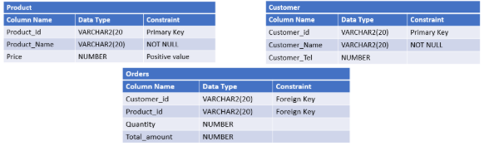

**DDL Check point:**

CREATE TABLE Customer (customer-id VARCHAR2 (20) PRIMARY KEY,customer-name VARCHAR2 (20),customer-tel NUMBER, )

CREATE TABLE Product (product-id VARCHAR2 (20) PRIMARY KEY, product-name VARCHAR2 (20) NOT NULL, price NUMBER CHECK (price 0), )

CREATE TABLE ORDERS (customer-id VARCHAR2 (20) foreign key, product-id VARCHAR2(20) foreign key ,quantity NUMBER, Total-amount NUMBER ,)

ALTER TABLE Product ADD category VARCHAR2(20),

ALTER TABLE orders ADD order Date (DATE),