Naqel Customs – Meeting Notes
Date: 8 March 2026

Action Items – Share by End of Day
- Sample of Commercial invoice raw data with item level data
- HS Code Mapping table
- HS Code Mapping logic
- Sample of a Bayan document

Meeting notes:

- Process
1. Merchant submits a Commercial Invoice → gateway uploads into Infotrack system as a Manifest → if accepted, submits a Declaration → Tabadul returns a Bayan number/Bayan copy PDF
2. Manifest has no HL/LV distinction. Declaration does: HL = 1 per shipment, LV = up to 9,999 batched.

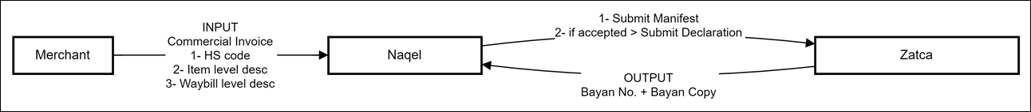

- HS Code Correction
- Low value (<1,000 SAR): Generic code 980300000001 + Arabic description "سلع قيمتها أقل من 1000 ريال منقولة بواسطة النقل السريع" — no item-level HS code required.
- Findings - No HS code (~1–2%): Manual assignment by gateway team.
- Findings - Incomplete HS code i.e less than 6 digits (~5–10%); Auto-completed to 12 digits via master mapping table and logic.
- Wrong HS code (valid format, wrong item): Not detected today
- Saudi HS codes are 12 digits. some Chinese merchants already send 12-digit codes.

- Zatca Validation
- Zatca rejects item descriptions that exactly match the HS code tariff text. Current workaround: append extra words.
- Two description levels: waybill-level (general) and item-level (per line). Rule above applies at item level.

