Youtube video link :

<https://youtu.be/afAyHwnBxiA>

screenshots:

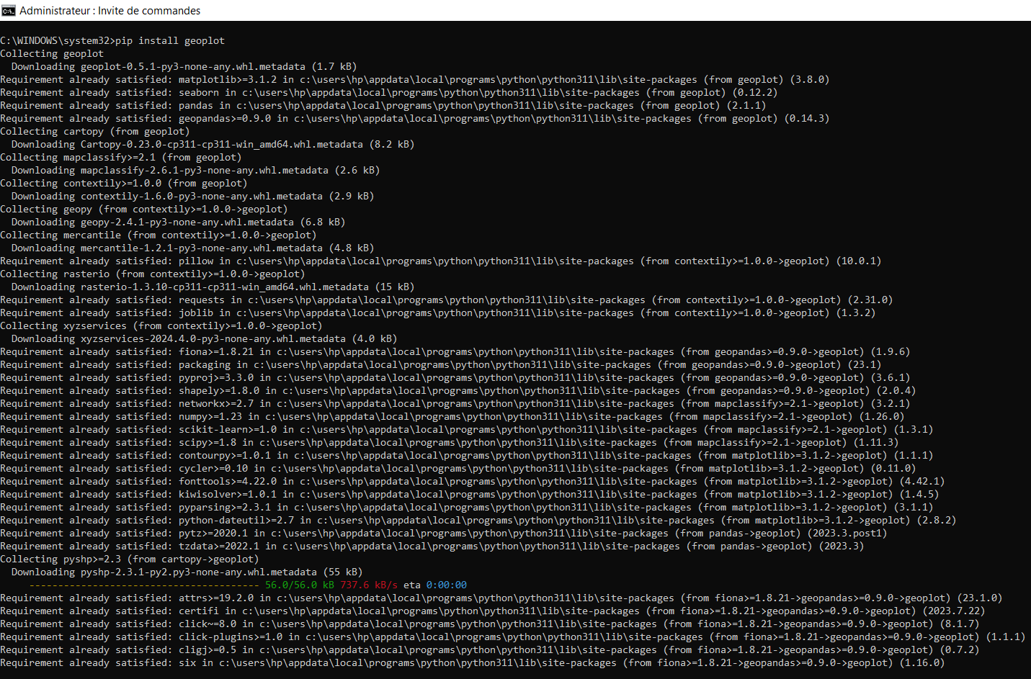

Geo Dataset

<https://drive.google.com/drive/folders/1C_Zx4r-zRyc_9mNJ0XFZM4CDKuvtITaW>

network dataset:

https://gist.github.com/mbostock

